1.4 Given a 0-indexed integer array nums of length n and an integer k, return the number of pairs (i, j) where 0 <= i < j < n, such that nums[i] == nums[j] and (i * j) is divisible by k.

AIM:
To find the number of pairs (i, j) in an array such that:
1. 0 <= i < j < n
2. nums[i] == nums[j]
3. (i * j) is divisible by k.
ALGORITHM:
1. Initialize count = 0.
2. Iterate over all possible pairs (i, j) where i < j:
• Check if nums[i] == nums[j].
• Check if (i * j) % k == 0.
• If both conditions hold, increment count.
3. Return count at the end.
PROGRAM:
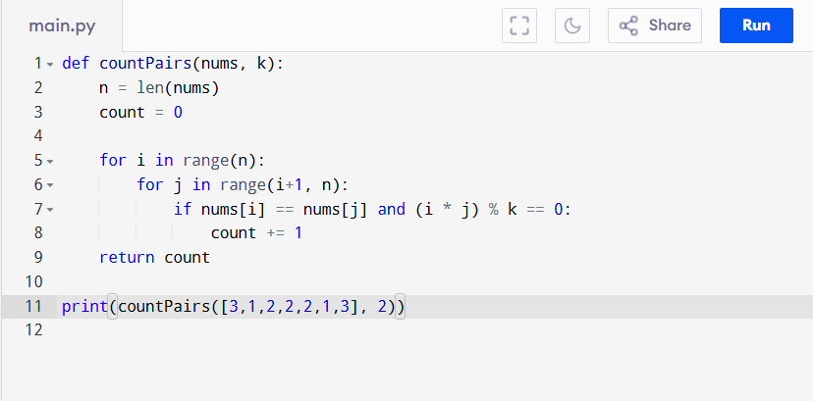

Input:
nums = [3,1,2,2,2,1,3], k = 2

Output:
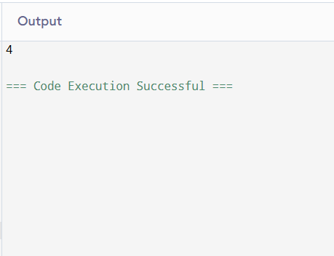
RESULT:
Thus the program to count number of pairs is successfully executed, and the output is verified.

PERFORMANCE ANALYSIS:
Time Complexity:
• Checking all pairs = O(n^2)
• Each check is O(1)
• Total: O(n^2)
Space Complexity:
• Only a counter variable → O(1)

