1.5 Write a program FOR THE BELOW TEST CASES with least time complexity Test Cases: -
Input: {1, 2, 3, 4, 5} Expected Output: 5
Input: {7, 7, 7, 7, 7} Expected Output: 7
Input: {-10, 2, 3, -4, 5} Expected Output: 5
AIM:
To find the maximum element from a given integer array efficiently.
ALGORITHM:
1. Initialize max_val = nums[0].
2. Traverse the array from index 1 to n-1.
3. For each element, compare with max_val:
• If current element > max_val, update max_val.
4. Return max_val as the result.
PROGRAM:
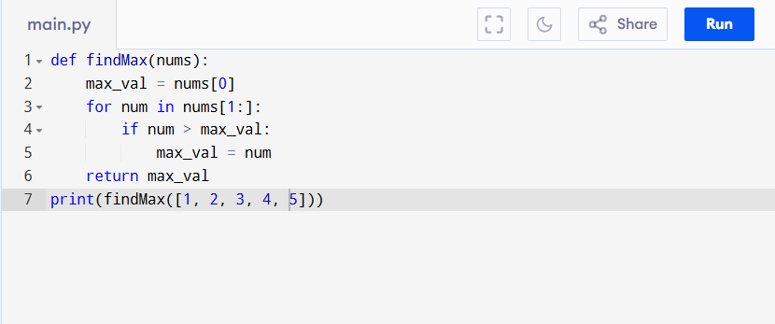

Input:
{1, 2, 3, 4, 5}

Output:
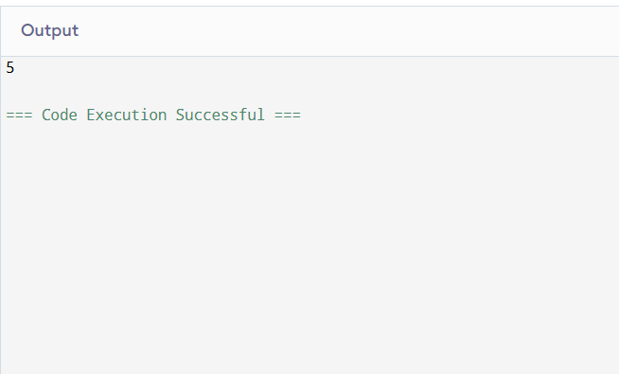

RESULT:
Thus the program to find the maximum element in array is successfully executed, and the output is verified.

PERFORMANCE ANALYSIS:
• Time Complexity: O(n) (must check each element once).
• Space Complexity: O(1) (only one variable used for max)

