1.6 You have an algorithm that process a list of numbers. It firsts sorts the list using an efficient sorting algorithm and then finds the maximum element in sorted list. Write the code for the same.

AIM:
To sort a list of integers efficiently and return the maximum element from the sorted list, while handling edge cases properly.
ALGORITHM:
1. If the list is empty, return None or print a message.
2. Sort the list using an efficient algorithm (O(n log n)).
3. Return the last element (which is the maximum).
PROGRAM:
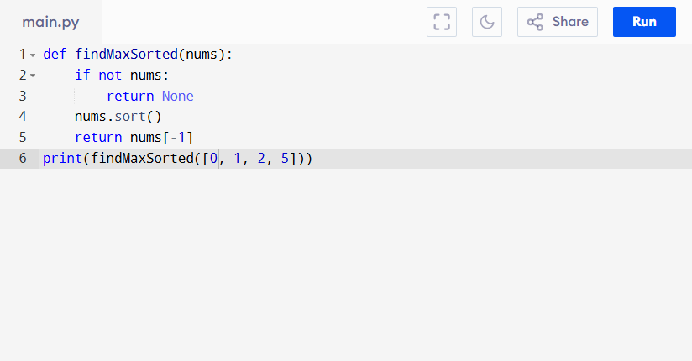
Input:
nums = [0, 1, 2, 5]

Output:
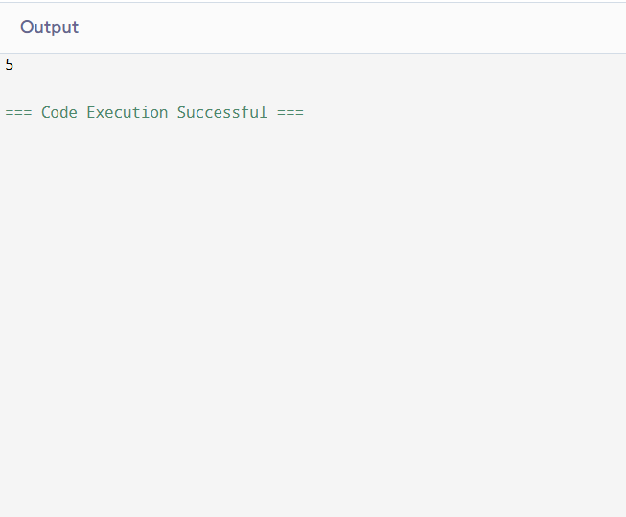
RESULT:
Thus the program to find maximum element from the sorted list is successfully executed, and the output is verified.

PERFORMANCE ANALYSIS:
- Sorting → O(n log n)
• Accessing last element → O(1)
• Total: O(n log n)
• Space: O(1) (in-place sort) or O(n) (depending on sorting algorithm).

