1.7 Write a program that takes an input list of n numbers and creates a new list containing only the unique elements from the original list. What is the space complexity of the algorithm

AIM:
To create a program that takes an input list of n numbers and creates a new list containing only the unique elements from the original list.

ALGORITHM:
1.Initialize an empty set seen and an empty list unique_list.
2.Iterate through each element x in the input list.
3.If x is not in seen, add it to both seen and unique_list.
4.Return unique_list.

PROGRAM:
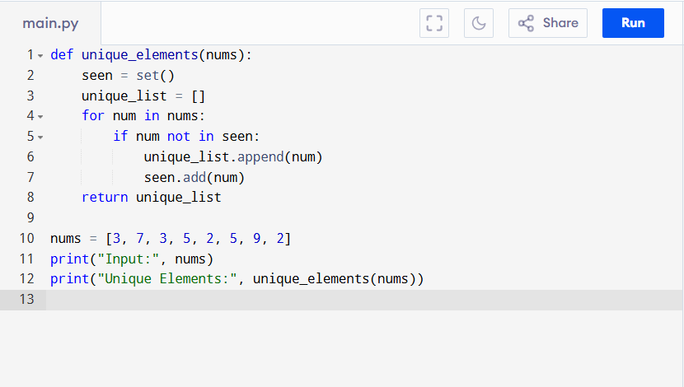

Input:
nums = [3, 7, 3, 5, 2, 5, 9, 2]

Output:
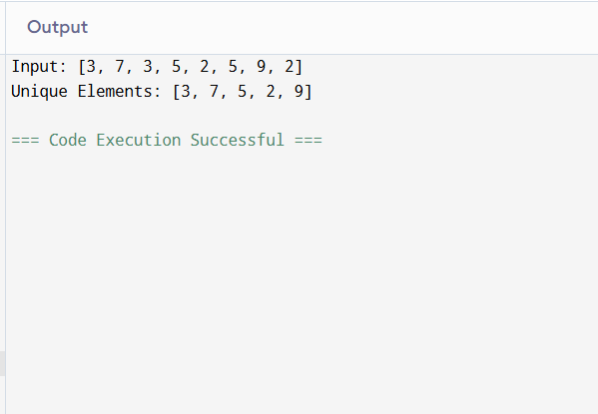

RESULT:
Thus the program to create a new list from the original list is successfully executed, and the output is verified.

PERFORMANCE ANALYSIS:
We use a set (seen) to store unique elements → O(n) in worst case.
We also use a list (unique_list) to return result → O(n).
- Total Space Complexity = O(n)
- Time Complexity = O(n) (since each membership check in a set is O(1) on average).

