1.8 Sort an array of integers using the bubble sort technique. Analyze its time complexity using Big-O notation

AIM:
To sort an array of integers using the bubble sort technique and analyze its time complexity using Big-O notation.
ALGORITHM:
1.​ Start with a list of unsorted elements.
2. Iterate through the list from the first element to the last.
3.​ For each element, compare it with the next element.
4.​ If the current element is greater than the next element, swap them.
5.​ Repeat steps 2-4 until the list is sorted.
6.​ The largest element will "bubble" to the end of the list after the first pass.
7.​ The process is repeated for the remaining unsorted elements until the entire list is sorted.
PROGRAM:
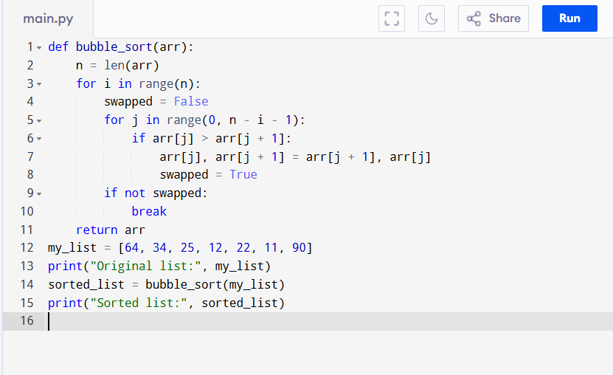
Input:
3,5,2,15,32,1
Output:
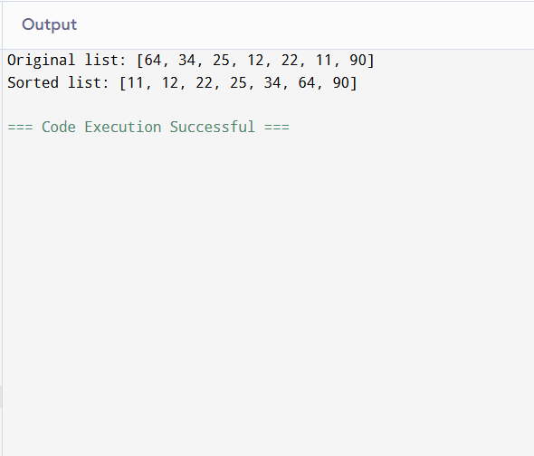
RESULT:
Thus the bubble sort technique program is successfully executed, and the output is verified.

PERFORMANCE ANALYSIS:
- Worst-Case and Average-Case Time Complexity: O(n^2)
- Best-Case Time Complexity: O(n)
- Space Complexity
- O(1) – Bubble Sort is an in-place algorithm.

