1.9 Checks if a given number x exists in a sorted array arr using binary search. Analyze its time complexity using Big-O notation.

AIM:
To design an algorithm that checks if a given number x exists in a sorted array using binary search and analyze its performance.

ALGORITHM:
- Start with two pointers:
low = 0, high = len(arr)-1
- Find the middle index:
mid = (low + high) // 2
- If arr[mid] == key, element is found → return index.
- If arr[mid] < key, search in the right half (low = mid+1).
- If arr[mid] > key, search in the left half (high = mid-1).
- Repeat until low > high.
- If not found, return -1.

PROGRAM:
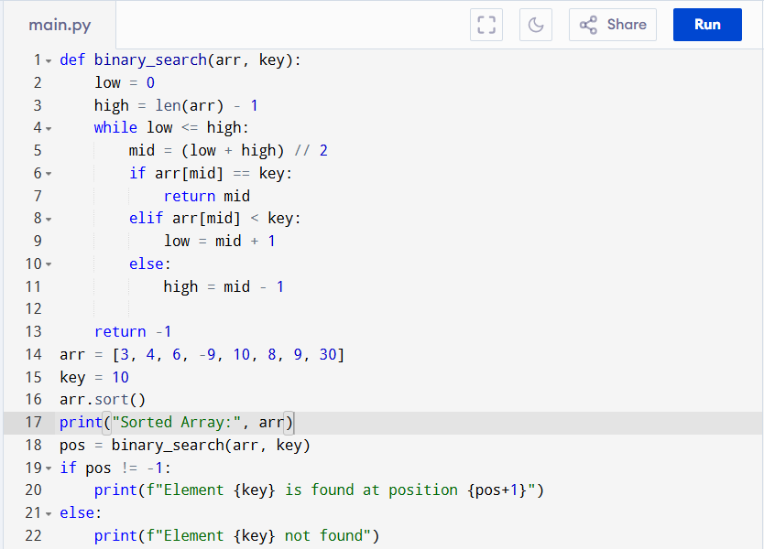
Input:
Array: [3, 4, 6, -9, 10, 8, 9, 30]
Key: 10
Output:
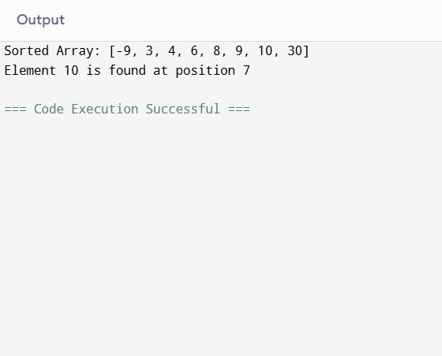
RESULT:
Thus the binary search program is successfully executed, and the output is verified.

PERFORMANCE ANALYSIS:
Time Complexity
1. Best Case: Key found at the middle on first try → O(1)
2. Worst Case: Array repeatedly divided in half until one element left →
Number of comparisons = log₂(n) → O(log n)
3. Average Case:
Same as worst case since search space halves each step → O(log n)

Space Complexity:
- Iterative version uses O(1) extra space.
- Recursive version would use O(log n) stack space.

