2.9 Finding Closest Pair of Points in 2D
AIM
To find the closest pair of points and their minimum Euclidean distance from a given set of 2D points using the brute force method.
ALGORITHM
- Start and Read the list of 2D points.
- Initialize min_distance as infinity and closest_pair as None.
- For each point p1 in the list
- For each other point p2 after p1:
- Calculate the Euclidean distance between p1 and p2.​
- If this distance is less than min_distance:- Update min_distance with the new distance.
- Update closest_pair with (p1, p2).
- Return closest_pair and min_distance.
PROGRAM
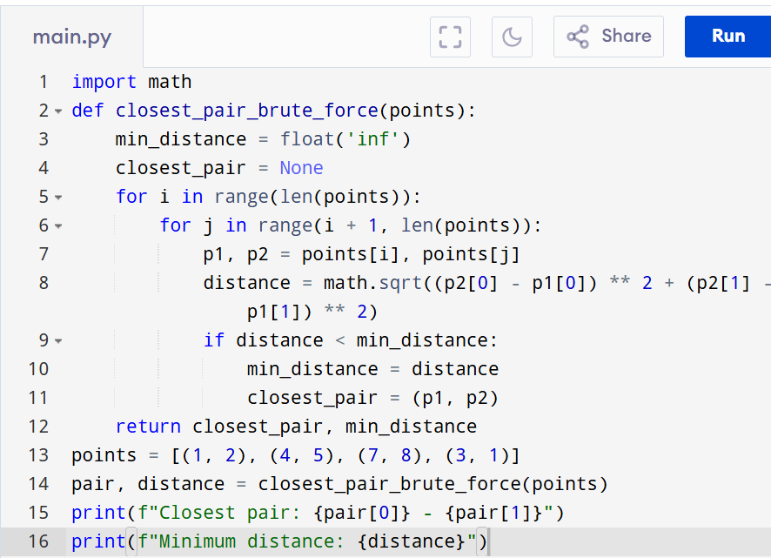

Input:
Points = [(1, 2), (4, 5), (7, 8), (3, 1)]

Output:
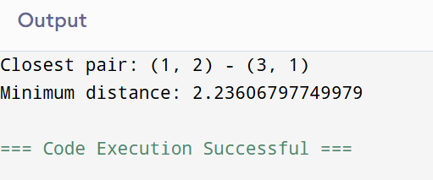

RESULT:
Thus the program is successfully executed and the output is verified.

PERFORMANCE ANALYSIS:
• Time Complexity: O(n²)
• Space Complexity: O(1)

