2.10 Finding Closest Pair of Points in 2D
AIM
To determine the closest pair of points and the minimum Euclidean distance between them using a brute force approach.
ALGORITHM
- Start
- Define a function to calculate the Euclidean distance.
- Read the list of points.
- Initialize min_distance = ∞ and closest_pair = None.
- Compare each pair of points:
- If the distance between them is smaller than min_distance:
- Update min_distance and closest_pair.
- Return closest_pair and min_distance
- End

PROGRAM
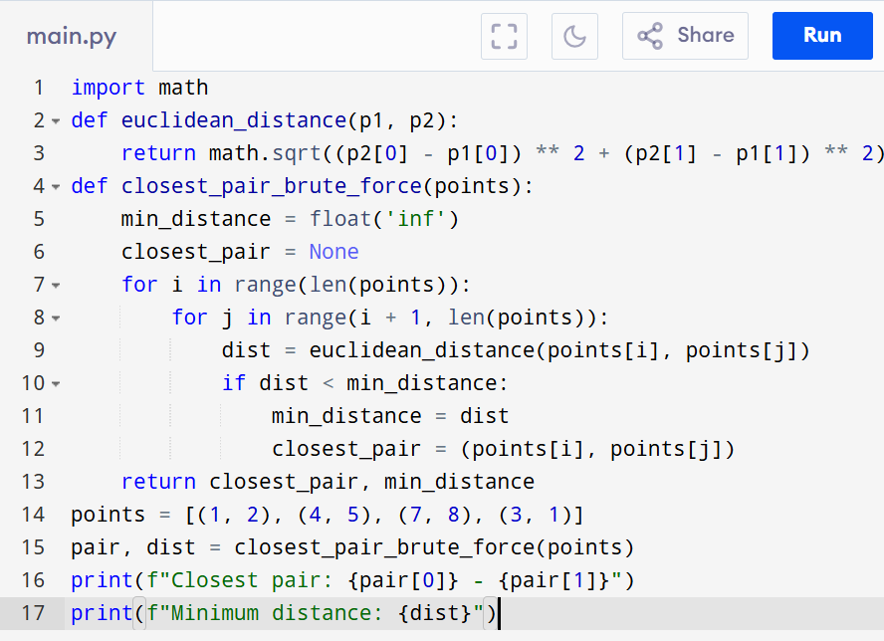

Input:
[(1, 2), (4, 5), (7, 8), (3, 1)]

Output:
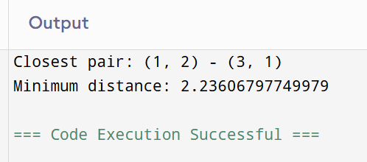

RESULT:
Thus the program is successfully executed and the output is verified.

PERFORMANCE ANALYSIS:
· Time Complexity: O(n²)
· Space Complexity: O(1)

