2.11 Write a program that finds the convex hull of a set of 2D points using the brute force approach. Input: A list or array of points represented by coordinates (x, y). Points: [(1, 1), (4, 6), (8, 1), (0, 0), (3, 3)] Output: The list of points that form the convex hull in counter-clockwise order. Convex Hull: [(0, 0), (1, 1), (8, 1), (4, 6)]
AIM
To determine the set of points that form the convex hull of a given set of 2D points using the brute force method and return them in counter-clockwise order
ALGORITHM
- Read the list of 2D points.
- For each pair of points (p1, p2) in the set:
- Assume they form an edge of the convex hull.
- Check all other points and Compute the cross product to determine if all points lie on one side of the line segment (p1, p2).
- If all points lie on the same side or are collinear, mark (p1, p2) as part of the hull.
- Collect all points that are part of at least one hull edge.
- Sort the hull points in counter-clockwise order using the centroid angle method.
- Output the hull points

PROGRAM
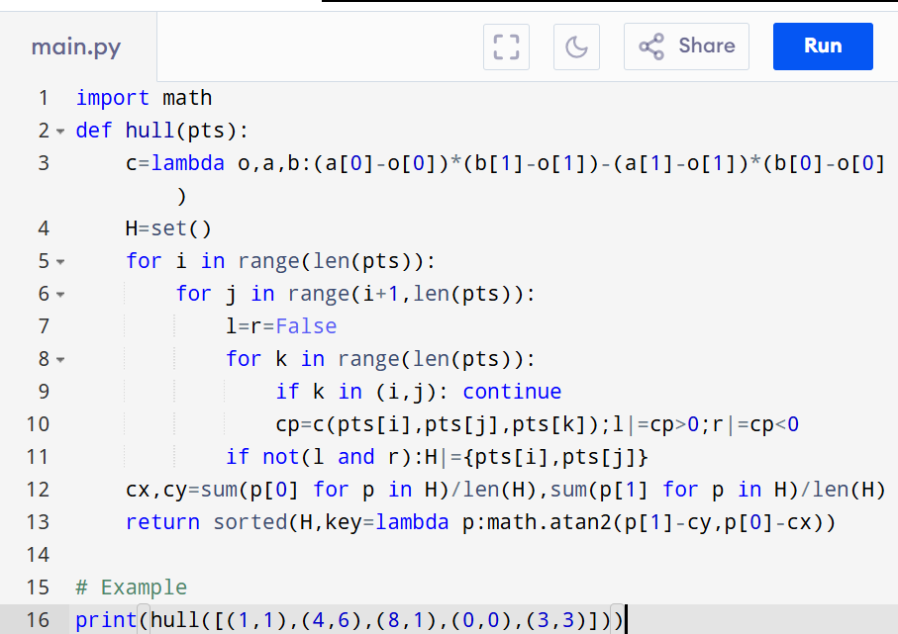

Input:
[(1, 1), (4, 6), (8, 1), (0, 0), (3, 3)]

Output:
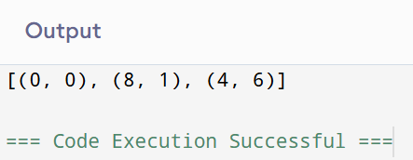

RESULT:
Thus finding convex hull of a set of 2d points using the brute force approach is successfully executed and the output is verified.

PERFORMANCE ANALYSIS:
· Time Complexity: O(n³)
· Space Complexity: O(n)

