2.14 You are given a list of items with their weights and values. Develop a program that utilizes exhaustive search to solve the 0-1 Knapsack Problem. The program should:
-Define a function total_value(items, values) that takes a list of selected items (represented by their indices) and the value list as input. It iterates through the selected items and calculates the total value by summing the corresponding values from the value list.
-Define a function is_feasible(items, weights, capacity) that takes a list of selected items (represented by their indices), the weight list, and the knapsack capacity as input. It checks if the total weight of the selected items exceeds the capacity.

AIM
To find the optimal selection of items that maximizes total value without exceeding the knapsack’s weight capacity, using exhaustive search.
ALGORITHM
- Start
- Define total_value(items, values) to Sum values of selected item indices from the values list.
- Define is_feasible(items, weights, capacity) to Calculate total weight of selected item indices.
- Return True if total weight ≤ capacity, otherwise False.
- For each combination:-Check feasibility with is_feasible.
- If feasible and value is higher than current best, update best selection and value.
- Return the optimal selection and maximum total value.
- · End

PROGRAM
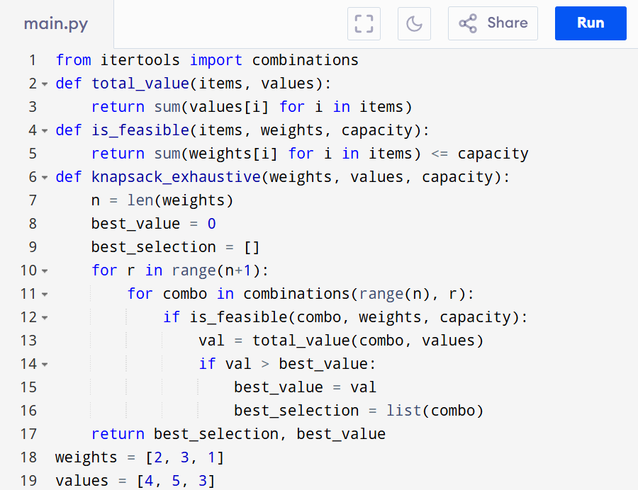
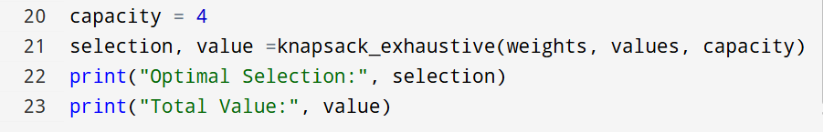

Input:
Items: 3 (indices 0, 1, 2)
Weights: [2, 3, 1]
Values: [4, 5, 3]
Capacity: 4

Output:
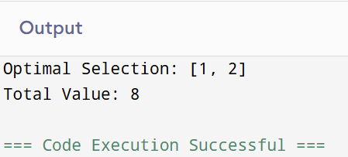
RESULT:
Thus Solving the 0-1 Knapsack Problem using Exhaustive Search is successfully executed and the output is verified.

PERFORMANCE ANALYSIS:
· Time Complexity: O(2^n)
· Space Complexity: O(n)

