2.6 Given an array arr of positive integers sorted in a strictly increasing order, and an integer k. return the kth positive integer thatis missing from this array.

AIM
To find the kth missing positive integer that does not appear in a strictly increasing array arr.
ALGORITHM
1. Initialize a counter missing = 0 to count missing numbers.
2. Traverse natural numbers starting from 1.
- If the current number exists in arr, skip it.
- Otherwise, increase missing.
3. Stop when missing == k.
4. Return the current number.
PROGRAM
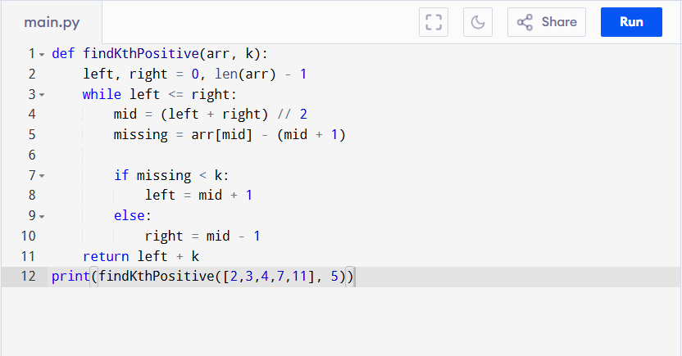
Input:
arr = [2,3,4,7,11], k = 5

Output:
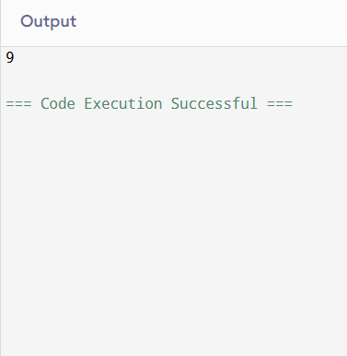
RESULT:
Thus the program to find the kth missing positive integer is successfully executed and the output is verified.

PERFORMANCE ANALYSIS:
- Time Complexity: O(log n) (binary search)
- Space Complexity: O(1)

