2.6 BINARY SEARCH FOR PEAK ELEMENT.

AIM
To design an algorithm that finds the index of a peak element in an array using binary search in O(log n) time.
ALGORITHM
1. Let low = 0, high = n-1.
2. While low < high:
- Compute mid = (low + high) // 2.
- If nums[mid] > nums[mid + 1]:
- Then the peak lies in the left half (including mid), so set high = mid.
Else:
The peak lies in the right half, so set low = mid + 1.
3. When the loop ends, low == high and that index is a peak.
PROGRAM
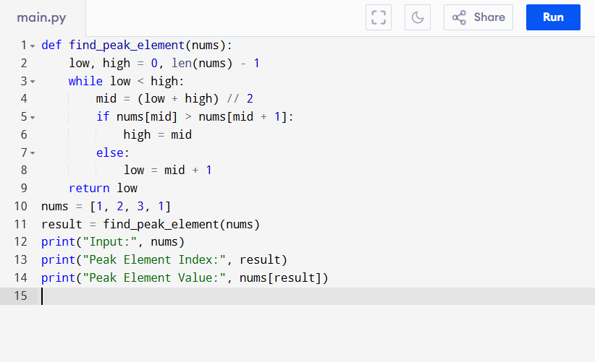
Input:
[1, 2, 3, 1]
Output:
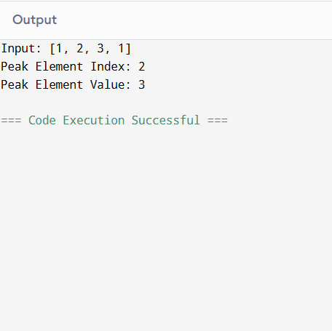
RESULT:
Thus the program is successfully executed and the output is verified.

PERFORMANCE ANALYSIS:
- Time Complexity:
  - Each step reduces the search space by half → O(log n).
- Space Complexity:
  - O(1) (binary search done in-place, no extra memory).
  - Best Case: Found in first comparison → O(1).
  - Worst Case: O(log n) comparisons until narrowing down to one element.

