2.7 FIRST OCCURRENCE OF SUBSTRING

AIM
To find the index of the first occurrence of the string needle in haystack.
ALGORITHM
1. Let n = len(haystack) and m = len(needle).
2. Traverse through each index i in haystack where a substring of length m can fit.
3. Compare haystack[i : i+m] with needle.
4. If match found, return i.
5. If no match found after loop, return -1.
PROGRAM
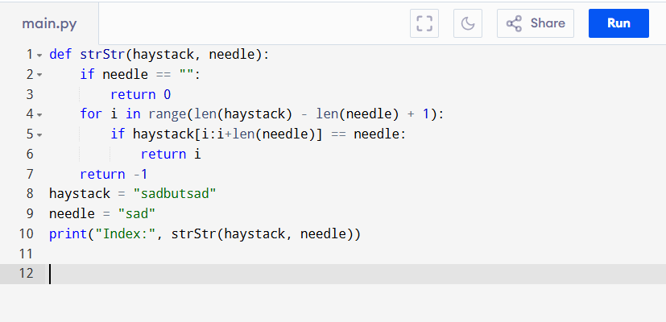
Input:
haystack = "sadbutsad", needle = "sad"Output:

Output:
Index: 0
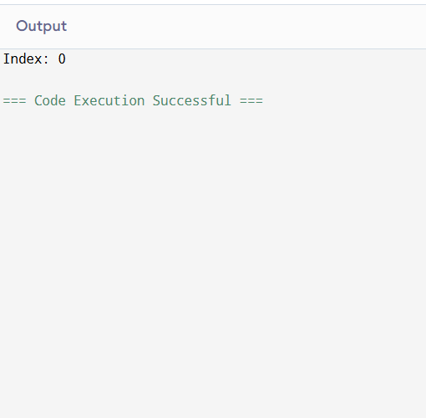
RESULT:
Thus the program is successfully executed and the output is verified.

PERFORMANCE ANALYSIS:
- Time Complexity:
  - O((n-m+1) * m) ≈ O(n*m) in worst case.
- Space Complexity:
  - O(1)

