2.7 Finding Substrings in a List of Words
AIM
To return all strings from a given list that are substrings of another string in the same list.
ALGORITHM
- Start
- Read the array of strings words.
- Initialize an empty list result.
- For each string w1 in words:
- For each string w2 in words:
- If w1 ≠ w2 and w1 is a substring of w2:
- Append w1 to result.
- Break inner loop.
- Return result.
- End

PROGRAM
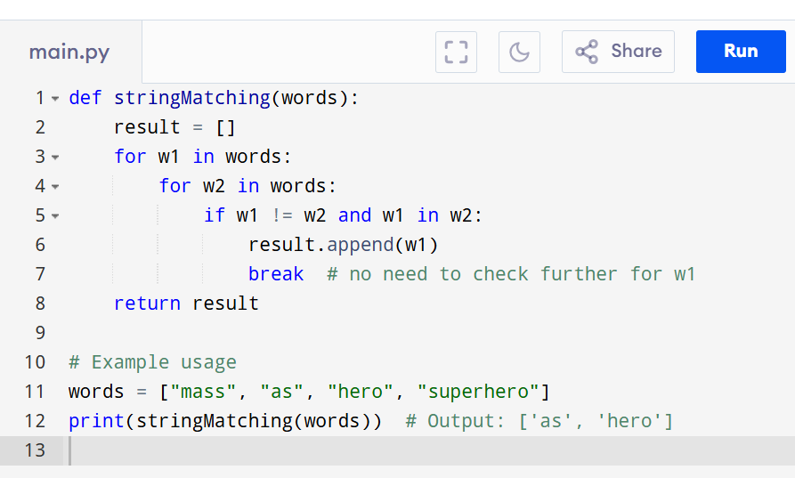

Input:
["mass", "as", "hero", "superhero"]

Output:
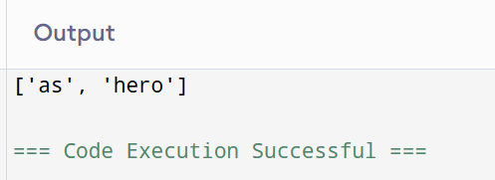

RESULT:
Thus the program is successfully executed and the output is verified.

PERFORMANCE ANALYSIS:
· Time Complexity: O(n² · k²)
· Space Complexity: O(n)

