

Rajiv Gandhi University of Knowledge Technologies
(Catering the Educational Needs of Gifted Rural Youth of A.P)
R.K Valley, Y.S.R Kadapa (Dist)-516330
Mood Music(MoMu)
Supervised By:
Mrs. Susmitha
Assistant professor
Department of CSE
Submitted By:
G Naveena R170030
T Bala Sai Teja R170054
D Jayakrishna R170064
N Manoj Kumar R170041
B Prakash R170046
Department of CSE

This Project report has been submitted in fulfilment of the requirements for the Degree of Bachelor ofTechnology in Software Engineering.

Rajiv Gandhi University of Knowledge Technologies
(Catering the Educational Needs of Gifted Rural Youth of A.P)
R.K Valley, Y.S.R Kadapa (Dist)-516330


CERTIFICATE

This is to certify the report entitled “MOOD MUSIC(MoMu)” submitted by the members of Group-5 in partial fulfillment of the requirement for the award of Bachelor of Technology in Computer Science and Engineering is a bonafide work carried out here under my supervision and guidance.
The report hasn't been submitted previously in part or in full to this or any other university or institution for the award of any degree.
Project Guide Coordinator Head of the Dept
E.Susmitha Ratna Kumari Challa
Project Internal Guide
Computer Science and Engineering,
RGUKT RK Valley

DECLARATION
We G Naveena , T Bala Sai Teja , D Jayakrishna , N Manoj Kumar and B Prakash hereby declare that this report entitled “Mood Music(MoMu)” submitted by me under the guidance and supervision of E.Susmitha. We also declare that it has not been submitted previously in part or in full to this University or other institution for the award of any degree or diploma.

Date: 02-05-2022 G Naveena (R170030)
Place:Rk Valley T Bala Sai Teja(R170054)
D Jayakrishna(R170064)
N Manoj Kumar(R170041)
B Prakash(R170046)

Acknowledgment

I would like to express my sincere gratitude to E.Susmitha, my project internal guide for valuable suggestions and interest in the progress.

I am grateful to Ratna Kumari Challa, HOD CSE, for providing excellent computing facilities and a congenial atmosphere for progressing with my project.

At the outset, I would like to thank Rajiv Gandhi University of Knowledge Technologies and Highradius Technologies, for providing all the necessary resources for the successful completion of my course work.

With Sincere Regards,
G Naveena(R170030),
T Bala Sai Teja(R170054),
D Jayakrishna(R170064),
N Manoj Kumar(R170041),
B Prakash(R170046).

Scenario:
Mood Music(MoMu) is a Music Player to play songs according to the user specified mood and enjoy the attractive interfaces.
Users login into the page and selects mood ,then related songs will be played.
Moods: Melody,Folk,Retro,Devotional,Broken,Zim,Sleep,Party

Requirements:
  - Two Actors
1) Admin
2) User
  - Home Page – basic details of each mood’s songs icons should be shown
  - Rigister – Users can register by filling the registration form. Here Users must fill the basic details like Phone Number, Gmail id.
  - Login – Users can login by filling their credintials.
  - Melody Icon – It should contains melody songs playlist.
  - Folk Icon – It should contains folk songs playlist.
  - Retro Icon – It should contains retro songs playlist.
  - Devotional Icon – It should contains devotional songs playlist.
  - Broken Icon – It should contains heart broken songs playlist.
  - Gym Icon – It should contains Gym songs playlist.
  - Sleep Icon – It should contains sleep songs playlist.
  - Party Icon – It should contains party songs playlist.
  - Each page of mood should contain song name,artist name,loop button,pause button,forward button,backward button and playlist button.

Software Requirement Specification(SRS)

for

Mood Music(MoMu)

1. Introduction
1 .1 Purpose: The purpose of this document is to present a detailed description of the Mood Music System that we will design and implement. In this user can choose his songs based on his/her mood. If he want to listen devotional/melody/folk songs, then he will be offered with all icons on the home page.
1 .2 Scope: The goal is to design a MoMu in which we can play songs based on our mood.It reduces the effort of searching the songs.
1 .3 Definitions:
- MoMu- Mood Music
- SRS- Software Requirement Specification

2.Overall Description:
MoMu player for palying songs based on the user’s mood.
Users can select the mood and they can listen the songs related to that mood.If they want to change their mood,they can come back and change their mood in the home page.It helps not to play random songs which are not related to user’s mood.
2.1 Product Perspective: This product is mainly aimed towards where songs will be played based on the user’s mood.
2.2 Product Functions: OSS should support this use case
2.3 User Characteristics: User should be familiar with the terms like login,register,folk,retro,melody,devotional,party etc.
2.4 Principle Actors:
2 Principle Actors are User and Admin.
3.Specific Requirements:
3.1 Functional Requirements: This section provides requirement overview of the system. Various functional modules that can be implemented by the system will be -
3.1.1 Register: Users can register by filling their details phone number and gmail id and password.
3.1.2 Login: Users can login by filling their details phone number and gmail id and password.Details will be validated by admin.
3.1.3 Client: The client-side of the system will be an application with a user interface that is integrated into a music listening website or application. This application gathers the information from users, investigates some actions of the users, and provides the connection with the server.
3.1.4 Home page: In this Home page we will have all available moods for the user. Users has to select their mood.Then songs related to that mood will be played.
3.1.5 Evaluating songs: It must be able to evaluate songs and send appropriate information to the server.
3.1.6 Display playlist: The application must display the playlist that are obtained from the server to the user in a proper way by providing a GUI.
3.2 Non-Functional Requirements:

PERFOMANCE REQUIREMENTS
● Accuracy
Since we will give the priority to the accuracy of the software, the
performance of the Music Recommender will be based on its accuracy on recommendations.
● Security
Sensitive information should be kept in safe.

DESIGN CONSTRAINTS
● Language
The product should be integratable with any music websites. Also we will handle with a lot of parameter and object. At this point, we need an object-oriented and commonly used language. As stated above, Neo4j will be used for server side and it has a Java API. So, Java programming language will be used for these aims.
● Hardware Constraints
The system will be integrated with a website. To use recommendation system, user should enter from a personal computer, mobile device with internet connection, tablet etc.
● Software System Attributes
➔ Usability
The software will be embedded in a website. It should be
scalable designed to be easily adopted by a system.
➔ Reliability
The system should have accurate results and fast responses to user’s changing habits.
➔ Security
User profile information will be used, so data security is one of the most important concern of the system.

3.3 Technical Issues: This system will work on client-server architecture. It will require an internet server and which will be able to run js application. The system should support some commonly used browser such as mozzila firefox,chrome, IE etc.

4.Software Interface:
1.Operating System: Linux/Windows.
2.Browser: mozzila firefox/chrome.
5.Hardware Interface:
Hardware requirements for insurance on internet will be same for both parties which are as follows:
Processor:Dual Core
RAM:2 GB
Hard Disk:100GB
NIC(Network Internet Card):For each party

6.System Design
6.1 Use Case Diagram

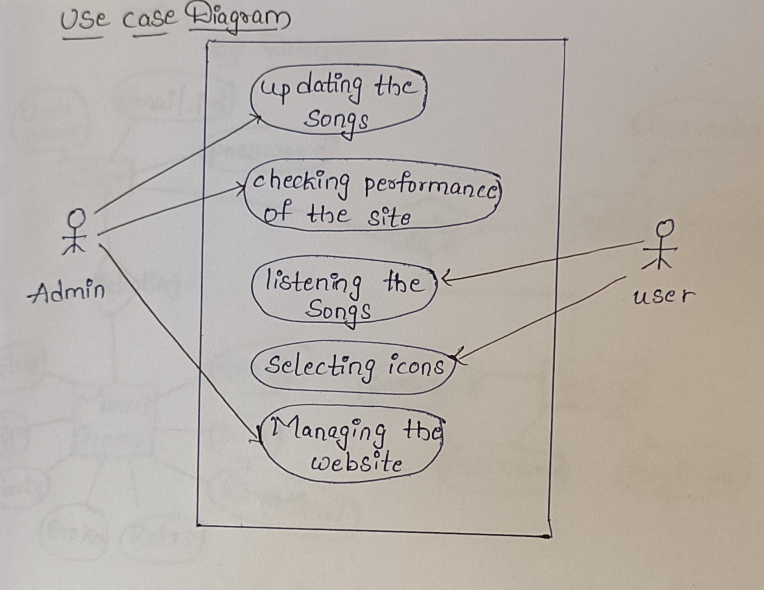

6.2 Context Diagram
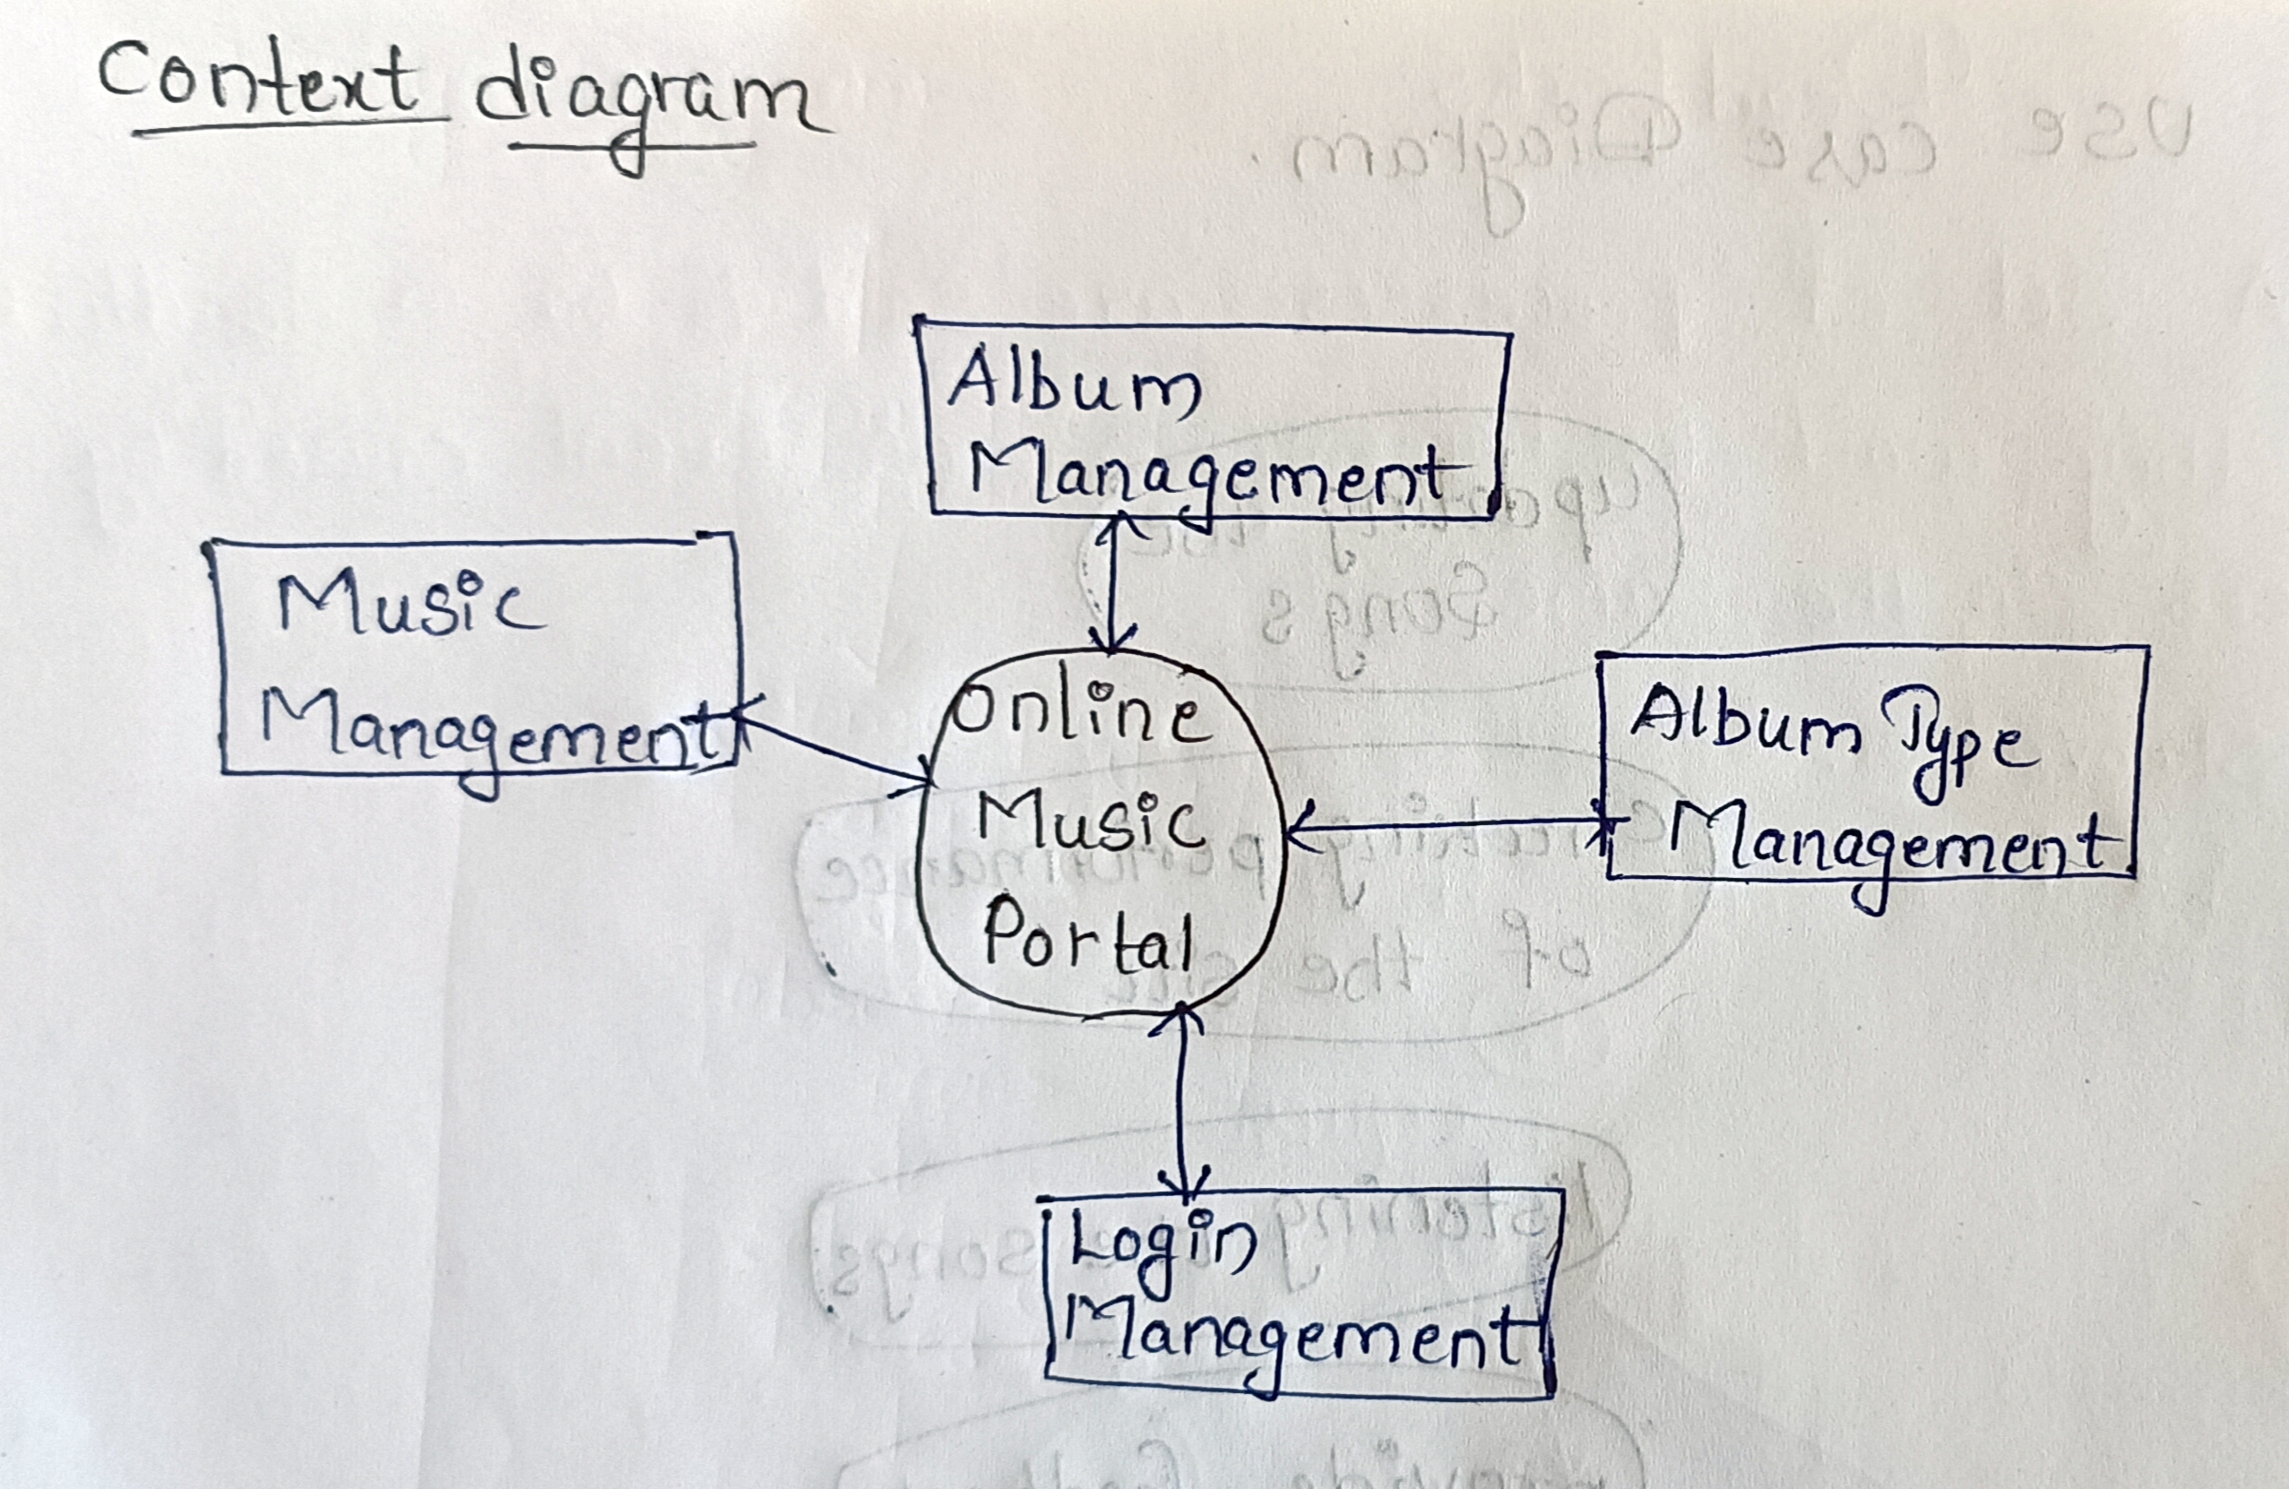

6.3 Data Flow Diagram
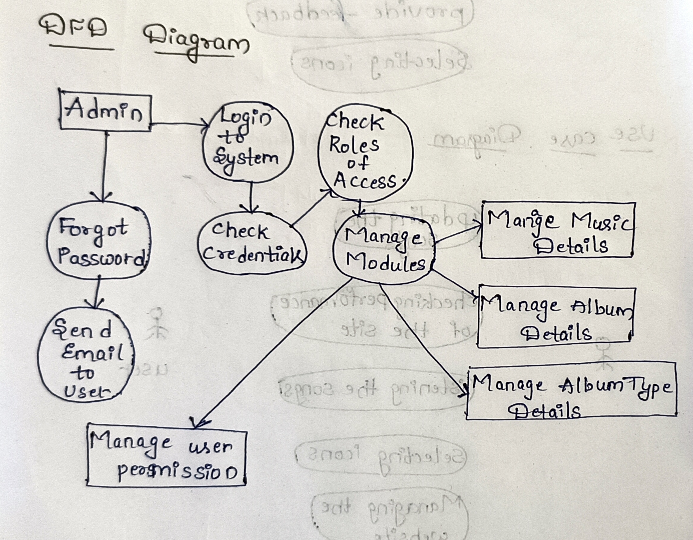

6.4 E R Diagram
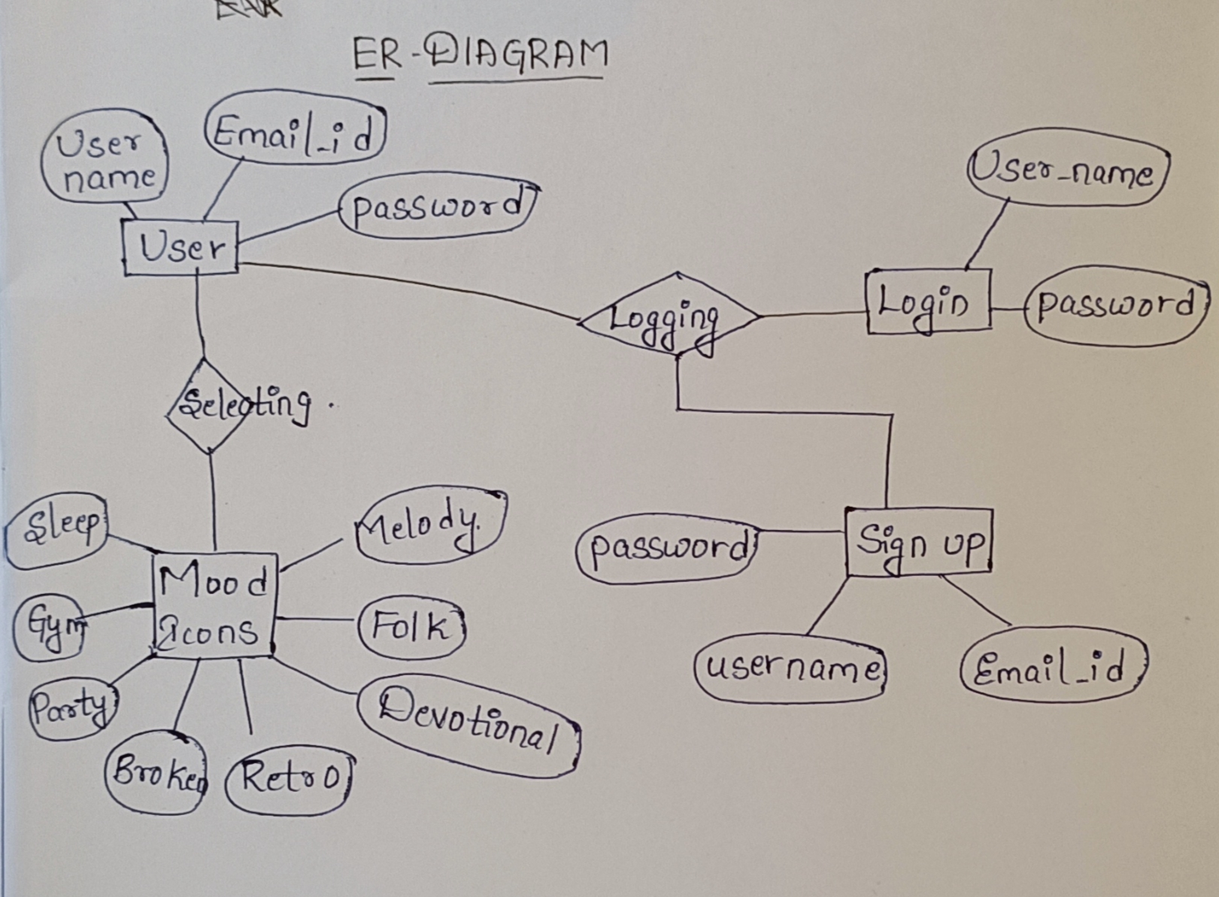

6.5 Sequence Diagram
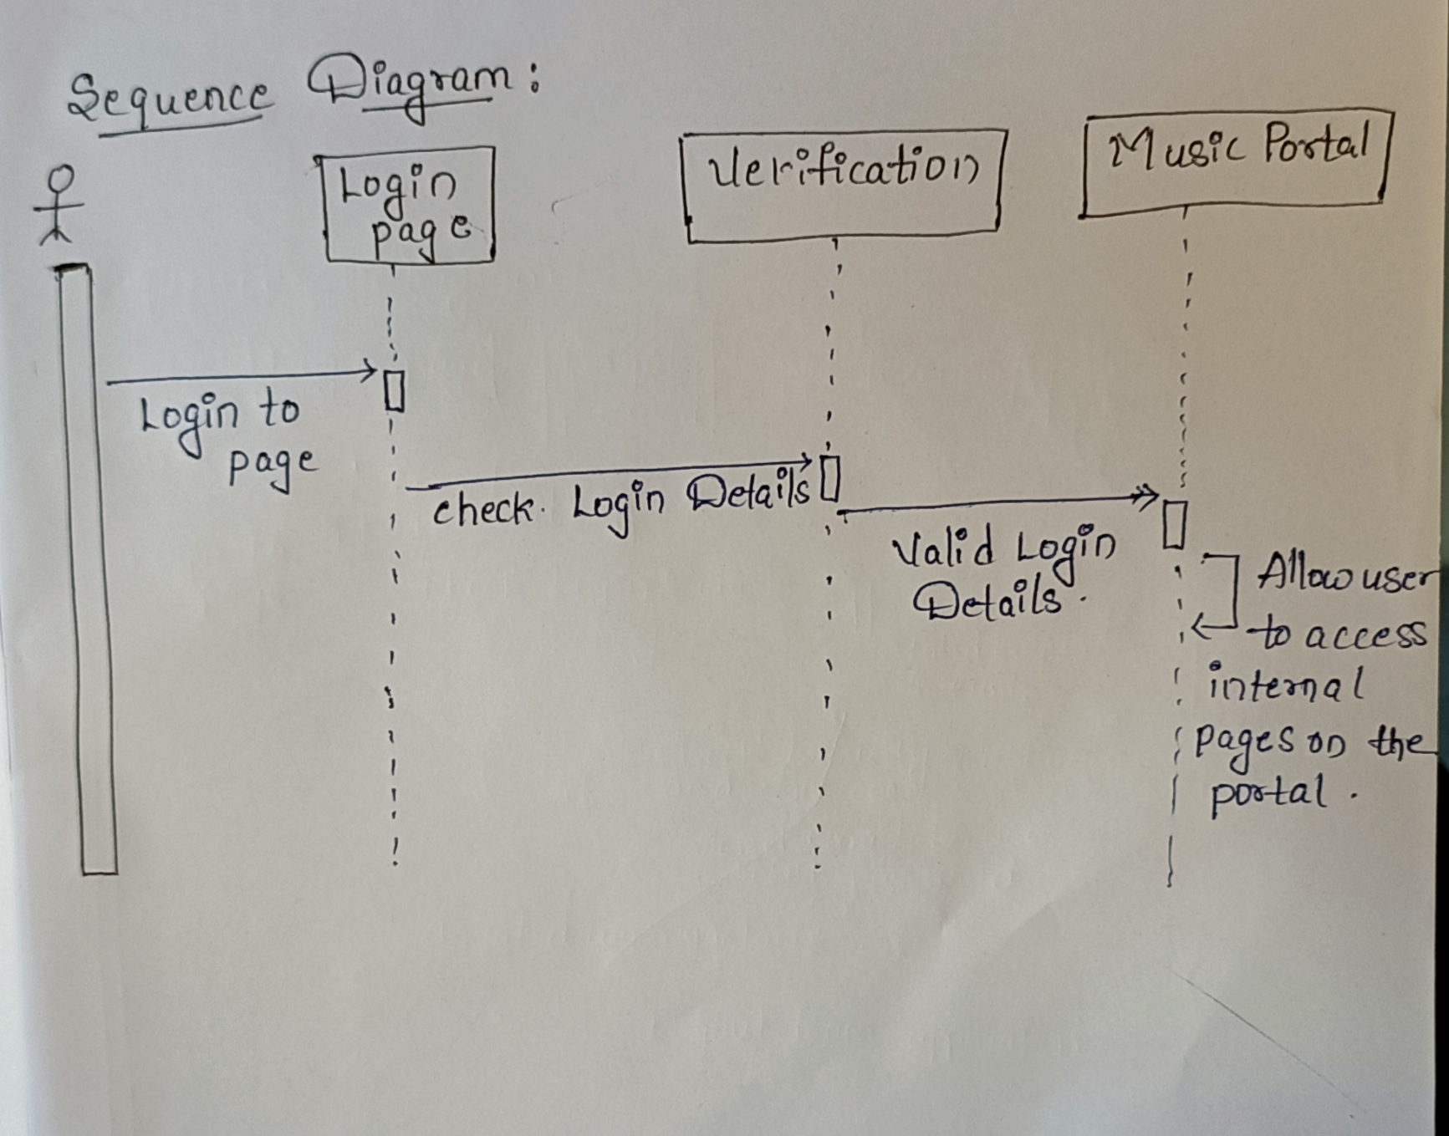

6.6 Activity Diagram


