1. Create a Recovery Case

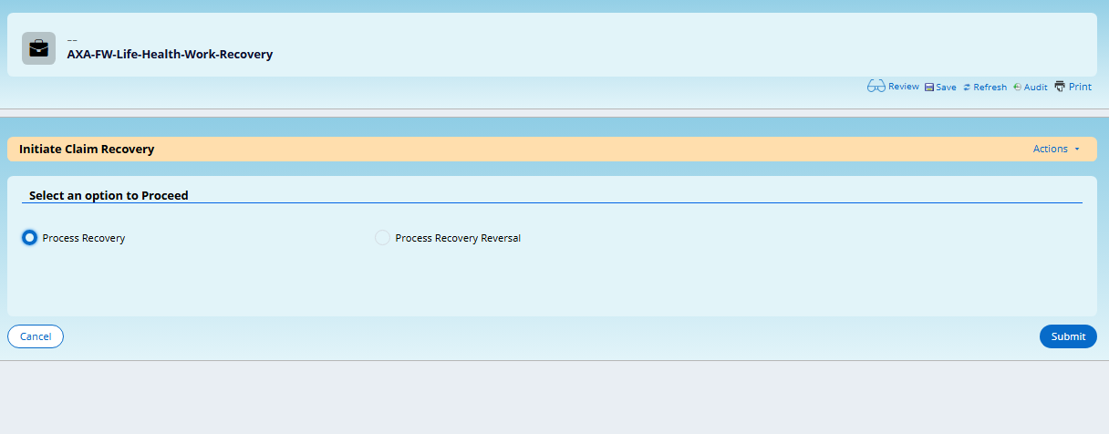

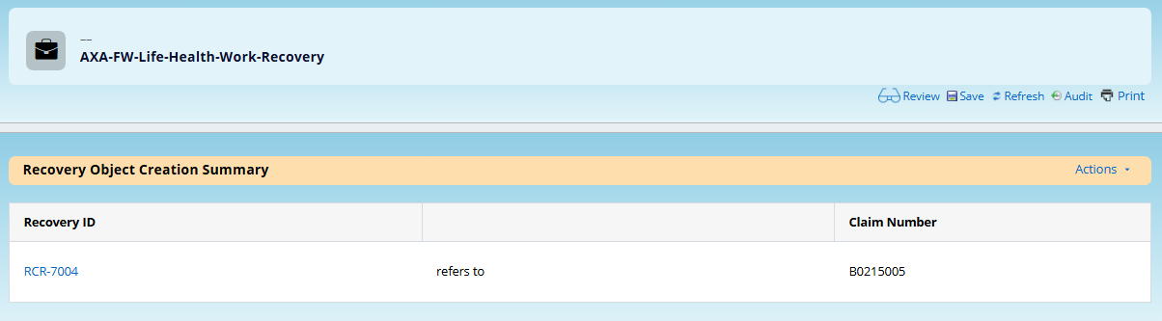

1. Click on Generate Claim Recovery Letter Checkbox to generate letter

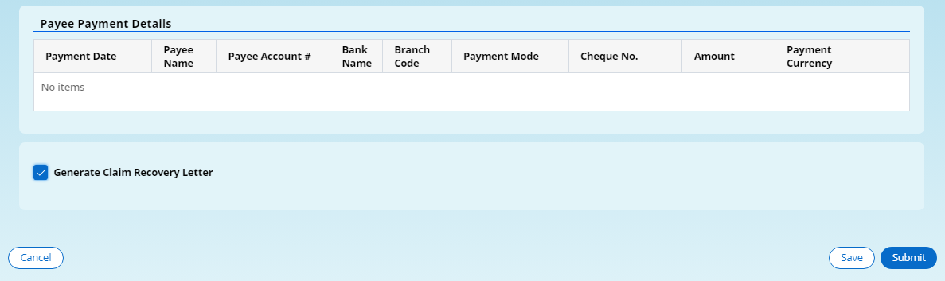

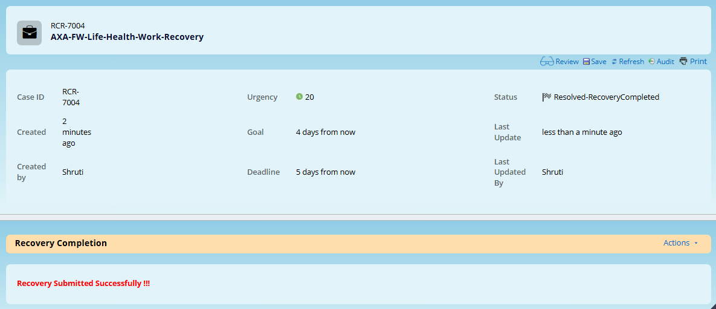

1. Recovery Letter Generated Successfully. RecoveryLetterStatus is Success

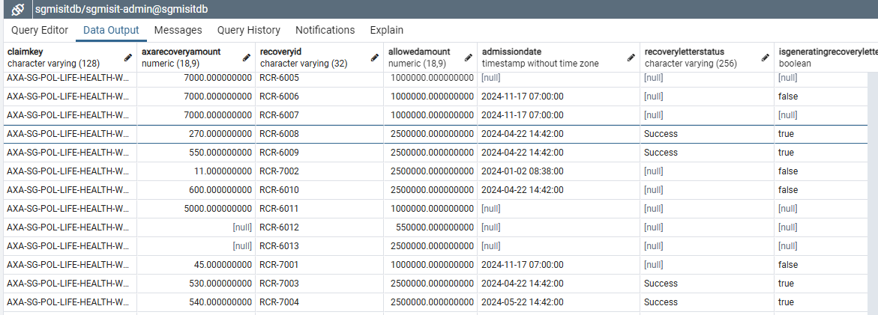

1. Recovery File Generated with File Name as SG_SG_claim-Recovery_20250206_500_00001.xml

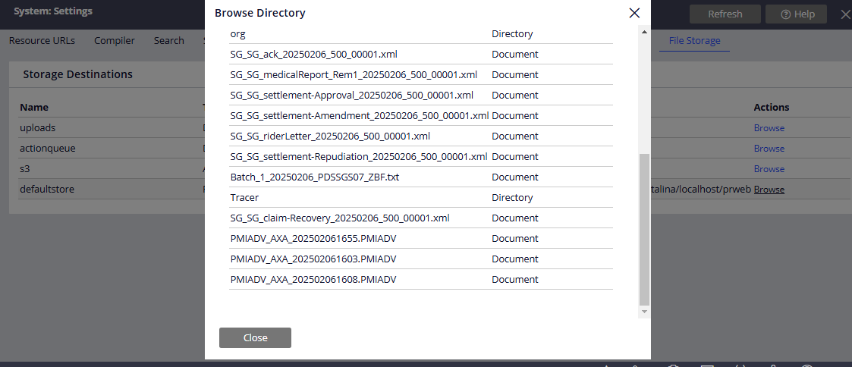

1. OTX and ZeroByte Generated Successfully

