RECRUITMENT Management System
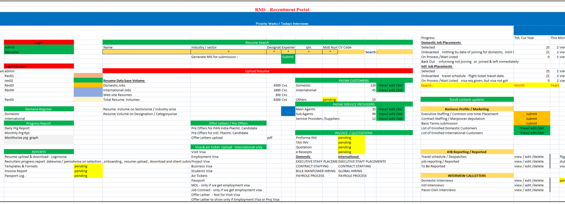

RECRUITMENT Management System
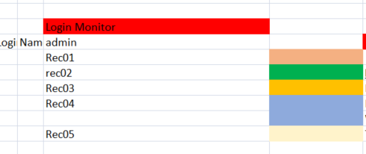
Recruiters Login Details
Domestic
SLNO | COMPANY SERIAL NUMBER | NAME | DESIGNATION | PHOTO | EMAIL ID | STAFF CONTACT NUMBER | ALTERNATE CONTACT NUMBER | ADDRESS | AADHAR CARD NUMBER | DATE OF JOINING | DATE OF BIRTH | Field 1 | Field 2 | Field 3
 |  |  |  |  |  |  |  |  |  | DATE | DATE

International
SLNO | COMPANY SERIAL NUMBER | NAME | DESIGNATION | PHOTO | EMAIL ID | STAFF CONTACT NUMBER | ALTERNATE CONTACT NUMBER | ADDRESS | AADHAR CARD NUMBER | DATE OF JOINING | DATE OF BIRTH | Field 1 | Field 2 | Field 3
 |  |  |  |  |  |  |  |  |  | DATE | DATE


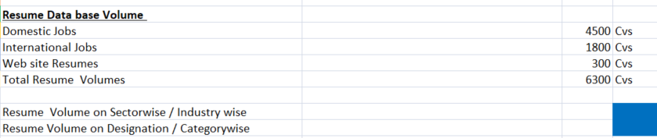
International
SNO | COMPANY SERIAL NUMBER | CODE NO | D O S | CANDIDATE NAME | DATE OF BIRTH | AGE | PASSPORT DETAILS | QUALFN | SECTOR | INDUSTRY | PLACEMENT TYPE | TOTAL EXP | POST & LOCATION APPLIED | CURRENT STAY | CTC, NOTICE PERIOD | MOBILE NUMBER | REMARKS | EMAIL  ID | SPECIALA  ZATION | F 3 | F  4
 |  |  |  |  | DATE |  |  |  |  |  | EXECUTIVE STAFF PLACEMENTS |  |  |  |  |  |  |  |  |  | DATE
 |  |  |  |  |  |  |  |  |  |  | PROJECT WORK FORCE
 |  |  |  |  |  |  |  |  |  |  | CONTRACT STAFFING
 |  |  |  |  |  |  |  |  |  |  | BULK MANPOWER HIRING
 |  |  |  |  |  |  |  |  |  |  | PAYROLE PROCESS

International
SNO | COMPANY SERIAL NUMBER | CODE NO | D O S | CANDIDATE NAME | DATE OF BIRTH | AGE | PASSPORT DETAILS | QUALFN | SECTOR | INDUSTRY | PLACEMENT TYPE | TOTAL EXP | POST & LOCATION APPLIED | CURRENT STAY | CTC, NOTICE PERIOD | MOBILE NUMBER | REMARKS | F 1 | F 2 | F 3 | F  4
 |  |  |  |  | DATE |  |  |  |  |  |  |  |  |  |  |  |  |  |  |  | DATE

Demand Register
Domestic
International

Forms
Upload and print

Progress Report
Daily Prg Report
Monthly Prg Rpt
Monthwise prg graph

 | DAILY PROGRESS REPORT (DPR)
 | INTERNATIONAL PLACEMENTS |  |  |  |  |  |  |  | Dated : 30 SEPT 2025
 | A | MARKETING & NEW CUSTOMER ENROLMENT
 |  | Activity |  | Today Prg |  | Tot . Prog | cumulative (incl Baky,Anan) |  | Remarks
 | 1 | Profile submission |  | 22 |  | 834 |  |  | June 2025 Cumulative B/P Sent 571, W/a 137
 | 2 | Tele Calling /Whatspp |  | 3 |  | 141 |  |  | July 2025 Cumulative B/P Sent 661, W/a 150
 | 3 | Basic Terms Sent |  | 3 |  | Reverse Engg, Miras Engg, Royal Mejan Engg 3 |  |  | Aug 2025 Cumulative B/P Sent 427 W/a 87
 | B | ACTIVE DEMANDS AVALABLE FOR WORKING ( To Know the Work Load )
 |  | Cus Name |  | Dmd Date |  | Status | Tot Rqmt |  | Remarks
 | 1 | JESH |  | NOT PREPARED NOW |  | TO WORK | MULTIPLE |  | DIRECT INTERVIEW 7 OCT 2025
 | 2 | NEW TECH QATAR |  | IR 445, 05.09.24 |  | REWORK | 1 |  | Sales Engr
 | C | UPCOMING INTERVIEW Scheduled
 |  | Cus Name |  | Position & Cand Name |  | Int Sch Date | Qty |  | Remarks
 | 1 | TRANSCEND - WAJEEN |  | MULTIPLE VACANCIES |  | DIRECT INTW : SUN, 28 SEPT |  |  | 3 ATTENDED, RESULT AWAITED
 | D | CANDIDATES UNDER VISA PROCESS
 |  | Cus Name |  | Candidate Name |  | Post | Cur Status |  | Remarks
 | 1 | PLQ DUBAI |  | K.VELMURUGAN |  | SITE ENGINEER | VISA REQ GIVN 23.08.25
 | 2 | ARAR QATAR |  | MUTHURAJ |  | CABLE JOINTER | VISA REQ GIVEN 23.08.25
 | E | CANDIDATES UNDER SELECTION PROGRESS
 |  | Cus Name |  | Candidate Name |  | Post | DOS |  | OTP Pmt Status
 | 1 | IWS BAHRAIN |  | SASHI WELDER |  | ARGON WELDER | INTW DONE, SALARY AWIATED
 | F | SELECTED CANDIDATES
 |  | CUSTOMER NAME |  | CANDIDATE NAME |  | POST | OFFER SIGNED |  | OTP Pmt Status
 | 1 | IWS BAHRAIN |  | SUSHIL KUMAR Padma |  | RO TECH | Pre Offer signed 02.09.25 |  | Main offer to get from client
 | G | READY TO FLY & JOINED COMPANY
 |  | CUSTOMER NAME |  | CANDIDATE NAME |  | POST | TRAVEL PLAN |  | INVOICE STATUS
 | 1 | PLQ DUBAI |  | ARAVINTH SIVA |  | ACCOUNTS-ADMIN | 12-Sep-25 |  | Travelled & Joined on 12 Sept
I N T E R N A T I O N A L
Progress Report In the Month Of JUNE 2025
 |  |  | (A) |  |  |  |  | S E L E C T E D CANDIDATES
Sl.No |  |  | Company Name |  | Placement type |  |  | Design |  | Recruiter | Location | Selection No: | Selection Date | Status
 |  |  |  |  |  |  |  |  |  |  |  |  | offer givn
EXECUTIVE STAFF PLACEMENTS
1 |  |  | PLQ DUBAI |  | SAQUIB AHMAD |  |  | ELECT ENGR |  | BAKYA | DUBAI | 6 | 05-Jul-25 | Visa Req 14 July
2 |  |  | PLQ DUBAI |  | NEVISON |  |  | SAFETY |  | BK | DUBAI | 7 | 12-Jul-25 | Visa Req 17 July
PROJECT WORK FORCE LABOURS
 |  |  | PLQ DUBAI |  | KUMAR NARESH |  |  | CIVIL WORKER |  | MD | ABUDHABI | 1 | 13-Jul-25 | Visa Req 14 July
 |  |  | PLQ DUBAI |  | KUMAR VIJAY |  |  | CIVIL WORKER |  | MD | ABUDHABI | 2 | 13-Jul-25 | Visa Req 14 July

 | (B) |  |  | J O B R E P O R T E D
Sl.No | Company Name | Candidates |  | Design | Recruiter |  | Location |  | Selection No: | Travel | Date of Joining
EXECUTIVE STAFF PLACEMENTS
1 | NEW TECH | EMANUEL CHARL |  | EXPERT ENVI | PADMA |  | QATAR |  | 1 | 08-Jul-25 | 09-Jul-25
 | (C) |  |  | ON PROCESS TO REPORT - Medical & Visa, Airticket under process
Sl.No | Company Name |  | Candidates | Design |  | Recruiter |  | No | Selection Date | Process Details | Tentative Travel
1 | PLQ ABUDHABI |  | ARAVINTH SIVA | ACCT-ADMIN |  | BAKYA |  | ABUDHABI | 6 | 28-Jun-25 | Visa Req Gvn
2 | PLQ DUBAI |  | KUMAR NARESH | CIVIL WORKER |  | MD |  | ABUDHABI | 1 | 13-Jul-25 | Visa Req 14 July

REPORTS
Resume upload & download - Loginwise
Recruiters progress report datewise / periodwise on selection , onboarding , resume upload , download and client submission

Recruiter's Daily Progress History Sheet
Month : APRIL 2025
NAME of HR STAFF : Ms. Padmavathi |  |  | Marketing |  |  | CV submission & Position Closing
 |  | Wtg % | 2% | 4% | 6% | 15% | 15% | 0% | 25% | 15% | 12% | 6% |  |  | 100.00%
 | Summary of Reports |  | 179.00 | 17.00 | 0.00 | 29.00 | 6.00 | 0.00 | 0.00 | 1.00 | 0.00 | 0.00 | 0.00% | 0.00% | Rec. Overall Prg %
 | Target |  | 520 | 260 | 10 | 182 | 46 | 34 | 11 | 6 | 6 | 3 |  |  | 7.82%
 | Achieved till date |  | 179.00 | 17.00 | 0.00 | 29.00 | 6.00 | 0.00 | 0.00 | 1.00 | 0.00 | 0.00 | 0.00% | 0.00% | 7.82%
 | % Unit Progress |  | 34.42% | 6.54% | 0.00% | 15.93% | 13.19% | 0.00% | 0.00% | 16.67% | 0.00% | 0.00% |  |  | 7.82%
 | % Over all Progress |  | 0.69% | 0.26% | 0.00% | 2.39% | 1.98% | 0.00% | 0.00% | 2.50% | 0.00% | 0.00% |  |  | 7.82%
Sl.No | Client Name | Date / day | Busi Profile submission | Tele marketing | Client empanelment | Cv submitted | Interview Org & attended | Rejected / Position closed | Selected / Position closed | Job Reported | Invoiced | Payment Recd | % selection | % rejection | Remarks
 |  | 1 Apr Tues | 15.00 | 2.00 | 0.00 | 0.00 | 0.00 | 0.00 | 0.00 | 0.00 | 0.00 | 0.00 | 0.00 | 0.00 | CV Thermal Engr Singapore
 |  | 2 Wed | 2.00 | 0.00 | 0.00 | 1.00 | 0.00 | 0.00 | 0.00 | 0.00 | 0.00 | 0.00 | 0.00 | 0.00 | CV Thermal Engr Singapore
 |  | 3 Thur | 3.00 | 0.00 | 0.00 | 1.00 | 0.00 | 0.00 | 0.00 | 0.00 | 0.00 | 0.00 | 0.00 | 0.00 | CV Thermal Engr Singapore
 |  | 4 Fri | 15.00 | 0.00 | 0.00 | 0.00 | 0.00 | 0.00 | 0.00 | 0.00 | 0.00 | 0.00 | 0.00 | 0.00 | CV Thermal Engr Singapore
 |  | 5 Sat | 15.00 | 2.00 | 0.00 | 0.00 | 0.00 | 0.00 | 0.00 | 0.00 | 0.00 | 0.00 | 0.00 | 0.00 | CV Thermal Engr Singapore
 |  | 30 Wed | 15.00 | 0.00 | 0.00 | 0.00 | 1.00 | 0.00 | 0.00 | 0.00 | 0.00 | 0.00 | 0.00% | 0.00% | Intw PLI Rajagopalan, O&M Engr
Total |  |  | 179.00 | 17.00 | 0.00 | 29.00 | 6.00 | 0.00 | 0.00 | 1.00 | 0.00 | 0.00 | 0.00 | 0.00

EXPECTED NEXT MONTH PLAN
INTERNATIONAL SELECTION PLAN AUGUST 2025
International Placements - Projection
 | A | Designation | EXPECTED SELECTION | Location
Sl.No | DIRECT COMPANIES | Designation | EXPECTED SELECTION | Location
1 |  | EXECUTIVE STAFF PLACEMENTS
 | PLQ | SITE SUPERVISOR | 1 | DUBAI | VELMU
2 |  | PROJECT WORK FORCE LABOURS
 | USPL | WELDER | 1 | SINGA
3 |  | CONTRACT STAFFING
4 |  | GLOBAL HIRING
 |  | 1 CANDIDATE TRIAL | 1
 |  |  |  |  | TOTAL | 15
5 |  | AUGUST NEW SOURCE CLIENTS | 2
6 |  | SELECTION BREAK UP
 |  |  |  | MENON | PADMA | BAKYA
 |  | EXEC STAFF PLACEMENT (ABOVE SUPERVISOR) |  | 2 | 3 | 3
 |  | PROJECT WORK FORCE (LABOURS) INCL AGENTS |  | 2 | 1 | 2
 |  | CONTRACT STAFFING (DEPLOYMENT) |  | 0 | 0 | 0
 |  | GLOBAL HIIRING - PLACEMENT FROM ONE COUNTRY TO ONE |  |  | 1 | 1

Offer Letters / Pre Offers
Pre Offers for PAN India Placmt. Candidate
Pre Offers for Intl. Placmt. Candidate
Offer Letters upload | pdf

 | JOB OFFER
 | OFFER ACCEPTANCE - DRAFT OFFER
 |  | DATE : 28 Aug 2025
NAME OF THE EMPLOYEE |  | PASSPORT NUMBER & VALIDITY
DHARMARAJ MANI |  | N 3631340, Valid : 5th Oct 2025
Interview Conducted on : 14 August 2025
Herewith furnished the following information about the employment terms and conditions from the employer as a preliminary acceptance of the offer. Based on this, company offer will be issued for final acceptance
1 | NAME OF THE EMPLOYER | INTEGRATED WATER SOLUTIONS
2 | JOB LOCATION (COUNTRY) | BAHRAIN
3 | NATURE OF INDUSTRY | WATER TREATMENT PLANT
4 | DESIGNATION OFFERED | R.O. TECHNICIAN
5 | TYPE OF EMPLOYMENT | CONTRACT, MINIMUM WORKING 2 YRS | CONTRACT (Internationa), Regular (Domestic)
6 | SALARY OFFERED | BD : 180 (BASIC 100, PERFORMANCE ALLWC 80)
7 | ALLOWANCE OFFERED | PHONE ALLOWANCE
 | TOTAL SALARY OFFER PER MONTH | BAHRAIN DHIRAMS ONE HUNDRED & EIGHT ONLY
8 | FOOD | CANDIDATE SCOPE
9 | ACCOMMODATION | COMPANY WILL PROVIDE
10 | ONWARD AIR TICKET | - | Only for International
11 | MEDICAL TEST | YES REQUIRED PASWI WILL GUIDE | Only for International
12 | CERTIFICATE ATTESTATION REQUIREMENTS, if need be | CANDIDATE SCOPE | Only for International
13 | PCC (Police Clearance Certificate) | NOT REQUIRED | Only for International
14 | PASSPORT EMMIGRATION STATUS | ECNR | Only for International
15 | PASSPORT VALIDITY | 5TH OCTOBER 2025 | Only for International
16 | WILLING TO WORK IN AFORESAID COUNTRY | YES | Only for International
17 | NOTICE PERIOD | UPON GETTING VISA, 10-12 DAYS CAN TRAVEL
18 | ANY OTHER INFORMATION TO CONVEY CANDIDATES | This is a Pre-Offer. Upon acceptance & submitting other documents, we will get main offer from the Company.
I read, understood and accept the given offer, I request PMC to process my documents for employment.
 |  | Candidate Signature & Date

Visa & Air ticket Upload International only
Visit Visa
Employment Visa
Project Visa
Business Visa
Students Visa
Air Tickets
Passport
MOL - only if we get employment visa
Job Contract - only if we get employment visa
Offer Letter - Not for Visit Visa
Offer Letter to show only if Employment Visa or Proj Visa

 | Domestic / International
COMPANY SERIAL NUMBER | CODE NO | CANDIDATE NAME | PASSPORT DETAILS | QUALFN | SECTOR | INDUSTRY | PLACEMENT TYPE | UPLOAD Above Content ( only PDF/JPG ) | DATE | Uploader Name | Remarks | Field  1 | Field  2 | Field  3
 |  |  |  |  |  |  |  |  |  |  |  |  |  | DATE
MOL - only if we get employment visa
Job Contract - only if we get employment visa
Offer Letter - Not for Visit Visa
Offer Letter to show only if Employment Visa or Proj Visa

Clients Details
type | Sub | INDUSTRY TYPE | COMPANY LOCATION | ADDRESS | GST NUMBER | CONTACT PERSON | DESIGNATION | MOBILE NUMBER | ALTERNATE NUMBER | EMAIL ID | ATTACHMENT OF JD | ATTACHMENT OF OTHER DOCS | Field  1 | Field  2 | Field  3
intername | gulf |  |  |  | Only Domestic |  |  |  |  |  |  |  |  |  | DATE
inter | sea

Agents / Sub-Agents / Supplier Details
SL.NO | AGENT COMPANY NAME | TYPE OF BUSINESS | AGENT NAME | ADDRESS | COMPANY LOCATION | GST NUMBER | DESIGNATION | MOBILE NUMBER | ALTERNATE NUMBER | EMAIL ID | AGENT BUSINESS PROFILE - ATTACHMENT |  | Field  1 | Field  2 | Field  3
 |  | Recruitment |  |  | Only Domestic |  |  |  |  |  |  |  |  |  | DATE
 |  | Tours & Travels
 |  | etc

Service Provider Details
SL.NO | Service Provider COMPANY NAME | TYPE OF BUSINESS | AGENT NAME | ADDRESS | COMPANY LOCATION | GST NUMBER | DESIGNATION | MOBILE NUMBER | ALTERNATE NUMBER | EMAIL ID |  |  | Field  1 | Field  2 | Field  3
 |  | Tours & Travels |  |  |  |  |  |  |  |  |  |  |  |  | DATE

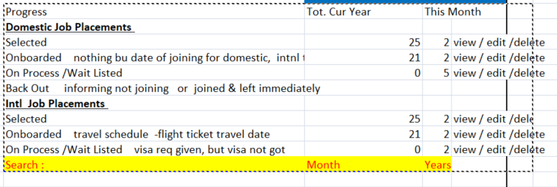

Report dynamically changed for the above process

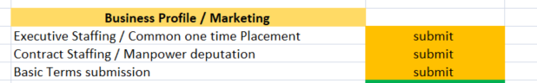
Mail content
se

Despatch Documentation
 |  |  |  |  | Date :
Check List cum DOC Receipt Acknowledgement
Name : Designation : Country :
Travel date : PASSPORT NO : Validity :
Sl. No | Details of Docs | No of Copies |  | Avail status. |  | Remarks
I | SET OF DOCUMENTS REQD. FOR POE Submission
1 | Power Of attorney | 1 |  | Yes / No |  | YES
1 | Client demand Letter | 1 |  | Yes / No |  | YES
2 | Passport Copy | 1 |  | Yes / No |  | YES
3 | Signed Offer Letter with acceptance copy | 1 |  | Yes / No |  | -
4 | Medical report Copy | 1 |  | Yes / No |  | -
5 | Visa Copy | 1 |  | Yes / No |  | YES
6 | Air Ticket Copy | 1 |  | Yes / No |  | YES
7 | Passport size Photo | 2 |  | Yes / No |  | -
8 | Self Declaration to be signed | 1 |  | Yes / No |  | YES
II | Candidate confirmation on receipt of the following original documents before Travel
1 | Original Passport | Received |  | YES |  | 1. received the documents from PMC. 2. PMC has Explained all the relevent details about my Employment, client and country. --------- Signature …………....
2 | Visa | Received |  | YES
3 | Degree Certificate Original | Received |  | Not applicable
4 | Medical report Original | Received |  | Not applicable
5 | Mark Sheet Originals | Received |  | Not applicable
6 | AIR Ticket | Received |  | YES
7 | Destination / Customer contact person details, address and tel Contacts | Received |  | YES
8 | Ensure the Air Port Pick up at customer side is done. | Confirmed |  | YES
Signature |  | HRM |  |  |  | C.E.O
Desp. Co-ordinator / Recruiter
Important Note : Handover the Documents after ensuring all the above documentation is completed along with , self declaration & despatch register signed by the candidates

Same report for job reporting

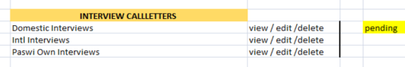

Interview
CODE NO | CANDIDATE NAME | QUALFN | SECTOR | INDUSTRY | PLACEMENT TYPE | Interview Date | Marks | Selected | REMARKS | Field  1 | Field  2 | Field  3
 |  |  |  |  |  |  |  |  |  |  |  | DATE

