Requirements for Windows:

1. Install Python 2.7 and set the Environment variables Path = "C:\Python27;C:\Python27\Scripts"

2. Install get-pip.py (Command prompt -> Python get-pip.py)

3. After installing double click the Setup.bat (It will install libraries required to run the script).

4. Modify the Config.py (navigate to the Script folder "cd Austonio_AutomationFinal\austonioLibraries") Change the SERVERUSERPROFILEID according to the user.

**Note:** Make sure the device is freshly installed the apks and provisioned. (Delete all the corresponding user data from the server portal).

**To get UserProfileID:**

Install Firebug Add-on for Firefox (<http://getfirebug.com/>)

Open <https://35.163.6.205/AustonioWeb/>

Login with the username which you running the script.

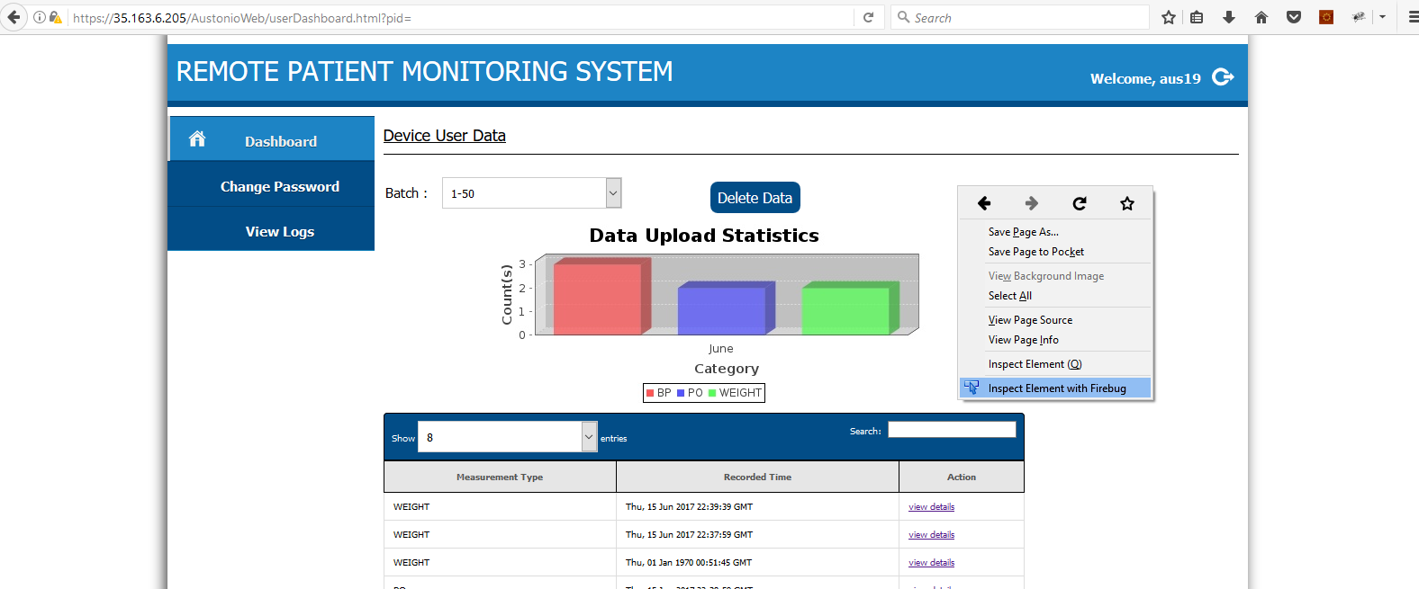Click on Inspect Element with firebug.

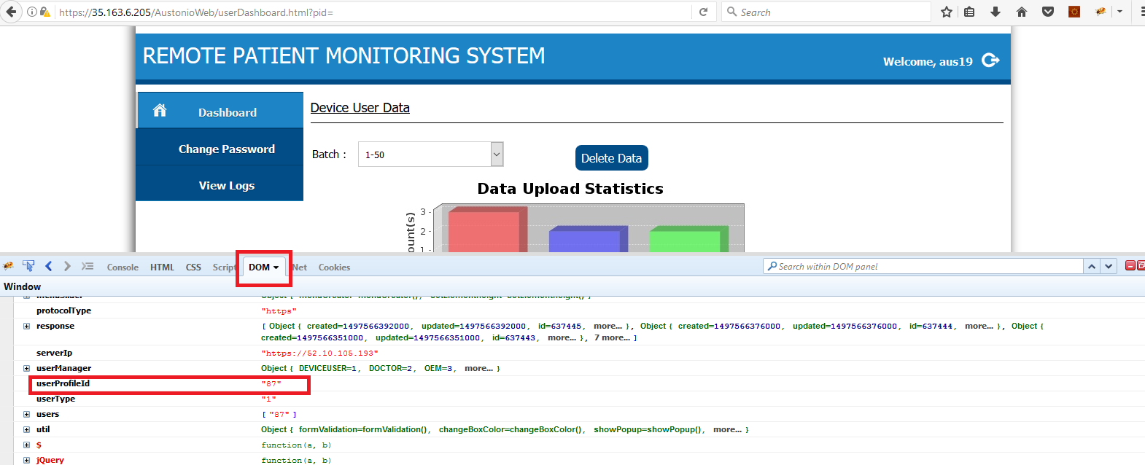

Find userProfileId by clicking on DOM.

Mention the Validation xml config file path and Validation apk fullpath in Config.py

######################################MENTION THE PATH WHERE VALIDATION APK PRESENT WITH FILE NAME######################

VALIDATIONAPK = "C:\Users\jmunis1x\PycharmProjects\Austonio_AutomationFinal\ValidationApk\Validation_6.66.20_signed.apk"

#####################################LOCAL PATH WHERE THE VALIDATION CONFIG PRESENT#####################################

VALIDATIONCONFIG = "C:\Users\jmunis1x\PycharmProjects\Austonio_AutomationFinal\Validation"

5. Run logVerification.py (navigate to the Script folder "cd Austonio_AutomationFinal\austonioLibraries" in Command prompt -> Python logVerification.py)

6. Provide valid Serial No, Which Os Platform.

7. To Stop script Press enter in the Command Prompt while script is running.

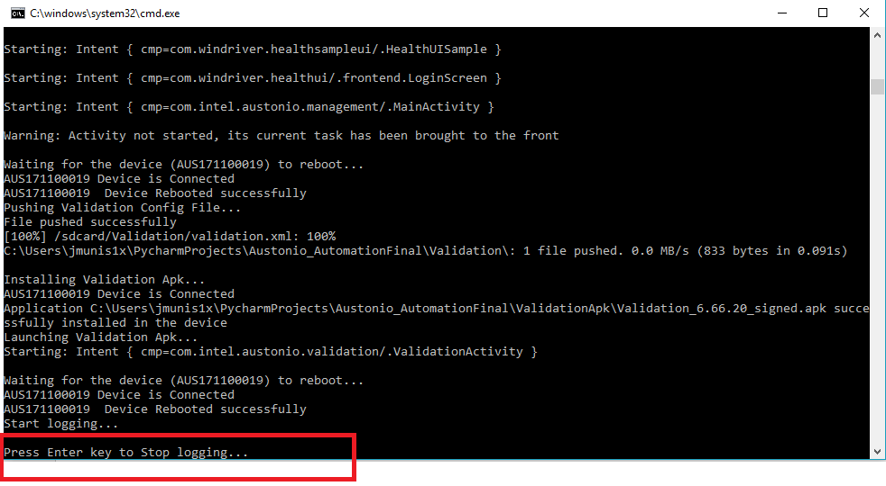

Logs and result will be generated in Austonio_AutomationFinal\Result