**Text Formatting Project**

Create a WPF C# project utilizing a **WPF RichTextBox (System.Windows.Control)** that displays text in a highlighted form as it might be seen on social media such as Twitter.

Characteristics of the Rich Text Box:

* Only one input box (a rich text box) which auto formats while you type
* Should be able to handle multiple lines
* Should be able to handle text that is pasted in

The following are not required but would be a plus:

* Rich text box can be themed in the xaml (bonus points)
* MVVM code architecture

The program should able to take any plain text input string and highlight portions such as hashtags (#) and usernames (@).  
  
For example:  
"This is a #hashtag and @username !"  
  
Some considerations:  
The logic should work for any input string, and should take measures to prevent any potential for crashing (unhandled exceptions.) Some social media posts may have odd spacing (multiple spaces) or odd scenarios (such as "This is a #@#@#@weird post.") so ideally the logic should take this into consideration. The highlighted form should match the plain text, except that it is colored.  
  
Test results with Twitter(see example below) to compare/match as closely as possible.

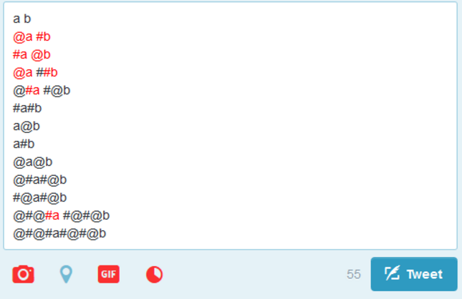

Text below for testing purposes:

a b  
@a #b  
#a @b  
@a ##b  
@#a #@b  
#a#b  
a@b  
a#b  
@a@b  
@#a#@b  
#@a#@b  
@#@#a #@#@b  
@#@#a#@#@b

Instructions for how to submit Project to Renewed Vision:

* Send a link to Git Repo(preferred), DropBox, or Google Drive where the solution and project is located.
* Please do not send in an email as these are usually rejected by our mail server.
* Please ensure that all necessary files are included in the submission to run the app out of the box.