## Image Recognition with IBM Cloud Visua Recognition :

* Computer vision is the process of using computers to understand digital images. A core task of computer vision is image recognition, which helps to recognize and categorize elements within images.
* Image recognition involves a high-level understanding of contextual knowledge and parallel processing, and that’s why the visual performance of humans is incomparable and far superior to that of computers. When we visually see an object or scene, we automatically identify objects as different instances and tend to associate them.

**Here’s what we’ll cover:**

* [Image recognition definition](https://www.v7labs.com/blog/image-recognition-guide)
* [History of image recognition technology](https://www.v7labs.com/blog/image-recognition-guide)
* [How it works: image recognition algorithms](https://www.v7labs.com/blog/image-recognition-guide)
* [Practical applications of AI for image recognition](https://www.v7labs.com/blog/image-recognition-guide)

**What is image recognition, and why does it matter?**

C:\Program Files (x86)\Microsoft Office\MEDIA\OFFICE12\Bullets\BD21298_.gif Today, users share a massive amount of data through apps, social networks, and websites in the form of images. With the rise of smart phones and high-resolution cameras, the number of generated digital images and videos has skyrocketed. In fact, it’s estimated that there have been over 50GB image upload to Instagram since its launch.

C:\Program Files (x86)\Microsoft Office\MEDIA\OFFICE12\Bullets\BD21298_.gif Image recognition allows machines to identify objects, people, entities, and other variables in images. It is a sub-category of computer vision technology that deals with recognizing patterns and regularities in the image data, and later classifying them into categories by interpreting image pixel patterns.

C:\Program Files (x86)\Microsoft Office\MEDIA\OFFICE12\Bullets\BD21298_.gif Image recognition includes different methods of gathering, processing, and analyzing data from the real world. As the data is high-dimensional, it creates numerical and symbolic information in the form of decisions.

C:\Program Files (x86)\Microsoft Office\MEDIA\OFFICE12\Bullets\BD21298_.gif A digital image consists of pixels, each with finite, discrete quantities of numeric representation for its intensity or the grey level. AI-based algorithms enable machines to understand the patterns of these pixels and recognize the image.

**How image recognition evolved over time:**

## It took almost 500 million years of human evolution to reach this level of perfection. In recent years, we have made vast advancements to extend the visual ability to computers or machines.

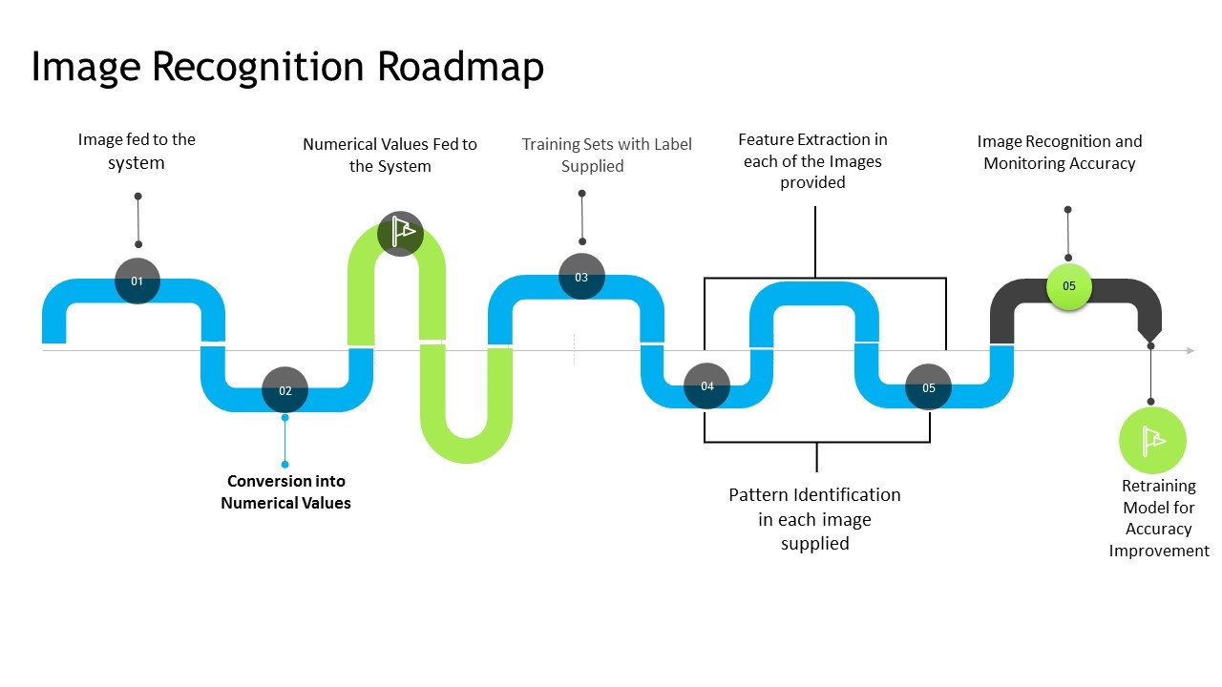

## How image recognition works: algorithms and technologies :

## Before diving into how image recognition works, let's look at the four primary purposes image recognition solves: detection, classification, tagging, and segmentation.

**Classification:**

* Artificial neural networks identify objects in the image and assign them one of the predefined groups or classification.

**Detection :**

**C:\Program Files (x86)\Microsoft Office\MEDIA\OFFICE12\Bullets\BD21298_.gif**The process of classification and localization of an object is called object detection. Once the object's location is found, a bounding box with the corresponding accuracy is put around it. Depending on the complexity of the object, techniques like bounding box annotation semantic segments  and key point annotation are used for detection.

**Tagging :**

## Tagging is similar to classification but aims for better accuracy. It tries to identify multiple objects in an image. Therefore, an image can have one or more tags.Returning to the example of the image of a road, it can have tags like 'vehicles,' 'trees,' 'human,' etc.

## ****Segmentation:****

**C:\Program Files (x86)\Microsoft Office\MEDIA\OFFICE12\Bullets\BD21298_.gif**instance segmentation is the detection task that attempts to locate objects in an image to the nearest pixel. Instead of aligning boxes around the objects, an algorithm identifies all pixels that belong to each class. Image segmentation is widely used in medical imaging to detect and label image pixels where precision is very important.

### 1.Data collection :

* To achieve image recognition, machine vision artificial intelligence models are fed with pre-labeled data to teach them to recognize images they’ve never seen before.
* Some of the massive publicly available databases include Pascal VOC and ImageNet. They contain millions of labeled images describing the objects present in the pictures everything from sports and pizzas to mountains and cats.

**Data collection, however, comes with challenges :**

## 633ae85910914d14c78dfbb6_pMSFpuLGBOju3-qjJKnUVaokU4KRNjk0zEuYp7WkKUxT3hy-qF2neXYhA8wuqLe4A3KrlVsBNyvfzjiTmnTmdMUmsz-Hd4sYzYFMPgeruEhsu_2464-qvKb5Izpjo5ttS8zvm1EvPOG0IhS6mcOv1CjxoztuoUJIEEUh7EZLtMa4LhPxVNyFCztYAA.png

**Variation in the viewpoint of the image :**

* The images can be aligned at different angles or vary in dimension, which can lead to inaccurate prediction of the machine learning model. The system fails to understand the effect of changing the alignment and viewport of the image.

**Deformation:**

C:\Program Files (x86)\Microsoft Office\MEDIA\OFFICE12\Bullets\BD21298_.gifGenerally, training data gives a biased perception that a particular object can only have a specific shape.

**Occlusion:**

C:\Program Files (x86)\Microsoft Office\MEDIA\OFFICE12\Bullets\BD21298_.gifSome objects may obstruct the full view of an image and result in partial information being fed to the system. The neural network should acknowledge these variations as a part of the training process.