**Exception**

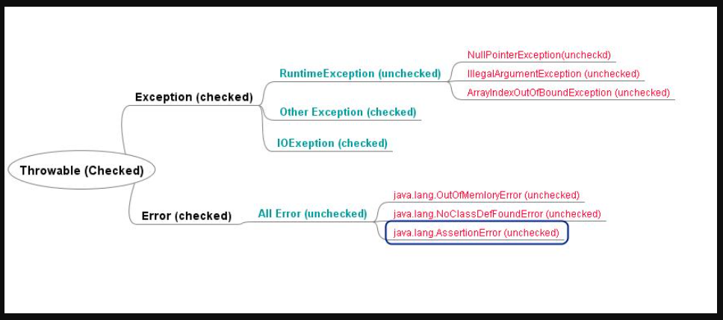

Difference between checked and unchecked

Checked-

1. are the exceptions that are checked at compile time.
2. forced by the compiler to either handle or specify the exception.
3. If some code within a method throws a checked exception, then the method must either handle the exception or it must specify the exception using throws keyword.
4. Ex-FileNotFoundException, IOException

