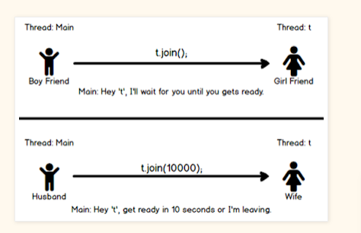

using the Thread.join()  method when you want one thread to start execution only if the first thread finishes its execution.

**Wait method**

* wait() is declared and defined in the Object class while join() is defined in the Thread class.
* wait() must be called from synchronized context i.e. synchronized method or block otherwise it will throw IllegalMonitorStateException.
* You can awake a thread waiting by calling the wait() method of the object class by using [notify()](http://javarevisited.blogspot.sg/2013/12/inter-thread-communication-in-java-wait-notify-example.html) and [notifyAll()](http://javarevisited.blogspot.sg/2012/10/difference-between-notify-and-notifyall-java-example.html#axzz51Q21YJnR) method but you can not break the waiting imposed by join without interruption.
* Though wait, notify, and notifyAll is related to threads they are not defined in java.lang.Thread class, instead they are defined in the Object class
* When a thread calls the wait() method in Java, it goes to the wait state by releasing the lock, which is later acquired by the other thread who can notify this thread.  
  The wait() method throws InterrruptedException in Java, which is a checked exception. You must provide a handler for this
* **Notify Method- and NotifyAll Method [in Object class]**
* When you call the[notify() method](http://javarevisited.blogspot.com/2012/10/difference-between-notify-and-notifyall-java-example.html) on a shared object and if more than one thread is waiting on that lock then anyone of them will get the notification, which thread will get the notification is not guaranteed. If only one thread is waiting then it will get the notification.
* When you call the notifyAll() method on the shared object and if more than one thread is waiting for notification then all of them will receive the notification but who will get the CPU to start execution is not guaranteed.
* Main difference between notify() and notifyAll() is that in the case of notify() only one of the waiting threads gets a notification but in the case of notifyAll() all threads get a notification.
* That's all about **wait(), notify() and notifyAll() methods in Java**. These are three of the most important methods every Java developer should know. It's key to implement inter-thread communication in Java.