**Tech Saksham**

**Case Study Report**

Data Analytics with Power BI

**“An Analysis of Unemployment in the Republic of India.”**

**“IMMACULATE COLLEGE FOR WOMEN”**

**VIRIYUR**

|  |  |
| --- | --- |
| **NM ID** | **NAME** |
| **asanm30530521ubca007** | **B. Jaya mariya** |

**Trainer Name :UMAMAHESWARI.R**

**Master Name :UMAMAHESWARI.R**

ABSTRACT

This Power BI project delves into the complexities of unemployment in India, leveraging Excel data to conduct a comprehensive analysis. By harnessing Power BI's capabilities, the project offers a multifaceted exploration of unemployment trends across different regions and demographics within the country. Through a combination of visualizations, statistical modelling, and data-driven insights, it aims to uncover underlying patterns and factors influencing unemployment rates.The project begins by collecting and organizing extensive datasets from various sources, including government reports, surveys, and economic indicators. These datasets are then meticulously cleaned, transformed, and integrated within Excel to ensure accuracy and consistency. Leveraging Power BI's powerful visualization tools, the project presents dynamic charts, graphs, and interactive dashboards to visualize unemployment trends over time and across different geographical regions.Furthermore, the analysis delves into the socio-economic factors contributing to unemployment disparities, such as education levels, industry sectors, and urban-rural divides. By identifying correlations and trends within the data, the project provides valuable insights for policymakers, economists, and stakeholders to formulate targeted interventions and policies aimed at reducing unemployment rates and fostering inclusive economic growth in India. Ultimately, this project serves as a robust analytical tool for understanding and addressing the complex challenges of unemployment in the Indian context.

INDEX

|  |  |  |
| --- | --- | --- |
| S. No | Table of Contents | Page No: |
| 1 | Chapter 1:Introduction | 4 |
| 2. | Chapter 2:Services and Tools Required | 6 |
| 3. | Chapter 3:Projec t Architecture | 7 |
| 4. | Chapter 4:Modelling and Result | 9 |
| 5. | Conclusion | 18 |
| 6. | Future scope | 19 |
| 7. | References | 20 |
| 8. | Links | 21 |

CHAPTER 1

INTRODUCTION

1.1. Problem Statement

The problem statement of this Power BI project centres on the persistent challenge of unemployment in India. Despite robust economic growth, unemployment rates remain alarmingly high, particularly among the youth demographic. This issue not only hinders individual prosperity but also undermines overall economic development and social stability. Additionally, the COVID-19 pandemic has exacerbated existing unemployment woes, resulting in widespread job losses and economic hardship. To address this pressing issue, it is crucial to conduct a thorough analysis of unemployment trends, factors, and disparities using available Excel data. By harnessing Power BI's analytical capabilities, this project aims to uncover underlying patterns, drivers, and potential solutions to alleviate unemployment issues in India. The insights gleaned from this analysis will empower policymakers, economists, and stakeholders to formulate targeted policies and interventions aimed at fostering sustainable economic growth and reducing unemployment rates across the nation.

1.2. Proposed Solution

The proposed solution entails utilizing Power BI, a powerful data visualization and analytics tool, to analyse unemployment in India using Excel data. Leveraging Power BI's robust capabilities, the solution involves integrating, cleaning, and transforming the Excel datasets containing unemployment-related information. This process ensures data accuracy and consistency.

Once the data is prepared, Power BI's visualization tools are employed to create dynamic charts, graphs, and interactive dashboards that visually represent unemployment trends across different regions and demographics in India. These visualizations allow for a comprehensive exploration of the data, enabling stakeholders to identify patterns, correlations, and insights regarding unemployment rates and their determinants.

Furthermore, the solution involves conducting statistical analysis within Power BI to delve deeper into the socio-economic factors contributing to unemployment disparities. By examining variables such as education levels, industry sectors, and urban-rural divides, the solution aims to uncover the root causes of unemployment and identify potential interventions.

Overall, the proposed solution provides a comprehensive and data-driven approach to understanding and addressing the complex issue of unemployment in India. It empowers policymakers, economists, and stakeholders with actionable insights to formulate targeted strategies and policies aimed at reducing unemployment rates and fostering inclusive economic growth.

1.3. Features

**Data Integration and Cleaning:** Power BI enables seamless integration of Excel datasets containing unemployment-related information. It also facilitates data cleaning and transformation processes, ensuring that the data is accurate and consistent for analysis.

**Visual Representation:** Power BI's visualization tools allow for the creation of dynamic and interactive charts, graphs, and dashboards. These visualizations provide stakeholders with intuitive and easy-to-understand representations of unemployment trends across different regions and demographics in India.

**Statistical Analysis:** The solution incorporates statistical analysis within Power BI to delve deeper into the socio-economic factors influencing unemployment. By examining variables such as education levels, industry sectors, and geographical locations, stakeholders can gain valuable insights into the underlying causes of unemployment disparities.

**Actionable Insights:** By leveraging Power BI's analytical capabilities, the solution empowers policymakers, economists, and stakeholders with actionable insights. These insights enable informed decision-making and the formulation of targeted strategies and policies aimed at reducing unemployment rates and fostering inclusive economic growth in India.

1.4. Advantages

**Data Integration:** Power BI seamlessly integrates with Excel, allowing for easy importation and integration of unemployment-related datasets. This integration streamlines the data preparation process, saving time and effort.

**Visualization Capabilities:** Power BI offers advanced visualization tools to create compelling charts, graphs, and dashboards. These visualizations make it easier to identify trends, patterns, and outliers in unemployment data, enhancing data understanding and communication.

**Interactivity:** Power BI enables interactive exploration of data through features like drill-down, filters, and slicers. Users can interact with visualizations to gain deeper insights and tailor analyses to specific regions, demographics, or time periods.

**Real-time Updates:** Power BI allows for real-time data connectivity, ensuring that unemployment data remains up-to-date. This feature is particularly useful for monitoring and responding to dynamic changes in unemployment rates and trends.

**Scalability:** Power BI is highly scalable, capable of handling large volumes of data with ease. Whether analysing national-level unemployment trends or drilling down to regional or demographic subsets, Power BI can accommodate diverse analytical needs.

**Integration with Other Tools:** Power BI seamlessly integrates with other Microsoft Office tools like Excel, SharePoint, and Teams, as well as third-party applications and data sources. This integration enables a cohesive workflow and facilitates collaboration among stakeholders involved in addressing unemployment challenges in India.

1.5. Scope

The scope of this Power BI project encompasses a comprehensive analysis of unemployment in India utilizing Excel data. It includes data collection, integration, cleaning, and transformation processes to ensure accuracy and consistency. The analysis will focus on exploring unemployment trends across various regions and demographics, identifying factors influencing unemployment rates, such as education levels, industry sectors, and urban-rural divides. The project aims to provide actionable insights through visualizations, statistical modeling, and data-driven findings. Additionally, it will examine the impact of external factors like the COVID-19 pandemic on unemployment dynamics. While the primary focus is on understanding the current state of unemployment in India, the project also seeks to propose targeted interventions and policies to address unemployment challenges and foster inclusive economic growth.

CHAPTER 2

SERVICES AND TOOLS REQUIRED

2.1 Services Used

**Power BI Desktop:** The primary tool for building and designing interactive reports and dashboards, integrating data from Excel and performing data analysis.

**Excel:** Used for storing and organizing unemployment-related datasets, which are then imported into Power BI for analysis.

**Power BI Service:** Enables sharing and collaboration by publishing Power BI reports and dashboards to the cloud, allowing stakeholders to access and interact with the insights generated.

**Data Integration Services:** Used to integrate Excel data seamlessly into Power BI Desktop, ensuring data accuracy and consistency throughout the analysis process.

**Visualization Tools:** Leveraging Power BI's built-in visualization capabilities to create dynamic charts, graphs, and dashboards that visually represent unemployment trends and insights.

**Statistical Analysis:** Utilizing Power BI's analytical features to conduct statistical analysis, exploring correlations, trends, and patterns within the unemployment data.

**Real-time Data Connectivity:** Employing Power BI's capabilities for real-time data connectivity to ensure that unemployment data remains up-to-date and responsive to changes.

2.2 Tools and Software Used

**Microsoft Power BI:** The central tool for data visualization, analysis, and reporting. Power BI Desktop is used for building interactive visualizations, while Power BI Service facilitates sharing and collaboration.

**Microsoft Excel:** Used for storing, organizing, and preprocessing unemployment-related datasets before importing into Power BI Desktop for analysis.

**Microsoft Power Query:** A data connection and transformation tool integrated into Excel and Power BI Desktop, used for cleaning and transforming data from various sources, including Excel files.

**2.3 Software Required**

**1.Microsoft Power BI Desktop:** This is essential for building interactive reports and dashboards, as well as performing data analysis. Power BI Desktop can be downloaded for free from the Microsoft website.

**2.Microsoft Excel:** Used for storing, organizing, and preprocessing unemployment-related datasets before importing into Power BI Desktop for analysis. Microsoft Excel is typically part of the Microsoft Office suite, which may require a license for access.

**3.Microsoft Power Query (included in Excel and Power BI Desktop):** This tool is integrated into Excel and Power BI Desktop for data connection and transformation, essential for cleaning and preparing data from various sources, including Excel files.

**4.Microsoft Power Pivot (included in Excel):** An Excel add-in used for data modeling and creating relationships between different datasets, enhancing data analysis capabilities within Excel.

**5.Microsoft Teams and SharePoint (optional):** These tools can be used for collaboration, communication, and document management among team members involved in the Power BI project, facilitating coordination and sharing of insights.

CHPATER 3

PROJECT ARCHITECTURE

**1.Data Sources:** The project starts with unemployment-related data sources, which typically include Excel files containing datasets on unemployment rates, demographics, regional information, and other relevant variables. These data sources may come from government reports, surveys, or other reputable sources.

**2.Data Modeling:** After data preparation, the data may undergo modeling within Power BI using tools like Power Pivot. This step involves creating relationships between different datasets, defining calculations, and structuring the data model to support analysis and visualization requirements.

**3.Analysis:** The prepared and modeled data is then analyzed within Power BI Desktop. This involves exploring unemployment trends, identifying patterns, correlations, and factors influencing unemployment rates across different regions and demographics in India.

**4.Visualization:** Power BI's visualization tools are used to create interactive reports, charts, graphs, and dashboards based on the analyzed data. These visualizations provide stakeholders with intuitive representations of unemployment trends and insights, enabling better understanding and decision-making.

**5.Sharing and Collaboration:** Once the visualizations are created, they can be published to the Power BI Service, where they can be shared with stakeholders. Tools like Microsoft Teams and SharePoint can facilitate collaboration among team members involved in the project, allowing for feedback, discussions, and sharing of insights.

**6.Data Refresh and Updates:** To ensure that the unemployment data remains up-to-date, mechanisms for data refresh and updates are established. Power BI offers features for scheduling data refreshes, allowing for regular updates to the visualizations with the latest data.

CHAPTER-4

MODELING AND RESULT

Managing Relationship

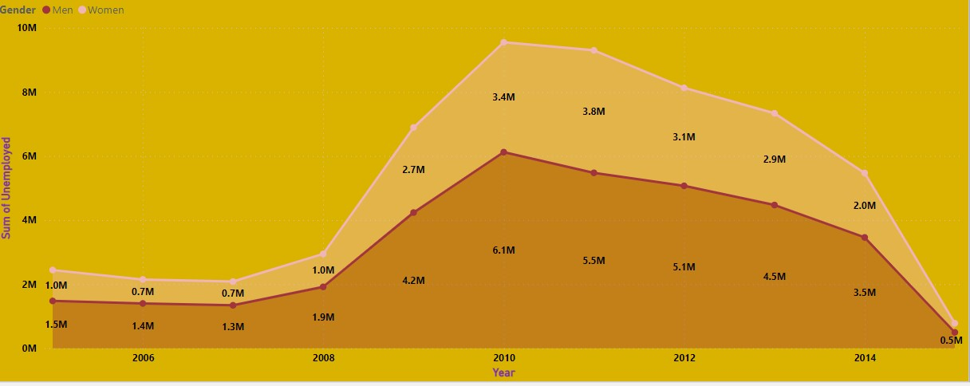

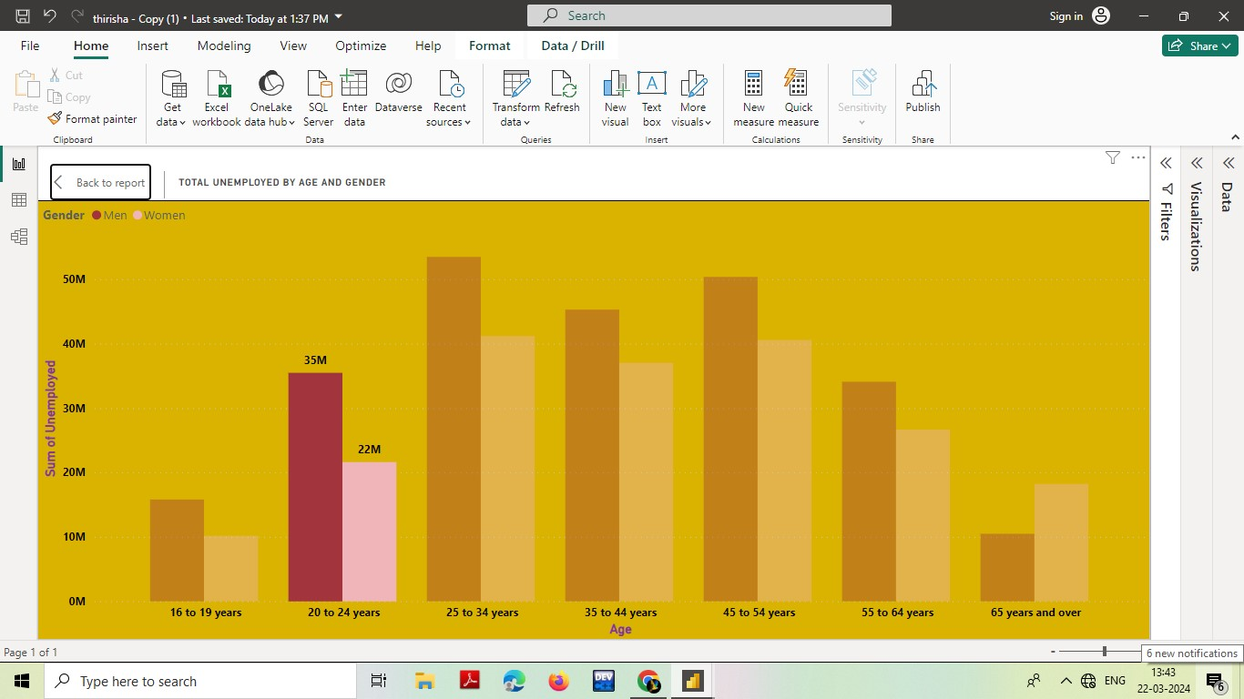

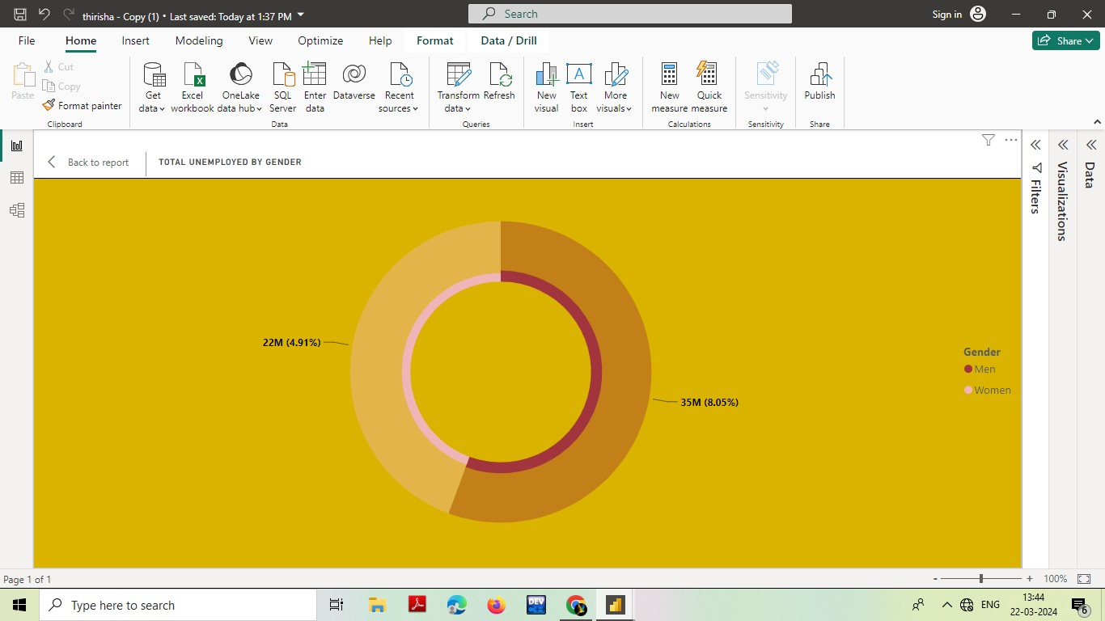

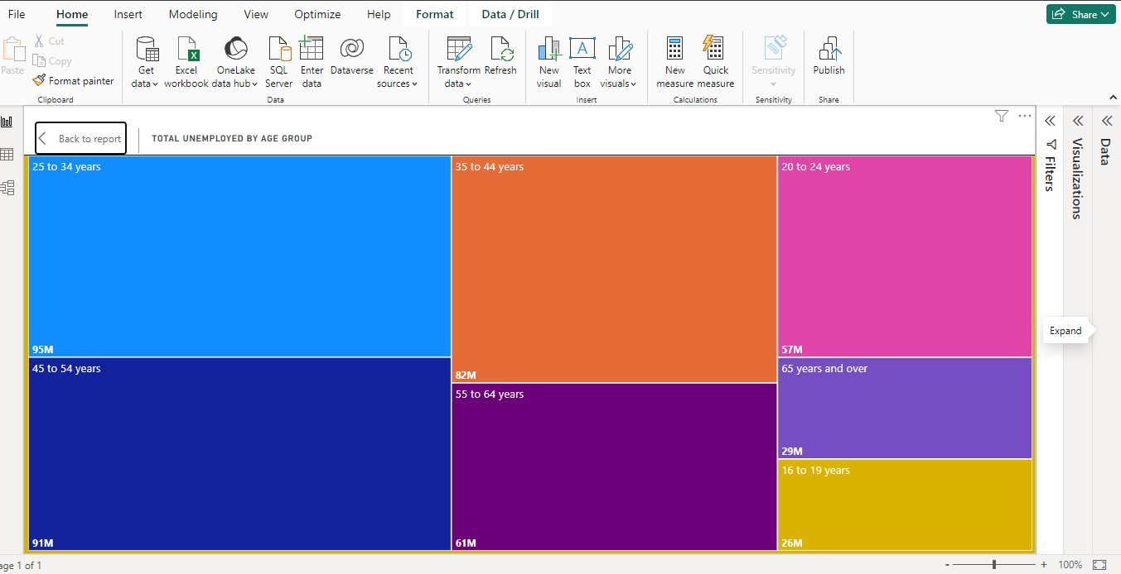

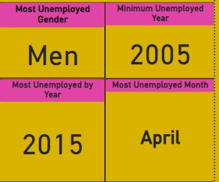

Dashboard

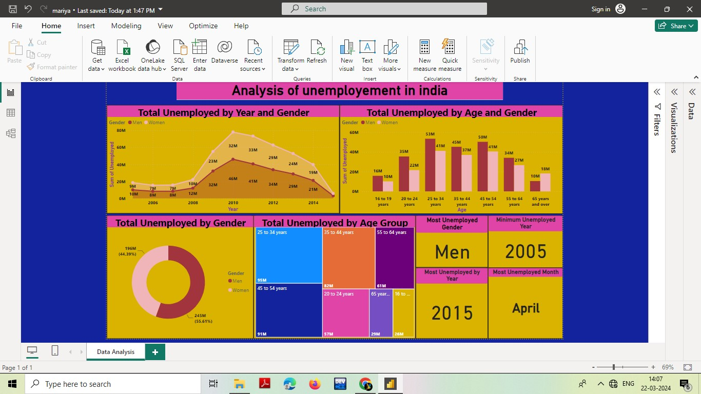

CONCLUSION

The Analysis of Unemployment in India using Power BI has provided valuable insights into the nation's labour market dynamics. Through robust data analytics and visualization techniques, the project has illuminated the complexities and disparities within unemployment trends across different regions and demographics. The interactive dashboards and visualizations have facilitated a deeper understanding of the factors influencing unemployment rates, enabling stakeholders to make informed decisions and formulate targeted interventions. This comprehensive analysis underscores the importance of leveraging data-driven approaches to address unemployment challenges effectively. As India strives for inclusive economic growth and social development, continued efforts in data analysis and policy formulation will be crucial. By harnessing the power of tools like Power BI, stakeholders can collaboratively work towards reducing unemployment rates, fostering job creation, and enhancing opportunities for all citizens in India's diverse economic landscape.

.

FUTURE SCOPE

Looking ahead, the analysis of unemployment in India using Power BI presents promising avenues for future exploration and intervention. Firstly, there's an opportunity to enhance predictive modelling capabilities within Power BI to forecast future unemployment trends based on historical data and economic indicators. Additionally, integrating real-time data streams could enable timely monitoring and response to evolving labour market dynamics, particularly in the post-pandemic recovery phase. The project can be extended to incorporate advanced analytics techniques such as machine learning algorithms to identify hidden patterns and drivers of unemployment, allowing for more precise targeting of interventions. Collaborative efforts with government agencies, NGOs, and private sector stakeholders can facilitate access to additional datasets and resources, enriching the analysis and enabling more comprehensive policy recommendations. Expanding the scope of analysis to include other socio-economic indicators like education, healthcare, and infrastructure could provide a holistic understanding of the factors influencing unemployment and inform broader development strategies. Finally, ongoing refinement of visualization techniques and user interface design within Power BI can enhance accessibility and usability, empowering stakeholders from diverse backgrounds to engage with and derive insights from the data. Overall, the future scope of this project holds immense potential for driving evidence-based policy-making and fostering sustainable socio-economic development in India.

REFERENCES

<http://youtu.be/eGaImwD> 8fPQ?si=8AxyR4DtCDIWRKAA