MitraBooks ERP
User Manual
Complete Guide for Business Users
Version 1.0 | June 2026
SanMitra Technologies

1. Introduction 5
2. Getting Started 5
2.1 Logging In 6
2.2 Workspace Layout 6
2.3 Navigation Groups 7
3. Dashboard 9
4. Parties (Customers & Vendors) 10
4.1 Adding a Party 10
4.2 Editing a Party 10
4.3 Party Subledger 11
5. Sales — Invoices 12
5.1 Creating a Sales Invoice 12
5.2 Composition Dealer — Bill of Supply 13
5.3 Invoice List 13
5.4 e-Invoice (IRN) 13
6. Sales — Credit Notes 13
6.1 Creating a Credit Note 13
7. Purchases — Vendor Bills 14
7.1 Creating a Vendor Bill 14
7.2 Debit Notes 14
8. Payment Allocation 14
8.1 Allocating a Payment 14
8.2 Reversing an Allocation 14
9. Banking — Bank Reconciliation 15
9.1 Uploading a Bank Statement 15
9.2 Matching Transactions 15
9.3 Bank Reconciliation Statement (BRS) 15
10. Compliance — GST Returns 16
10.1 GSTR-3B (Monthly Summary) 16
10.2 GSTR-1 (Outward Supply Details) 16
10.3 GSTR-2B / ITC Reconciliation 16
10.4 CMP-08 (Composition Quarterly Statement) 16
10.5 GSTR-4 (Annual Composition Return) 17
10.6 GST Settlement 17
10.7 ITC Reversals (Rule 37) 17
11. Compliance — TDS / TCS 18
11.1 TDS on Purchases 18
11.2 TCS on Sales 18
11.3 TDS / TCS Register 18
12. Accounting — Core Ledger & Journal Posts 19
12.1 Core Ledger (Chart of Accounts) 19
12.2 Manual Journal Post 19
12.3 Audit Trails 20
13. Financial Statements 21
13.1 Trial Balance 21
13.2 Profit & Loss 21
13.3 Balance Sheet 21
13.4 General Ledger 22
13.5 Receivables / Payables 22
13.6 AR / AP Aging 22
14. Statements & Dunning 22
14.1 Customer / Vendor Statement 22
14.2 Dunning Letters 22
15. Period Locks 23
16. Opening Balances & Year-End Close 24
16.1 Uploading Opening Balances 24
16.2 Year-End Close 24
17. Fixed Assets 24
17.1 Asset Register 24
17.2 Running Depreciation 25
18. Accounting Dimensions 25
18.1 Setting Up Dimensions 25
18.2 Dimension Report 25
19. Inventory (Optional) 26
19.1 Item Master 26
19.2 Stock Register 26
19.3 Closing Stock Entry 26
20. Settings 26
20.1 Invoice Settings 26
20.2 Numbering Pattern 27
21. CA Practice Portal 27
21.1 Inviting a Chartered Accountant (CA) 27
21.2 CA Login and Password Update Flow 27
21.3 Managing CA Invites 28
22. HR & Payroll (Optional add-on) 28
22.1 Activating HR & Payroll 28
22.2 Salary Structures 28
22.3 Adding an Employee 29
22.4 Appointment & Joining Letters 29
22.5 Running Payroll 29
22.6 Leave Management 29
22.7 Form 12BB (Investment Declarations) 29
22.8 Full & Final Settlement 29
22.9 Analytics 29
23. Manufacturing & Cost Centres (Optional add-on) 29
23.1 Activating the Add-on 30
23.2 Cost Centres 30
23.3 Tagging Postings to a Cost Centre 30
23.4 Cost-Centre Budgets 30
23.5 Cost-Centre P&L 31
23.6 Bills of Materials (BOM) 31
23.7 Work Orders 31
23.8 How It Affects Stock and the Ledger 31
24. OfficeMitra AI (Optional module) 31
24.1 Opening the workspace 32
24.2 Tasks 32
24.3 Email Summary 32
24.4 Calendar (paste-in) 32
24.5 Meeting Notes 32
24.6 Notifications 32
24.7 Today Brief 32
24.8 Proposals (confirmation and checker) 33
24.9 MIS Packs (CA Analysis Pack) 33
24.10 Advisory and data boundaries 35
25. Workflow Tips 35
26. Common Errors & Fixes 35
27. Glossary 37
28. Support 37

1. Introduction
MitraBooks is a cloud-based ERP and accounting platform built for Indian SMEs, traders, manufacturers, and professionals. It covers the full accounting cycle — from sales invoices to statutory GST filings — in a single, integrated workspace.

Who this manual is for: Business owners, accountants, and finance staff who manage day-to-day transactions, GST compliance, and financial reporting inside MitraBooks.

Key principles:
- Every transaction posts a double-entry journal automatically
- GST is computed and tracked at the line level
- All reports are derived live from the posted ledger — no separate data entry
- Period locks prevent backdating once a month is closed

2. Getting Started
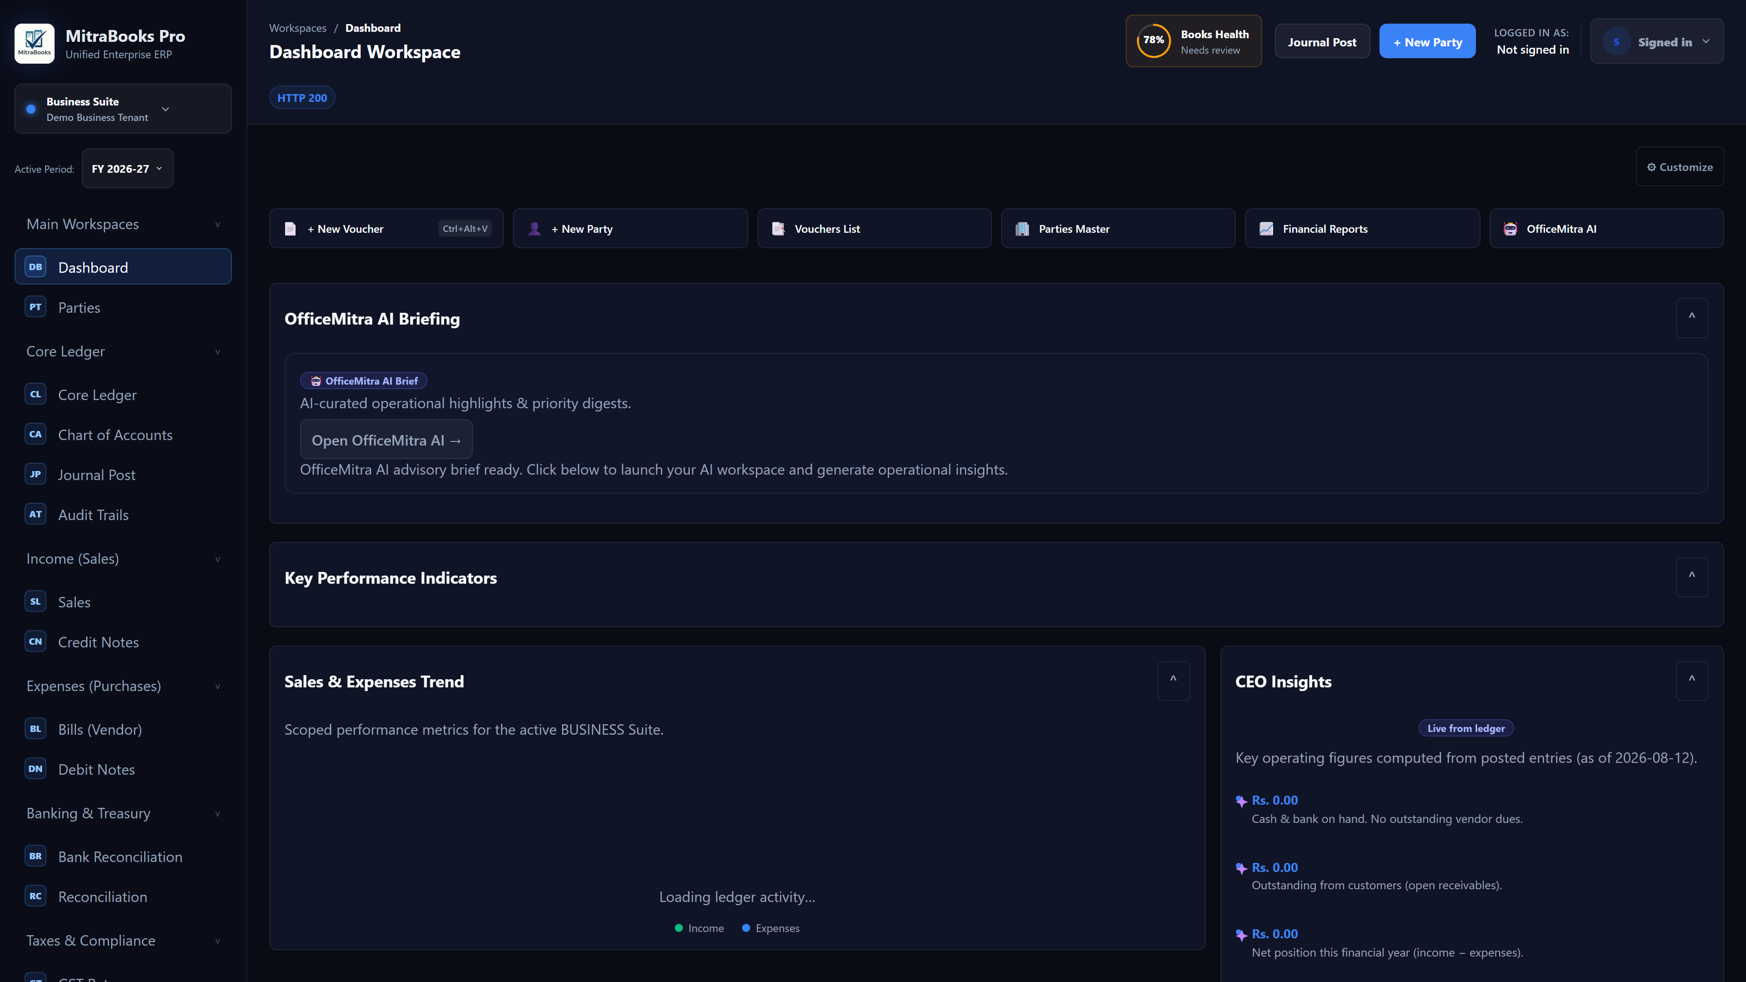
Figure 2 — Getting Started

2.1 Logging In
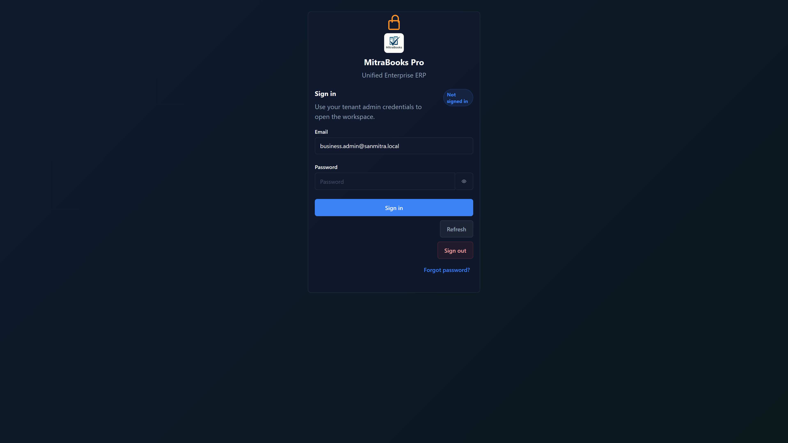
Figure 2.1 — Logging in
- Open the MitraBooks web app in your browser.
- Enter your registered email and password.
- Sign In. The system loads your organisation's workspace automatically.

2.2 Workspace Layout
Figure 2.2 — Workspace layout
The screen is divided into three areas:
- Left sidebar — navigation grouped by function (Main Workspaces, Core Ledger, Income, Expenses, Banking, Taxes, Reports, HR, Manufacturing and more).
- Top bar — the business/entity selector, Active Period, the Books Health indicator, quick actions (Journal Post, New Party) and the logged-in user.
- Main panel — the active workspace: the Dashboard, a document form, a report or a module screen.

Area | Description
Left sidebar | Navigation grouped by function (Operations, Sales, Purchases, Banking, Compliance, Reports, Settings)
Main panel | The active workspace — forms, lists, and reports appear here
API output strip | Raw JSON responses from the server (useful for debugging or CA review)

2.3 Navigation Groups
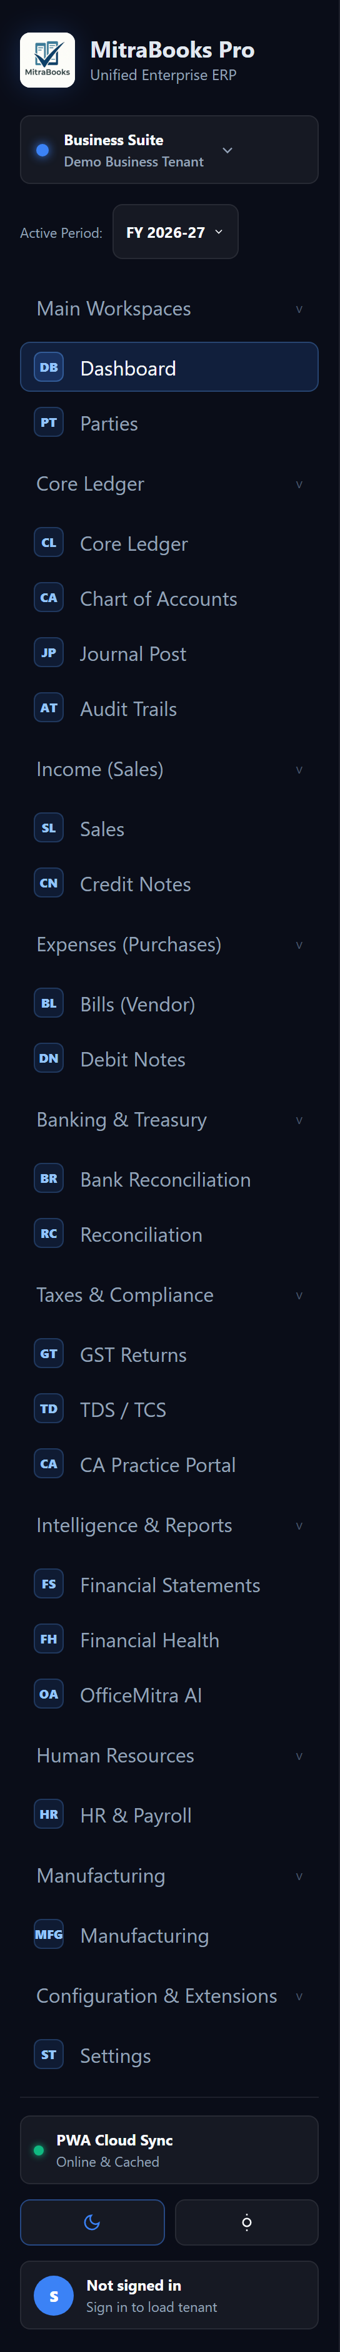
Figure 2.3 — Navigation groups (sidebar)
MitraBooks organises features into the following sidebar groups:
- Main Workspaces
- Core Ledger
- Income (Sales)
- Expenses (Purchases)
- Banking & Treasury
- Taxes & Compliance
- Intelligence & Reports
- Human Resources
- Manufacturing
- Configuration & Extensions

Group | Items
Operations | Dashboard, Parties, Core Ledger, Journal Post, Audit Trails
Sales | Sales (Invoices), Credit Notes
Purchases | Bills (Vendor), Debit Notes
Banking | Bank Reconciliation, Reconciliation
Compliance | GST Returns, TDS / TCS, CA Practice Portal
Reports | Financial Statements, Financial Health
Settings | Invoice & company settings

3. Dashboard
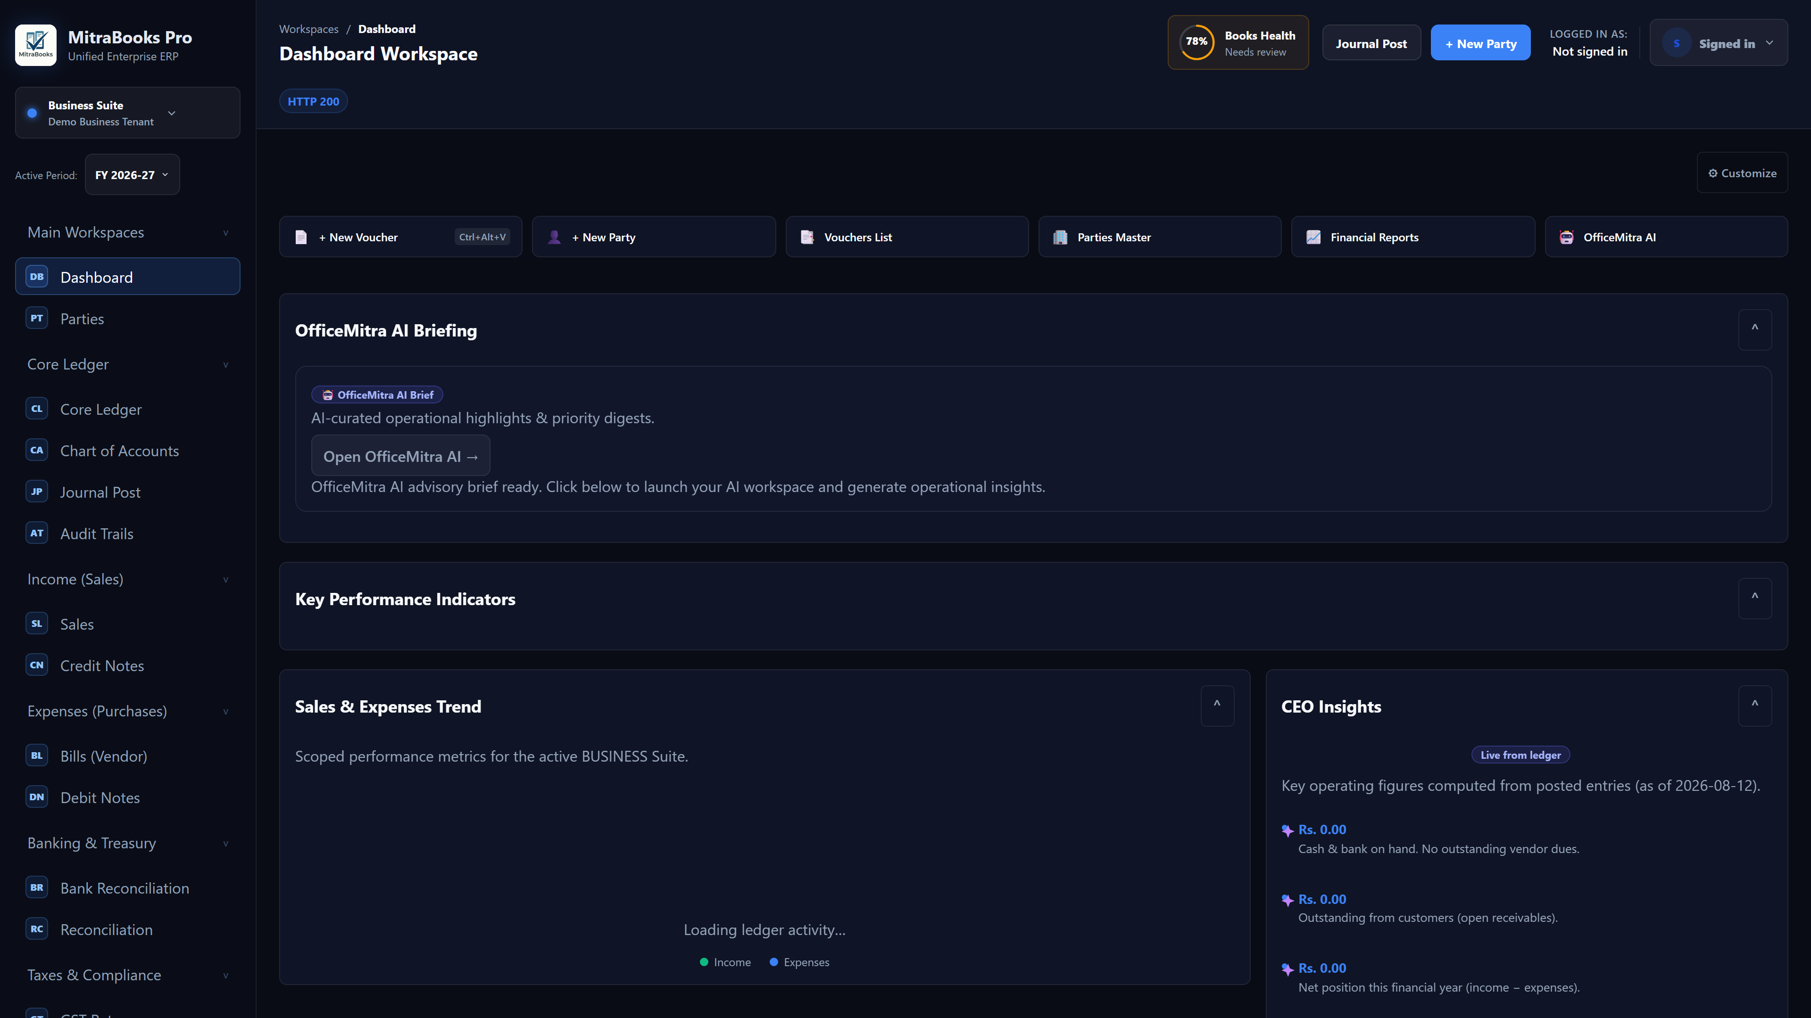
Figure 3 — Dashboard workspace
The Dashboard gives a live snapshot of your business health.

The workspace shows:
- Key Performance Indicators — Income, Expenses and Net Position (financial-year-to-date) tiles.
- Sales & Expenses Trend — a monthly chart of invoiced sales against posted expenses.
- CEO Insights — key operating figures computed live from posted entries (e.g. cash & bank coverage of vendor dues, outstanding receivables).
- Books Health — the readiness indicator shown in the top bar.
Customising widgets: Click the settings icon (gear) on any widget to show/hide it. Preferences are saved per user.

Financial Health: a deeper CFO-style analysis is available at Intelligence & Reports → Financial Health; every figure is computed server-side from the posted ledger.

4. Parties (Customers & Vendors)
Parties are the customers and vendors your business transacts with. Every invoice, bill, and statement is linked to a party.

4.1 Adding a Party
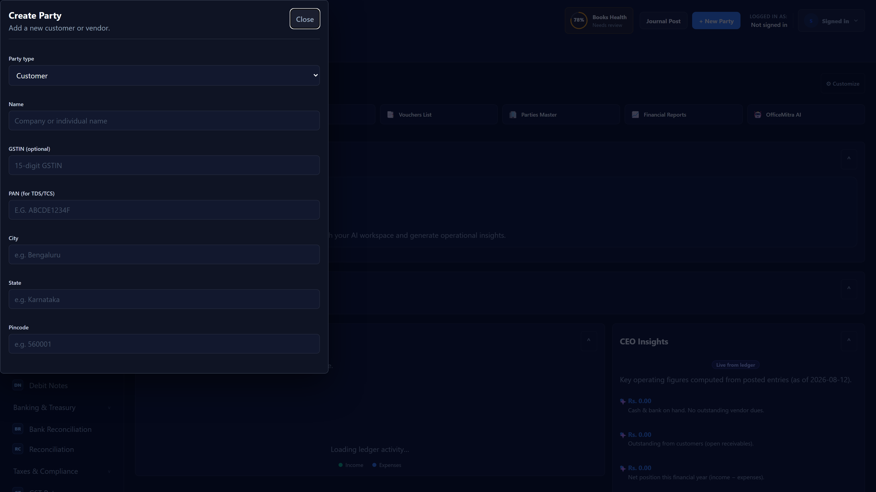
Figure 4.1 — Adding a party
- Click Parties in the sidebar.
- Click + New Party.
- Fill in:
- Name (required)
- Code — short identifier used in reports and CSV imports
- GSTIN — 15-character GST identification number
- PAN — required for TDS/TCS compliance (206AA flag if missing)
- Type — Customer, Vendor, or Both
- Contact details — phone, email, address
- Click Save.

4.2 Editing a Party
Click any party row to open it. Edit the fields and click Update.

4.3 Party Subledger
Every receivable and payable posting is tagged to the party. The Receivables / Payables tab in Financial Statements shows a party-wise breakdown tied to the Trial Balance.

5. Sales — Invoices

5.1 Creating a Sales Invoice
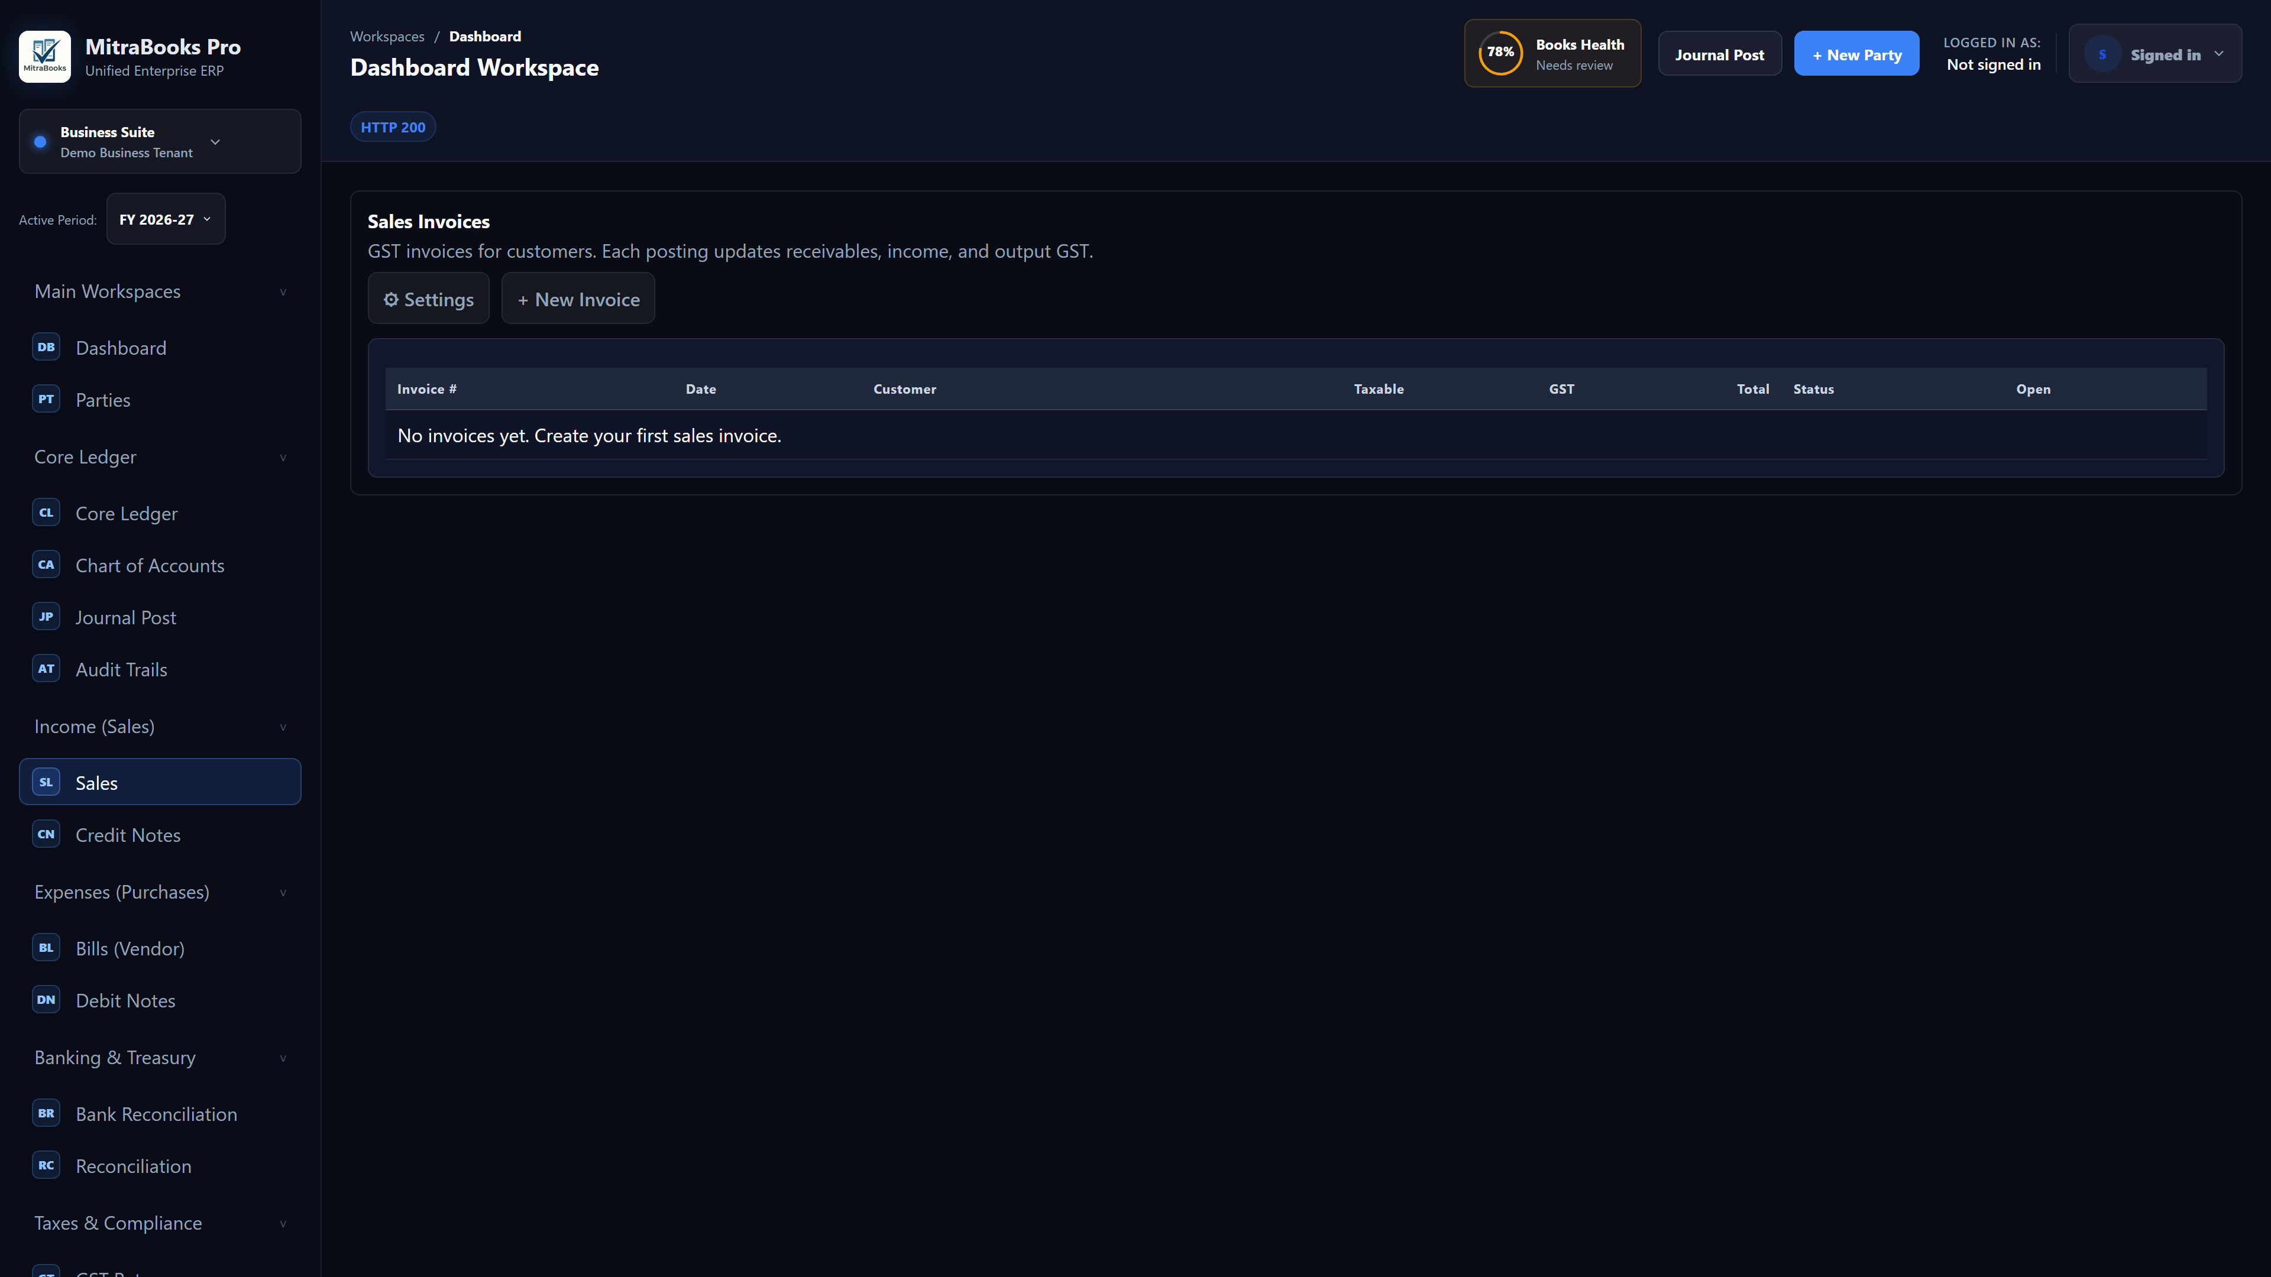
Figure 5.1 — Creating a sales invoice
- Click Sales in the sidebar.
- Click + New Invoice.
- Fill in the header:
- Customer — select from the party list
- Invoice Date and Due Date
- Invoice Number — auto-generated per the numbering pattern in Settings, or override manually (must be ≤ 16 characters, no leading special characters, for e-invoicing compliance)
- Place of Supply — state code; defaults from customer GSTIN; must match for inter-state / intra-state tax computation
- Supply Type — Taxable / Zero-Rated / Exempt (zero-rated applies for SEZ / export)
- Cost Centre / Project (optional) — appears only if Accounting Dimensions are set up
- TCS Section (optional) — select if Tax Collected at Source applies
- Add line items:
- Description
- HSN / SAC code — 4 to 8 digits
- UQC — Unit of Quantity Code (e.g., NOS, KGS, MTR) — required for GSTR-1 HSN summary
- Quantity and Unit Price
- GST Rate — 0%, 5%, 12%, 18%, or 28%
- Supply Type (per line) — Taxable / Zero-Rated / Exempt
- Item (optional) — if Inventory is enabled, select an item to update stock
- Review the computed totals: Taxable Value, CGST, SGST (intra-state) or IGST (inter-state), TCS, Grand Total.
- Click Post Invoice.

Important: Once posted, an invoice is locked in the ledger. Use a Credit Note to reverse or adjust.

5.2 Composition Dealer — Bill of Supply

5.3 Invoice List
Figure 5.3 — Invoice list
The Sales workspace shows all invoices with status (Posted / Draft), outstanding amount, and due date. Click any row to view the full invoice.

5.4 e-Invoice (IRN)
For businesses eligible for e-invoicing:
- Open a posted invoice.
- Scroll to the e-Invoice section.
- The system shows a readiness checklist (GSTIN format, document number length, HSN validity, etc.).
- If ready, click Download INV-01 JSON to get the payload for uploading to the IRP portal.
- After the IRP generates an IRN and acknowledgement number, enter them in the Record IRN form and click Record. The IRN is stored against the invoice.

6. Sales — Credit Notes
A Credit Note reduces a customer's outstanding balance. Use it to correct an invoice, record a return, or grant a discount after the fact.

6.1 Creating a Credit Note
- Click Credit Notes in the sidebar.
- Click + New Credit Note.
- Select the Customer and the Reference Invoice (optional but recommended).
- Add lines with Description, HSN, UQC, Quantity, Unit Price, and GST Rate.
- Select Supply Type per line (for zero-rated credit notes, GST is zero).
- Click Post Credit Note.

The journal reverses the original sales entry: Dr Sales Income / Cr Accounts Receivable.

7. Purchases — Vendor Bills

7.1 Creating a Vendor Bill
- Click Bills (Vendor) in the sidebar.
- Click + New Bill.
- Fill in:
- Vendor — select from party list
- Bill Date, Due Date, Vendor Invoice Number
- TDS Section (optional) — TDS is deducted at source; Net Payable = Taxable − TDS
- RCM (checkbox) — tick if this is a Reverse Charge Mechanism purchase
- Cost Centre / Project (optional)
- Add line items (Description, HSN, Quantity, Unit Price, GST Rate).
- Click Post Bill.

ITC (Input Tax Credit): For regular GST dealers, the GST paid on purchases is automatically credited to ITC Receivable and debited against GST Payable at settlement time. For RCM bills, the GST is posted to GST Payable under RCM (cash payment required; no ITC offset until paid). For Composition dealers, GST is capitalised into the cost of the item — no ITC is available.

7.2 Debit Notes

8. Payment Allocation
Payment Allocation links actual receipts and payments to specific invoices and bills. It does not post new journal entries — it is metadata that drives aging and outstanding calculations.

8.1 Allocating a Payment
- Go to Financial Statements → Payment Allocation tab.
- Select the Party and Side (Receivable or Payable).
- Open items (unallocated invoices / bills) are listed with their outstanding amounts.
- Enter the amount to allocate against each invoice.
- Click Allocate. The allocated amount is deducted from the outstanding.

8.2 Reversing an Allocation

9. Banking — Bank Reconciliation
Bank Reconciliation matches your bank statement to your book entries, ensuring the ledger agrees with the bank's records.

9.1 Uploading a Bank Statement
- Go to Bank Reconciliation (sidebar or Financial Statements → Bank Reconciliation tab).
- Select the Bank Account (accounts with code 11xxx).
- Paste or upload the bank statement as a CSV file:
- Supported formats: 2-column (Withdrawal / Deposit), signed Amount column, Amount + Dr/Cr indicator
- Supported date formats: DD-MM-YYYY, YYYY-MM-DD, DD-Mon-YYYY (e.g., 15-Jun-2026)
- Duplicate lines are skipped automatically on re-upload
- Click Upload Statement.

9.2 Matching Transactions
The system auto-suggests matches between statement lines and book entries (same amount and side, within a 7-day window; reference number hit upgrades confidence). Suggestions are never auto-applied — you review and confirm each one.
- Review the suggested matches.
- Click Confirm Match to link a statement line to a book entry.
- Click Reverse Match to undo a confirmed match.

9.3 Bank Reconciliation Statement (BRS)
The BRS identity:

BRS Formula: Bank Balance per Statement = Book Balance + Uncleared Book Credits − Deposits in Transit + Bank-only Deposits − Bank-only Withdrawals

Unmatched bank-only lines (bank charges, interest credits) should be posted as journal vouchers manually, then re-imported.

10. Compliance — GST Returns

10.1 GSTR-3B (Monthly Summary)
- Select the Period (YYYY-MM).
- Click Load GSTR-3B. The system shows:
- Table 3.1 — Outward supplies (taxable, zero-rated, exempt, RCM inward)
- Table 4 — ITC available (ISRC from RCM, Others from regular purchases)
- Table 6.1 — Payment of tax (IGST, CGST, SGST)
- Click Download GSTN JSON to get the filing-ready JSON for the GST portal.

10.2 GSTR-1 (Outward Supply Details)
- Select the Period (YYYY-MM).
- Click Load GSTR-1. Sections generated:
- B2B — invoices to registered buyers (GSTIN-tagged)
- B2CL — large invoices to unregistered buyers (> ₹2.5 lakh, inter-state)
- B2CS — small invoices to unregistered buyers
- CDNR — credit / debit notes (registered)
- EXP (6A) — zero-rated / export supplies
- HSN — HSN-wise summary (uses UQC from invoice lines)
- DOCS — document summary (invoice series)
- Click Download GSTN JSON for portal upload.

10.3 GSTR-2B / ITC Reconciliation
- Switch to the GSTR-2B (ITC recon) toggle.
- Select the Period.
- Upload the GSTR-2B JSON downloaded from the GST portal.
- Click Reconcile. Results are categorised into:
- Matched — invoice in both portal and books
- Mismatch — amount or rate differs
- In 2B, not in books — vendor filed, you have not recorded the bill
- In books, not in 2B (at-risk) — you recorded the bill but the vendor has not filed; ITC claim is at risk

10.4 CMP-08 (Composition Quarterly Statement)
For Composition Scheme dealers only.
- Switch to the CMP-08 (composition) toggle.
- Select the Quarter (e.g., 2026-Q1 = April–June 2026).
- Click Load CMP-08. The system calculates turnover × composition rate split into CGST/SGST.
- Click Post Composition Liability (admin only) to post the tax payable to the ledger.
- Click Download GSTN JSON for portal filing.

10.5 GSTR-4 (Annual Composition Return)
For Composition Scheme dealers only.
- Switch to the GSTR-4 (annual) toggle.
- Select the Financial Year (e.g., 2025-26).
- Click Load GSTR-4. Tables generated:
- Table 5 — consolidated CMP-08 (all 4 quarters)
- Table 6 — annual outward supplies and composition liability
- Table 4 — inward purchases split by registered / unregistered, rate-wise
- Click Download GSTN JSON.

10.6 GST Settlement
Before filing GSTR-3B, settle your ITC against output tax:
- Go to Financial Statements → GST Settlement tab.
- Select the Period.
- Review: Output Tax, ITC Available, ITC Reversal (if any), Net Tax Payable.
- Click Post Settlement (admin only). This creates the offsetting journal entry.

10.7 ITC Reversals (Rule 37)
If a vendor bill remains unpaid for 180 days, ITC claimed on it must be reversed with 18% interest.
- Go to Financial Statements → ITC Reversals tab.
- Click Scan for Reversals. The system identifies all unpaid bills older than 180 days.
- Review the list (amount, interest, vendor).
- Click Post Reversals (admin only). The ITC is reversed and interest is expensed.
- Once the bill is paid, click Reclaim ITC to restore the credit.

11. Compliance — TDS / TCS

11.1 TDS on Purchases

- Computes TDS = Taxable Amount × Section Rate (GST-exclusive, per Circular 23/2017)
- Posts: Dr Expense / Cr TDS Payable (23001) / Cr Accounts Payable (net payable)
- Flags 206AA if the vendor's PAN is missing (higher deduction rate applies)

11.2 TCS on Sales

- Computes TCS = Grand Total (GST-inclusive) × Section Rate (per Circular 17/2020)
- Grosses up the AR to include TCS; posts Cr TCS Payable (23004)

11.3 TDS / TCS Register
- Go to Financial Statements → TDS / TCS tab (or TDS/TCS in sidebar).
- Select the Quarter (e.g., 2026-Q1).
- The register shows deductee / collectee name, PAN, section, taxable amount, and TDS/TCS deducted.
- PAN-missing entries are flagged with a pill indicator.

Note: Challan payment (ITNS 281) and Form 26Q/27EQ file export are v2 features.

12. Accounting — Core Ledger & Journal Posts

12.1 Core Ledger (Chart of Accounts)
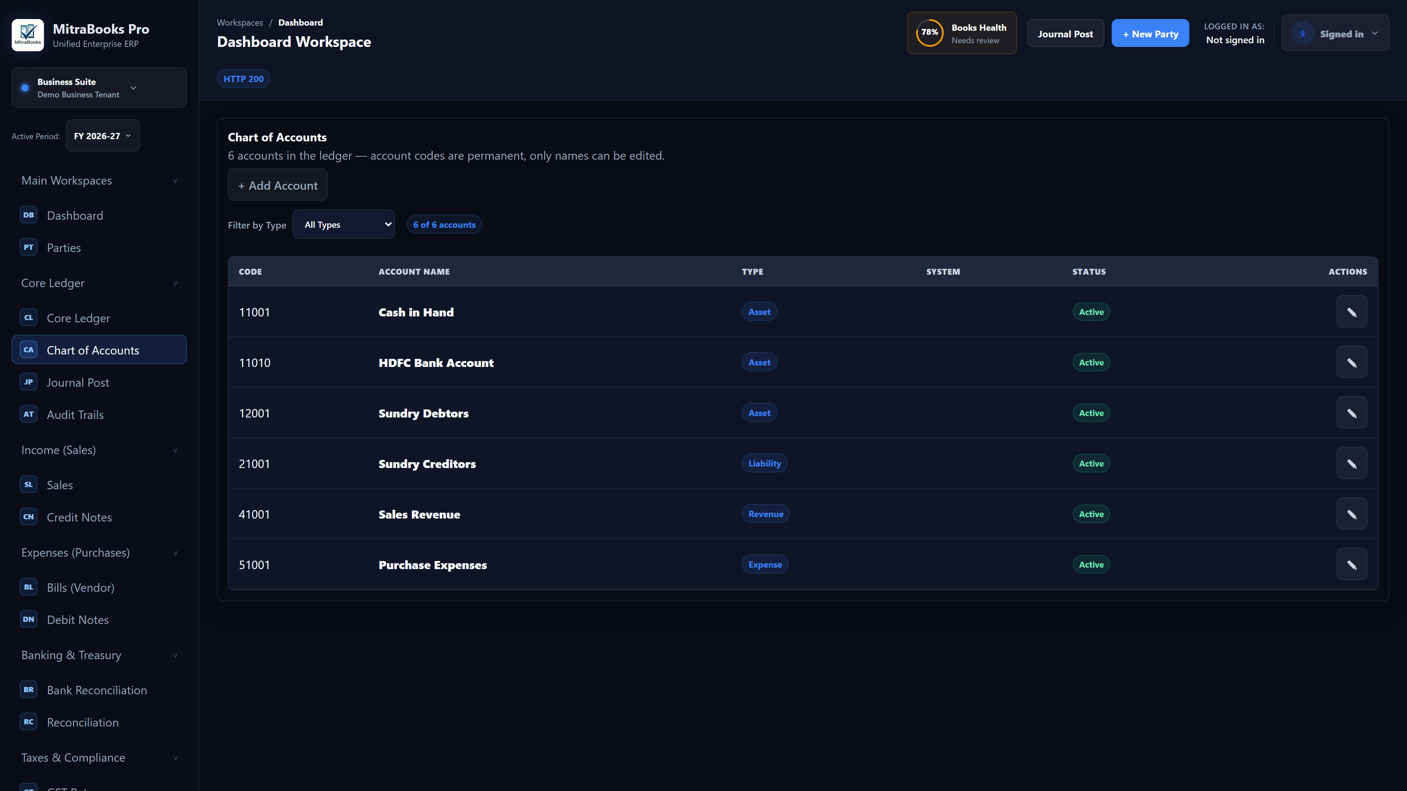
Figure 12.1 — Core Ledger (Chart of Accounts)

Code Range | Group
10001–14999 | Assets (Current Assets, Fixed Assets)
20001–23999 | Liabilities (Payables, Tax Payables)
30001–31999 | Equity (Capital, Retained Earnings)
40001–49999 | Income (Sales, Other Income)
50001–59999 | Expenses (COGS, Operating, Depreciation)

12.2 Manual Journal Post
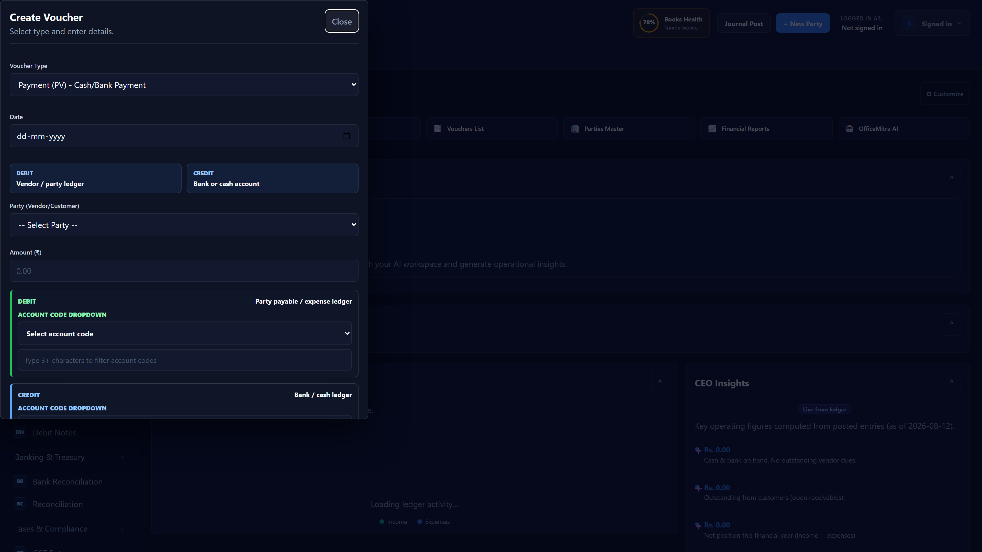
Figure 12.2 — Manual journal post
For transactions not covered by invoice / bill forms (e.g., bank charges, depreciation adjustments, opening entries):
- Click Journal Post in the sidebar.
- Click + New Voucher.
- Enter:
- Date
- Description / Narration
- Reference (optional)
- Lines: select account, enter Debit or Credit amount
- The entry must balance (Total Debits = Total Credits).
- Click Post. The system validates balance before posting.

12.3 Audit Trails

13. Financial Statements

13.1 Trial Balance
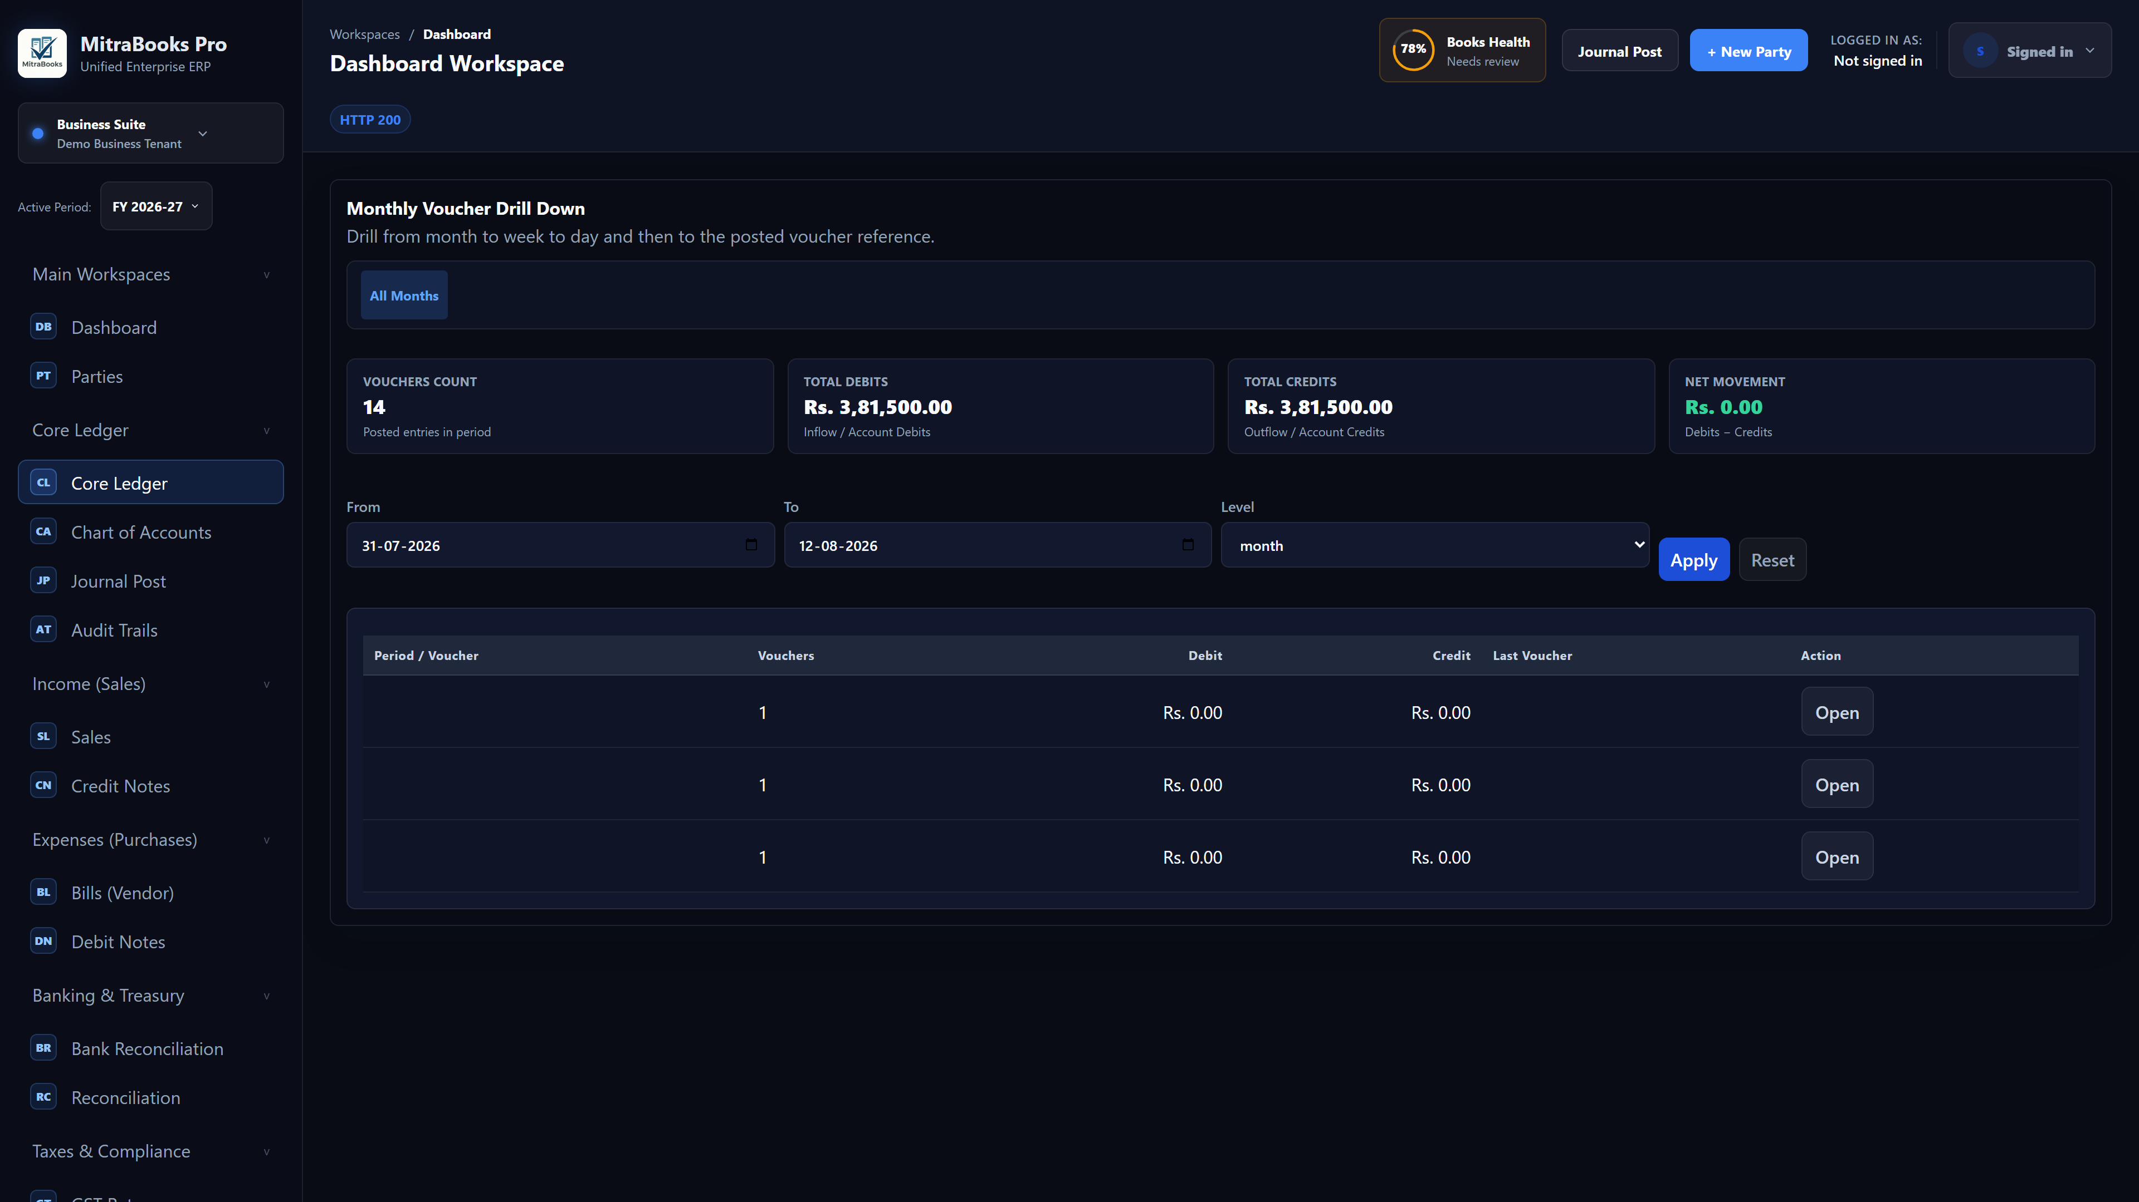
Figure 13.1 — Trial Balance
Shows all accounts with their debit and credit balances for a selected period.
- Select From Date and To Date.
- Toggle Net Only to collapse debit/credit into a single net column.
- Click Load Trial Balance.
- Use the Export toolbar (CSV / Excel / Print) to download.

13.2 Profit & Loss
- Select the Financial Year or custom date range.
- Click Load P&L. The report shows:
- Revenue (Income accounts 40xxx)
- Cost of Goods Sold (50xxx)
- Gross Profit
- Operating Expenses (51xxx–54xxx)
- Other Income / Expenses
- Net Profit / Loss
- Export as PDF, Excel, or Print.

13.3 Balance Sheet
- Select the As-of Date.
- Click Load Balance Sheet. The report shows:
- Assets: Current Assets, Fixed Assets (net of accumulated depreciation), Other Assets
- Liabilities & Equity: Current Liabilities, Long-term Liabilities, Equity (Capital + Retained Earnings)
- Assets must equal Liabilities + Equity. Any imbalance indicates an unposted opening balance or year-end close.

13.4 General Ledger
- Select an Account and date range.
- Click Load GL.
- The GL shows every journal line for the account with running balance.
- Filter by party to see a party-specific sub-ledger.

13.5 Receivables / Payables
Shows the party-wise sub-ledger for all receivable (11001) and payable (20001) accounts.
- Select Side (Receivable or Payable) and date range.
- The report shows per-party outstanding and the "Unallocated" bucket.

13.6 AR / AP Aging
Ageing buckets your outstanding by how long invoices have been overdue.
- Select Side (Customer or Vendor) and As-of Date.
- Click Load Aging.
- Columns: Current (not yet due), 1–30 days, 31–60 days, 61–90 days, 90+ days.
- Export to Excel for follow-up action.

14. Statements & Dunning

14.1 Customer / Vendor Statement
A statement shows the complete transaction history with a party and the current outstanding balance.
- Go to Financial Statements → Statements tab.
- Select Party, Side (Receivable / Payable), From Date, To Date.
- Click Load Statement.
- The statement shows: Opening Balance, each transaction (invoice / payment / credit note) with running balance, Closing Balance.
- Open items (unallocated) are listed separately below.
- Click Export to download a PDF / Excel copy for sending to the party.

14.2 Dunning Letters
If a customer has overdue invoices, MitraBooks suggests a dunning level automatically:

Level | Trigger | Tone
1 | 1–30 days overdue | Gentle reminder
2 | 31–60 days overdue | Firm reminder
3 | 61+ days overdue | Final notice

- Load the customer's Statement.
- Scroll to the Dunning panel. The recommended level and overdue total are shown.
- Review the auto-generated letter.
- Click Copy to Clipboard to paste into email / WhatsApp.
- Click Record Sent to log that the letter was dispatched (with timestamp and your notes).
- The dunning history for the party is shown below.

15. Period Locks
Period Locks prevent any backdated journal posting once a month is closed. Once locked, that period cannot receive new entries.
- Go to Financial Statements → Period Locks tab.
- Click Lock Period and select the month to lock.
- Locked periods are listed with the lock date and admin who locked them.

Important: Period locking is irreversible. Lock a period only after you have reconciled the bank, filed GST, and verified the Trial Balance.

16. Opening Balances & Year-End Close

16.1 Uploading Opening Balances
Use this feature when migrating from another system or at the start of a new financial year.
- Go to Financial Statements → Opening & Year-End tab.
- Click Download Template to get a sample CSV.
- Fill in the CSV:
- Column: Account Code or Account Name, Amount (Dr or Cr), Party Code (optional)
- Amounts in lakhs with comma separators are accepted
- Upload the CSV and click Preview. The system:
- Resolves account codes / names
- Resolves party codes to party IDs (enables party-opening-balance tracking)
- Shows a balancing line → Opening Balance Equity (31004)
- Flags any row errors
- If the preview shows no errors and the entry balances, click Post Opening Balances (admin only).
- Use Allow Duplicate checkbox to re-post if corrections are needed (reverses the previous entry first).

16.2 Year-End Close
At financial year end (31 March), all income and expense accounts are zeroed out and transferred to Retained Earnings.
- Select the Financial Year (e.g., 2025-26).
- Click Preview Year-End Close. The system shows:
- All income accounts being debited (Dr Income / Cr Retained Earnings)
- All expense accounts being credited (Cr Expense / Dr Retained Earnings)
- Net profit (or loss) carried to Retained Earnings (31003)
- Click Post Year-End Close (admin only).
- To reopen a year-end close (e.g., for an audit correction), click Reverse — this posts the exact opposite journal.

17. Fixed Assets

17.1 Asset Register
- Go to Financial Statements → Fixed Assets tab.
- Click + Add Asset.
- Fill in:
- Asset Name, Category
- Purchase Date, Cost
- Salvage Value (residual value at end of life)
- Depreciation Method: SLM (Straight Line) or WDV (Written Down Value)
- Useful Life (years) (for SLM) or Depreciation Rate % (for WDV)
- Opening Accumulated Depreciation — for assets being migrated into the system mid-life
- Click Save. The asset appears in the register with its current book value.

17.2 Running Depreciation
- Select the Financial Year.
- Click Preview Depreciation. The system calculates:
- SLM: (Cost − Salvage) ÷ Useful Life (prorated for first year)
- WDV: Opening Book Value × Rate % (salvage-clamped)
- Click Post Depreciation (admin only). Journal: Dr Depreciation Expense (54003) / Cr Accumulated Depreciation (16099).
- Once posted for a year, the run is locked to prevent double-posting. To redo, click Reverse first.

18. Accounting Dimensions

18.1 Setting Up Dimensions
- Go to Financial Statements → Dimensions tab.
- Click + New Dimension.
- Select Type (Cost Centre or Project), enter Code and Name.
- Click Save.

Once masters exist, a Cost Centre and Project dropdown appear on sales invoice and vendor bill forms.

18.2 Dimension Report
- Select Type (Cost Centre or Project) and date range.
- Click Load Report.
- The report shows income and expense totals per dimension. Untagged transactions appear in an Untagged bucket. All rows tie to the total document amounts.

19. Inventory (Optional)

19.1 Item Master
- Once inventory is enabled, go to Financial Statements → Inventory tab.
- Click + New Item.
- Fill in:
- Item Code (unique), Description
- UQC (Unit of Quantity Code)
- HSN Code, GST Rate %
- Opening Quantity and Opening Value (for migrated stock)
- Click Save.

Items appear as a dropdown on Sales Invoice and Vendor Bill line items once the master exists.

19.2 Stock Register
The stock register shows:
- Opening stock (quantity and value)
- Purchases (inward)
- Sales (outward)
weighted-average cost valuation
- Negative stock flag — posting is blocked if stock goes negative

19.3 Closing Stock Entry
At period end, post the closing stock value to the balance sheet:
- Click Post Closing Stock (admin only).
- Journal: Dr Inventory (13001) / Cr COGS (51002).
- Only one active closing entry is allowed at a time. Reverse it before posting a new one.

20. Settings

20.1 Invoice Settings

Setting | Description
Company / Legal Name | Printed on invoices and GST returns
Trade Name | Optional DBA name
GSTIN | 15-character GST registration number
GST Registration Type | Regular or Composition Scheme
Composition Category | Goods (1%), Restaurant (5%), Services (6%) — shown only for Composition
Invoice Number Prefix | e.g., "INV-" — combined with auto-incrementing number
Invoice Number Pattern | Format string for auto-generation
Financial Year Start | Typically April (month 4 for India)
Enable Inventory Accounting | Toggle inventory module on/off

20.2 Numbering Pattern
Invoice numbers must comply with GST e-invoicing rules: maximum 16 characters, no leading zero, hyphen, or slash. MitraBooks validates this before posting.

21. CA Practice Portal
The CA Practice Portal lets a Chartered Accountant manage multiple client firms from a single login.
- Access via CA Practice Portal in the sidebar.
- Switch between client firms using the firm selector.
- Each firm's data is fully isolated — viewing one client's ledger does not expose another's data.
- All audit trail entries record the CA's user ID, providing a clear access log for compliance purposes.

21.1 Inviting a Chartered Accountant (CA)
To grant an external CA access to your books, follow these steps:
1. Navigate to the CA Practice Portal via the sidebar.
2. Under the Invite a CA section, enter the CA's Name and Email Address.
3. Click Send Invite. The system will create a pending invitation, generate a secure temporary password, and display it on-screen (along with sending an email notification).
4. The newly invited CA will appear in the CA Access — Invited Users table with the status set to Invited.

21.2 CA Login and Password Update Flow
When the invited CA logs in for the first time, the system enforces a secure onboarding flow:
1. The CA navigates to the login page (/mitrabooks-erp/login.html).
2. The CA logs in using their registered email and the temporary password.
3. Upon a successful first login, the system automatically detects the temporary password and opens the Change Password dialog.
4. The CA must enter their temporary password as the current password, and choose a new secure permanent password (minimum 6 characters).
5. Once the password is successfully updated, the CA can enter the workspace and view reports. All subsequent log-ins must use their new permanent password.

21.3 Managing CA Invites
As a Tenant Administrator, you can manage active, pending, or revoked CA accounts from the CA Access table:
* Resend: Generates a new temporary password and updates the invite status (useful if the CA lost their credentials).
* Cancel: Deletes a pending invitation before the CA accepts it.
* Revoke: Temporarily suspends access for an active CA who has already accepted the invitation.
* Reinstate: Restores access for a previously revoked CA account.

22. HR & Payroll (Optional add-on)
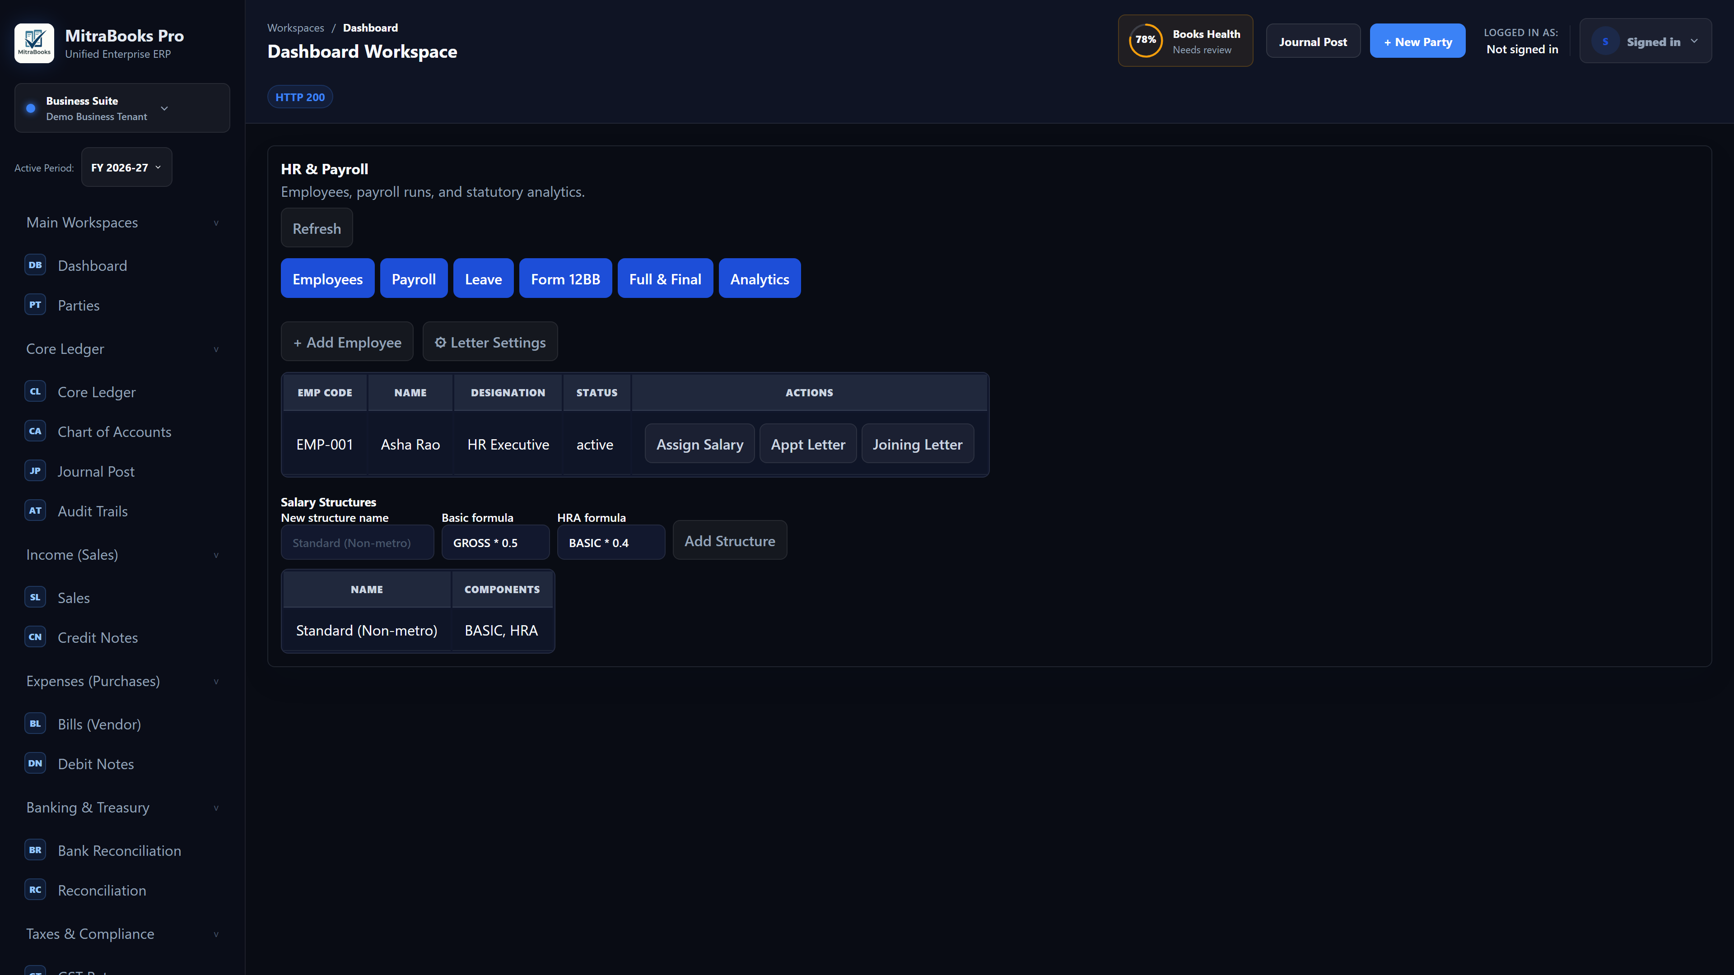
Figure 22 — HR & Payroll workspace
HR & Payroll is an enterprise add-on. It is off by default and must be provisioned by your platform administrator and then enabled in MitraBooks before the workspace becomes active. It manages employees, salary structures, payroll runs, leave, investment declarations (Form 12BB) and full & final settlements, and posts payroll to the General Ledger.
Open it from Human Resources → HR & Payroll in the left navigation.

22.1 Activating HR & Payroll
- Your platform administrator first provisions the add-on for your organization.
- A business administrator then sees an Enable HR & Payroll button in the workspace and clicks it.
- Once active, the tabs Employees, Payroll, Leave, Form 12BB, Full & Final and Analytics appear.
Access is role-based: an HR Manager or the tenant administrator can manage; a Payroll Auditor has read-only access.

22.2 Salary Structures
A salary structure is a reusable template of formula-driven components (Basic, HRA, allowances) used when assigning salaries.
- On the Employees tab, find Salary Structures.
- Enter a name (e.g. Standard (Non-metro)), a Basic formula (e.g. GROSS * 0.5) and an HRA formula (e.g. BASIC * 0.4).
- Click Add Structure.

22.3 Adding an Employee
Employees follow an onboarding lifecycle: Offered → Joined or Declined. An employee code is minted only when the candidate joins, so declined candidates never consume a code.
- Click + Add Employee and fill in name, designation, dates and contact details. The new employee starts in the Offered state.
- Use Assign Salary to attach a salary structure and the CTC figures.
- When the candidate joins, click Mark Joined — the employee code is generated at this point.

22.4 Appointment & Joining Letters
- Open Letter Settings to configure the clauses and branding that appear on letters.
- From an employee row, generate the Appointment Letter (offer stage) or the Joining Letter (after joining) as a PDF.

22.5 Running Payroll
- Go to the Payroll tab and click Run Payroll for the pay period.
- The engine computes each slip with EPF, ESI, Professional Tax (state slabs), TDS (new and old regime, with rebate and cess) and gratuity, all in fixed-precision money.
- Loss-of-pay is derived from approved leave — it is never typed in.
- The run produces salary slips and one consolidated journal entry to the GL. Download any slip as a PDF from the run.

22.6 Leave Management
- Create leave types on the Leave tab (mark a type as loss-of-pay if applicable).
- Allocate leave balances to employees.
- Employees apply for leave; an approver approves or rejects. Approved leave feeds the loss-of-pay calculation in payroll.

22.7 Form 12BB (Investment Declarations)
Form 12BB lets employees declare investments and submit proofs so old-regime TDS is computed correctly.
- On the Form 12BB tab the employee declares investments and uploads proof.
- HR verifies the declaration; verified amounts flow into the old-regime TDS calculation at payroll time.

22.8 Full & Final Settlement
- On the Full & Final tab, create an F&F for a leaving employee. Gratuity is computed from tenure.
- Move it through Draft → Approved → Paid. Download the F&F statement as a PDF.

22.9 Analytics
The Analytics tab shows a trailing-month payroll dashboard (headcount, payroll cost and statutory totals) computed from the posted runs.

23. Manufacturing & Cost Centres (Optional add-on)
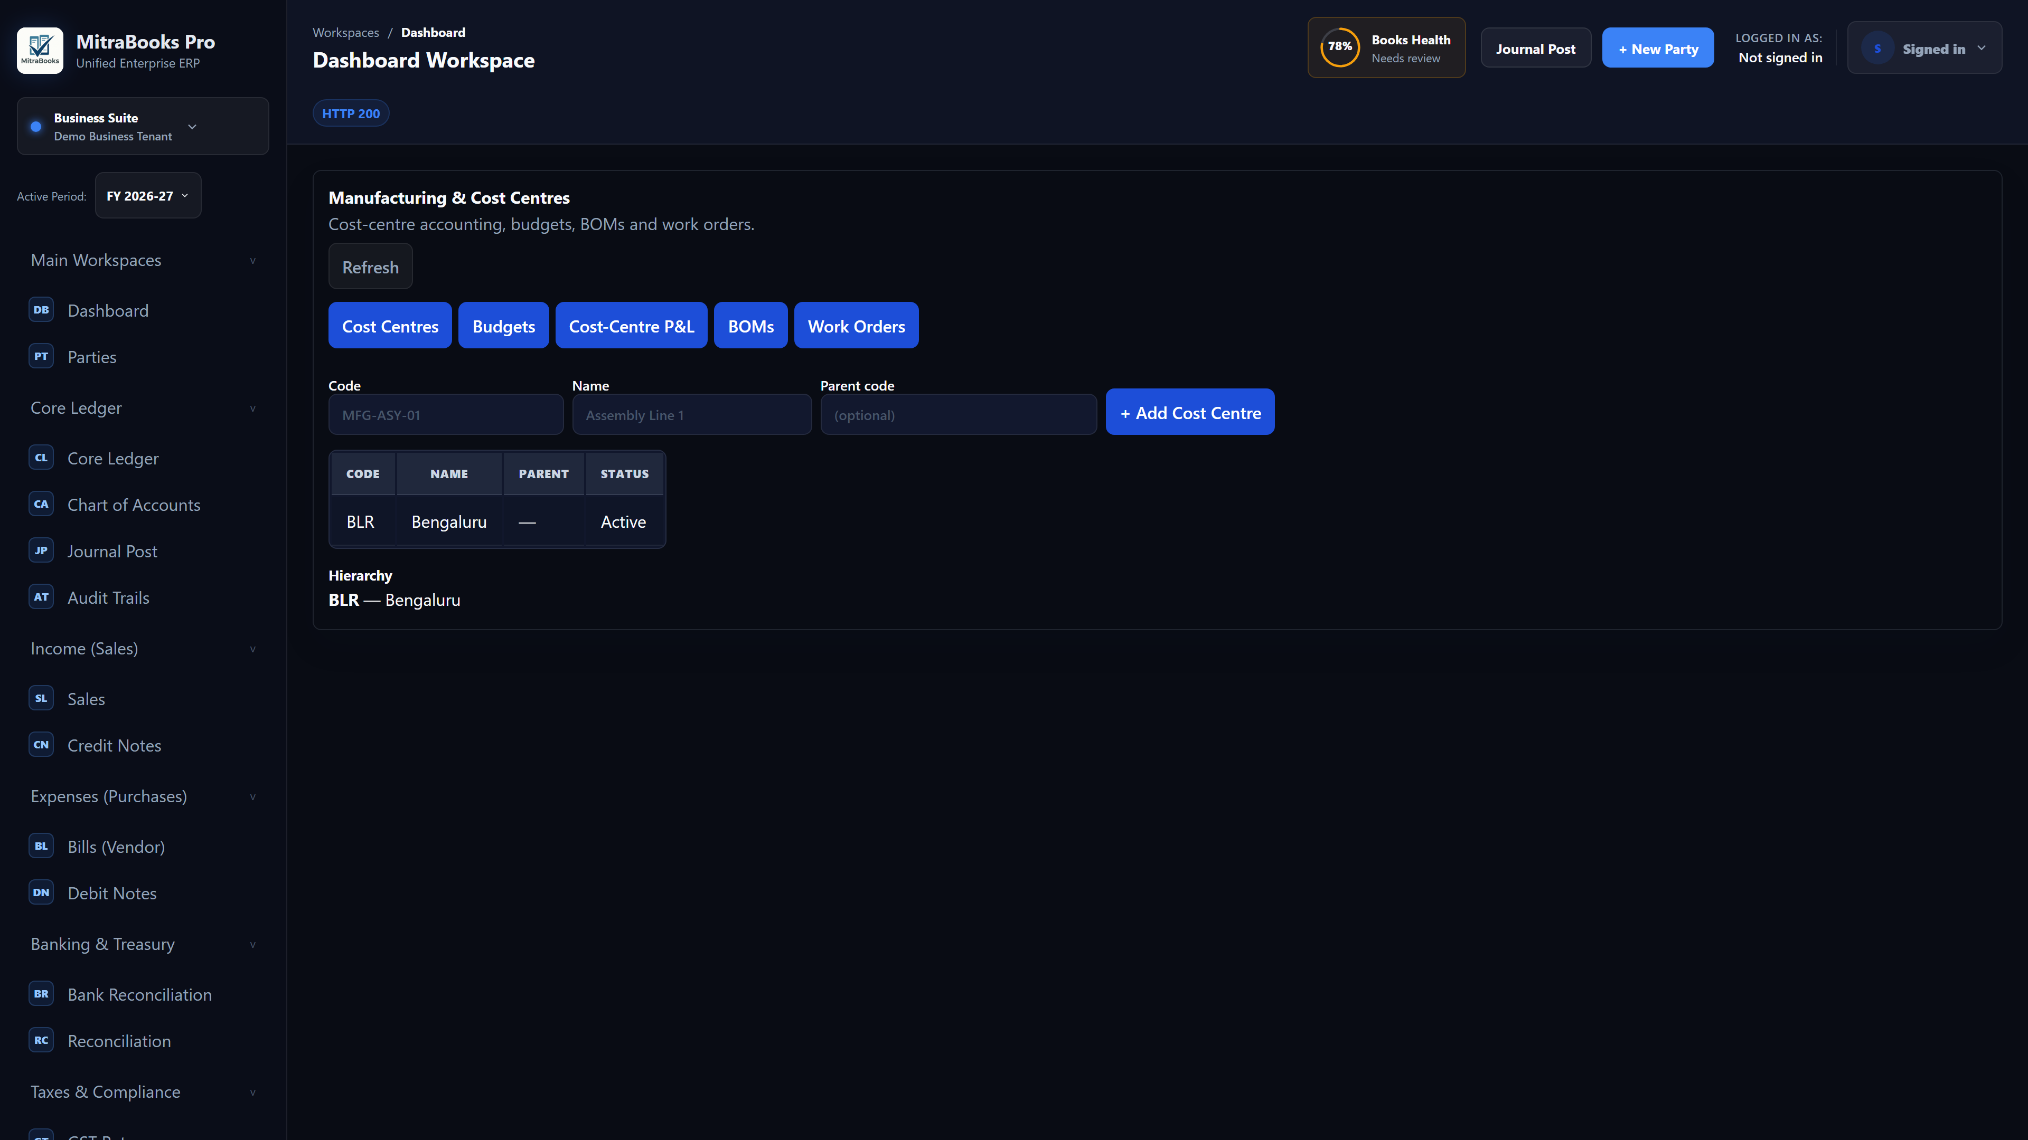
Figure 23 — Manufacturing & Cost Centres workspace
This is an enterprise add-on with two independent layers: Cost-Centre Accounting (departmental/branch budgets and P&L) and Manufacturing (bills of materials and work orders). Manufacturing depends on cost centres. Both are off by default and provisioned per organization.
Open it from Manufacturing → Manufacturing in the left navigation. It has five tabs: Cost Centres, Budgets, Cost-Centre P&L, BOMs and Work Orders.
Important — how it affects your books: the module is built for periodic inventory. Work orders do not post their own inventory journals (that would double-count against the period-end closing-stock entry). Instead they record production and a standard-vs-actual variance for reporting, and feed finished goods and raw-material consumption into the stock register so closing-stock valuation stays correct.

23.1 Activating the Add-on
- The platform administrator provisions Cost-Centre Accounting (and, if needed, Manufacturing) for the organization.
- A business administrator clicks Enable Cost Centres; enabling Manufacturing automatically requires cost centres to be on.

23.2 Cost Centres
A cost centre is a department, branch or activity you want to measure separately. Cost centres can be nested (e.g. Assembly Line rolls up into Factory, which rolls up into Operations).
- On the Cost Centres tab, enter a Code (e.g. MFG-ASY-01), a Name (e.g. Assembly Line 1) and an optional Parent code.
- Click + Add Cost Centre. The hierarchy is shown beneath the list.

23.3 Tagging Postings to a Cost Centre
Cost centres become useful when transactions carry them. A journal line may be tagged with a cost centre; the system rejects any cost centre that does not belong to your entity, so figures never mix across tenants or entities.

23.4 Cost-Centre Budgets
- On the Budgets tab, pick a cost centre, a fiscal year (and optional month), an account and an allocated amount, then + Add Budget.
- Move a budget Draft → Approved → Locked. Only approved/locked budgets drive the variance report.
- Click Vs Actual on a budget to see allocated vs actual spend, variance and burn-rate per account, with unbudgeted spend surfaced separately.

23.5 Cost-Centre P&L
- On the Cost-Centre P&L tab, choose a date range and click Run.
- The report shows income, expense and net per cost centre, plus an Untagged bucket, with totals that tie back to the period P&L.
- Export to CSV or Excel with the buttons provided.

23.6 Bills of Materials (BOM)
A BOM is the recipe for a finished good: the component items it consumes (with a standard rate and scrap allowance) and the operations performed (with an overhead rate). From these the system computes a deterministic standard cost. BOMs reference items from the inventory item master, so create your items first.
- On the BOMs tab, open + New BOM, choose the finished good and an output quantity.
- Add each component (item, quantity, rate, scrap %) with Add line.
- Click Save BOM. The standard cost (total and per unit) is shown in the BOM list.

23.7 Work Orders
A work order plans production of a finished good against a BOM and tracks it through its lifecycle: Draft → Released → In Progress → Completed (or Cancelled).
- On the Work Orders tab, pick a BOM, a planned quantity and (optionally) the production cost centre, then + Create Work Order. The standard cost is snapshotted.
- Use Release and Start to advance the work order.
- Click Complete, enter the produced quantity, actual overhead and actual material consumed (item, quantity, rate), then Confirm Completion.
- The work order shows the variance (actual vs standard); a favourable variance is marked. The finished goods and consumed materials flow into the stock register.

23.8 How It Affects Stock and the Ledger
- Finished goods produced are added to stock at their production cost.
- Raw materials consumed reduce stock at weighted-average cost.
- No separate work-order inventory journal is posted; financial recognition flows through the existing closing-stock entry, keeping the books consistent under periodic inventory.
- Variance is management information for cost control, tagged to the production cost centre.

24. OfficeMitra AI (Optional module)
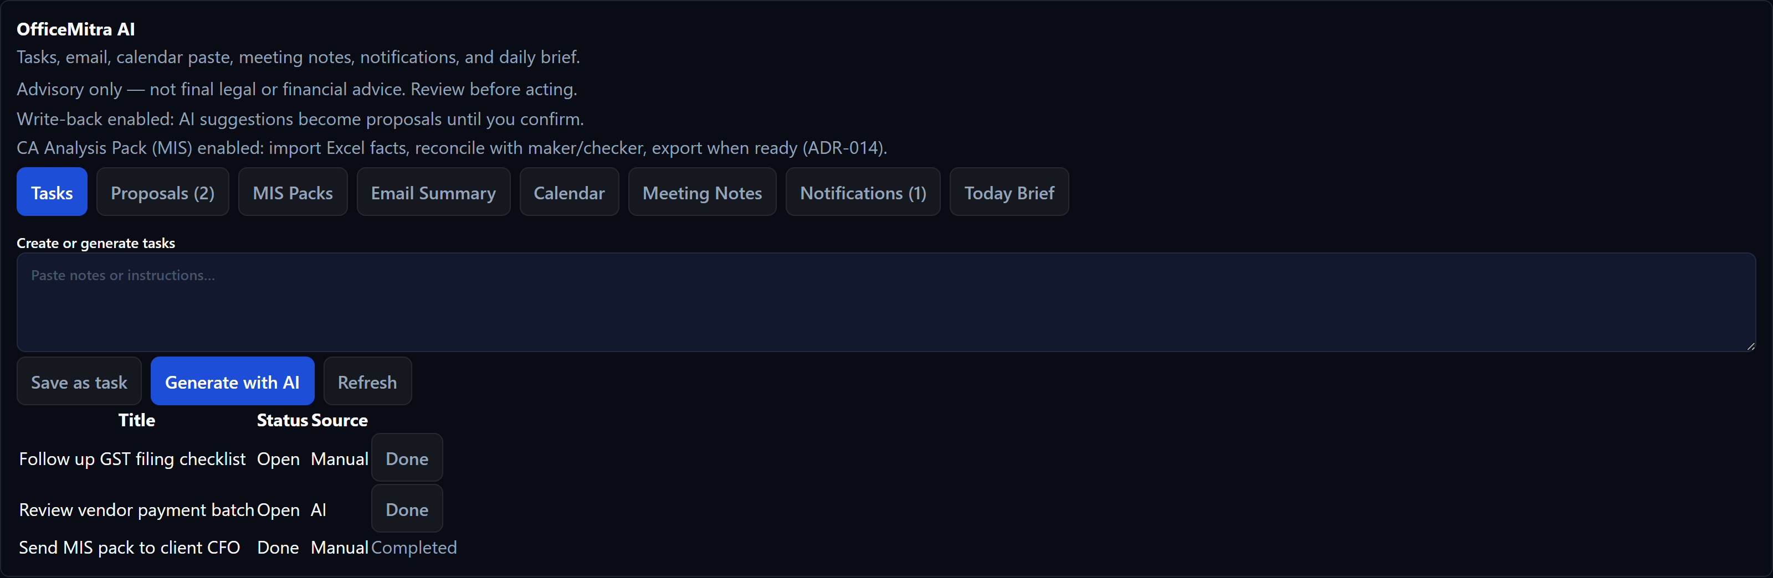
Figure 24 — OfficeMitra AI workspace (Tasks)
OfficeMitra AI is SanMitra's thin AI productivity layer inside MitraBooks ERP. It helps you capture tasks, summarize pasted email and meeting notes, parse calendar text, view in-app notifications, and generate a Today Brief. When enabled for your tenant, it can also run the CA Analysis Pack (MIS) workflow: import Excel facts, reconcile with maker/checker, and export PDF/Excel/PPT packs. It does not post journals, invoices, or GST entries from MIS flows.
Open it from Main Workspaces → OfficeMitra AI in the left navigation, or from the OfficeMitra AI chip on the dashboard.
All AI output is advisory only — review before acting. It is not final legal or financial advice.

24.1 Opening the workspace
- Sign in to MitraBooks ERP with a user whose tenant has the office_ai module enabled.
- In the sidebar, under Main Workspaces, click OfficeMitra AI.
- The workspace opens with tabs across the top: Tasks, Email Summary, Calendar, Meeting Notes, Notifications, and Today Brief. Additional tabs appear when your administrator enables write-back, MIS, or workflows.

24.2 Tasks
Use Tasks to track follow-ups manually or with AI assistance. Paste notes or instructions in the text area, then:
- Click Save as task to store the first line as a manual task.
- Click Generate with AI to ask OfficeMitra to suggest tasks (requires AI provider configuration; otherwise the UI soft-fails with a clear message).
- Click Done on an open task when it is complete.
- Click Refresh to reload the task list.

24.3 Email Summary
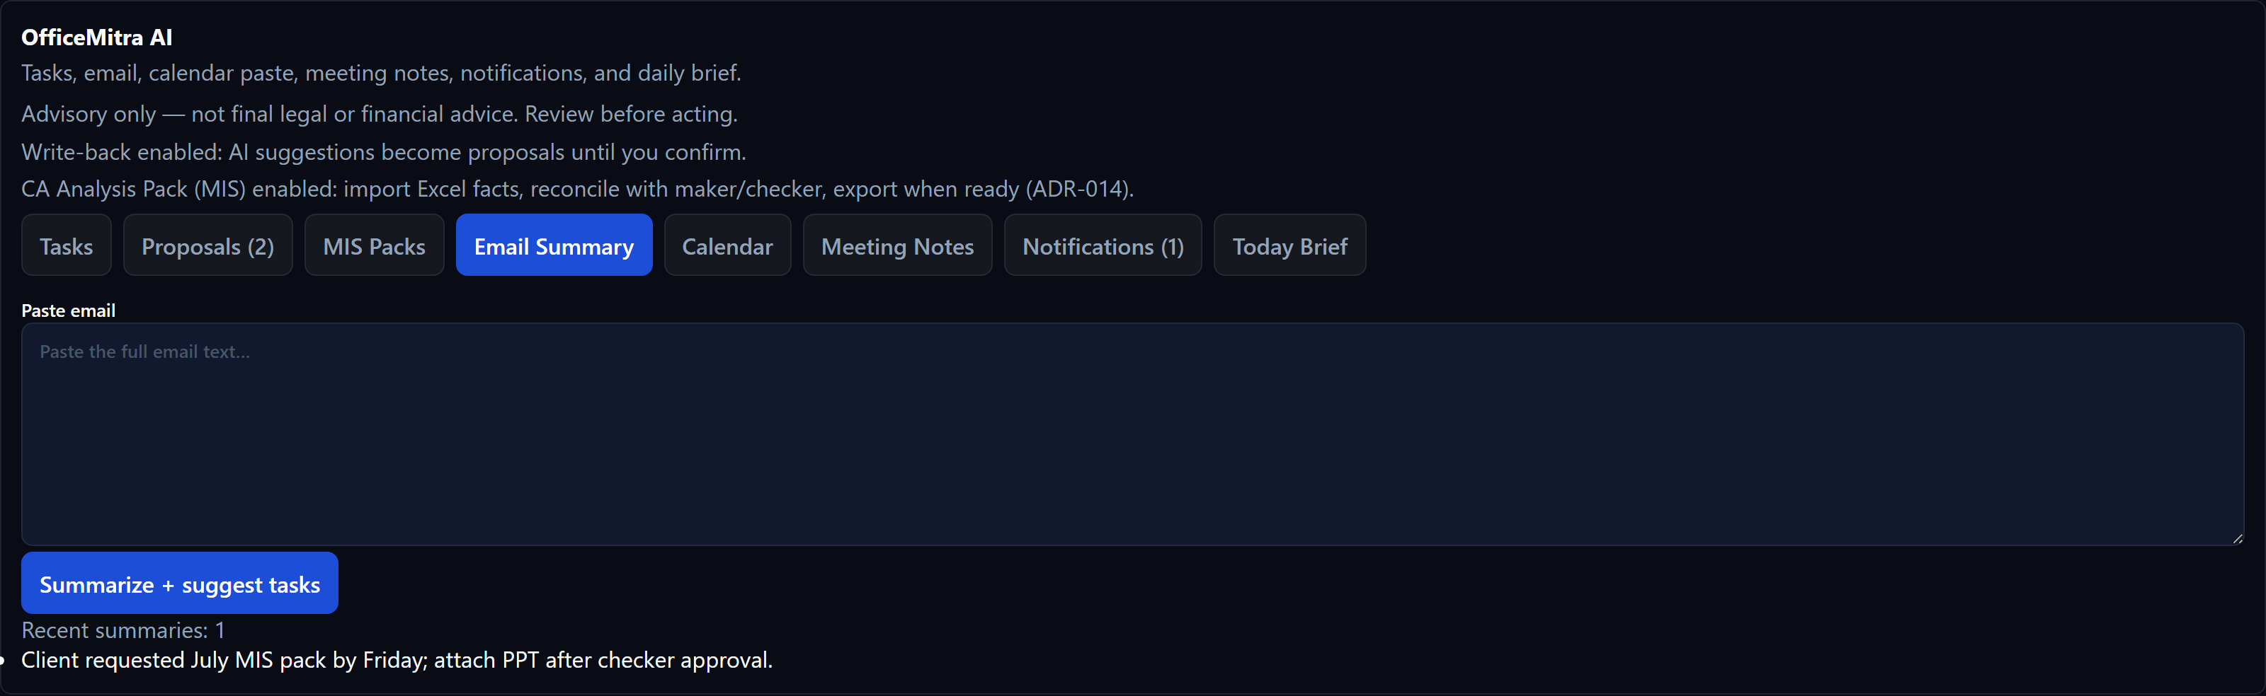
Figure 24.3 — Email Summary
Paste the full text of an email (no mailbox OAuth in this release). Click Summarize + suggest tasks to store a summary and optional follow-up tasks.

24.4 Calendar (paste-in)
Paste ICS calendar blocks or simple agenda lines (for example "10:00 Client GST review"). Click Parse + save events to add today's events. Use Refresh today to reload the list.

24.5 Meeting Notes
Paste meeting notes, then click Summarize + suggest tasks. Summaries are stored for later reference; optional tasks may be proposed when write-back is enabled.

24.6 Notifications
OfficeMitra maintains an in-app notification inbox (not email push). Click Mark read on individual items or Refresh to update the unread count badge on the tab.

24.7 Today Brief
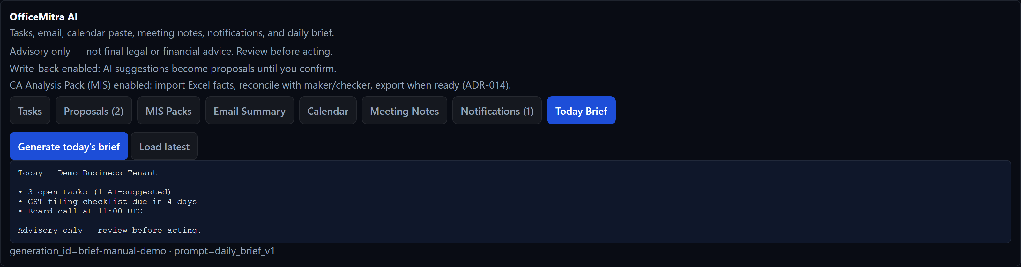
Figure 24.7 — Today Brief
The Today Brief combines OfficeMitra-native data and any available connector sections (for example open tasks and today's calendar). Click Generate today's brief to create or refresh today's digest. Click Load latest to fetch the saved brief without regenerating.

24.8 Proposals (confirmation and checker)
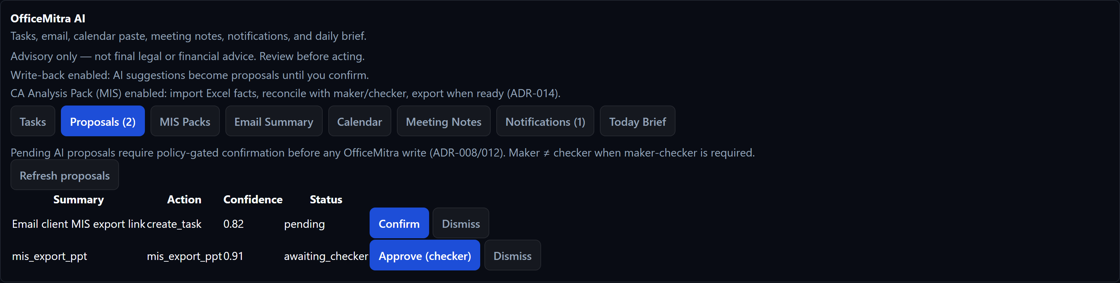
Figure 24.8 — Proposals queue
When office_ai.writeback or MIS export/reconcile is enabled, AI-suggested writes and MIS actions appear in the Proposals tab instead of executing immediately.
- Review the summary, action type, confidence, and status.
- As maker, click Confirm on pending proposals you prepared.
- When maker-checker policy applies, a different user (checker) clicks Approve (checker) — you cannot approve your own proposal.
- Click Dismiss to discard a proposal you do not want to execute.

24.9 MIS Packs (CA Analysis Pack)
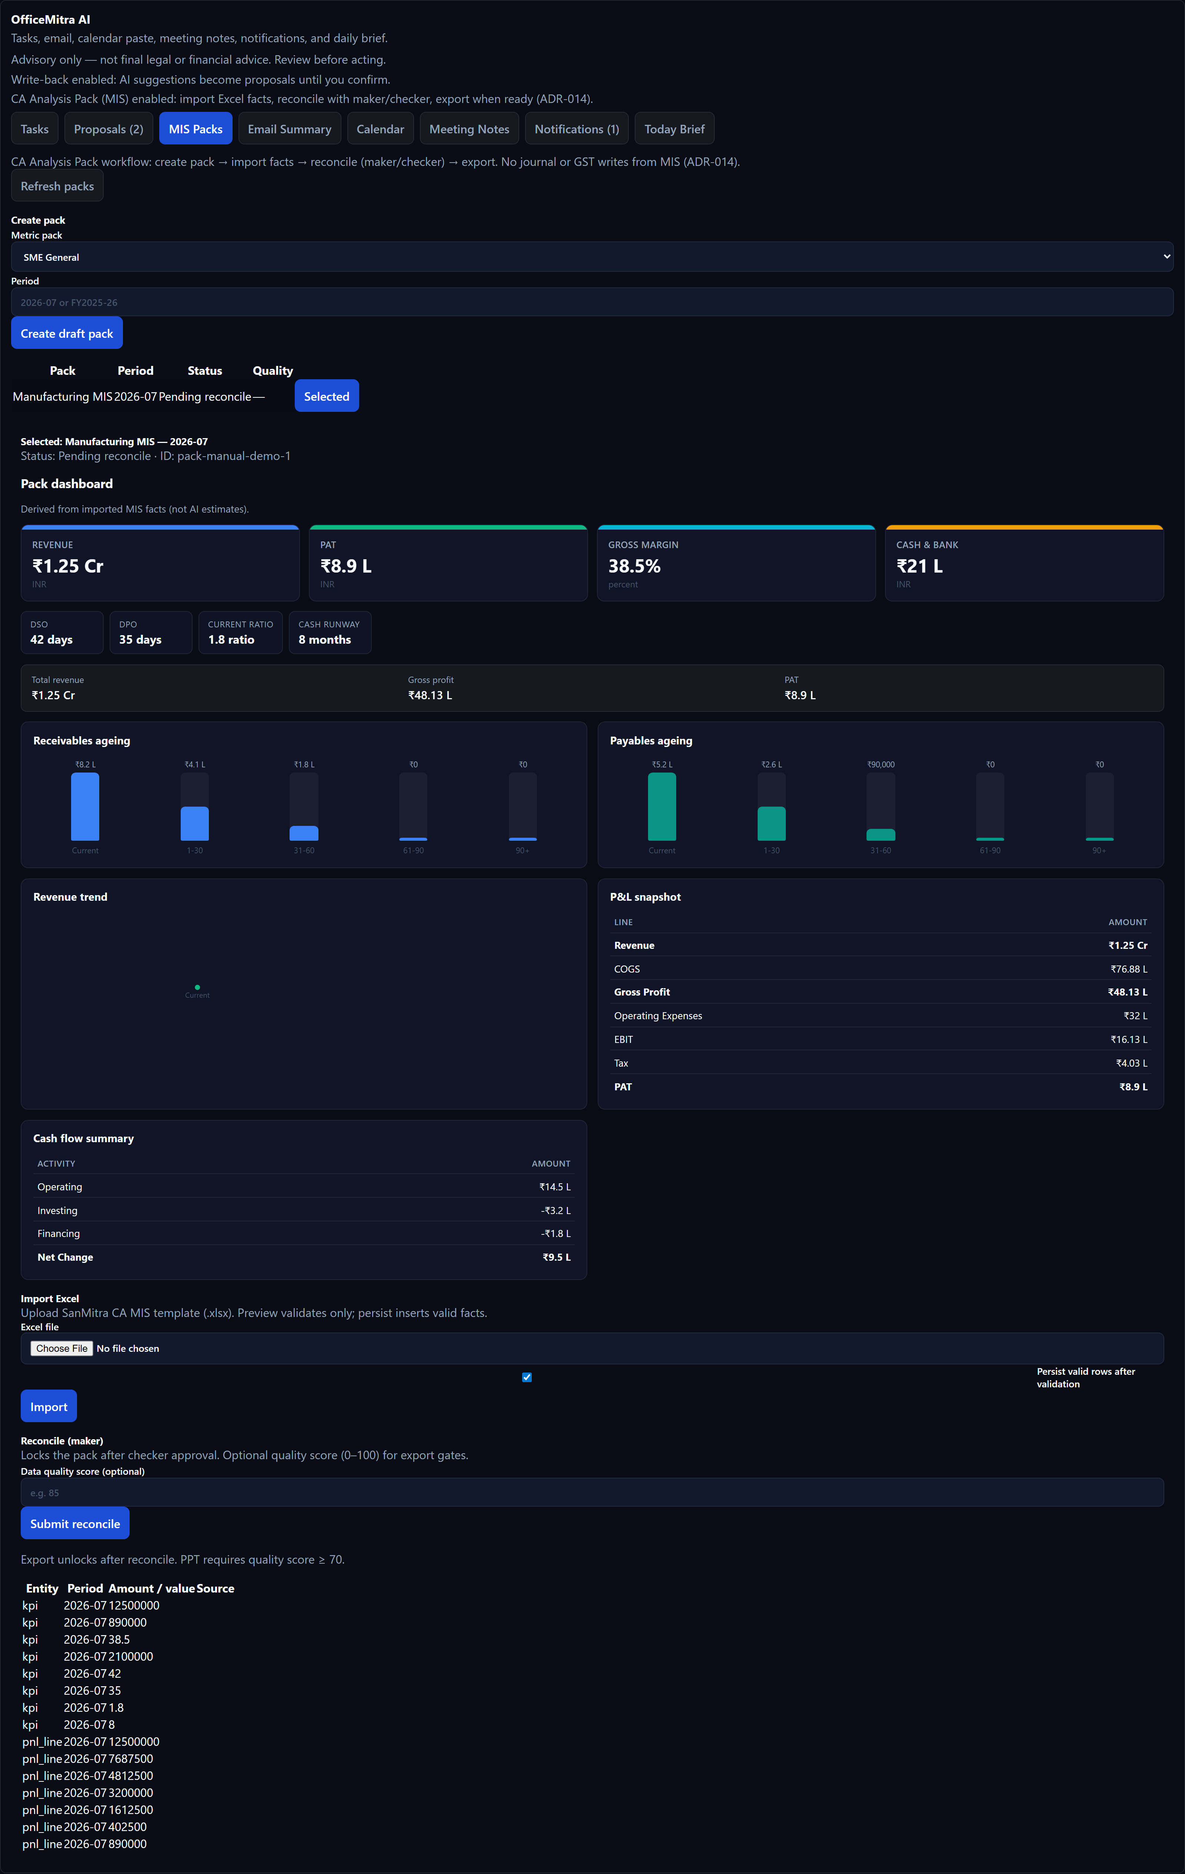
Figure 24.9 — MIS Packs (CA Analysis Pack)
Available when office_ai.mis and related import/export flags are enabled. This is for monthly MIS assembly — not day-to-day bookkeeping.
- Open the MIS Packs tab.
- Choose a metric pack and period, then click Create draft pack.
- Upload the SanMitra CA MIS Excel template. Use Persist valid rows after validation when ready to insert facts.
- Review the KPI dashboard and fact table derived from imported rows (not AI estimates).
- As maker, enter an optional data-quality score and click Submit reconcile.
- After checker approval, use Export Excel, Export PDF summary, or Export PPT (checker). Files download to your browser.
- MIS flows never write to the General Ledger or GST registers.
- PPT export typically requires a quality score of at least 70 and a separate checker.

24.10 Advisory and data boundaries
- OfficeMitra reads companion modules through connectors only — it is not the books of record.
- Figures in MIS packs come from imported or connector-sourced facts; narrative AI must cite those facts.
- Without an AI provider key, task generation and briefs still work with deterministic fallbacks where implemented.
- Contact your platform administrator to enable office_ai, MIS, or write-back flags for your tenant.

25. Workflow Tips

Action | How
Switch sidebar sections | Click any nav item
Switch report tabs | Click the tab bar inside Financial Statements
Export a report | Use the Export toolbar (CSV / Excel / PDF / Print) on any report
Download GST JSON | Use the Download GSTN JSON button on each return type
Refresh data | Click the Load / Refresh button on any panel
Copy dunning letter | Click Copy to Clipboard in the Dunning panel

26. Common Errors & Fixes

Error Message | Cause | Fix
Journal does not balance | Debit ≠ Credit in a manual voucher | Check all line amounts; total must match
Period is locked | Trying to post into a closed period | Contact admin; period locks are irreversible
Negative stock | Sales quantity exceeds available stock | Post a purchase bill or opening stock first
Inter-state blocked for composition | Composition dealers cannot make inter-state sales | Check Place of Supply
Invoice number too long | e-Invoice compliance requires ≤ 16 characters | Shorten the prefix in Settings
PAN missing (206AA) | Vendor has no PAN on file | Add PAN to the party record
HSN must be 4–8 digits | e-Invoice validation failure | Correct the HSN code on the invoice line
In books, not in 2B | Vendor has not filed GSTR-1; ITC at risk | Follow up with vendor; consider reversing ITC

27. Glossary

Term | Definition
ITC | Input Tax Credit — GST paid on purchases that can be offset against output tax
RCM | Reverse Charge Mechanism — buyer pays GST directly to the government instead of the vendor
GSTIN | Goods and Services Tax Identification Number — 15-character registration number
HSN | Harmonised System of Nomenclature — international code for classifying goods
SAC | Services Accounting Code — Indian code for classifying services
UQC | Unit Quantity Code — standardised unit used in GST returns (e.g., NOS, KGS, MTR)
GSTR-1 | Monthly/quarterly return of outward supplies
GSTR-3B | Monthly summary return of tax liability and ITC
GSTR-2B | Auto-drafted statement of ITC available (generated by GST portal from supplier filings)
CMP-08 | Quarterly statement of self-assessed tax for Composition Scheme dealers
GSTR-4 | Annual return for Composition Scheme dealers
IRN | Invoice Reference Number — unique identifier assigned by the IRP for e-invoices
IRP | Invoice Registration Portal — government portal for e-invoice generation
BRS | Bank Reconciliation Statement — reconciles book balance with bank statement balance
SLM | Straight Line Method — depreciation method that spreads cost evenly over asset life
WDV | Written Down Value — depreciation method applied on the reducing balance each year
TDS | Tax Deducted at Source — tax withheld by the payer at the time of payment
TCS | Tax Collected at Source — tax collected by the seller at the time of sale
Dunning | Systematic process of sending reminders to customers with overdue invoices
Period Lock | Administrative control that prevents posting to a closed accounting period
Cost Centre | An organisational unit (department, branch) for tracking income and expenses
Dimension | A tag (Cost Centre or Project) on a transaction for segmented reporting

28. Support
For assistance, contact your MitraBooks administrator or the SanMitra support team.

Email: contact@sanmitratech.in
Website: www.sanmitratech.in

