**Task**

**1. Get me the IP address of a particular domain (guvi.in)**

The ping command will often used to gather information about network connectivity and to obtain the

IP address of a domain or server. And also their is a tracert command which also shows us the ip address of that

domain but the main purpose of these tracert command is used to Trace route to destination.

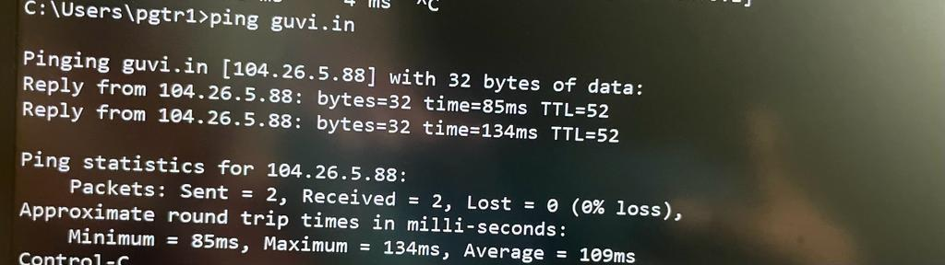

Here you can see the ip address of guvi.in was **104.26.5.88**

**2. How do I find the CPU/memory usage of my server?**

To find out the cpu/memory usage of our server we can use top command and also we can use free -h also both

commands used in Linux/Unix environments to monitor system resource usage, but they provide different

perspectives on the system's performance.here i displayed both commands to display output that how much cpu

memory got used you can see it.

**Top command output**

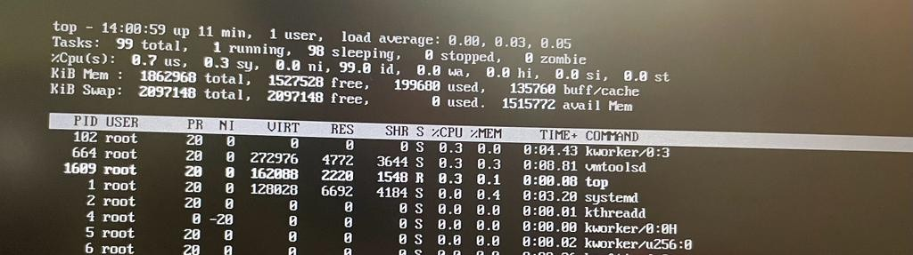

**Free -h command output** 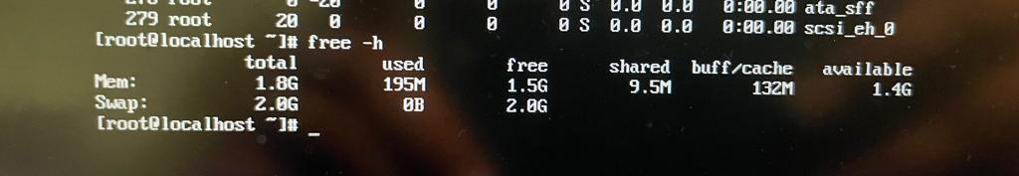

**3. Test the connectivity between 2 nodes.**

Ping command used to check the connectivity between two nodes Type ping <ip-address> or <DNS> or

<hostname> If the connectivity is available, the ping command typically shows a series of responses indicating

that the destination host is reachable. You will see lines displaying round-trip time (in milliseconds) for each packet

sent to the destination. Here i displayed sample output

