API Testing Screenshots
FAST API - get - health
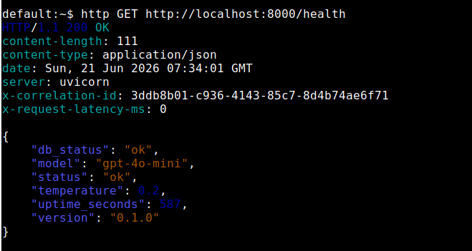

FAST API - reset
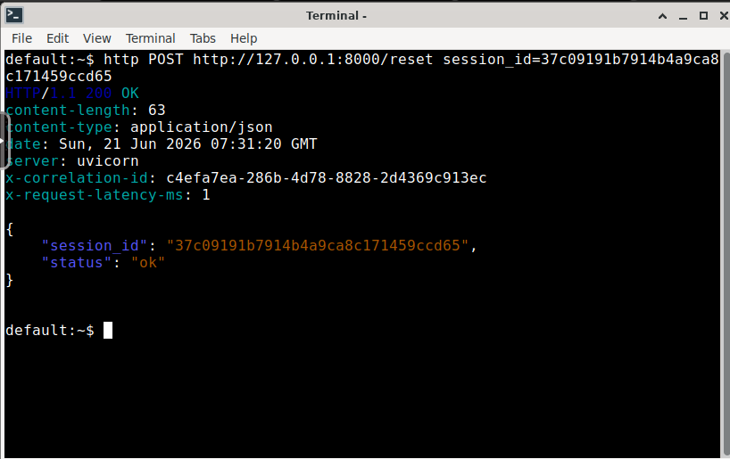

FAST API - Chat
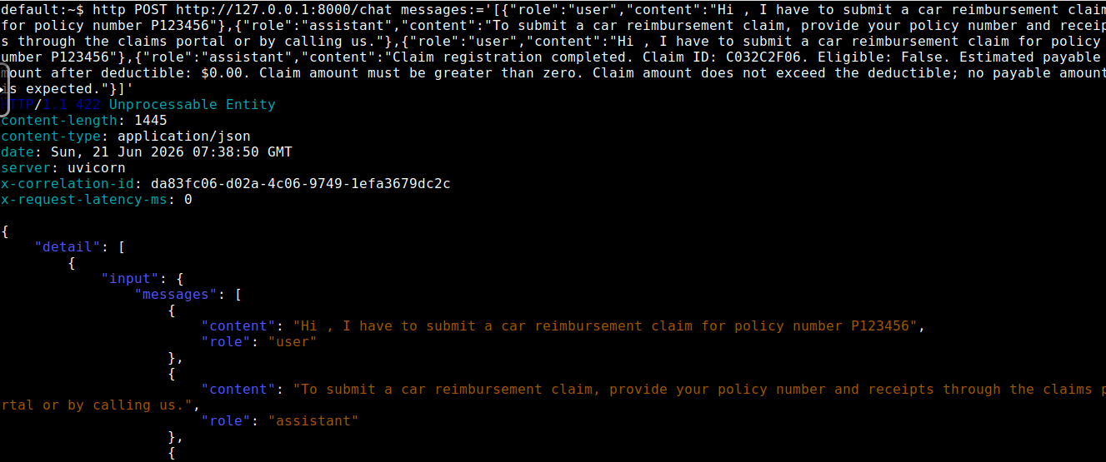
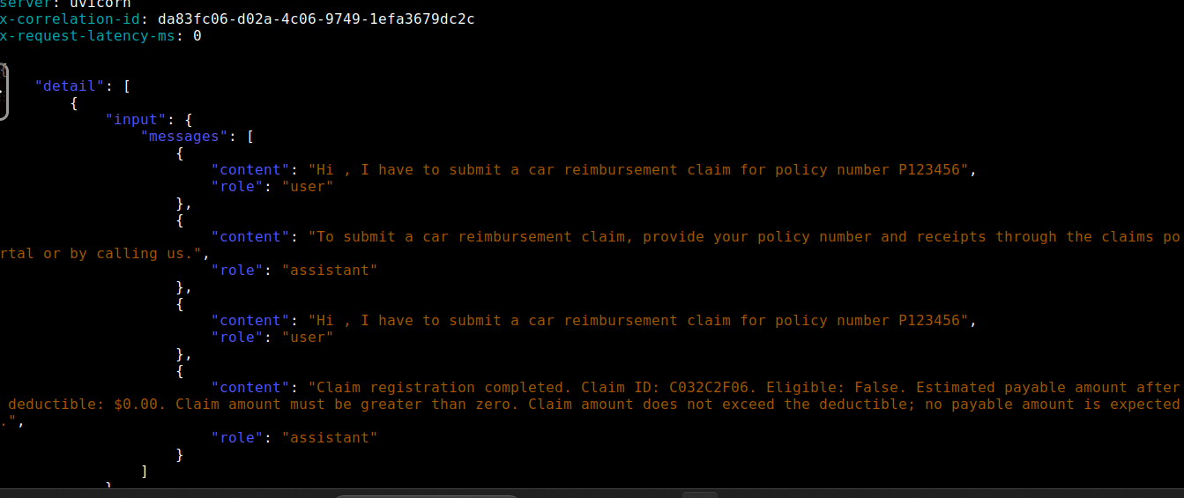

Langsmith traceability

Claim Submission for a policy number enabling langsmith tracing :

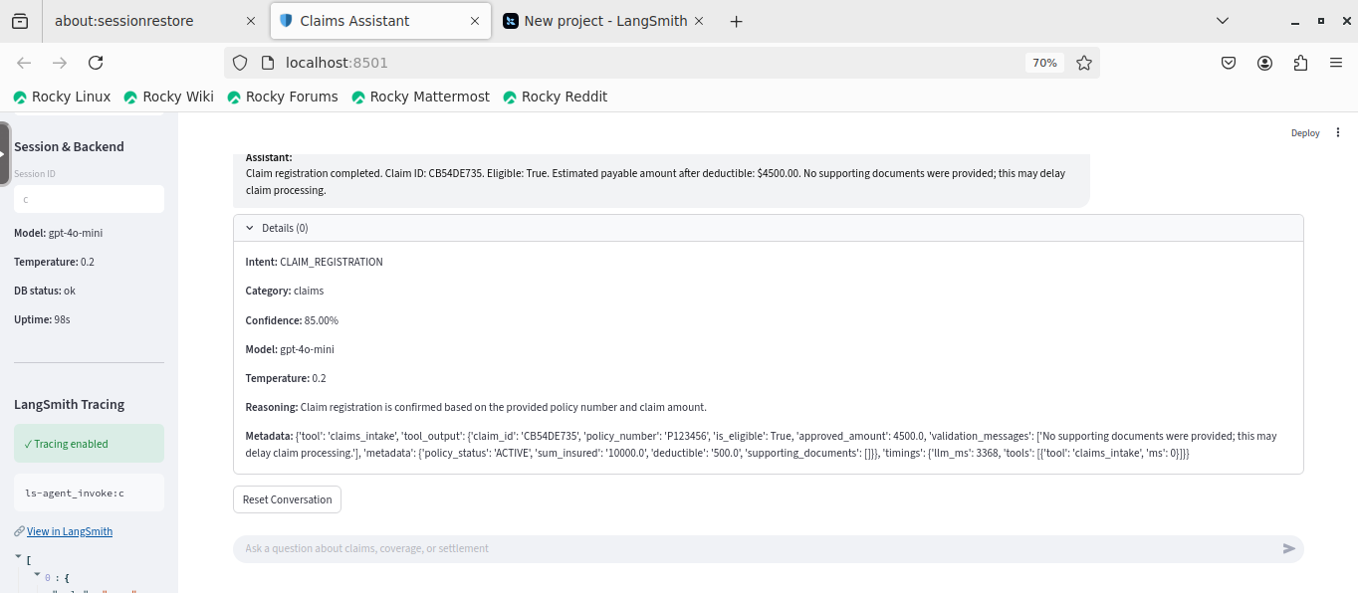
Langsmith Tracing
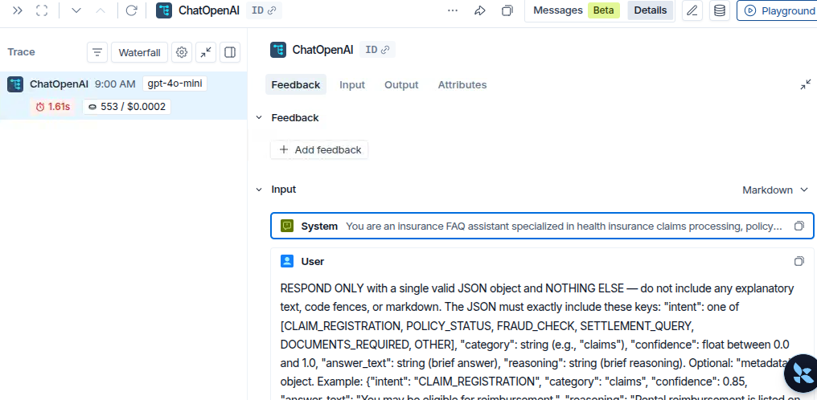
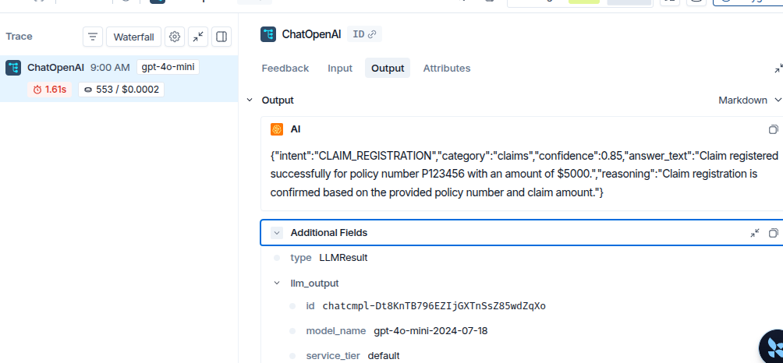
{
"inputs": {
"messages": [
[
{
"id": [
"langchain",
"schema",
"messages",
"SystemMessage"
],
"kwargs": {
"content": "You are an insurance FAQ assistant specialized in health insurance claims processing, policy coverage, fraud detection, and settlement calculations. Support multi-turn conversations and use relevant domain tools when appropriate. Your role is to provide clear, accurate answers to customer and agent questions about policies, claims, claim history, exclusions, and settlement details. Always be helpful, professional, and honest about limitations. Do not cite or reference any external documentation or reference docs. Answer only with the insurance information requested, and do not include extraneous guidance or documentation references.",
"type": "system"
},
"lc": 1,
"type": "constructor"
},
{
"id": [
"langchain",
"schema",
"messages",
"HumanMessage"
],
"kwargs": {
"content": "RESPOND ONLY with a single valid JSON object and NOTHING ELSE — do not include any explanatory text, code fences, or markdown. The JSON must exactly include these keys: \"intent\": one of [CLAIM_REGISTRATION, POLICY_STATUS, FRAUD_CHECK, SETTLEMENT_QUERY, DOCUMENTS_REQUIRED, OTHER], \"category\": string (e.g., \"claims\"), \"confidence\": float between 0.0 and 1.0, \"answer_text\": string (brief answer), \"reasoning\": string (brief reasoning). Optional: \"metadata\": object. Example: {\"intent\": \"CLAIM_REGISTRATION\", \"category\": \"claims\", \"confidence\": 0.85, \"answer_text\": \"You may be eligible for reimbursement.\", \"reasoning\": \"Rental reimbursement is listed on declarations page.\"}\n\nUser: Show me the claim history for policyholder ID P-3321.\nAssistant: Claim history summaries include filed claims, statuses, settled amounts, and pending actions. Provide your policyholder ID and I can look up the relevant history records.\n\nUser: Calculate settlement for a claim of ₹5,60,000 with 10K deductible.\nAssistant: With a ₹10,000 deductible, the claim amount subject to coverage is ₹5,50,000. The final settlement will then depend on co-pay, sub-limits, and approved claim items.\n\nUser: Process a new claim for policy #HI-445021. Hospital bill is ₹3,40,000.\nAssistant: Claim registered as #CLM-88712. Policy validated: Sum insured ₹5L, deductible ₹5,000, room rent sub-limit ₹4,000/day. After applying deductible and sub-limits, eligible settlement: ₹3,12,000. No fraud signals detected.\n\nUser: claim submission for policy number P123456. Claim ampunt $5000\nAssistant:",
"type": "human"
},
"lc": 1,
"type": "constructor"
}
]
]
},
"outputs": {
"generations": [
[
{
"generation_info": {
"finish_reason": "stop",
"logprobs": null
},
"message": {
"id": [
"langchain",
"schema",
"messages",
"AIMessage"
],
"kwargs": {
"additional_kwargs": {
"refusal": null
},
"content": "{\"intent\":\"CLAIM_REGISTRATION\",\"category\":\"claims\",\"confidence\":0.85,\"answer_text\":\"Claim registered successfully for policy number P123456 with an amount of $5000.\",\"reasoning\":\"Claim registration is confirmed based on the provided policy number and claim amount.\"}",
"id": "run--019ee969-3dad-7203-a06b-5fd039ce1b58-0",
"invalid_tool_calls": [],
"response_metadata": {
"finish_reason": "stop",
"id": "chatcmpl-Dt8KnTB796EZIjGXTnSsZ85wdZqXo",
"logprobs": null,
"model_name": "gpt-4o-mini-2024-07-18",
"service_tier": "default",
"system_fingerprint": "fp_eee5e0b136",
"token_usage": {
"completion_tokens": 56,
"completion_tokens_details": {
"accepted_prediction_tokens": 0,
"audio_tokens": 0,
"reasoning_tokens": 0,
"rejected_prediction_tokens": 0
},
"prompt_tokens": 497,
"prompt_tokens_details": {
"audio_tokens": 0,
"cached_tokens": 0
},
"total_tokens": 553
}
},
"tool_calls": [],
"type": "ai",
"usage_metadata": {
"input_token_details": {
"audio": 0,
"cache_read": 0
},
"input_tokens": 497,
"output_token_details": {
"audio": 0,
"reasoning": 0
},
"output_tokens": 56,
"total_tokens": 553
}
},
"lc": 1,
"type": "constructor"
},
"text": "{\"intent\":\"CLAIM_REGISTRATION\",\"category\":\"claims\",\"confidence\":0.85,\"answer_text\":\"Claim registered successfully for policy number P123456 with an amount of $5000.\",\"reasoning\":\"Claim registration is confirmed based on the provided policy number and claim amount.\"}",
"type": "ChatGeneration"
}
]
],
"llm_output": {
"id": "chatcmpl-Dt8KnTB796EZIjGXTnSsZ85wdZqXo",
"model_name": "gpt-4o-mini-2024-07-18",
"service_tier": "default",
"system_fingerprint": "fp_eee5e0b136",
"token_usage": {
"completion_tokens": 56,
"completion_tokens_details": {
"accepted_prediction_tokens": 0,
"audio_tokens": 0,
"reasoning_tokens": 0,
"rejected_prediction_tokens": 0
},
"prompt_tokens": 497,
"prompt_tokens_details": {
"audio_tokens": 0,
"cached_tokens": 0
},
"total_tokens": 553
}
},
"run": null,
"type": "LLMResult"
},
"metadata": {
"LANGSMITH_PROJECT_NAME": "claimprocessing",
"LANGSMITH_TRACING": "true",
"ls_model_name": "gpt-4o-mini",
"ls_model_type": "chat",
"ls_provider": "openai",
"ls_run_depth": 0,
"ls_temperature": 0.2
},
"langsmith": {
"organization": {
"name": "Personal",
"id": "ff5e054f-ae89-42cd-8d90-803d3075020a"
},
"workspace": {
"name": "Workspace 1",
"id": "9ee6788c-0b9e-4b59-96eb-5ef7e24d2f54"
},
"tracing_project": {
"id": "5f38923b-191f-4391-a03d-96227706e07c",
"name": "default"
}
}
}

Sample request for tracing: 