**Stock Price Prediction**

**Innovation Phase - 2**

**Jaya Nandhanan V**

**(Team Leader)**

**Innovation: Stock Price Prediction**

**Problem Statement:**

The challenge of predicting stock prices accurately remains a central quest for investors and traders. The stock market's intricate dynamics, shaped by multifaceted factors, pose a formidable problem. Traditional forecasting methods often struggle to capture the complex, non-linear patterns exhibited by stock prices. This project aims to address this challenge by exploring advanced deep learning techniques, such as CNN-LSTM and attention mechanisms, to enhance the accuracy of stock price predictions. Leveraging Microsoft's lifetime stock data from Kaggle, we seek to empower investors with a tool that aids in more informed investment decisions in a notoriously unpredictable market.

**Introduction:**

Our project delves into the fascinating domain of stock price prediction, where finance meets data science. In an ever-shifting market landscape, the ability to forecast stock prices accurately holds immense potential for investors and traders. Leveraging advanced deep learning techniques like CNN-LSTM and attention mechanisms, we aim to enhance prediction accuracy. Our dataset, featuring Microsoft's lifetime stock data from Kaggle, serves as the foundation for this endeavour. This project is a testament to the synergy of technology and finance, seeking to empower market participants with more informed decisions in an inherently unpredictable stock market.

**Dataset Analysis:**

MSFT.csv contains all the life time stocks data from 3/13/1986 to 12/10/2019 this dataset contains 7 columns including dates, opening, high, low, closing, adj_ close, volume. code up your first kernel: LSTMs and Deep Reinforcement Learning agents works well for this dataset.

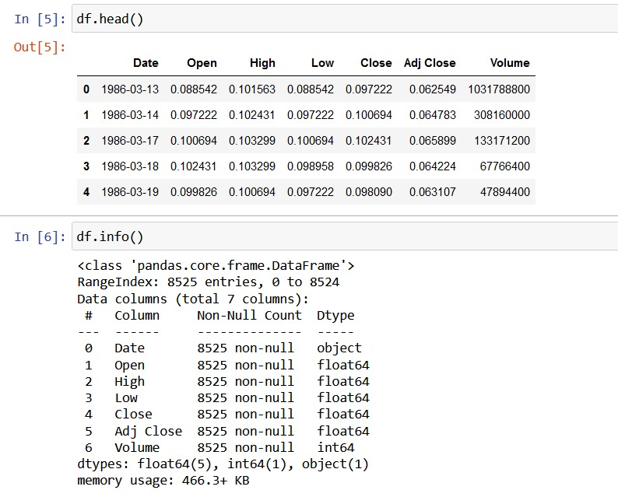

**Libraries Needed**

The libraries we will be using in our project will be as follows:

Pandas: Pandas is a library for data analysis and manipulation. It can be used to read the Netflix original films dataset into a DataFrame, clean the data, and prepare it for machine learning.

Scikit-learn: Scikit-learn is a library for machine learning. It provides a variety of machine learning algorithms that you can use to train your model.

Matplotlib: Matplotlib is a library for data visualization. It can be used to create plots and charts to explore the dataset and visualize the results of your model.

NumPy: NumPy is a library for scientific computing. It can be used to perform mathematical operations on the data.

Seaborn: Seaborn is a library for statistical data visualization. It provides a high-level interface to Matplotlib that makes it easier to create informative and attractive plots.

XGBoost: XGBoost is a library for gradient boosted decision trees. It is a very powerful machine learning algorithm that is often used for regression tasks, such as predicting IMDb scores.

**Training and Testing for Microsoft Stock Price Prediction:**

1. Data Preparation:

Import the Microsoft stock price dataset, ensuring it's properly formatted and structured.

Split the data into training and testing sets. A common split is 80% for training and 20% for testing, but you can adjust this based on your requirements.

2. Feature Selection and Engineering:

Choose the relevant features from the dataset. These may include historical stock prices, trading volumes, or any additional features you've engineered.

Perform any necessary feature scaling or normalization.

3. Model Selection:

Select the model for stock price prediction. Given your interest in advanced deep learning techniques, consider using a CNN-LSTM model or an attention mechanism-based model.

4. Model Training:

Configure the selected model, including architecture, hyperparameters, and optimization algorithms.

Train the model using the training dataset. Monitor training progress, and employ early stopping if needed to prevent overfitting.

5. Model Evaluation:

Evaluate the trained model's performance using the testing dataset.

Calculate relevant metrics like Mean Absolute Error (MAE), Root Mean Squared Error (RMSE), and Mean Absolute Percentage Error (MAPE) to assess prediction accuracy.

Visualize the model's predictions against the actual stock prices for insights.

6. Model Refinement:

If the model performance is not satisfactory, consider fine-tuning the architecture or hyperparameters.

Reiterate the training and testing process until you achieve acceptable results.

7. Interpret Results:

Analyse the evaluation metrics and insights gained from the testing phase. Consider the model's strengths and limitations.

This outline provides a structured approach to train and test your Microsoft stock price prediction model. Please note that specific implementation details will depend on the programming language and libraries you're using for your project. Be sure to adjust the steps to fit your project's requirements and chosen model.

**Traditional Regression Approaches:**

Linear Regression:

Overview: Linear regression is a straightforward and widely used technique that models the relationship between a dependent variable (stock price) and one or more independent variables (features) using a linear equation.

Applicability: It's suitable when you want to explore linear relationships between features and stock prices. You can include lagged prices, trading volumes, and other relevant factors as features.

Strengths: Simplicity and interpretability, which make it easy to understand the model's behavior.

Limitations: Linear regression assumes a linear relationship, which may not capture complex, non-linear patterns in stock prices.

Polynomial Regression:

Overview: Polynomial regression extends linear regression by introducing polynomial terms to model non-linear relationships between features and stock prices.

Applicability: It's useful when you suspect that stock price movements exhibit non-linear patterns, and you want to capture those patterns.

Strengths: Flexibility to model more complex relationships compared to linear regression.

Limitations: Polynomial regression can become overly complex, leading to overfitting if not carefully managed.

Lasso and Ridge Regression:

Overview: Lasso and Ridge regression are variants of linear regression that introduce regularization terms to prevent overfitting and feature selection.

Applicability: They are valuable when dealing with a dataset with many features. Lasso can perform feature selection by driving some coefficients to zero.

Strengths: They help control overfitting and reduce the impact of irrelevant features.

Limitations: The choice between Lasso and Ridge depends on the specific problem, and the models may be less interpretable.

Time Series Regression:

Overview: Time series regression methods, like Autoregressive Integrated Moving Average (ARIMA) and Seasonal Decomposition of Time Series (STL), are traditional approaches tailored for time series data.

Applicability: ARIMA, in particular, is well-suited for modeling stock price movements over time. It accounts for trends, seasonality, and autoregressive components.

Strengths: Specifically designed for time series data, capturing temporal patterns and dependencies.

Limitations: May not handle external features or factors outside the time series itself.

Exponential Smoothing:

Overview: Exponential smoothing is another time series forecasting technique that considers weighted averages of past observations to predict future stock prices.

Applicability: Effective for capturing trend and seasonality components in time series data.

Strengths: Simplicity and suitability for time series forecasting.

Limitations: Limited ability to capture more complex patterns in stock prices.

When applying traditional regression approaches to stock price prediction, feature engineering plays a crucial role. The choice of features, including lagged prices, trading volumes, technical indicators, and economic indicators, significantly impacts the model's performance. Keep in mind that while these methods offer transparency and interpretability, they may not capture all the nuances and complexities of stock price movements, especially in the presence of non-linear or highly dynamic patterns.

**Advanced Regression Approaches:**

Gradient Boosting for Stock Price Prediction:

Data Prep: Prepare and clean the stock price dataset.

Feature Eng: Create relevant features.

Data Split: Split into training, validation, and test sets.

Model: Choose gradient boosting (e.g., XGBoost).

Training: Train the model with decision trees.

Hyperparameter: Optimize model settings.

Eval: Assess on validation and test data.

Interpret: Analyze feature importance.

Predictions: Use the model for future predictions.

Gradient boosting is adept at capturing complex stock price patterns but requires careful setup and tuning.

Feature importance analysis assesses the significance of each feature in a predictive model. In the context of stock price prediction, it helps identify which factors are most influential in determining stock price movements.

Brief Feature Importance Analysis:

Purpose: To understand the impact of individual features on stock price predictions.

Method: Calculate feature importance scores using techniques like Gini impurity, gain, or permutation importance.

Output: A ranked list of features by importance, highlighting those most influential.

Benefits: Helps focus on key drivers of stock price movements and aids in feature selection and model interpretability.

Feature importance analysis is crucial in refining predictive models and gaining insights into the factors affecting stock prices.

Embedding Layers :

Purpose: To transform categorical data (like stock symbols) into a numerical format for machine learning models.

Method: Uses embeddings to map each category to a low-dimensional vector.

Output: Provides a continuous representation for categorical features, enabling models to understand relationships between categories.

Benefits: Enhances model performance when dealing with non-numeric data and captures complex interactions between categories. Particularly useful when dealing with multiple categorical features in stock price prediction.

**Implementation Steps for Stock Price Prediction:**

Data Acquisition:

Gather historical stock price data, trading volumes, and any other relevant financial data sources. You can use platforms like Yahoo Finance or financial APIs for data retrieval.

Data Preprocessing:

Clean the data by handling missing values, outliers, and formatting issues.

Convert data into a suitable format for analysis.

Feature Engineering:

Create additional features that might impact stock prices, such as moving averages, technical indicators, and sentiment scores from financial news.

Data Splitting:

Divide the dataset into training, validation, and test sets to enable model training, hyperparameter tuning, and evaluation.

Model Selection:

Choose the appropriate model for stock price prediction. Options include deep learning models (e.g., LSTM), gradient boosting models (e.g., XGBoost), or traditional regression methods.

Model Training:

Configure the chosen model's architecture and hyperparameters.

Train the model on the training data, monitoring its performance and avoiding overfitting.

Hyperparameter Tuning:

Optimize model hyperparameters using techniques like grid search or random search.

Model Evaluation:

Assess the model's performance on the validation dataset using relevant metrics (e.g., MAE, RMSE).

Fine-tune the model as needed.

Testing:

Evaluate the model's generalization on the test dataset to ensure its real-world applicability.

Interpretation and Visualization:

Analyse the model's output, feature importance, and visualize predictions against actual stock prices to gain insights.

Future Directions and Enhancements:

Consider exploring ensemble models, reinforcement learning strategies, and additional data sources for improving prediction accuracy.

Documentation and Reporting:

Document your implementation, results, and insights comprehensively for future reference and collaboration.

Deployment (Optional):

If you intend to use the model in a live trading environment, prepare it for deployment with robust testing and monitoring mechanisms.

These steps provide a structured approach to implementing your stock price prediction project. The specific tools and programming languages you use will depend on your preferences and expertise. Remember that model training and hyperparameter tuning may require iterations for optimal results.