Homework1_Stat463_DeWoody

Melissa DeWoody

9/19/2018

## R Markdown

## Question 3:

meantemp=read.csv("mean-daily-temperature-fisher-ri.csv", header=T)  
plot.ts(meantemp)

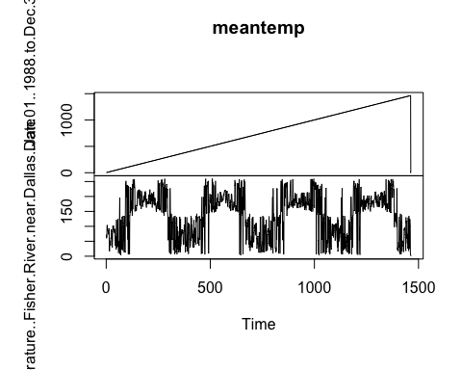

clearwater=read.csv("clearwater-river-at-kamiah-idaho.csv", header=T)  
plot.ts(clearwater)

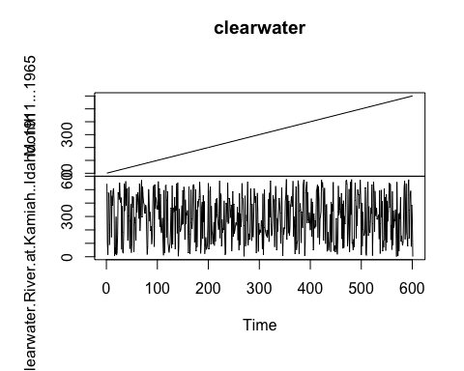

## Question 6:

Part (i):

library(simts)  
n=1000  
phi=(-.85)  
sigma2=1  
Xt = gen_gts(n, AR1(phi = phi, sigma2 = sigma2))  
plot(Xt)

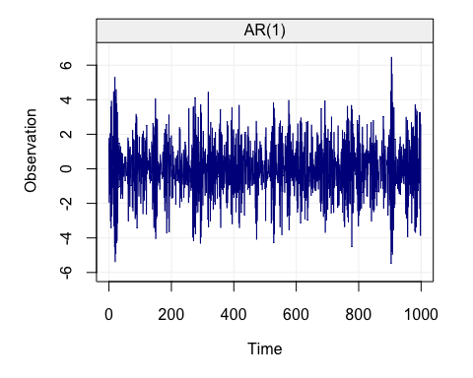

Part (ii):

n=1000  
sigma2=2  
theta=0.9  
Yt=gen_gts(n, MA1(theta = theta, sigma2 = sigma2))  
plot(Yt)

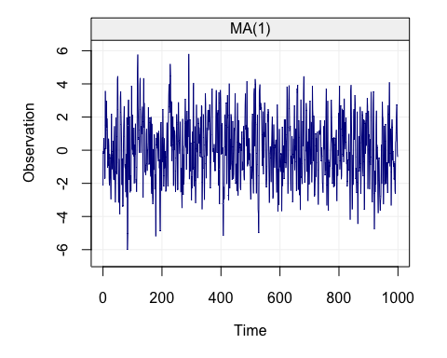

Part (iii):

n = 1000   
delta = 0.1   
sigma2 = 1   
model = WN(sigma2 = sigma2) + DR(omega = delta)  
At = gen_lts(n = n, model = model)  
plot(At)

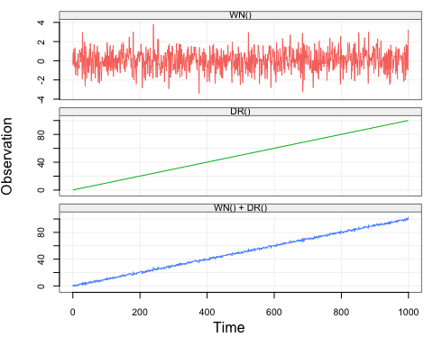

Part (iv):

n = 1000   
gamma2 = 1   
Bt = gen_gts(n, RW(gamma2 = gamma2))  
plot(Bt)

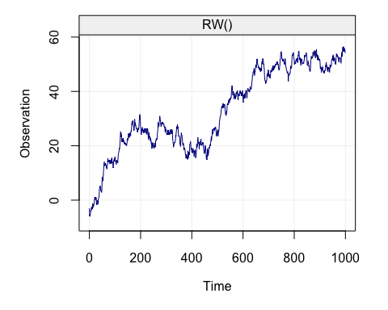

## Question 9:

library(quantmod)

## Warning: package 'quantmod' was built under R version 3.4.4

## Loading required package: xts

## Loading required package: zoo

## Warning: package 'zoo' was built under R version 3.4.4

##   
## Attaching package: 'zoo'

## The following objects are masked from 'package:base':  
##   
## as.Date, as.Date.numeric

## Loading required package: TTR

## Version 0.4-0 included new data defaults. See ?getSymbols.

getSymbols("MSFT", from = '2017-09-01')

## 'getSymbols' currently uses auto.assign=TRUE by default, but will  
## use auto.assign=FALSE in 0.5-0. You will still be able to use  
## 'loadSymbols' to automatically load data. getOption("getSymbols.env")  
## and getOption("getSymbols.auto.assign") will still be checked for  
## alternate defaults.  
##   
## This message is shown once per session and may be disabled by setting   
## options("getSymbols.warning4.0"=FALSE). See ?getSymbols for details.

##   
## WARNING: There have been significant changes to Yahoo Finance data.  
## Please see the Warning section of '?getSymbols.yahoo' for details.  
##   
## This message is shown once per session and may be disabled by setting  
## options("getSymbols.yahoo.warning"=FALSE).

## [1] "MSFT"

msft = MSFT[, "MSFT.Close"]  
plot.ts(msft)

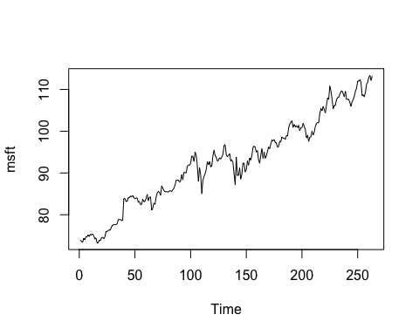

## Question 10:

library(simts)  
  
N = 1000  
mu = 0.5  
phi = 0.25  
sigma2 = 1.5  
  
model = AR1(phi = phi, sigma2 = sigma2)  
  
set.seed(123)  
Xt = mu + gen_gts(N, model)  
  
head(Xt)

## Observed  
## [1,] 0.2180913  
## [2,] 2.3385428  
## [3,] 1.0459905  
## [4,] 0.7948421  
## [5,] 2.6742276  
## [6,] 1.6080617