Problem Statement

1. Write a Python program to find those numbers which are divisible by 7 and multiple of 5, between 1500 and 2700 (both included)
2. Write a Python program to convert temperatures to and from celsius, fahrenheit.
3. Write a Python program to construct the following pattern, using a nested for loop.

\*

\* \*

\* \* \*

\* \* \* \*

\* \* \* \* \*

\* \* \* \*

\* \* \*

\* \*

\*

4. Write a Python program to get the Fibonacci series between 0 to 50

5. Write a Python program to check the validity of password input by users. Validation :

* At least 1 letter between [a-z] and 1 letter between [A-Z].
* At least 1 number between [0-9].
* At least 1 character from [$#@].
* Minimum length 6 characters.
* Maximum length 16 characters.

6.Write a Python program to print alphabet pattern 'A'.

Expected Output:

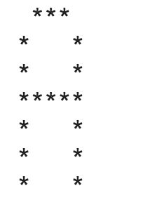

7. Write a Python program to print alphabet pattern 'D'.

Expected Output: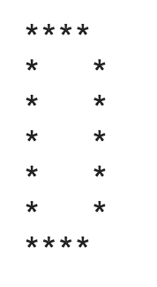

8. Write a Python program to print alphabet pattern 'E'.

Expected Output: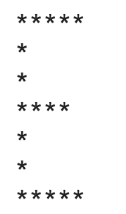

9. Write a Python program to print alphabet pattern 'G'.

Expected Output: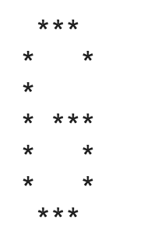

10. Write a Python program to print alphabet pattern 'L'.

Expected Output: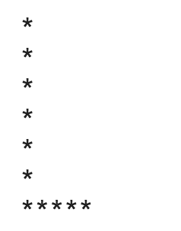

11. Write a Python program to print alphabet pattern 'M'.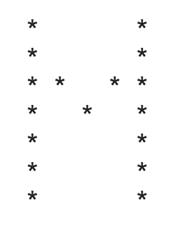

12. Write a Python program to calculate a dog's age in dog's years.

Note: For the first two years, a dog year is equal to 10.5 human years. After that, each dog year equals 4 human years.

Input a dog's age in human years: 15

The dog's age in dog's years is 73

Click me to see the sample solution

13. Write a Python program to check whether an alphabet is a vowel or consonant.

Expected Output:

Input a letter of the alphabet:

k is a consonant.

14. Write a Python program to get next day of a given date.

*Expected Output:*

Input a year: 2016   
Input a month [1-12]: 08   
Input a day [1-31]: 23   
The next date is [yyyy-mm-dd] 2016-8-24

15. Write a program to solve a classic ancient Chinese puzzle:

We count 35 heads and 94 legs among the chickens and rabbits in a farm. How many rabbits and how many chickens do we have?

16. Please write a program which prints all permutations of [1,2,3]

17.Please write a program which accepts a string from console and print the characters that have even indexes.

Example:

If the following string is given as input to the program:

H1e2l3l4o5w6o7r8l9d

Then, the output of the program should be:

Helloworld

18.Please write a program which accepts a string from console and print it in reverse order.

Example:

If the following string is given as input to the program:

rise to vote sir

Then, the output of the program should be:

ris etov ot esir

19. Please write a program which count and print the numbers of each character in a string input by console.

Example:

If the following string is given as input to the program:

abcdefgabc

Then, the output of the program should be:

a,2

c,2

b,2

e,1

d,1

g,1

f,1

20. Define a class Person and its two child classes: Male and Female. All classes have a method "getGender" which can print "Male" for Male class and "Female" for Female class.

21.With a given list [12,24,35,24,88,120,155,88,120,155], write a program to print this list after removing all duplicate values with original order reserved.

22.By using list comprehension, please write a program to print the list after removing the v0th, 2nd, 4th,6th numbers in [12,24,35,70,88,120,155].

23.Please write a binary search function which searches an item in a sorted list. The function should return the index of element to be searched in the list.

24.Write a program which accepts a sequence of words separated by whitespace as input to print the words composed of digits only.

Example:

If the following words is given as input to the program:

2 cats and 3 dogs.

Then, the output of the program should be:

['2', '3']

In case of input data being supplied to the question, it should be assumed to be a console input.

25.Assuming that we have some email addresses in the "username@companyname.com" format, please write program to print the company name of a given email address. Both user names and company names are composed of letters only.

Example:

If the following email address is given as input to the program:

john@google.com

Then, the output of the program should be:

google

26..Define a custom exception class which takes a string message as attribute

27.Write a program to generate and print another tuple whose values are even numbers in the given tuple (1,2,3,4,5,6,7,8,9,10).

28. A website requires the users to input username and password to register. Write a program to check the validity of password input by users.

Following are the criteria for checking the password:

1. At least 1 letter between [a-z]

2. At least 1 number between [0-9]

1. At least 1 letter between [A-Z]

3. At least 1 character from [$#@]

4. Minimum length of transaction password: 6

5. Maximum length of transaction password: 12

Your program should accept a sequence of comma separated passwords and will check them according to the above criteria. Passwords that match the criteria are to be printed, each separated by a comma.

Example

If the following passwords are given as input to the program:

ABd1234@1,a F1#,2w3E\*,2We3345

Then, the output of the program should be:

ABd1234@1

29.Write a program that computes the net amount of a bank account based a transaction log from console input. The transaction log format is shown as following:

D 100

W 200

D means deposit while W means withdrawal.

Suppose the following input is supplied to the program:

D 300

D 300

W 200

D 100

Then, the output should be:

500