Creating the Project

Use https://start.spring.io/ and fill in details as below to generate maven project

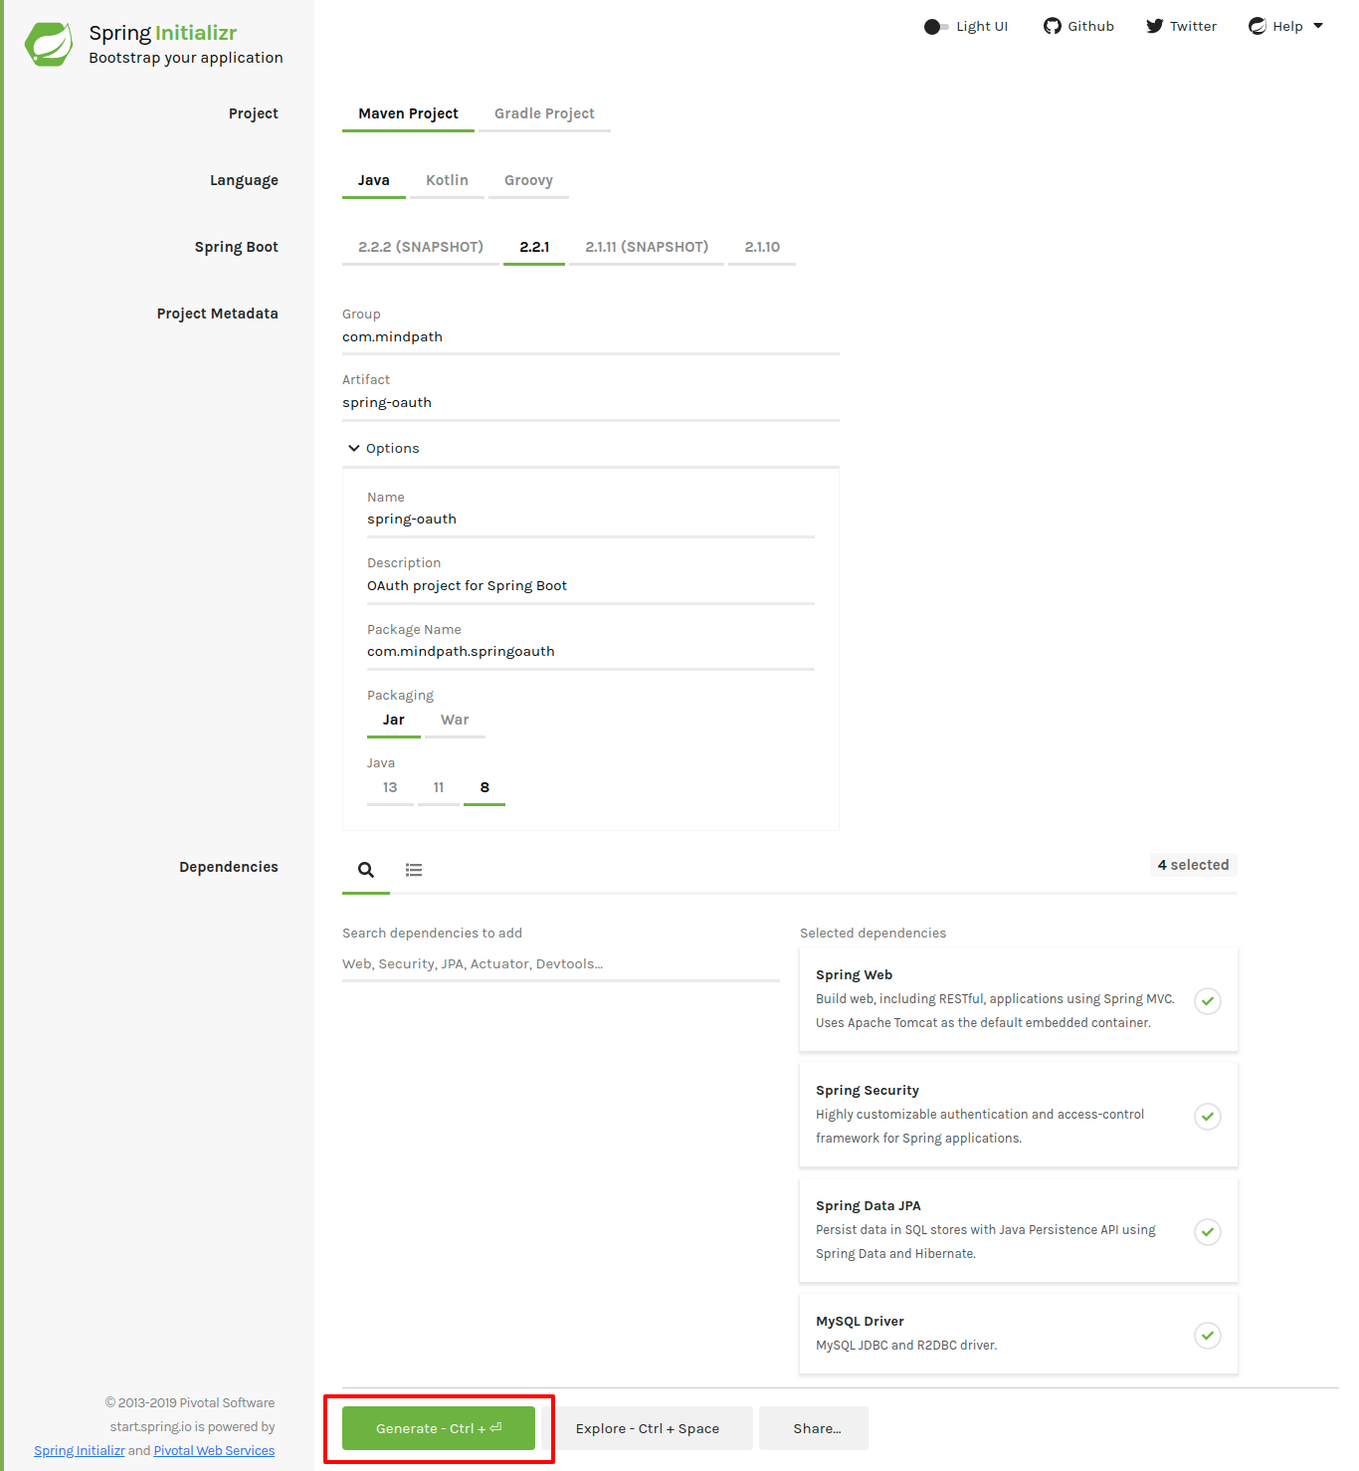

Additional dependencies

Put these dependencies in your pom.xml file at root of your project:

<!-- OAuth2 Client -->
<dependency>
<groupId>org.springframework.security</groupId>
<artifactId>spring-security-oauth2-client</artifactId>
</dependency>

<!-- JWT library -->
<dependency>
<groupId>io.jsonwebtoken</groupId>
<artifactId>jjwt</artifactId>
<version>0.5.1</version>
</dependency>

Creating OAuth2 apps for social login[Google/Facebook/Linked]
To enable social login with an OAuth2 provider, you’ll need to create an app in the OAuth2 provider’s console and get the ClientId and ClientSecret, sometimes also called an AppId and AppSecret.
OAuth2 providers use the ClientId and ClientSecret to identify your app. The providers also ask for many other settings that include -
Authorized redirect URIs: These are the valid list of redirect URIs where a user can be redirected after they grant/reject permission to your app. This should point to your app endpoint that will handle the redirect.
Scope: Scopes are used to ask users for permission to access their data.
Creating Facebook, Linkedin, and Google Apps
Facebook App: We can create a facebook app from the Facebook apps dashboard
Linkedin App: Linkedin apps can be created from the Linkedin apps dashboard
Google Project: Head over to Google Developer Console to create a Google Project and the credentials for OAuth2.

Configuring the Spring Boot application:

Spring boot reads configurations fromsrc/main/resource/application.propertiesfile by default. It also supports.yamlconfigurations. In this project, we’ll use yaml configurations because they represent hierarchical data more clearly.

Rename application.properties filetoapplication.yamland add the following configurations -

spring:
datasource:
url: jdbc:mysql://localhost:3306/spring_oauth?useSSL=false
username: root
password: mindpath

jpa:
show-sql: true
hibernate:
ddl-auto: update
naming-strategy: org.hibernate.cfg.ImprovedNamingStrategy
properties:
hibernate:
dialect: org.hibernate.dialect.MySQL5InnoDBDialect
security:
oauth2:
client:
registration:
google:
clientId: 5014057553-8gm9um6vnli3cle5rgigcdjpdrid14m9.apps.googleusercontent.com
clientSecret: tWZKVLxaD_ARWsriiiUFYoIk
redirectUriTemplate: "{baseUrl}/oauth2/callback/{registrationId}"
scope:
- email
- profile
- openid
app:
auth:
tokenSecret: 926D96C90030DD58429D2751AC1BDBBC
tokenExpirationMsec: 864000000
oauth2:
# After successfully authenticating with the OAuth2 Provider,
# we'll be generating an auth token for the user and sending the token to the
# redirectUri mentioned by the frontend client in the /oauth2/authorize request.
# We're not using cookies because they won't work well in mobile clients.
authorizedRedirectUris:
- http://localhost:3000/oauth2/redirect
- myandroidapp://oauth2/redirect
- myiosapp://oauth2/redirect

The datasource configurations are used to connect to the MySQL database. Please create a database namedspring_oauthand specify correct values forspring.datasource.usernameandspring.datasource.passwordas per your MySQL installation.
Thesecurity.oauth2configurations define all the oauth2 providers and their details. Theapp.authconfigurations are used to generate a JWT authentication token once the user is successfully logged in.

Binding AppProperties
Let’s bind all the configurations prefixed withappto a POJO class using Spring Boot’s@ConfigurationPropertiesfeature- “@ConfigurationPropertiesbind external configurations to a strongly typed bean in your application code.”

Please refer com.mindpath.springoauth.config.AppProperties.java file in GitLab.

Enabling AppProperties
We’ll need to enable configuration properties by adding the@EnableConfigurationPropertiesannotation. Please open the main application classSpringSocialApplication.javaand add the annotation like so
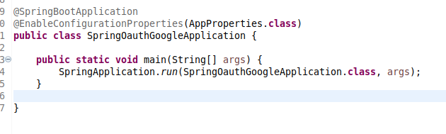

Enabling CORS
Let’s enable CORS so that our frontend client can access the APIs from a different origin. We’ve enabled all origins in the following configuration. But you should make it more strict in a production application -
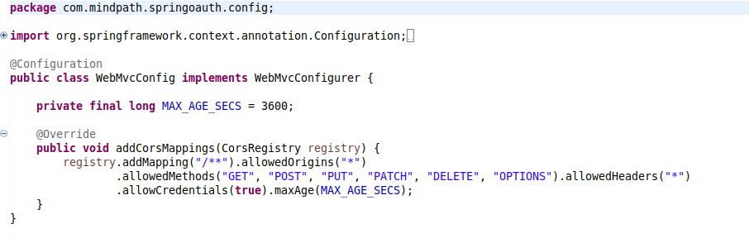

Creating the database entities
Let’s now create the Entity classes of our application. Following is the definition of the User class -
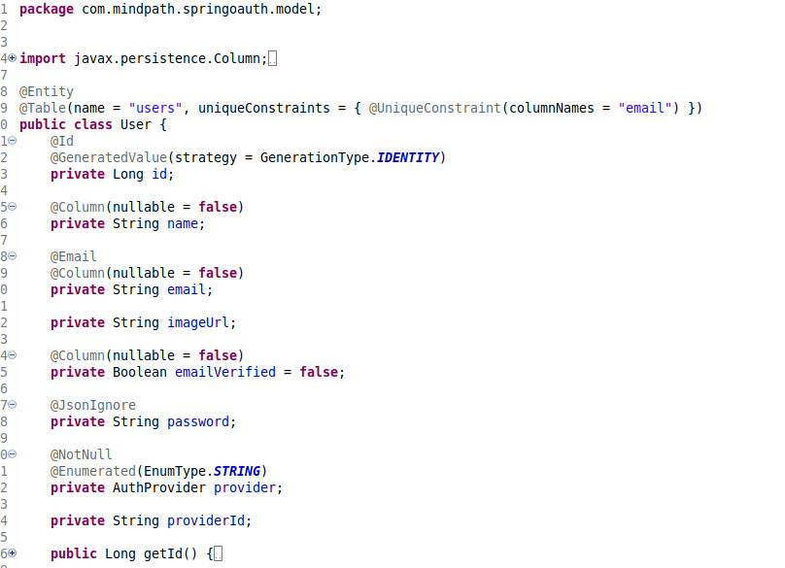
The User class contains information about the authentication provider. Following is the definition of the AuthProvider enum -
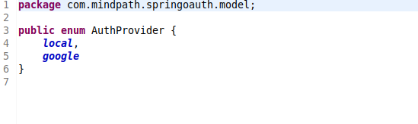

Creating the repositories for accessing data from the database
Let’s create the repository layer for accessing data from the database. The following UserRepository interface provides database functionalities for the User entity. Thanks to Spring-Data-JPA, we don’t need to write much code here -

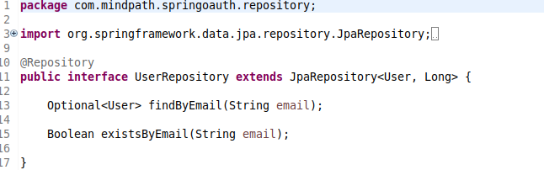

SecurityConfig
The following SecurityConfig class is the crux of our security implementation. It contains configurations for both OAuth2 social login as well as email and password based login.
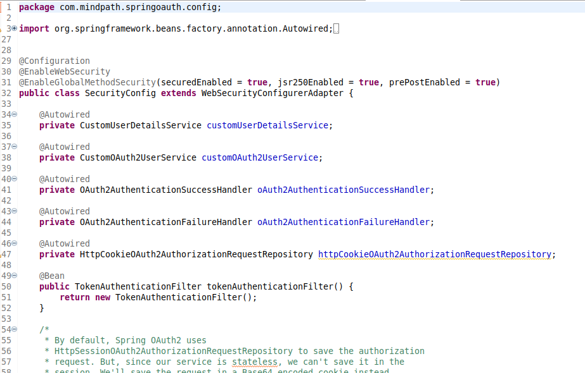
The above class basically ties up different components together to create an application-wide security policy

OAuth2 Login Flow

- The OAuth2 login flow will be initiated by the frontend client by sending the user to the endpointhttp://localhost:8080/oauth2/authorize/{provider}?redirect_uri=<redirect_uri_after_login>.
The provider path parameter is one of google, facebook, or linkedin. The redirect_uri is the URI to which the user will be redirected once the authentication with the OAuth2 provider is successful. This is different from the OAuth2 redirectUri.
- On receiving the authorization request, Spring Security’s OAuth2 client will redirect the user to the AuthorizationUrl of the supplied provider.
All the state related to the authorization request is saved using the authorizationRequestRepository specified in the SecurityConfig.
The user now allows/denies permission to your app on the provider’s page. If the user allows permission to the app, the provider will redirect the user to the callback url http://localhost:8080/oauth2/callback/{provider}with an authorization code. If the user denies the permission, he will be redirected to the same callbackUrl but with an error.
- If the OAuth2 callback results in an error, Spring security will invoke the oAuth2AuthenticationFailureHandler specified in the above SecurityConfig.
- If the OAuth2 callback is successful and it contains the authorization code, Spring Security will exchange the authorization_code for an access_token and invoke the customOAuth2UserService specified in the above SecurityConfig.
- The customOAuth2UserService retrieves the details of the authenticated user and creates a new entry in the database or updates the existing entry with the same email.
- Finally, the oAuth2AuthenticationSuccessHandler is invoked. It creates a JWT authentication token for the user and sends the user to the redirect_uri along with the JWT token in a query string.

Custom classes for OAuth2 Authentication

HttpCookieOAuth2AuthorizationRequestRepository

The OAuth2 protocol recommends using a state parameter to prevent CSRF attacks. During authentication, the application sends this parameter in the authorization request, and the OAuth2 provider returns this parameter unchanged in the OAuth2 callback.
The application compares the value of the state parameter returned from the OAuth2 provider with the value that it had sent initially. If they don’t match then it denies the authentication request.
To achieve this flow, the application needs to store the state parameter somewhere so that it can later compare it with the state returned from the OAuth2 provider.
We’ll be storing the state as well as the redirect_uri in a short-lived cookie. The following class provides functionality for storing the authorization request in cookies and retrieving it.
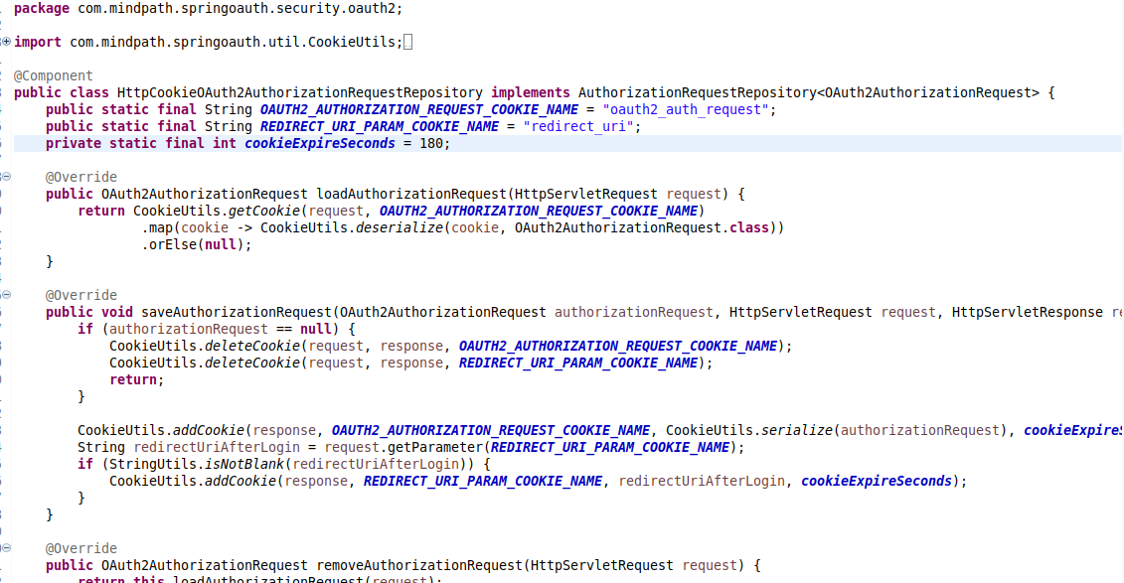

CustomOAuth2UserService
The CustomOAuth2UserService extends Spring Security’s DefaultOAuth2UserService and implements its loadUser() method. This method is called after an access token is obtained from the OAuth2 provider.
In this method, we first fetch the user’s details from the OAuth2 provider. If a user with the same email already exists in our database then we update his details, otherwise, we register a new user.
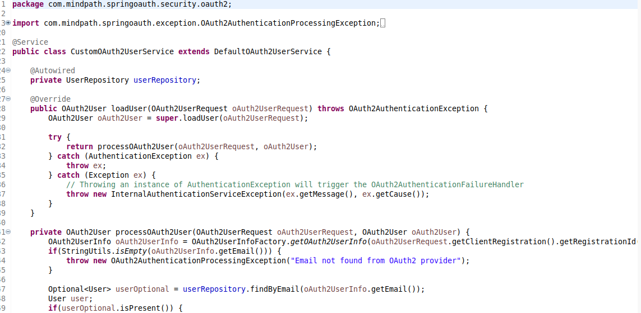

OAuth2UserInfo mapping
Every OAuth2 provider returns a different JSON response when we fetch the authenticated user’s details. Spring security parses the response in the form of a generic map of key-value pairs.
The following classes are used to get the required details of the user from the generic map of key-value pairs -
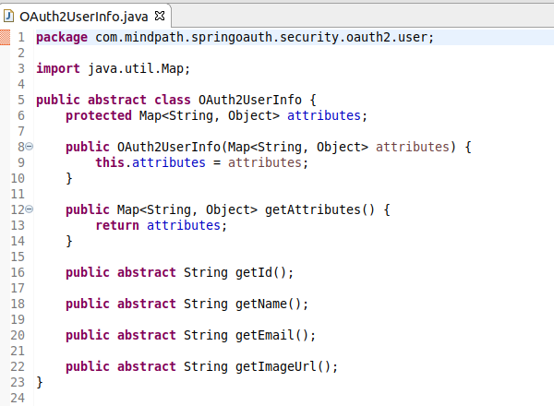

GoogleOAuth2UserInfo
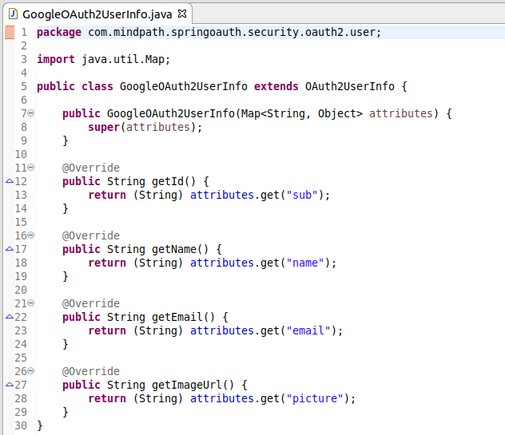

OAuth2UserInfoFactory
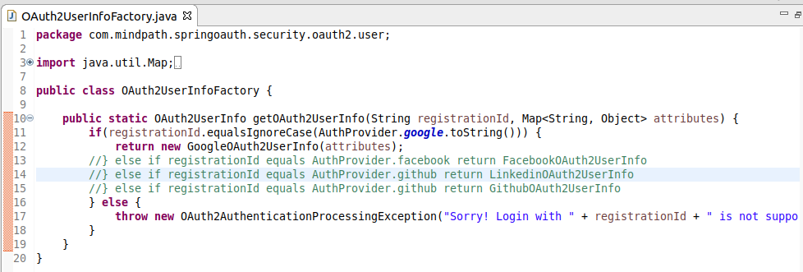

OAuth2AuthenticationSuccessHandler
On successful authentication, Spring security invokes theonAuthenticationSuccess()method of theOAuth2AuthenticationSuccessHandlerconfigured inSecurityConfig.
In this method, we perform some validations, create a JWT authentication token, and redirect the user to theredirect_urispecified by the client with the JWT token added in the query string -

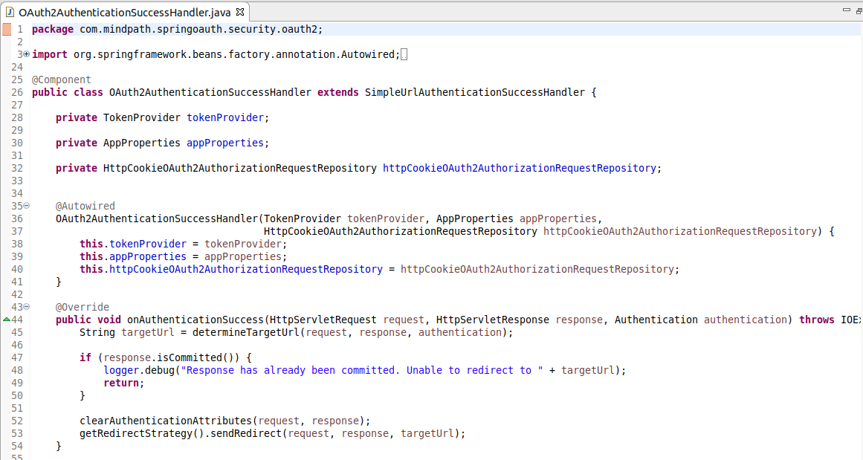

OAuth2AuthenticationFailureHandler
In case of any error during OAuth2 authentication, Spring Security invokes theonAuthenticationFailure()method of theOAuth2AuthenticationFailureHandlerthat we have configured inSecurityConfig.
It sends the user to the frontend client with an error message added to the query string -
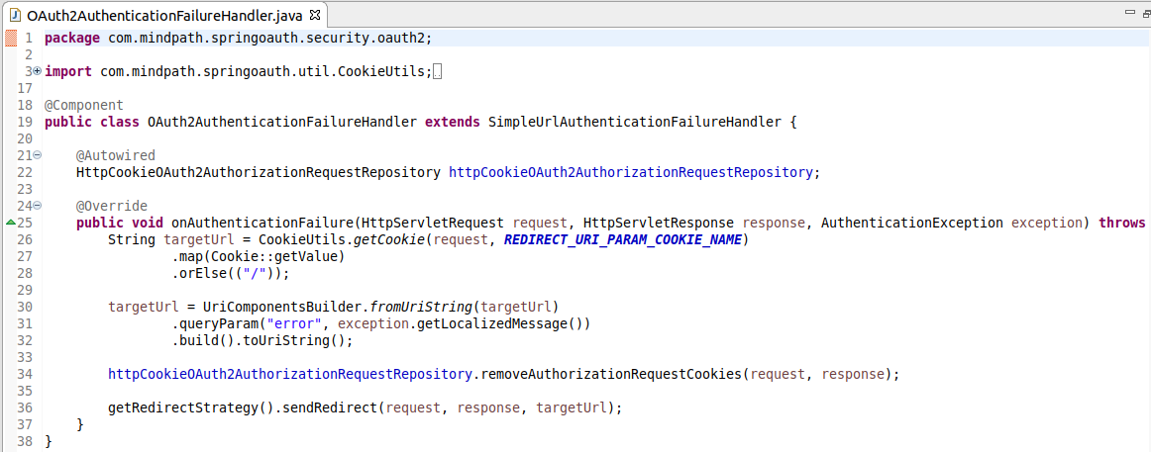

Controllers and Services for Email based authentication

AuthController
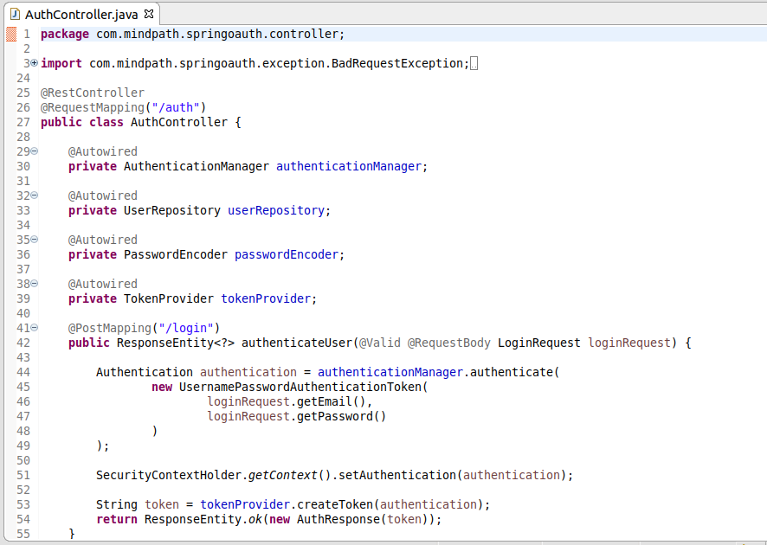

CustomUserDetailsService

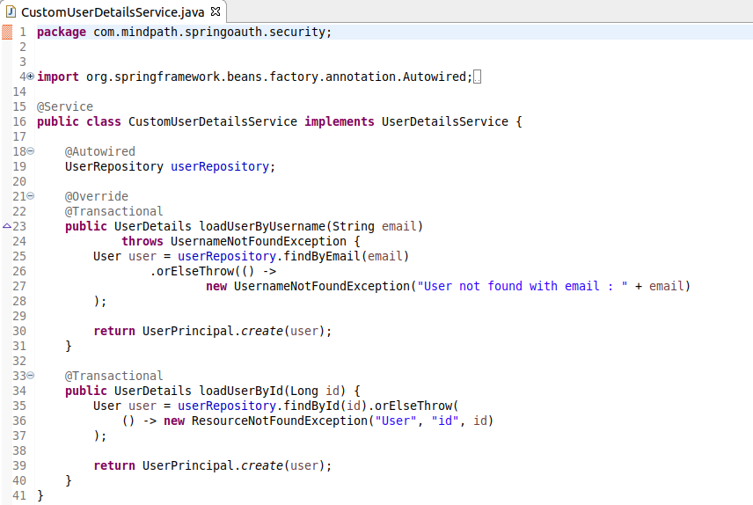

JWT Token provider, Authentication Filter, Authentication error handler, and UserPrincipal

TokenProvider
This class contains code to generate and verify Json Web Tokens -

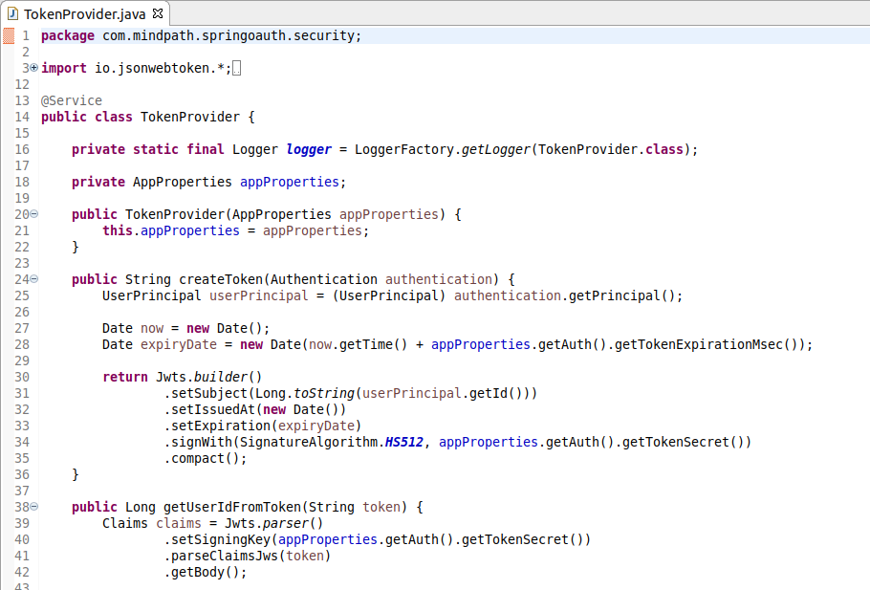
TokenAuthenticationFilter
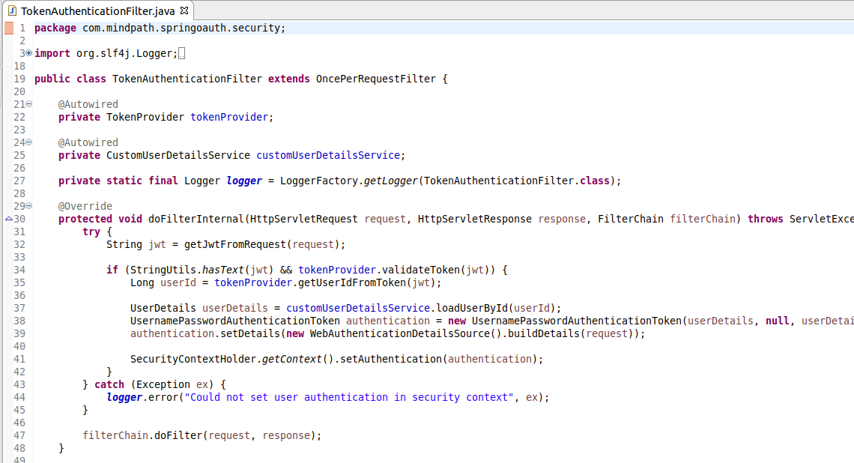

RestAuthenticationEntryPoint
This class is invoked when a user tries to access a protected resource without authentication. In this case, we simply return a 401 Unauthorized response -
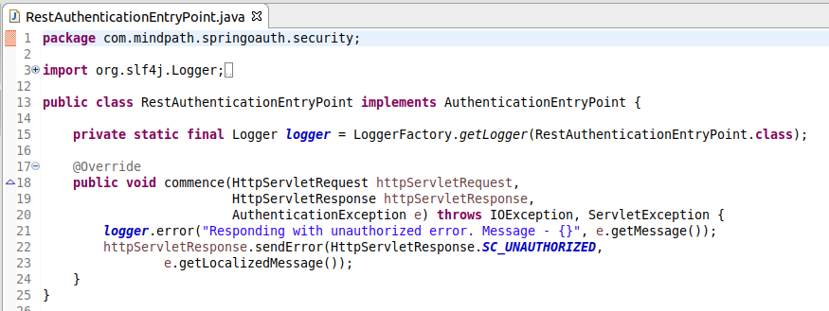

UserPrincipal
The UserPrincipal class represents an authenticated Spring Security principal. It contains the details of the authenticated user -
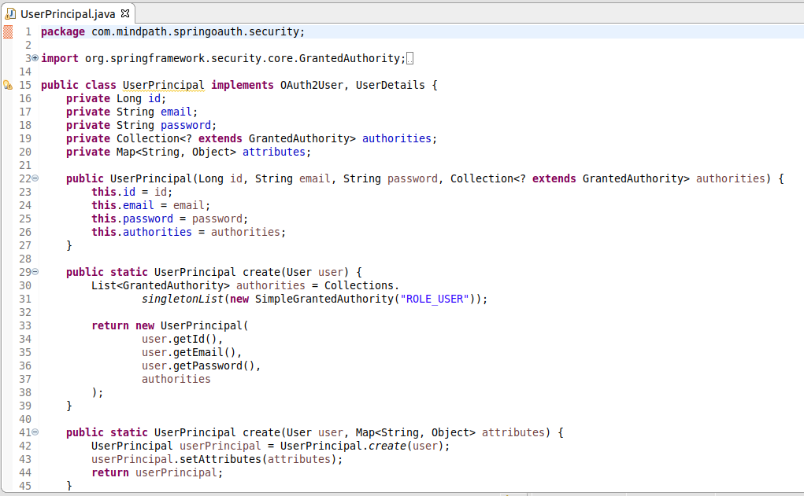

CurrentUser meta annotation
This is a meta-annotation that can be used to inject the currently authenticated user principal in the controllers -
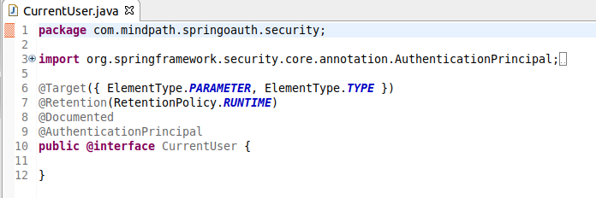

UserController - User APIs
TheUserControllerclass contains a protected API to get the details of the currently authenticated user -
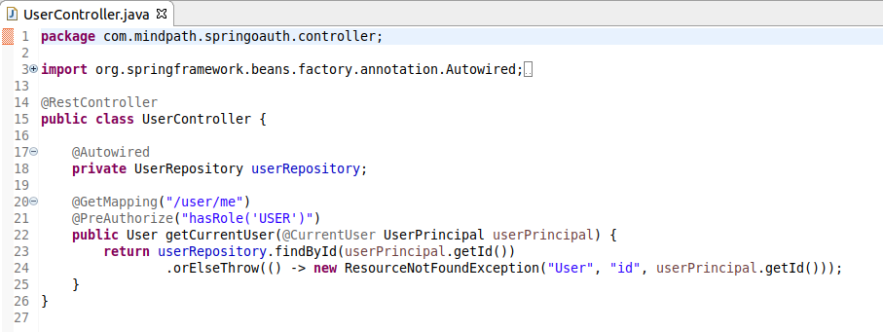

Utility classes
The project uses some utility classes to perform various tasks -

CookieUtils
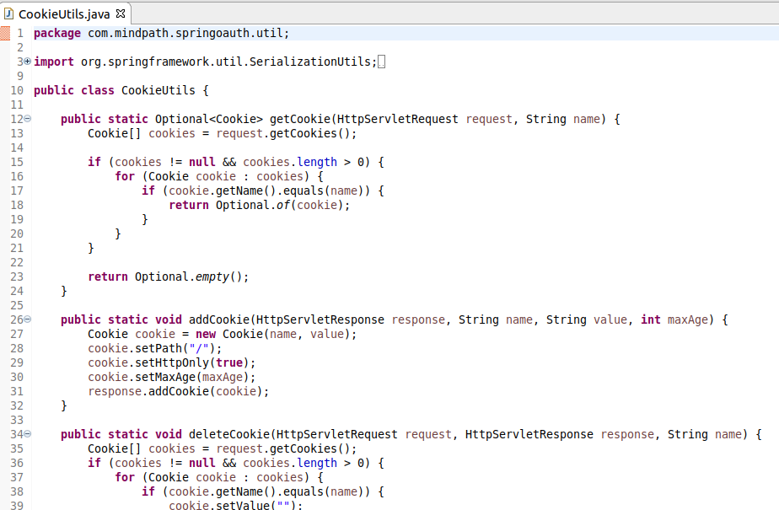

Request/Response Payloads
The following request/response payloads are used in our controller APIs -

LoginRequest
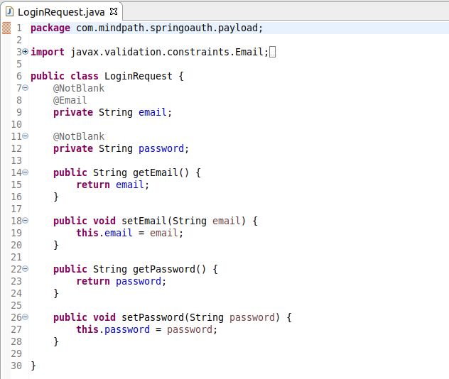

SignUpRequest
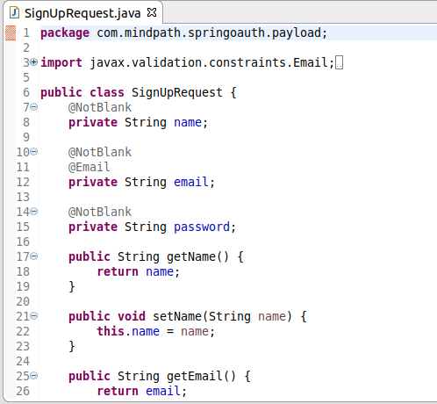

AuthResponse
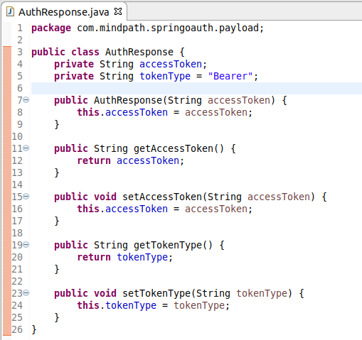

ApiResponse
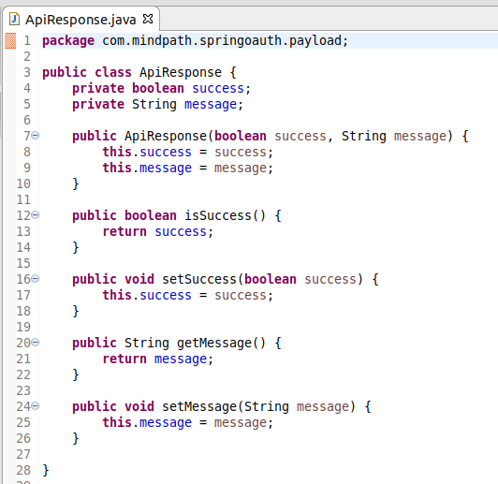

Exception Classes

The following exception classes are used throughout the application for various error cases -

BadRequestException
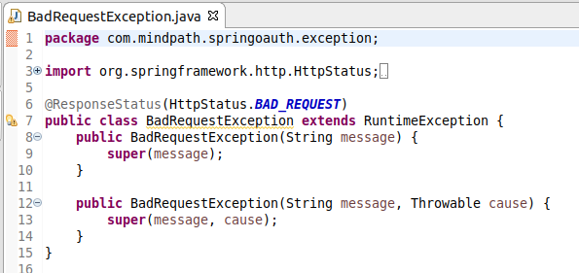

ResourceNotFoundException
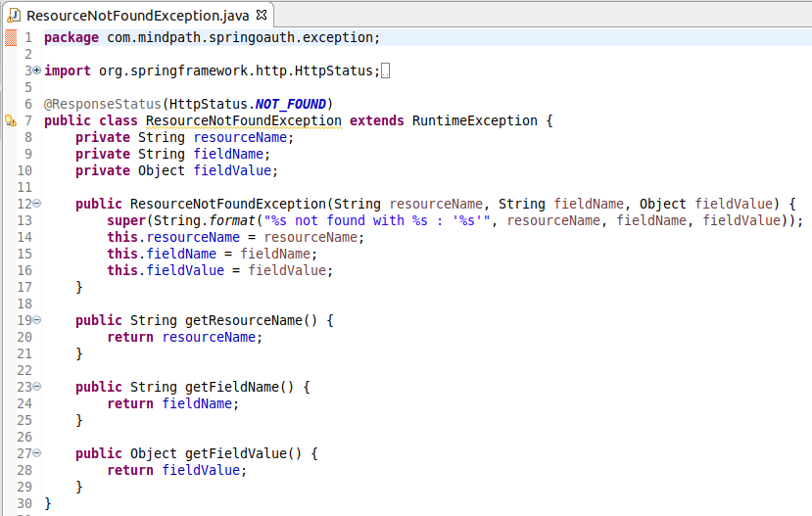

OAuth2AuthenticationProcessingException
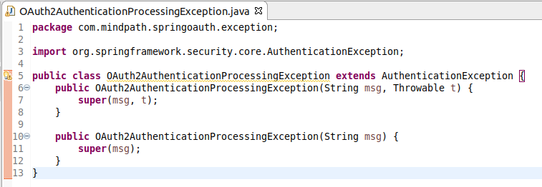

References
Spring Security OAuth2 Login

