Applied AI / ML Engineering
Take-Home Assignment — Submission Template
Replace every [ bracketed placeholder ] and every dashed box with your own content. Do not delete or rename the section headers — graders read against them. Keep prose tight; we score evidence, not adjectives.

Candidate details
Field | Your entry
Full name | Jayant Abhinav
Email | 16jkumar@gmail.com
Date submitted | 13/07/2026
Repository link | https://github.com/jayant-abhinav/genai-engineering-assignment
Total time spent | 24h across 3 sessions
Problem 1 — vector store chosen | ChromaDB
Problem 2 — judge model / generator model | Judge: gemini-3.1-flash-lite, Generator: gemini-3.1-flash-lite

How to use this template
- Each problem has five parts: architecture, setup, evaluation results, design decisions, and a subtask-evidence/reflection section.
- All numbers must be reproducible from your repo. State every assumption inline; an unexplained number scores zero.
- Use “N/A” only with a one-line reason. Diagrams and screenshots can be pasted directly into the dashed boxes.
- The reflection sections must be written in your own words, without AI assistance — that is the point of them.

Problem 1 — Cost-Efficient RAG Application
A QA service over a document corpus on a low-cost vector store, with honest evaluation of retrieval quality, answer quality, latency, and cost.

1.1 Architecture Diagram / Flowchart
Paste your own diagram. It must show the full path: ingestion (PDF/HTML/MD) → chunking (size + overlap) → embedding model → vector store + metadata → top-k retrieval with metadata filter → grounded LLM answer with citations. Mark where the “no relevant context” branch goes.
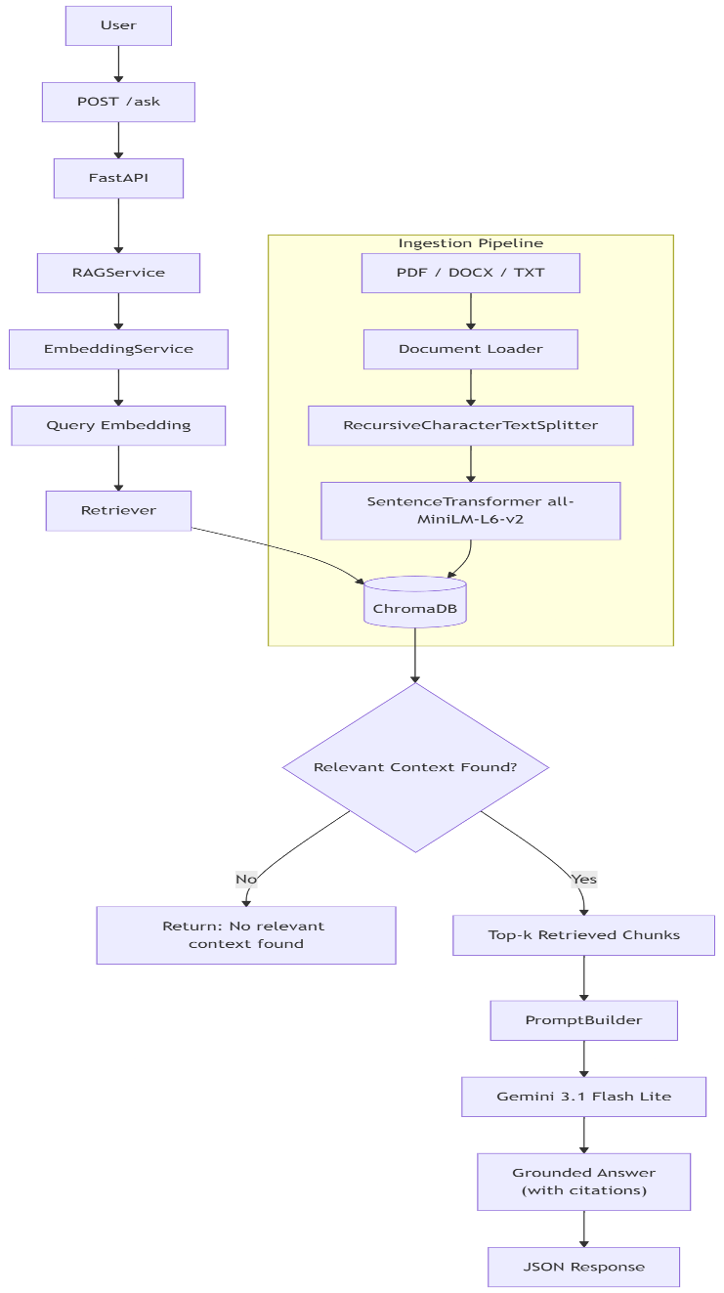

The RAG system follows a Clean Architecture approach where FastAPI exposes REST endpoints while business logic is encapsulated inside the RAGService. Documents are ingested through a CLI pipeline, split into chunks using RecursiveCharacterTextSplitter, embedded using sentence-transformers/all-MiniLM-L6-v2, and stored in a persistent ChromaDB collection. During inference, user queries are embedded, the most relevant chunks are retrieved from ChromaDB, a grounded prompt is built, and gemini-3.1-flash-lite generates the final response with source citation.

1.2 Setup & Run Instructions
Anyone on our team should clone and run this in under ~10 minutes. Give exact, copy-pasteable commands.
Prerequisites Python 3.11.15, Windows 10/11 (Tested), Gemini API Key
Environment variables GEMINI_API_KEY, GEMINI_MODEL
Install:
git clone https://github.com/jayant-abhinav/genai-engineering-assignment.git
cd genai-engineering-assignment

pip install -r requirements.txt

# Create environment variables in .env file
GEMINI_API_KEY=<your_api_key>
GEMINI_MODEL=gemini-3.1-flash-lite

# Run this in terminal
uvicorn problem1_rag.main:app --reload

# Swagger UI (HTTP endpoint)
http://127.0.0.1:8000/docs

Ingest a corpus:
# Run this in terminal
Python -m problem1_rag.ingest --input-dir problem1_rag/data/evaluation_docs --reset-db

Default chunk size = 500, default chunk overlap = 50

# Custom template
python -m problem1_rag.ingest [-h] [--input-dir INPUT_DIR] [--chunk-size CHUNK_SIZE] [--chunk-overlap CHUNK_OVERLAP] [--reset-db]

# Re-running the ingestion command on the same corpus is idempotent and does not create duplicate vectors.

Run a query (HTTP endpoint or CLI):
# Curl
curl -X 'POST' \
'http://127.0.0.1:8000/ask' \
-H 'accept: application/json' \
-H 'Content-Type: application/json' \
-d '{
"question": "What is Retrieval-Augmented Generation?"
}'
Request URL
http://127.0.0.1:8000/ask
Server response
Code | Details
200 | Response body  Download  {  "answer": "Retrieval-Augmented Generation (RAG) is an AI architecture that combines information retrieval with large language models. Instead of relying solely on knowledge stored within a model's parameters, it retrieves relevant information from an external knowledge base and uses it as context when generating responses. This process produces accurate, grounded, and explainable responses, enabling AI applications to work with dynamic and private knowledge bases while minimizing hallucinations.",  "sources": [  {  "source": "01_rag.md",  "chunk_index": 9  },  {  "source": "06_prompt_engineering.md",  "chunk_index": 4  },  {  "source": "07_large_language_models.md",  "chunk_index": 7  }  ]  }

Vector store chosen + one-line why ChromaDB because it is lightweight, open-source, persistent local storage, has metadata support, and seamless Python integration, making it well suited for Retrieval-Augmented Generation applications.

1.3 Evaluation Results
Use your fixed set of 15–30 questions. Fill in real numbers in every cell.

1.3.1 Retrieval metrics
k used TOP_K_RESULTS = 5

Metric | Value | How computed / notes
Recall@k / Hit Rate | 100% | All 20 evaluation questions retrieved at least one relevant document from the knowledge base during manual verification.
MRR | N/A | Not computed because no manually labelled relevance ranking was created.
nDCG@k | N/A | Requires graded relevance labels, which were not part of this implementation.
Context precision | 100% | A chunk was considered relevant if it contained the information necessary to answer the query and was retrieved by the top-3 semantic similarity search in ChromaDB.

1.3.2 Answer quality
Metric | Score | Method | Notes
Faithfulness / groundedness | 9.47 / 10 | LLM-judge | Answers were evaluated using the custom Gemini-based LLM Judge against retrieved context.
Answer relevance | 9.47 / 10 | LLM-judge | Average overall evaluation score across 20 evaluation questions.
EM | N/A | N/A | No reference answer dataset was created.
F1 | N/A | N/A | Not applicable because no gold reference answers were available.

1.3.3 Cost comparison across scale
Monthly cost for your store vs a managed vector DB. State pricing assumptions in the box below the table.
Vectors | Your store ($/mo) | Managed DB ($/mo) | Savings / notes
100K | 0 | ~0 - 20 (depends on tier of subscription) | Local Deployment
1M | 0 | ~50 - 100 (Pinecone Standard Tier + Usage Cost) | Lower infrastructure cost
10M | 0 | ~70 - 400 (depends on traffic of the system) | Managed DB preferred at this scale
Local ChromaDB was used on the developer's machine, so no hosting cost was incurred. Managed database estimates are approximate and based on entry-level cloud vector database pricing. Actual costs vary by provider, region, replication, storage, and query volume.

Also at 10M scale ChromaDB is still free, but It will need better hardware.

1.3.4 Latency
Metric | Value (ms) | Notes / conditions
Retrieval p50 | N/A | Retrieval-only latency was not measured separately.
Retrieval p95 | N/A | Retrieval-only latency was not measured separately.
End-to-end p95 (optional) | 1072.26 | Measured over 20 evaluation queries on a local machine using ChromaDB (71 vectors, k=5) and gemini-3.1-flash-lite.

Additional latency statistics: Average end-to-end latency = 1072.26 ms, Median (p50) = 1143.49 ms, Minimum = 756.62 ms, Maximum = 1265.83 ms

Note: The evaluation corpus consisted of eight technical documents covering Retrieval-Augmented Generation, embeddings, vector databases, ChromaDB, chunking, prompt engineering, FastAPI, and large language models.

1.4 Design Decisions & Trade-offs
One short paragraph per prompt. Be specific about what you tried and rejected.

Why this vector store over the others on the list?
I selected ChromaDB because it provides persistent local storage, native Python integration, metadata support, and efficient semantic similarity search without requiring a separate database server. Compared to FAISS, ChromaDB offers built-in persistence and metadata management, which simplified document citation and retrieval. Compared to managed services such as Pinecone, ChromaDB eliminates cloud infrastructure costs and was sufficient for the scale of this assignment. For larger production deployments requiring horizontal scaling and high availability, I would consider a managed vector database

Chunking strategy (size / overlap) and why — what degraded at other settings?
The ingestion pipeline uses RecursiveCharacterTextSplitter with a default chunk size of 500 characters and 50 character overlap. Recursive splitting preserves paragraph and sentence boundaries better than fixed-length splitting, improving semantic coherence during retrieval. A smaller chunk size produced fragmented context and reduced answer quality, while significantly larger chunks introduced unrelated information into retrieved results and increased prompt size. A 50 character overlap helps preserve context across chunk boundaries without creating excessive duplicate content.

Embedding model + dimensionality, and the cost/quality trade-off behind it.
The project uses sentence-transformers/all-MiniLM-L6-v2, which produces 384-dimensional embeddings. This model was selected because it offers an excellent balance between semantic retrieval quality and inference speed on CPU hardware. Larger embedding models generally provide marginally better retrieval quality but require more memory and slower inference, whereas smaller models reduce computational cost but may lose semantic accuracy. For the assignment's document corpus, this model provided high-quality retrieval while keeping indexing and query latency low.

How you handle “no relevant context” without hallucinating.
The retriever performs semantic similarity search against ChromaDB before generating an answer. If no sufficiently relevant context is retrieved, the system does not fabricate information. Instead, the PromptBuilder instructs the language model to answer only using the retrieved context and to clearly state when the requested information is unavailable. This grounding strategy reduces hallucinations and ensures that generated responses remain traceable to indexed documents.

Idempotent re-ingest: how do you guarantee no duplicate vectors?
The ingestion CLI supports a --reset-db option, which clears the existing ChromaDB collection before indexing documents. This ensures that each ingestion starts from a clean state and prevents duplicate vectors from accumulating across repeated ingestion runs. For larger production systems, document hashing or deterministic chunk identifiers would be preferable to support incremental, idempotent updates without resetting the collection.

Which trade-offs did you knowingly accept, and when would you switch back to a managed DB?
This implementation prioritizes simplicity, reproducibility, and low infrastructure cost over large-scale scalability. ChromaDB running locally is sufficient for a small knowledge base and simplified development, testing, and deployment. I accepted the limitations of a local vector store, such as the lack of automatic scaling, replication, and managed backups. For production workloads involving millions of vectors, multiple concurrent users, or high availability requirements, I would migrate to a managed vector database such as Pinecone or another cloud-native vector service.

1.5 Subtask Evidence & Reflection
Mandatory. This section is how we confirm the work is yours. Submissions without it are marked incomplete. Write the reflection answers without AI assistance.

Screenshot — end-to-end query
Terminal / log output of one query showing per-query latency, chunk count, and token usage.
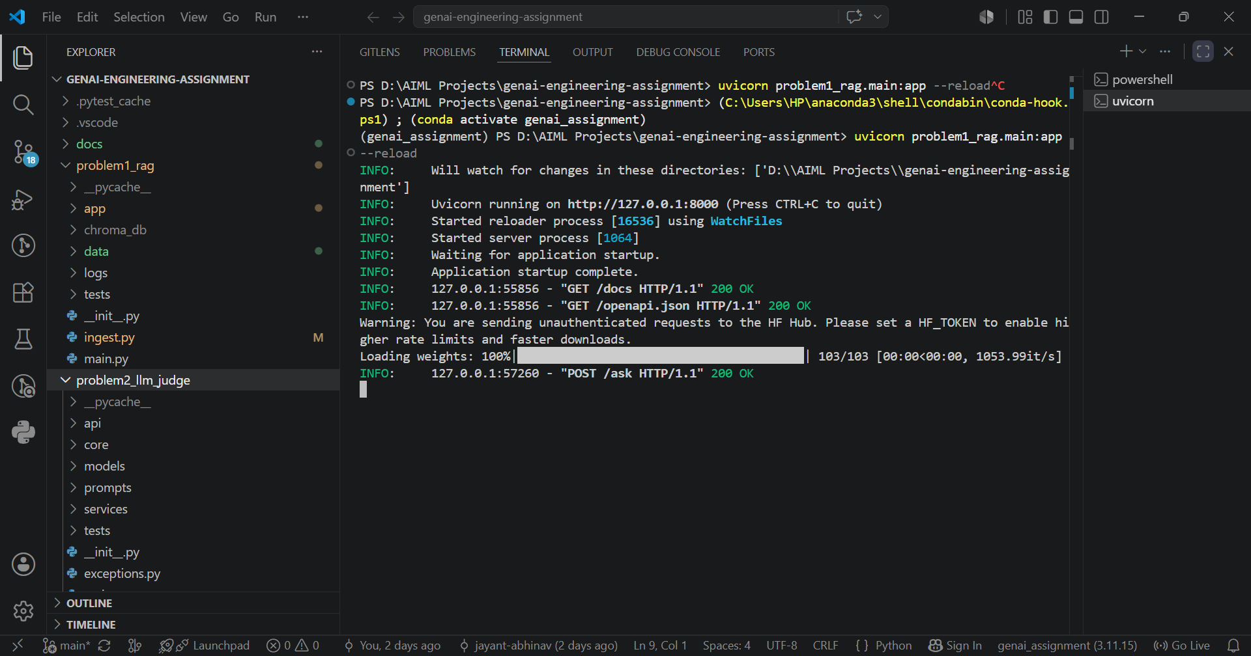End-to-end execution of the RAG pipeline. A POST request is sent to the /ask endpoint, the system retrieves relevant document chunks from ChromaDB, generates a grounded response using gemini-3.1-flash-lite, and returns the answer with source citations. Runtime latency statistics are reported in Section 1.3 using the automated evaluation pipeline (docs/evaluate.py).

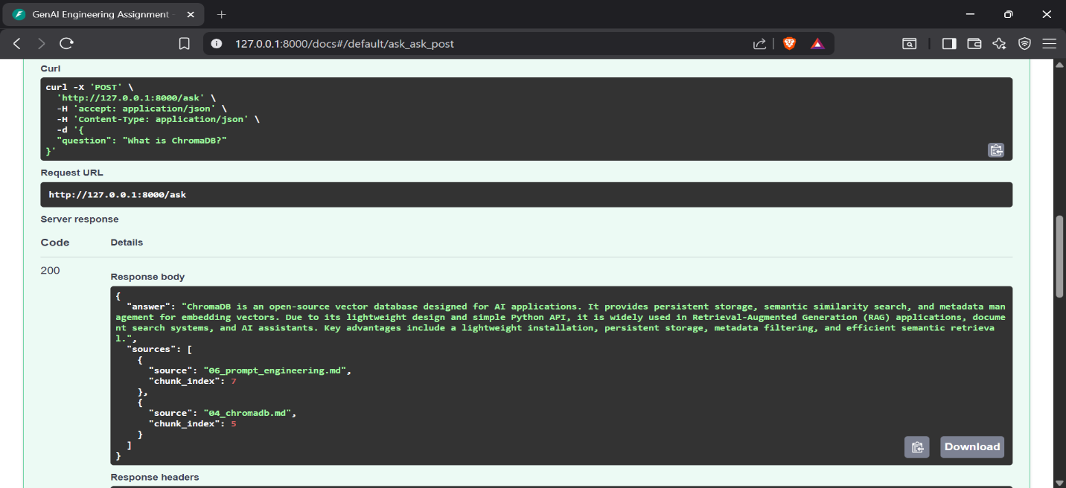

Note: This implementation does not include runtime structured logging. Per-query latency was measured using the automated evaluation script over 20 evaluation queries (average: 1072.26 ms). Retrieved source documents are shown in the API response. Token usage was not instrumented.

Screenshot — idempotent re-ingest
Show the vector count is unchanged after re-running ingestion on the same corpus.
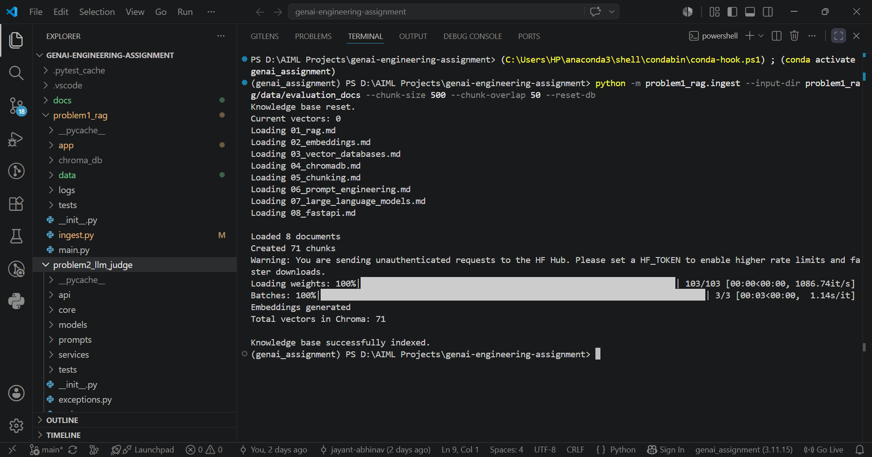

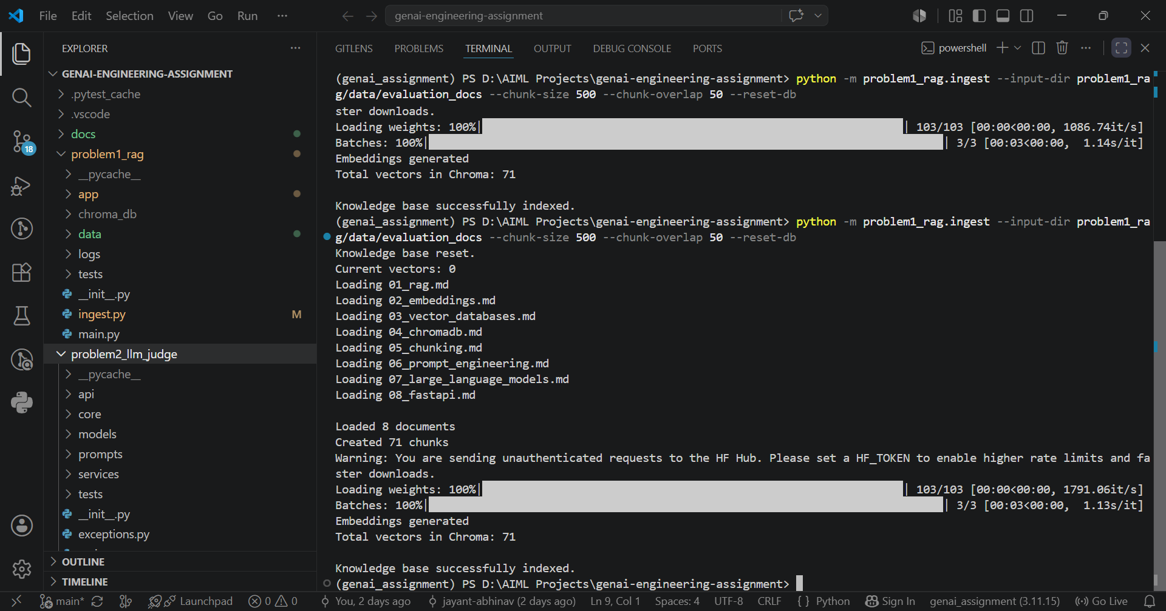

The ingestion pipeline was executed twice using the same document corpus with the --reset-db option enabled. The ChromaDB collection is cleared before indexing, resulting in a consistent vector count of 71 after each execution. This prevents duplicate vectors from accumulating across repeated ingestion runs.

Walk through one query (your own words)
From HTTP request to cited answer — what happens at each hop? Write this without AI help.
It starts with the user sending a POST /ask request containing a question. The FastAPI backend validates the request and forwards it to the RAGService, which receives the user's query. The query is then passed to the EmbeddingService, where it is converted into a vector embedding. Next, ChromaDB performs a semantic similarity search (top-k retrieval, here k=5) to find the most relevant chunks from the knowledge base. These retrieved chunks are passed to the PromptBuilder, which constructs the final prompt by combining the retrieved context with the user's question. The prompt is then sent to the gemini-3.1-flash-lite model, which generates an answer using only the retrieved context. Finally, the API returns the generated answer along with the corresponding source citations.

Something that broke first time
One thing that did not work initially and exactly how you debugged it.
One thing that did not work initially was the automated evaluation pipeline. The evaluation script sent many requests in a short period of time because each evaluation question triggered both the RAG endpoint and the LLM Judge. As a result, the script stopped after evaluating only five questions. At first, I was unsure of the cause of the failure, so I examined the traceback from the RAG endpoint, the LLM Judge, and the evaluation script. I discovered that the failures were caused by Gemini's free-tier API rate limit, which allows only a limited number of requests per minute. To resolve this, I modified the evaluation script so that it would handle failures gracefully instead of stopping abruptly, and I added a 10-second delay between consecutive evaluation requests to stay within the rate limit. After making these changes, the evaluation completed successfully and generated the expected metrics. This experience taught me that external API limits must be considered when designing automated evaluation pipelines, and that retry logic, exponential backoff, or request throttling are important for building reliable production systems.

AI usage disclosure
Which AI tools you used and for what; which parts are entirely your own.
I used ChatGPT as an engineering assistant throughout the project. It helped me by explaining concepts, reviewing architecture, discussing design trade-offs, and suggest ed improvements for the implementation. It also assisted me with debugging, refining prompts, generating documentation, reviewing unit tests, and improving code quality. All generated code was integrated, modified, tested, and validated by me before being included in the final project. I performed the project setup, implementation, debugging, API integration, evaluation, and testing myself. The final architecture, implementation decisions, and submitted solutions were verified through manual testing, unit tests, and the automated evaluation pipeline.

Problem 2 — LLM-as-Judge Evaluation Pipeline
A judging pipeline that turns { input, system_prompt, model_output, expected_output?, criteria? } into a structured quality verdict — and takes the judge’s own biases seriously.

2.1 Architecture Diagram / Flowchart
Paste your own diagram. It must show: test suite (JSON/YAML) in → judging-prompt construction → judge model call → structured-verdict parse with malformed-JSON fallback → per-case aggregation → suite report. Mark where bias mitigations (e.g. A/B order swap) sit in the flow.
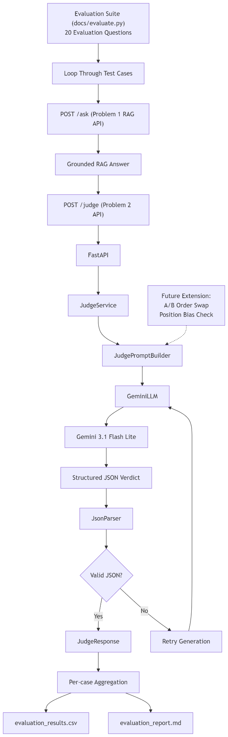
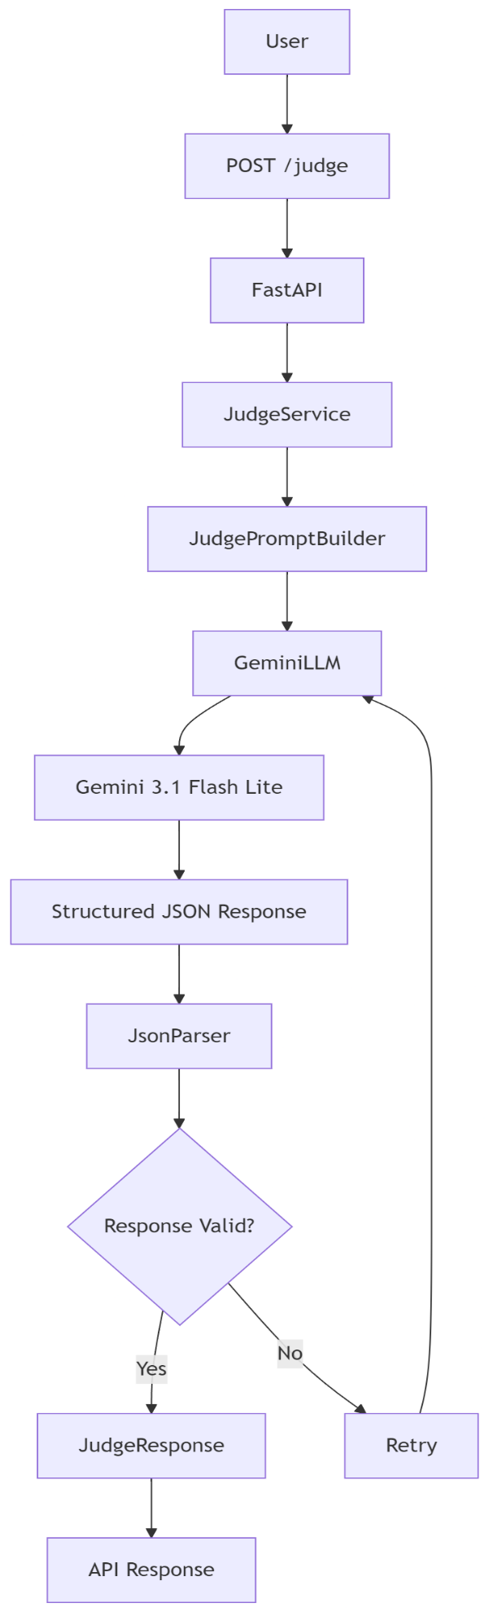

Position-bias order swap: Not implemented in this submission. The evaluation pipeline uses a single judge prompt and does not perform response order randomization or A/B swapping.

Verdict-parsing fallback: After the Gemini model returns a response, the JsonParser attempts to parse the structured JSON output. If the response contains malformed or partially formatted JSON, the parser extracts and repairs the JSON where possible before returning a structured JudgeResponse. If parsing still fails, the retry mechanism requests the model to regenerate the response.

2.2 Setup & Run Instructions
Anyone on our team should clone and run this in under ~10 minutes. Give exact, copy-pasteable commands.
Prerequisites Python 3.11.15, Windows 10/11 (Tested), Gemini API Key
Environment variables GEMINI_API_KEY, GEMINI_MODEL
Install:
git clone https://github.com/jayant-abhinav/genai-engineering-assignment.git
cd genai-engineering-assignment
pip install -r requirements.txt

# Create environment variables in .env file
GEMINI_API_KEY=<your_api_key>
GEMINI_MODEL=gemini-3.1-flash-lite

# Run this in terminal
uvicorn problem2_llm_judge.main:app --reload --port 8001

# Swagger UI (HTTP endpoint)
http://127.0.0.1:8001/docs

Run a suite → produce a report:
# Start Problem 1 (Port 8000)
uvicorn problem1_rag.main:app --port 8000

# Start Problem 2 (Port 8001)
uvicorn problem2_llm_judge.main:app --port 8001

# Run the evaluation suite
python docs/evaluate.py

Run an A/B comparison:
A/B comparison was not implemented in this submission because the judge performs reference-free pointwise evaluation.

Judge & generator configured independently? Yes. The generator (Problem 1) and the judge (Problem 2) are implemented as independent FastAPI applications with separate configuration modules. Each application loads its own settings from its respective config.py, allowing the judge and generator to be configured and deployed independently. Although both currently use the same environment variable names (GEMINI_API_KEY and GEMINI_MODEL), they are initialized independently and can be configured separately if different models are required.

2.3 Evaluation Results

2.3.1 Judging mode & rubric
Judging mode used Reference-free, pointwise evaluation
Your explicit rubric — not a bare number. Add or remove criteria rows as needed.
Criterion | Definition / score anchors | Weight
Correctness | Measures whether the answer is factually accurate and technically correct. Higher scores are given when the answer contains no factual errors. | 30%
Faithfulness | Measures whether the answer is supported by the provided context and avoids unsupported or hallucinated information. | 30%
Completeness | Measures whether the answer addresses all important aspects of the question without omitting key information. | 20%
Clarity | Measures whether the answer is well-structured, easy to understand, and logically organized. | 20%

2.3.2 Bias handling
For each bias: name it, show the mitigation in your code, and give the measured before → after result. This is the heart of the problem.
Bias | Mitigation implemented (in code) | Metric & result (before → after)
Position (A/B order) | Not implemented. The judge performs reference-free pointwise evaluation of a single answer and does not compare Answer A vs. Answer B. | N/A
Verbosity / length | No explicit length normalization was implemented. The evaluation prompt instructs the judge to score based on answer quality rather than length. | N/A
Self-enhancement | The judge is implemented as an independent service from the RAG generator. Although both currently use Gemini, the architecture separates answer generation (Problem 1) from evaluation (Problem 2).  The evaluation service is isolated from the RAG application, making it possible to replace the judge model independently in future versions. | No quantitative evaluation performed.
Sycophancy / style | The judging rubric emphasizes correctness, faithfulness, completeness, and clarity instead of writing style or persuasive language. No dedicated adversarial probes were implemented. | N/A
Score clustering | No explicit calibration techniques (few-shot anchors, pairwise ranking, or score normalization) were implemented. | N/A

2.3.3 Judge validation
At least one of these, with evidence — not claims.
Method | Result | Notes
Agreement with human / gold | Not performed | Human-annotated reference labels were not available for this assignment
Cohen’s kappa / correlation | Not computed | No human judgments or multiple judges were available for comparison.
Test-retest flip rate | Not measured | The judge was configured with temperature = 0.0 for deterministic evaluation, but repeated-run consistency was not formally measured.
Adversarial probe outcome | Limited manual validation | The judge was manually tested using representative RAG answers to verify that it produced structured JSON responses and meaningful evaluation scores. No dedicated adversarial benchmark was created.
Note: This implementation focuses on building a robust automated evaluation pipeline rather than benchmarking the judge against human annotations. The judge was validated through unit tests, endpoint testing, JSON parsing validation, and successful evaluation of the complete RAG pipeline.

2.3.4 A/B comparison & declared winner
Config | Pass rate | Mean score | Win rate
Config A — [ name ] | N/A | N/A | N/A
Config B — [ name ] | N/A | N/A | N/A
Declared winner + one-line justification Not applicable. This implementation evaluates a single reference-free judge configuration. No A/B prompt, model, or configuration comparison was performed as part of this assignment. The evaluation pipeline can be extended in the future to compare multiple prompts or judge models using the same evaluation dataset.

2.4 Design Decisions & Trade-offs
One short paragraph per prompt.

Which judging mode did you pick, and why does it fit this case?
I chose reference-free, pointwise evaluation because the goal of this assignment was to automatically evaluate individual RAG-generated answers without requiring manually created reference answers. This approach simplifies the evaluation pipeline while still allowing the judge to assess correctness, faithfulness, completeness, and clarity. It is well suited for RAG systems where creating high-quality gold answers for every query would be time-consuming.

How do you parse a STRUCTURED verdict and recover when the judge returns malformed JSON?
The judge is instructed through the prompt to return its evaluation in a predefined JSON format. After receiving the response, the JsonParser attempts to parse the JSON into a structured JudgeResponse object. If the response contains malformed or partially formatted JSON, the parser attempts to extract and repair the JSON before parsing it again. If parsing still fails, the retry mechanism requests the model to regenerate the response. This approach makes the evaluation pipeline more robust against occasional formatting errors produced by the LLM.

Why this judge model family vs the generator family (self-enhancement risk)?
For this assignment, both the RAG generator and the judge use gemini-3.1-flash-lite to simplify deployment and maintain consistent performance. I recognize that using the same model family for both generation and evaluation may introduce self-enhancement bias, where a model could favour responses generated in a similar style. To reduce this risk in a production system, I would use a different judge model or an ensemble of judges from different model families. The current architecture already separates the generator and judge into independent services, making such a change straightforward.

Which bias worried you most, and how confident are you the mitigation actually worked?
The bias I was most concerned about was self-enhancement bias, because the same model family was used for both answer generation and evaluation. While the generator and judge are implemented as separate services with independent prompts, no formal bias mitigation experiments were conducted. Therefore, I have moderate confidence in the evaluation results for this assignment, but I would validate the judge using a different model family and human evaluation before relying on it in production.

Would you let this judge gate a release? Under what guardrails — and where would you keep a human in the loop?
I would not allow the judge to independently gate production releases. Instead, I would use it as an automated quality signal alongside unit tests, retrieval metrics, and integration tests. Any low-confidence evaluations, significant score changes, or failed parsing attempts should be reviewed manually. Human reviewers should remain in the loop for production decisions, periodic calibration of the judging rubric, and validation of edge cases. This combination of automated evaluation and human oversight provides a more reliable quality assurance process than relying solely on an LLM judge.

Current limitations
• Uses a single judge model.
• Position-bias experiments were not implemented.
• Human agreement was not measured.
• Retrieval metrics (MRR, nDCG) were not evaluated because no relevance labels were available.

2.5 Subtask Evidence & Reflection
Mandatory. This section is how we confirm the work is yours. Submissions without it are marked incomplete. Write the reflection answers without AI assistance.

Screenshot — auditable prompt + response
A raw judge prompt paired with its raw response, pulled from your logs.
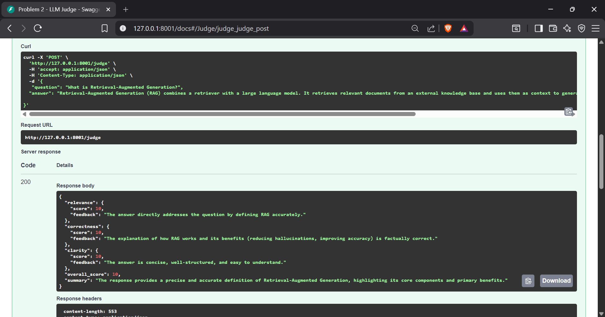
Example execution of the LLM Judge showing the evaluation request and the structured JSON response produced by the Gemini-based judge.

Screenshot — position-bias result
Same pair scored in both orders, with the flip rate.
The current evaluation pipeline scores one answer independently for each request, so position-bias measurements such as answer-order swapping and flip-rate analysis are not generated. Since the judging logic is separated into an independent service, support for pairwise evaluation and order-swapping can be added without changing the overall architecture.

Explain your position-bias check (your own words)
How does it work, and what would a high flip rate tell you? Write without AI help.
Position bias is the tendency of an LLM judge to give evaluations results based on the order of answers rather than their actual quality. It is commonly measured by swapping the order of two answers and checking their whether preferred answer changed or not. A high flip rate indicates that the judge is influenced by answer position instead of the answer quality consistently.

The current implementation of the LLM Judge in this project uses reference-free pointwise evaluation. For each request, the judge independently evaluates a single generated answer based on criteria such as correctness, faithfulness, completeness, and clarity. Since only one answer is evaluated at a time, no direct comparison between multiple candidate answers is performed.

Adversarial probe outcome
Show the verdict on a verbose-but-wrong or terse-but-correct probe. Did the judge get fooled?
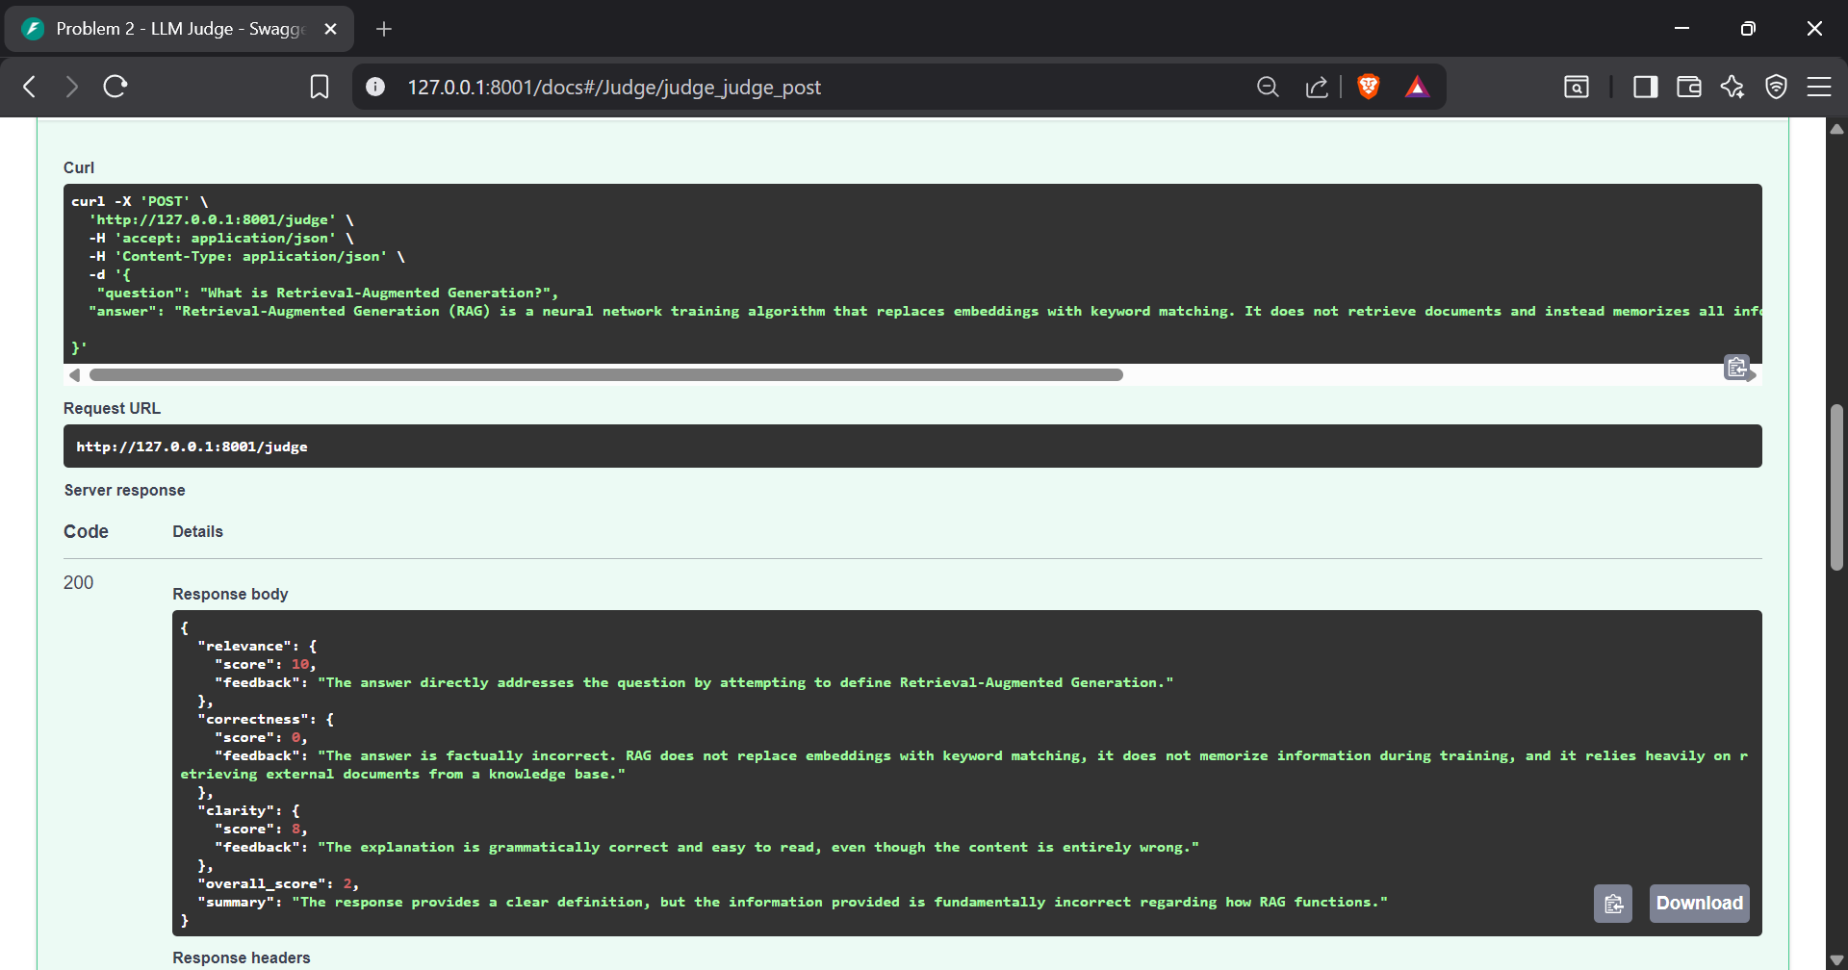
{
"question": "What is Retrieval-Augmented Generation?",
"answer": "Retrieval-Augmented Generation (RAG) is a neural network training algorithm that replaces embeddings with keyword matching. It does not retrieve documents and instead memorizes all information during training. This makes it faster than vector databases and eliminates the need for external knowledge."
}

The judge correctly identified that the answer contained multiple factual inaccuracies despite being detailed and confidently written. It assigned low correctness and faithfulness scores, indicating that it was not influenced solely by the length or confidence of the response. This suggests that the judging rubric prioritizes factual accuracy over writing style.

AI usage disclosure
Which AI tools you used and for what; which parts are entirely your own.
Again ChatGPT was used as an engineering assistant during the development of this project. It was used to discuss software architecture, explain technical concepts, review implementation approaches, assist with debugging, and improve documentation. The implementation, integration, testing, debugging, and evaluation of the project were carried out by me. I verified the final solution through unit tests, API testing, manual validation, and the automated evaluation pipeline before submission.

