DIABETIC RETINOPATHY DETECTION

Enrol. No. : 13103588
Name of Student : Jayant Yadav
Name of supervisor: Dr. Vikas Saxena

December – 2016

Submitted in partial fulfillment of the Degree of

Bachelor of Technology or
5 Year Dual Degree Programme B. Tech

in

Computer Science Engineering

DEPARTMENT OF COMPUTER SCIENCE ENGINEERING & INFORMATION TECHNOLOGY

JAYPEE INSTITUTE OF INFORMATION TECHNOLOGY, NOIDA

(I)
TABLE OF CONTENTS

Chapter No. Topics Page No.

Acknowledgement I
Summary II

Chapter-1 Introduction Page No to Page No
1.1 General Introduction
1.2 List some relevant current/open problems.
1.3 Problem Statement
1.4 Overview of proposed solution approach and Novelty/benefits

Chapter-2 Background Study Page No to Page No
2.1 Literature Survey
2.1.1 Additional literature survey (if any) include in the following format
2.2 Results of revised Literature Survey (If any)
2.2.1 Revised integrated Summary of the literature studied
2.2.2 Redefined problem statement
2.2.3 Revised solution approach to revised problem in terms of technology /platform to be used.

Chapter 3: Analysis, Design and Modeling Page No to Page No
3.1 Functional and Non Functional requirements
3.2 Overall architecture with component description and dependency details
3.3 Design Documentation
3.3.1 Data Structures and Algorithms / Protocols
3.4 Risk Analysis and Mitigation Plan

Chapter-4 Implementation and Testing
4.1 Implementation details and issues
4.2 Testing
4.2.1 Testing Plan
4.2.2 Limitations of the solution

Chapter-5 Findings & Conclusion Page No to Page No
5.1 Findings
5.2 Conclusion
5.3 Future Work

References Page No to Page No

Appendices Page No to Page No

(I)

ACKNOWLEDGEMENT

The members of the Group gratefully thank all the members of staff JAYPEE INSTITUTE OF INFORMATION TECHNOLOGY, NOIDA for their kind hearted cooperation and guidance, which helped us to our project development.

We acknowledge the support of Dr. Dharmveer Singh Rajpoot and Shardha Porwal ma’am (phase-1 evaluator), Mahendra Gurve sir (phase-2 evaluator) for pointing out the flaws and providing their valuable advice for our progress.

Last but not least we would like to pay our regards to Dr. Vikas Saxena, project coordinator
who provided us with some useful guidelines for making the project report and also his kind
cooperation at every step of the project.

Signature:
Name of Student: Jayant Yadav
Enrollment Number: 13103588
Date:

(II)

SUMMARY

Diabetic retinopathy is the leading cause of blindness in the working-age population of the developed world. It is estimated to affect over 93 million people. The longer a person has diabetes, the higher his or her chances of developing diabetic retinopathy. Currently, detecting DR is a time-consuming and manual process that requires a trained clinician to examine and evaluate digital color fundus photographs of the retina. By the time human readers submit their reviews, often a day or two later, the delayed results lead to lost follow up, miscommunication, and delayed treatment. The need for a comprehensive and automated method of DR screening has long been recognized, and previous efforts have made good progress using image classification, pattern recognition, and machine learning.

With some diligent work and honest approach, we hope to make this detection process in large a success. This project showcases how the use of computer vision and machine learning algorithms, can help medical science to deal with large number of patients suffering from diabetic retinopathy easily.

Signature of Student
Name
Date

(III)

LIST OF SYMBOLS & ACRONYMS

DR: Diabetic Retinopathy
MT: Morphological Transformation
DH: Dot Hemorrhages

Chapter-1
INTRODUCTION
1.1 Genereal:
Diabetic retinopathy is the leading cause of blindness in the working-age population of the developed world. It is estimated to affect over 93 million people.

It is an ocular manifestation of diabetes, a systemic disease, which affects up to 80 percent of all patients who have had diabetes for 20 years or more. At least 90% of these new cases could be reduced if there were proper and vigilant treatment and monitoring of the eyes. The longer a person has diabetes, the higher his or her chances of developing diabetic retinopathy.

Vision of normal and defective person:
Fig1:

Normal Vision The same view with diabetic
retinopathy.

1.2Relevant current/open problems:

- Right now, DR detection is a time consuming and manual process, that requires a clinical expert to examine and evaluate fundus photos of retina in coloured digital format. So, by the time these experts submit their reviews, there are delayed results, that result in lost follow ups and miscommunication, resulting delayed treatment.

- Experts identify DR by looking for the presence of lesions that must be associated with vascular abnormalities caused by the disease. This method is effective yet very resource demanding. As the number of individuals with diabetes continues to grow, the infrastructure needed to prevent blindness due to DR will become even more insufficient.

The need for making an automated method for DR scanning has long been recognized. A study shows the number of people getting effected by this disease, the table has been taken from there as a reference.

Table1:

Age-wise distribution of the diabetic patients screened and the prevalence of diabetic retinopathy in India.
Fig2:
Fundus image showing Diabetic Retinopathy (Right eye)

VS

Fundus image showing no Diabetic Retinopathy (Left eye)

Signs and Symptoms of DR:

- In the first stage which is called non-proliferative diabetic retinopathy (NPDR) there are no symptoms, the signs are not visible to the eye and patients will have 20/20 vision.

- Macular edema in which blood vessels leak their contents into the macular region can occur at any stage of NPDR. The symptoms of macular edema are blurred vision and darkened or distorted images that are not the same in both eyes. Ten percent (10%) of diabetic patients will have vision loss related to macular edema.

- Diagram of an eye: Fig3

- In the second stage, abnormal new blood vessels form at the back of the eye as part of proliferative diabetic retinopathy (PDR); these can burst and bleed (vitreous hemorrhage) and blur the vision, because these new blood vessels are fragile.

- Eye Diagram suffering from Diabetic Retinopathy(Fig4):

- As the disease progresses, severe nonproliferative diabetic retinopathy enters an advanced or proliferative (PDR) stage, where blood vessels proliferate/grow.

The DR detection includes detection of (Fig5):
- Exudates

- And Dot Hemorrhages

1.3 Problem Statement:

The patients with diabetes may be suffering from DR without realization. Since Proliferative diabetic retinopathy does not show any symptoms until they are in last stage of vision loss. With the help of image processing and machine learning, we can determine whether exudates and dot hemorrhages are developing or not , so that patients can take steps accordingly.

1.4 Proposed Benefits:

- aThe most hcommon acurrent approaches tto automating DRy screening qare statistical classifying methods and/or neural networks and xsimilar methods.

- This project takes an alternative, much better approach by focusing on analytics like, direct identification using geometric models at the preprocessing stage.

- There are two different independent algorithms that we have developed to detect exudates and DH. The number of exudates and DHs are determind by the information like colour, gradients and morphology of the fundus photos.

- Finally, it uses the information such as indentifying physiologically observed states, directly, which some other algos ignore.

Chapter-2
Background study
2.1 Literature survey:
2.1.1 Additional literature survey (if any) include in the following format:
- Title :ImageNet Classification with Deep Convolutional Neural Networks
- Authors:
- Alex Krizhevsky University of Toronto kriz@cs.utoronto.ca
- lya Sutskever University of Toronto ilya@cs.utoronto.ca
- Geoffrey E. Hinton University of Toronto hinton@cs.utoronto.ca

- Summary:
  - The paper talks about the convolution neural network and the various terminologies associated with it.
  - It explain its model by working on ILSVRC dataset and explains why convolution networks are best suited for achieving record-breaking results on highly challenging datasetusing purely supervised learning.

Title : Using Convolutional Neural Network for the Tiny ImageNet Challenge

- Authors:
- Jason Ting Stanford University jmting@stanford.edu
- Year of Publication: 2016
- Summary:
        - The paper shows how to create model for classiying images for Tiny
ImageNet challenge. The images ffrom the dataset are classified and labbeled
according to their class.
- The library used is theano and have trained 4 cnn that varies in filter and depth.
- They used image processing techniques, which includes mirroring, which flip images horizontally, for the training images, which helped improve the test accuracy

- Title : Diagnosis of Diabetic Retinopathy
- Authors:
Anupriyaa Mukherjeeet
- Year of Publication: February 2015
- Publishing Details:
Int. Journal of Engineering Research and Applications

- Summary:
  - In this paper different image processing techniques are used to differentiate between the normal and the diseased image. The attempt is made to see where the problem actually lies so that proper diagnosis of patient can be done. Pre processing of an image, optic disk detection, Blood vessels extraction, Exudates detection are some of the methods that are applied here.
  - Morphological image processing is a type of processing and a collection of non linear operations which is used to determine the structure and morphology of the image. It has two mathematical morphology operations: erosion and dilation where erosion is used to shrink the image whereas dilation
is used to expand the given image.

2.Results of revised Literature Survey (If any)
2.2.1 Revised integrated Summary of the literature studied

The papers studied talks about the importance of using neural networks and convolution network, to be precise, for classifying images. These are best to recognize images due to the ability to convolve images into less number of dimension magnitude while preserving the input parameters the same, only supressing the less important ones.

They have used famous dataset from like ILSVRC and Mnist dataset. The dataset prior to learning are sent for preprocessing so that the features can be distinguised significantly.

2.2.2 Redefined problem statement

The patients with diabetes may be suffering from DR without realization. Since Proliferative diabetic retinopathy does not show any symptoms until they are in last stage of vision loss. With the help of image processing and machine learning, we can determine whether exudates and dot hemorrhages are developing or not , so that patients can take steps accordingly.

2.2.3 Revised solution approach to revised problem in terms of technology /platform to be used
The approach pre training remains the same as we have to do the preprocessing.
The only changes needs to be done are with the training of data. This can be done using various models such as
- feed forward neural network
- convolutional neural network
- support vector machine
- back propagation neural network
This will be done also using gradient descent or stockhastic gradient descent where paprameteres are cross-validated offline.

Chapter- 3
Analysis, Design and Modeling

3.1 Funcitonal Requirements:

Title: Input

Description: The program must be able to accept the range of images on which it has to do the detection of DR and then its training an testing to predict further input of images quickly in large scale.

Various image processing and kernel level libraries needed to accomplish input will include ‘os’, ‘image’ and ‘shutil’.

Title: Image Processing

Desciption: The program has to do some funcitons on the given images to determine the type of DR the patient is suffering from. This requires various image procesing tools like ‘cv2’, ‘numpy’ and ‘imutils’.

Title: Dataset

Desciption: There is specific type of data of fundus images which needs to be passed. The images must be having ground truth so that it helps the program in training.

Title: Output

Description : The program will take your input and print the images with their predicted results, ie the type of DR they are suffering from or weather they are normal fundus imaegs.

3.1 Non-Functional Requirements:

Efficiency of the program:

This is the main aim of the project. We strive to make an efficient program to detect, train and then test for DR.

Reliability:

The system needs to dependable. The mission lies in reliability, so that it can be commercialised in the future.

Portability:

The program is operable in different environments like Linux, Windows 7/8 and OS x.

Usability:

The program is usable in terms of
- Easy to operate
- Memorable
- subjectively satisfying
- safe: to the environment and user
- knowable

Performance:

Following factors that may determine the performance of the system. It also takes into consideration the efficiency of the system:
• High accuracy.
• Short response time.
• High throughput (rate of processing work).
• Utilisation of computing resources must be less.
• Much Efficient.

3.2
Overall architecture with component description and dependency details:
Fig6

Fundus Images
Dataset

PreProcessing of Images

Optic Disk Extraction and subtration

Blood vessel Exctraction and subtraction

Exudate Detection

Dot hemorrhages detection

Images Trainging

Testing fundus images for DR in bulk

3.3 Design Implementations:

Algorithms/ Protocols used:

- Morphological Closing:
Closing is reverse of Opening, Dilation followed by Erosion. It is useful in closing small holes inside the foreground objects, or small black points on the object.(7)
closing = cv2.morphologyEx(img, cv2.MORPH_CLOSE, kernel)
Result:
fig7
- Histogram Equalization:
Its input is just grayscale image and output is our histogram equalized image.

Result:
fig8

- Gaussian Blur:
Blurs an image using a Gaussian filter.
The function convolves the source image with the specified Gaussian kernel. In-place filtering is supported.

- Contour Detection:

It outputs the contours and hierarchy. contours is a Python list of all the contours in the image. Each individual contour is a Numpy array of (x,y) coordinates of boundary points of the object.

- Erosion:

All the pixels near boundary will be discarded depending upon the size of kernel. So, the thickness or size of the foreground object decreases or simply white region decreases in the image. It is useful for removing small white noises.

fig9

- Dilation:

It is just opposite of erosion. Here, a pixel element is ‘1’ if atleast one pixel under the kernel is ‘1’. So it increases the white region in the image or size of foreground object increases.
fig10

3.4 Risk analysis and mitigation plan:
Table1:
Risk Id | Description | Risk Area | Probability | Impact | RE (P*I) | Mitigation Plan
1 | Absence of a clinical expert who can study the fundus images and tell the accuracy of our project | Result Verification | H(0.9) | M(5) | M(4.5) | Explore university papers and accept their findings as our ideal output
2 | Unavailabilty of noiseless images | Detection of DR | M(0.5) | M(8) | M(4.0) | Use of extensive amount of image processing algorithms
3 | Unavailabilty of required libraries, like py or cv | Image Preprocesssing and DR Detection | M(0.4) | H(9) | M(4.5) | Makeshift algo
4 | Hardware specs low | Training and Testing | L(0.3) | M(5) | L(1.5) | Reduce Dataset
5 | Unavailabilty of DR resources and info | Detection of DR | M(0.5) | H(9) | M(4.5) | no

Weighted Interrelationship Graph of Project:
Absence of a
clinical expert or
ground truth

6

Unavailabilty of
required libraries
/Open source modules
Unavailabilty of
noiseless images

7

9
7
5

Unavailabilty of
DR resources
and info
Hardware specs low
5

Risk Area Wise Total Weighting Factor:
Table2:
S.no | Risk Area | # of Risk  Statements | Weights(In+  Out) | Total Weight | Priority
1 | Absence of a  clinical expert or  ground truth | 2 | 6+9 | 15 | 3
2 | Unavailabilty of  noiseless images | 3 | 6+7+5 | 18 | 2
3 | Unavailabilty of  required libraries  /Open source modules | 2 | 7+7 | 14 | 4
4 | Hardware specs low | 2 | 5+5 | 10 | 5
5 | Unavailabilty of  DR resources  and info | 3 | 5+7+9 | 21 | 1

Chapter-4
Implementation and Testing

4.1 Implementation details and Issues:

Implementation steps:

- The fundus image dataset is first preprocessed to make it easier on machine to run.
  - Image sizes are converted into same dimensions or 640X491 to remove descripencies.

  - Since the available dataset was having images in .png format to .jpg

- Extraction of Optic Disk:
  - Various methods are tested, as given by various papers. Finally, a different method is invented.

  - Image in Green channel is extracted from its original, since yellow colour is high in green channel and optic disk is yellow in colour.

  - Thresholding is done in the range of 200 to 250.

  - contours are detected to encompass yellow regions and they are they labelled accoring to their size.

  - Since optic disk is greatest in size, this contour is selected.

  - A circle is drawn around the contour This circle is closest fitting circle.

  - Another circle is drawn, with radius 1.5X of the previously drawn cicle. This is to insure that it encompasses the whole optic disk.

  - A mask is drawn with this circle.

  - This mask is then deleted from the orginal image.

- Extraction of Blood vessel:
  - Image in Green channel is extracted from its original, since red colour is high in green channel and blood vessels are in red colour.

  - Two different kernels are made of varying sizes.

  - Two different morphological closing are applied on the images using those two kernels.

  - A gradient image is made by subtracting the kernel image and the original green channel image.

  - Threshold is applied on the resultant image to get a binary image as an output. The rage of the threshold will varying according to the quality of images in the dataset. For now, it is hardcoded for the available dataset to 2,255.

  - This image is then subtractedfrom the green channel image to give the desired result.

- Detection of Exudates:
  - Two kernels are generated and then applied to the green channel image, since exudates are yelllow in colour.

  - Dilation of the morphological operation is used on two seperate images using one kernel each.

  - Subtraction of the resultant two dilated images are done to highlight the edges of the yellow exudates in the fundus image.

  - Threshholding is done for better contrast.

  - Blood vessels and optic disk detected previously are removed from the resultant image to get the exudates.

- Detection of Dot Hemorrhages:
  - A binary image is created by calculating red/green (R/G) intensities from the given fundus image.

  - A 50 pixel median filter is applied to the resultant.

  - Subtracting Red/Green ratio image and the resultant image.

  - Applying threshold to the resultant image so that the red component of the fundus is visible clerly.

  - The resultant image is converted into binary image and taken compliment of it.

  - Canny edge detection is applied to the resultant image to highlight the dots in Dhs.

Implementation details of machine learning part:

- The required libraries and python distribution packages are included:
  - keras with TensorFlow backend
  - numpy for representing images in arrays
  - opencv to read write images
  - sklearn to do preprocessing on images

- The images to be trained are divided into 4 categories namely;
  - normal
  - dot hemorrhages
  - exudates
  - both
- grab the image paths and use preprocessing on them in order to distinguish their features among themselves
- reduce the resolution of the images to train them
- flattern the images into raw pixel intensities
- convert the labels from string to integers, into a vector where ith index is 1 and others are zero .
- The architecture of the network is as follows:
  - there are 4 layers :
    - 1st layer is the number of features in the image: 128x128x3. Since there are three chanells RBG
    - 2nd layer is the hidden layer and has 768 filters this number must be between number of input and output.
    - 3rd layer is again a hidden layer having 384 filters
    - 4th layer is the output layer which has 4 outputs corresponding to 4 classes of DR.
- The output is an array of probabilities for a specific image. The softmax function is applied to get the max of the probabilities.
- Stockhostic Gradient descent is applied to get the accuracy of each images. It is run for 50 epochs with 4 aas its batch size.

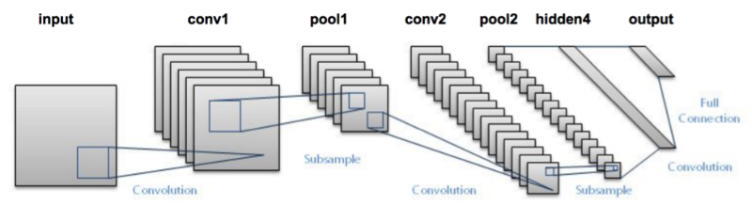

4.2 Testing:

Table 3:
4.2.1 Testing plan
Type of Test | Will test be performed? | Comments  /Explanations | Software Component
Requirements Testing | Yes | It is crucial to check the feasibility of the project. It lets us know the needsa of the project, which will help in better developmenta of the project | This test is the inital test that will be done on the project. Time, cost and budget will evaluated from this.
Unit | Yes | This is an imporant one, since it points out where the bug is coming.This makes it economical to test the program as a whole | This test will be performed on individual blocks of code.
Integration | No | This test is required in very large projects where their integration is kept inot consideration. | Not required
Performance | Yes | This is required to understand the upper limits of our program. This tests the programs robustness in times of extreme load. | The software will  be tested to check if  it works properly if  there is load during  execution.
Security | No | This test is required to test confidentiality,  integrity,  authentication,  availability,  authorisation and  nonrepudiation. We dont need this in our project. | Not required.
Load | Yes | This will test how much can our program withstand when flooded with large dataset | This will be tested in the testing and training part of the fundus images

The accuracy comparison with preprocessed and non-preprocessed images comes out to be this:
- for svm and processed: 60-65%
- for NN and non-preprocessed; 70-75%
- for NN and preprocessed: 73-78%

4.2.2 Limitations of the solution:

The Limitations of this solution lies in the fact that it has high chances of failing if the fundus images are not in proper intensity and/or they are not of high quality. This makes the algo hard to differentiate between dark regions and the the red DH, or sometimes, when the image is too bright, it cannot differentiate between exudates and optic disk. This may greatly hamper the result.

Chapter-5
Findings & Conclusion

5.1 Findings:

Through this project we were able to successfully detect exudates and Dot hemorrhages in fundus images. The dataset was initially trained without image processing and then, with image processing. The output in both the cases were noted down. The accuracy came out as follows:

Table4:
Type | Exudates | Dot Hemorrhages | Both | Normal
Without Preprocessing | 42/82 | 34/80 | 14/72 | 18/22
After Preprocessing | 74/82 | 66/80 | 50/72 | 18/22

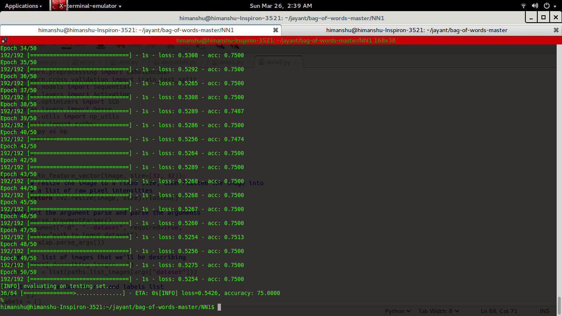

5.2 Concluion:

After analysing the output it is clear that preprocessing is must for the detection of DR.
This project will help the opthalmologists to detect DR at early stage of a diabetic person and suggest medication early to prevent it from expanding. This will also help in detecting DR in bulk and getting the output in short period of time, thus saving the specialist from the pain of going through each and every image by himself and wasting time, which could have been devoted to the patients.

5.3 Future Work:

The scope for future work is huge in this field. We will further try applying different algorithms and will see which works best for which case. Also, a UI can be provided for manual input of the doctor, so that variables like Thresholding can be manually inputted as it gives more accurate result. This will also insure that the program works better even if used with low quality fundus image producing machines. With help of better hardware, the training of the fundus images can be improved tremendously.

References:

- Diabetic Retinopathy Screening Using Computer Vision, Christopher E. Hann, James A. Revie, Darren Hewett, Dept of Mechanical Engineering, Geoffrey M. Shaw, August 12 - 14, 2009, Proceedings of the 7th IFAC Symposium on Modelling
and Control in Biomedical Systems, Aalborg, Denmark

- Dynamic Thresholding Technique for Detection of Hemorrhages in Retinal Images Akhilesh Sharma, Malay Kishore Dutta, Anushikha Singh, M.Parthasarathi, Carlos M. Travieso, Las Palmas de Gran Canaria, August 7 - 9, 2014, 2014 Seventh International Conference on Contemporary Computing (IC3) , Noida, India

- Automated detection of bright lesions from contrast normalized fundus images, Ashish Issac, Rishabh Madan, Malay Kishore Dutta, August 11 - 13, 2016, 2016 Ninth International Conference on Contemporary Computing (IC3) , Noida, India

- Diagnosis of Diabetic Retinopathy, Anupriyaa Mukherjeeet, February 2015, Int. Journal of Engineering Research and Applications

- Screening for Diabetic Retinopathy Using Computer Vision and Physiological Markers Christopher E. Hann, Ph.D., B.Sc., James A. Revie, BE(Hons), Darren Hewett, BE(Hons), J. Geoffrey Chase, B.S., M.S., Ph.D., and Geoffrey M. Shaw

- wikipedia.org/wiki/Diabetic_retinopathy

- docs.opencv.org/3.0-beta/doc/py_tutorials

Appendices:

Project Plan:

