.NET Dependency Agent
How to Use the Application
Simple step-by-step user guide

Application | .NET 8 WPF Desktop Tool
Main Use | Analyze .NET project dependencies, call flow and architecture
Input | Local .csproj or GitHub repository URL

Quick flow: Select project → Select model → Analyze → Review tabs → Open output

1. Start the Application
1. Open the application
Launch DotNetDependencyAgent.exe or run the solution from Visual Studio.
2. Choose project source
Select either Local .csproj or GitHub Repository URL.
3. Select the input
For local mode, click Browse and select the required .csproj file. For GitHub mode, paste the repository URL.
4. Choose Gemini model
Select the required Gemini model from the dropdown. The selected model is used only for the AI report.
5. Choose whether AI analysis is required
Keep Run Gemini AI analysis checked to generate the AI Impact Report. Uncheck it if you only want static dependency analysis.
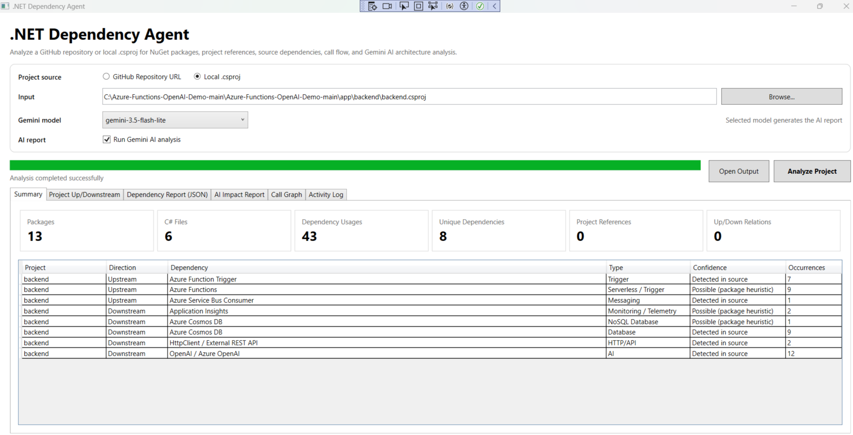
Main application screen - project selection, Gemini model and Analyze Project button

2. Run Project Analysis
6. Click Analyze Project
The application starts scanning the selected project/repository.
7. Wait for completion
The progress bar becomes green and the message “Analysis completed successfully” appears when the scan is finished.
During analysis, the tool checks:
- .csproj files and target frameworks
- NuGet packages
- ProjectReference relationships
- C# source dependencies
- External services such as databases, APIs, messaging and telemetry
- Function/method call flow
- Gemini AI architecture analysis, if enabled
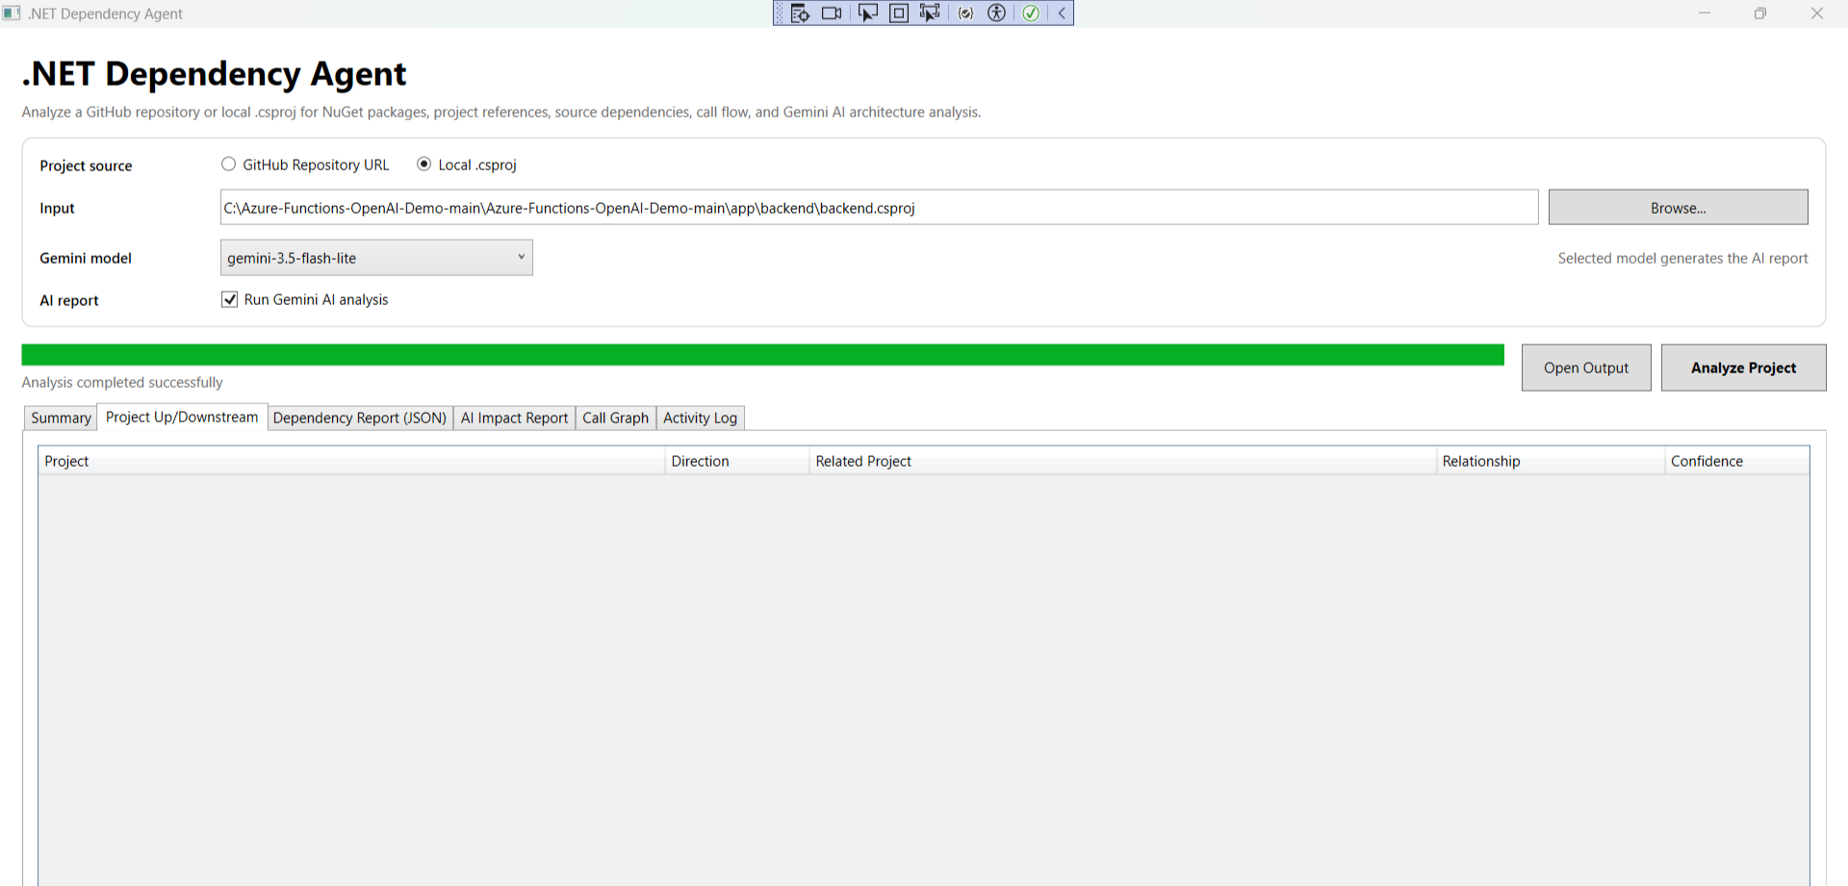

3. Review the Result Tabs
Tab | What to Check
Summary | Overall package count, C# files, dependency usage, unique dependencies and project references.
Project Up/Downstream | Confirmed project-to-project dependency direction.
Dependency Report (JSON) | Detailed structured/static analysis data.
AI Impact Report | Readable AI summary, architecture, dependencies, risks and recommendations.
Call Graph | Detected functions/methods and call relationships.
Activity Log | Analysis steps, selected model, generated file paths and execution status.

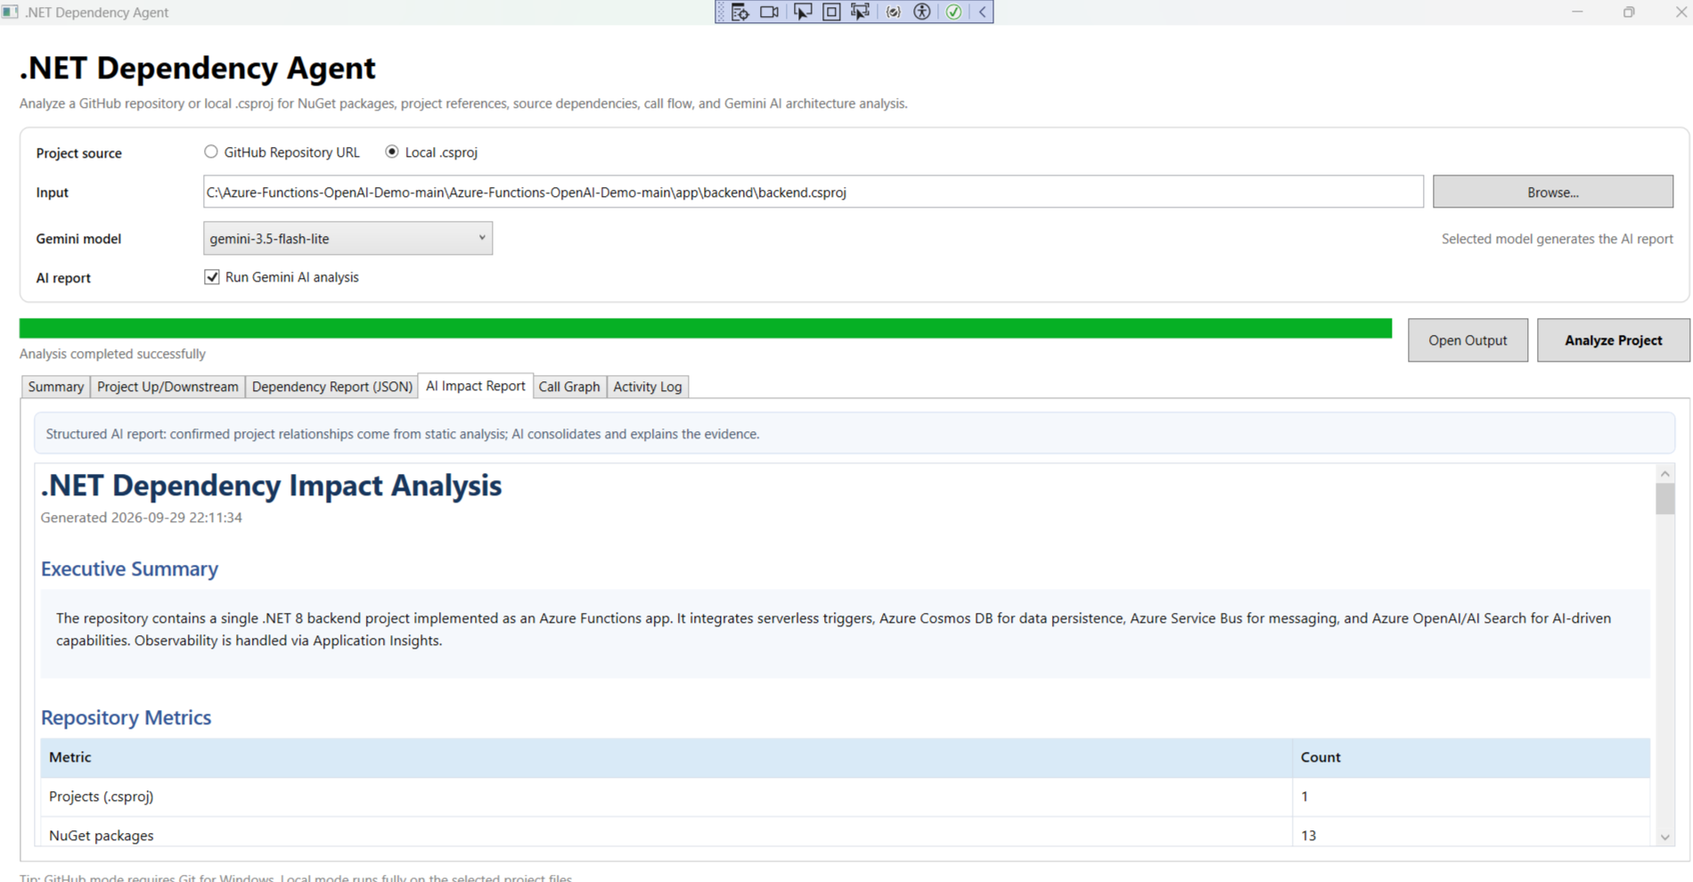
AI Impact Report - readable report generated for manager/developer review

4. Check Call Graph and Activity Log
8. Review Call Graph
Use the Call Graph tab to see detected functions and methods from the source code. This gives a quick view of the code flow.
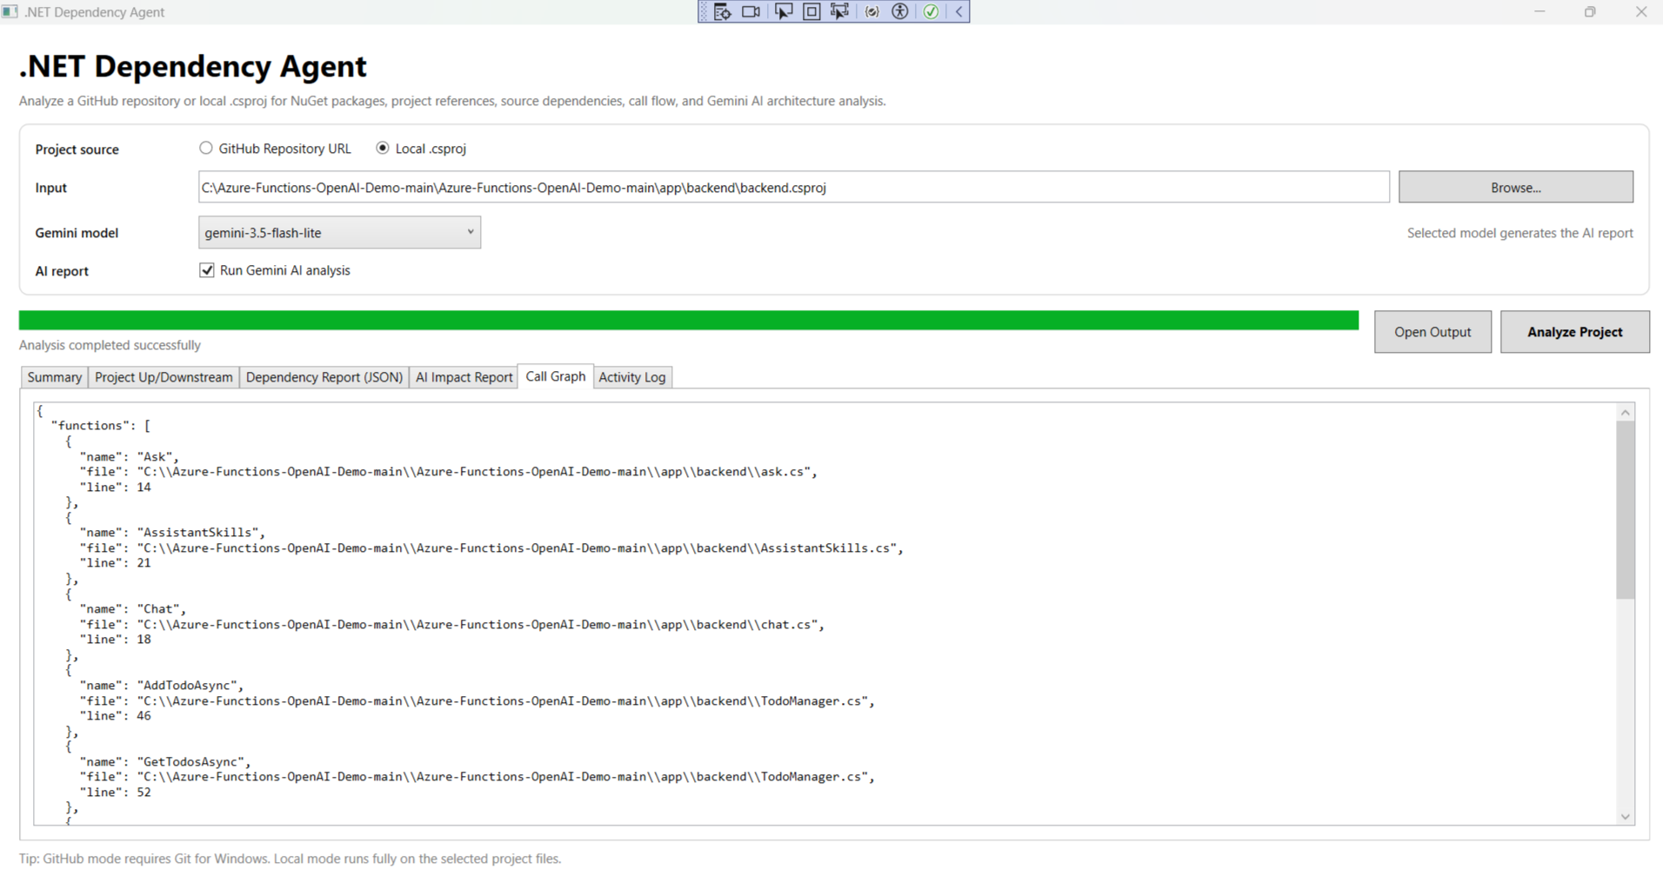
Call Graph tab - detected functions/methods from the analyzed project
9. Review Activity Log
Use Activity Log to confirm which model was selected, where reports were saved and whether diagram/report generation completed successfully.
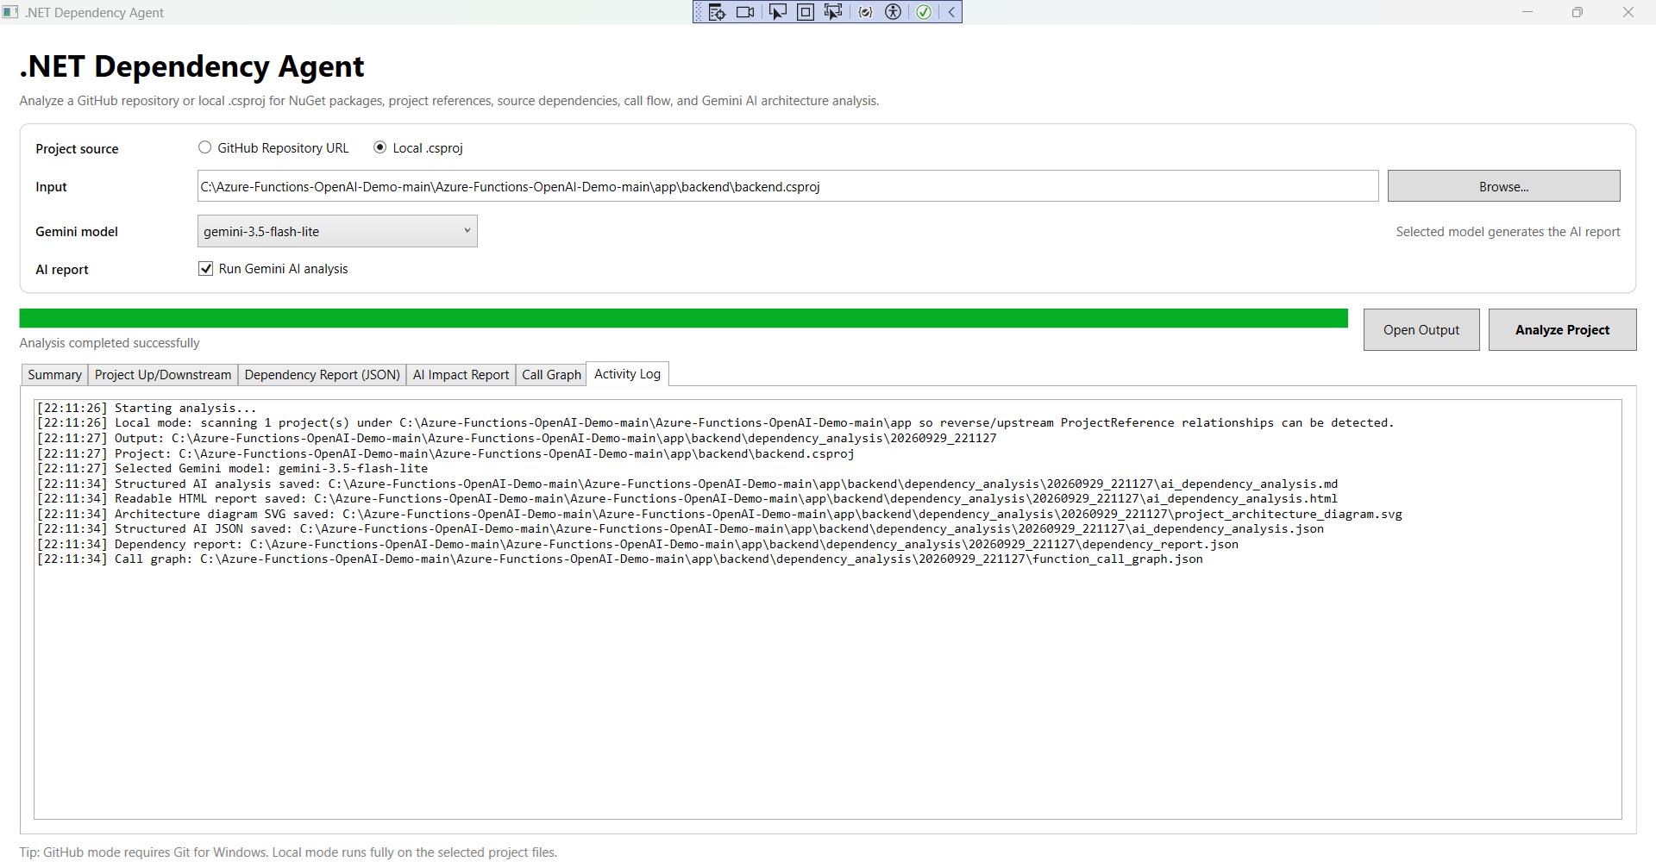
Activity Log - shows analysis steps and generated output paths

5. Open and Use the Generated Output
10. Click Open Output
This opens the dependency_analysis output folder generated for the current run.
Main output files:
- ai_dependency_analysis.html - readable report for browser/manager review
- ai_dependency_analysis.md - Markdown report
- ai_dependency_analysis.json - structured AI report data
- dependency_report.json - static dependency analysis
- function_call_graph.json - call graph data
- project_architecture_diagram.svg - visual project architecture diagram

Recommended Usage
- Use the HTML report for normal review and sharing.
- Use Project Up/Downstream when checking change impact between projects.
- Use JSON outputs when another tool or automation needs the raw analysis data.

6. Quick User Checklist
- Select correct project source
- Select correct .csproj / repository
- Select Gemini model
- Enable AI analysis if required
- Click Analyze Project
- Wait for successful completion
- Review Summary and Up/Downstream
- Review AI Impact Report
- Check Activity Log
- Open generated output folder

7. Important Notes
- GitHub mode requires Git for Windows and internet access.
- Gemini AI analysis requires a valid Gemini API key and network access.
- If Gemini is unavailable, static dependency analysis can still be used by unchecking AI analysis.
- ProjectReference relationships are detected from static project analysis; AI is used mainly to explain and summarize the findings.
Simple usage flow: Input → Analyze → Review → Export

