.NET Dependency Agent
Project Understanding & User Guide
Simple functional and technical overview for users, developers, and managers

Application Type | .NET 8 WPF Windows Desktop Application
Purpose | Analyze .NET project dependencies, call flow, upstream/downstream impact, and AI-based architecture
AI Integration | Google Gemini (optional)
Primary Output | Dependency report, AI Impact Report, architecture diagram, JSON and call graph

1. Project Overview
The .NET Dependency Agent is a Windows desktop utility created to understand an existing .NET codebase quickly. The user can select a local .csproj file or provide a GitHub repository URL. The application scans the project files, NuGet packages, ProjectReference entries, C# source code, method calls, and common integration patterns.
After static analysis, the application can optionally send the structured dependency information to Gemini. Gemini is used to explain the findings and create a readable AI Impact Report. Confirmed project relationships still come from static analysis.
- Detects .NET projects and target framework.
- Finds NuGet packages and external integrations.
- Detects project-to-project upstream and downstream relationships.
- Scans source code for databases, queues, APIs, cloud services, AI services and telemetry.
- Builds a function/method call graph.
- Generates project-wise AI dependency and architecture reports.
- Creates a visual architecture diagram with blocks and arrows.

2. Why This Project Is Useful
Use Case | Benefit
Understanding a new codebase | Shows projects, packages, integrations and dependency direction in one place.
Impact analysis | Helps identify what a project depends on and what can be affected by a change.
Architecture review | Creates a high-level project architecture view from detected evidence.
Developer handover | Provides a simple report that can be shared with another developer or manager.
Modernization / migration planning | Highlights external services, libraries and project relationships that should be reviewed.
Documentation | Produces HTML, Markdown, JSON and SVG artifacts that can be reused.

3. Main Application Screen
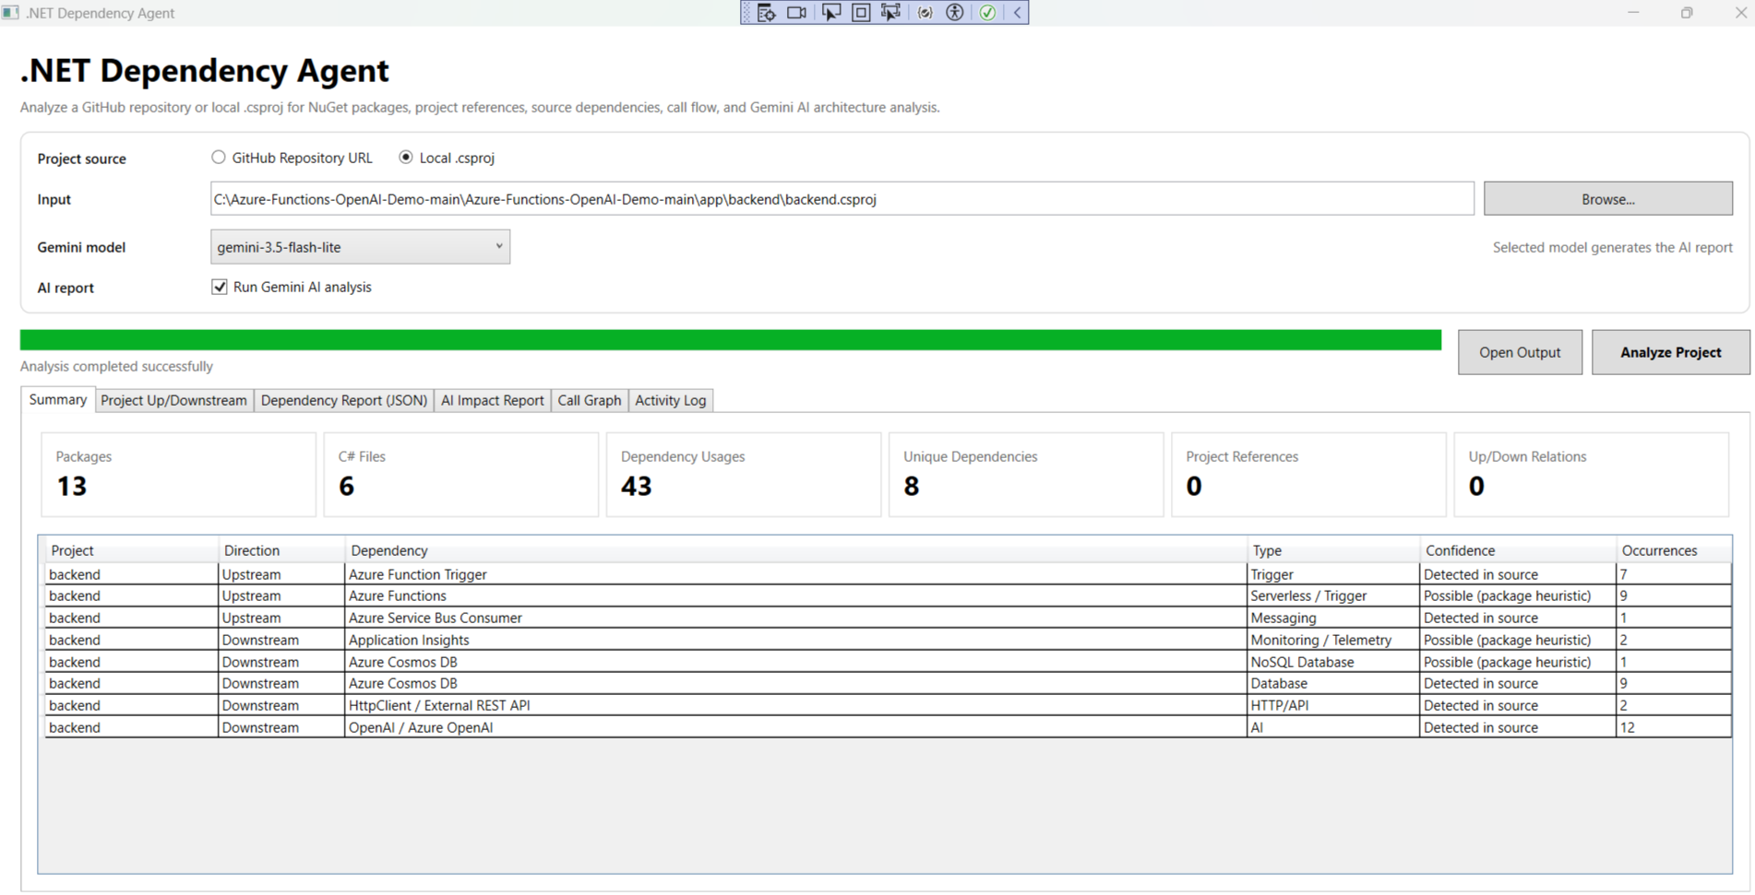
Main screen - project input, Gemini model selection, analysis progress and summary
Important controls:
- Project source: choose GitHub Repository URL or Local .csproj.
- Input: repository URL or selected .csproj path.
- Gemini model: select the model used for the AI report.
- Run Gemini AI analysis: disable this if only static dependency analysis is required.
- Analyze Project: starts the complete scan.
- Open Output: opens the generated report folder.

4. How to Use the Application
- Open DotNetDependencyAgent.exe (or run the solution from Visual Studio).
- Choose Local .csproj for a local project, or GitHub Repository URL for a repository.
- Select the project/repository input.
- Choose a Gemini model from the dropdown.
- Keep Run Gemini AI analysis checked if an AI Impact Report is required.
- Click Analyze Project.
- Wait until the green progress bar shows completion.
- Review Summary, Project Up/Downstream, Dependency Report, AI Impact Report, Call Graph and Activity Log.
- Click Open Output to view the generated files.

Local .csproj Mode
The analyzer starts from the selected project and scans the nearby solution or repository when available. This allows it to identify reverse ProjectReference relationships and not only the references inside the selected project.

GitHub Repository Mode
The application clones the repository into a short temporary path and analyzes the discovered .csproj files. Git for Windows must be installed for this mode.

5. Understanding Upstream and Downstream
For ProjectReference relationships, direction is determined from the code structure:
- Downstream: a project that the current project directly references or calls.
- Upstream: another project that references the current project.
- Possible / heuristic dependency: a package or source pattern suggests an integration, but direction may not be fully proven.
Example: if Project A contains a ProjectReference to Project B, Project B is downstream of Project A. From Project B's point of view, Project A is upstream.

6. Analysis Flow
Step | Component | What Happens
1 | Input Resolver | Finds the selected .csproj or clones/scans the GitHub repository.
2 | DependencyAnalyzer | Reads projects, packages, ProjectReference data and C# source files.
3 | Static Dependency Logic | Classifies dependencies and determines confirmed/possible directions.
4 | Call Graph Builder | Finds methods/functions and common method-call relationships.
5 | GeminiService (optional) | Receives structured analysis data and returns a structured architecture/dependency explanation.
6 | AI Report Formatter / Renderer | Creates the readable AI report in the WPF screen, HTML and Markdown.
7 | ArchitectureDiagramBuilder | Creates the visual architecture diagram for WPF, HTML, SVG and Mermaid.
8 | Output | Saves all generated reports to the dependency_analysis folder.

7. Main Modules in the Source Code
File / Module | Responsibility
MainWindow.xaml / MainWindow.xaml.cs | Desktop UI, user input, model dropdown, progress, tabs, running analysis and opening output.
DependencyAnalyzer.cs | Main static analyzer: project discovery, NuGet packages, ProjectReference, source dependency scanning and call graph.
GeminiService.cs | Sends structured dependency data to Gemini and normalizes the returned AI report.
AiReportFormatter.cs | Formats AI report content and project-wise sections.
AiReportRenderer.cs | Renders the structured report for readable display/output.
ArchitectureDiagramBuilder.cs | Builds architecture blocks, edges, SVG, Mermaid and WPF diagram preview.
AnalysisModels.cs | Data models for projects, packages, dependencies, usages and call graph.
AiReportModels.cs | Structured models used for Gemini architecture and dependency report.
AppSettings.cs / appsettings.json | Loads Gemini API key and default model configuration.

8. Application Tabs and What They Mean
Tab | Purpose
Summary | Overall counts and detected dependencies.
Project Up/Downstream | Confirmed project-to-project relationships.
Dependency Report (JSON) | Raw structured dependency analysis result.
AI Impact Report | Readable project-wise dependency, architecture, risk and recommendation report.
Call Graph | Detected functions/methods and call relationships.
Activity Log | Execution steps, selected Gemini model, output paths and errors/status.

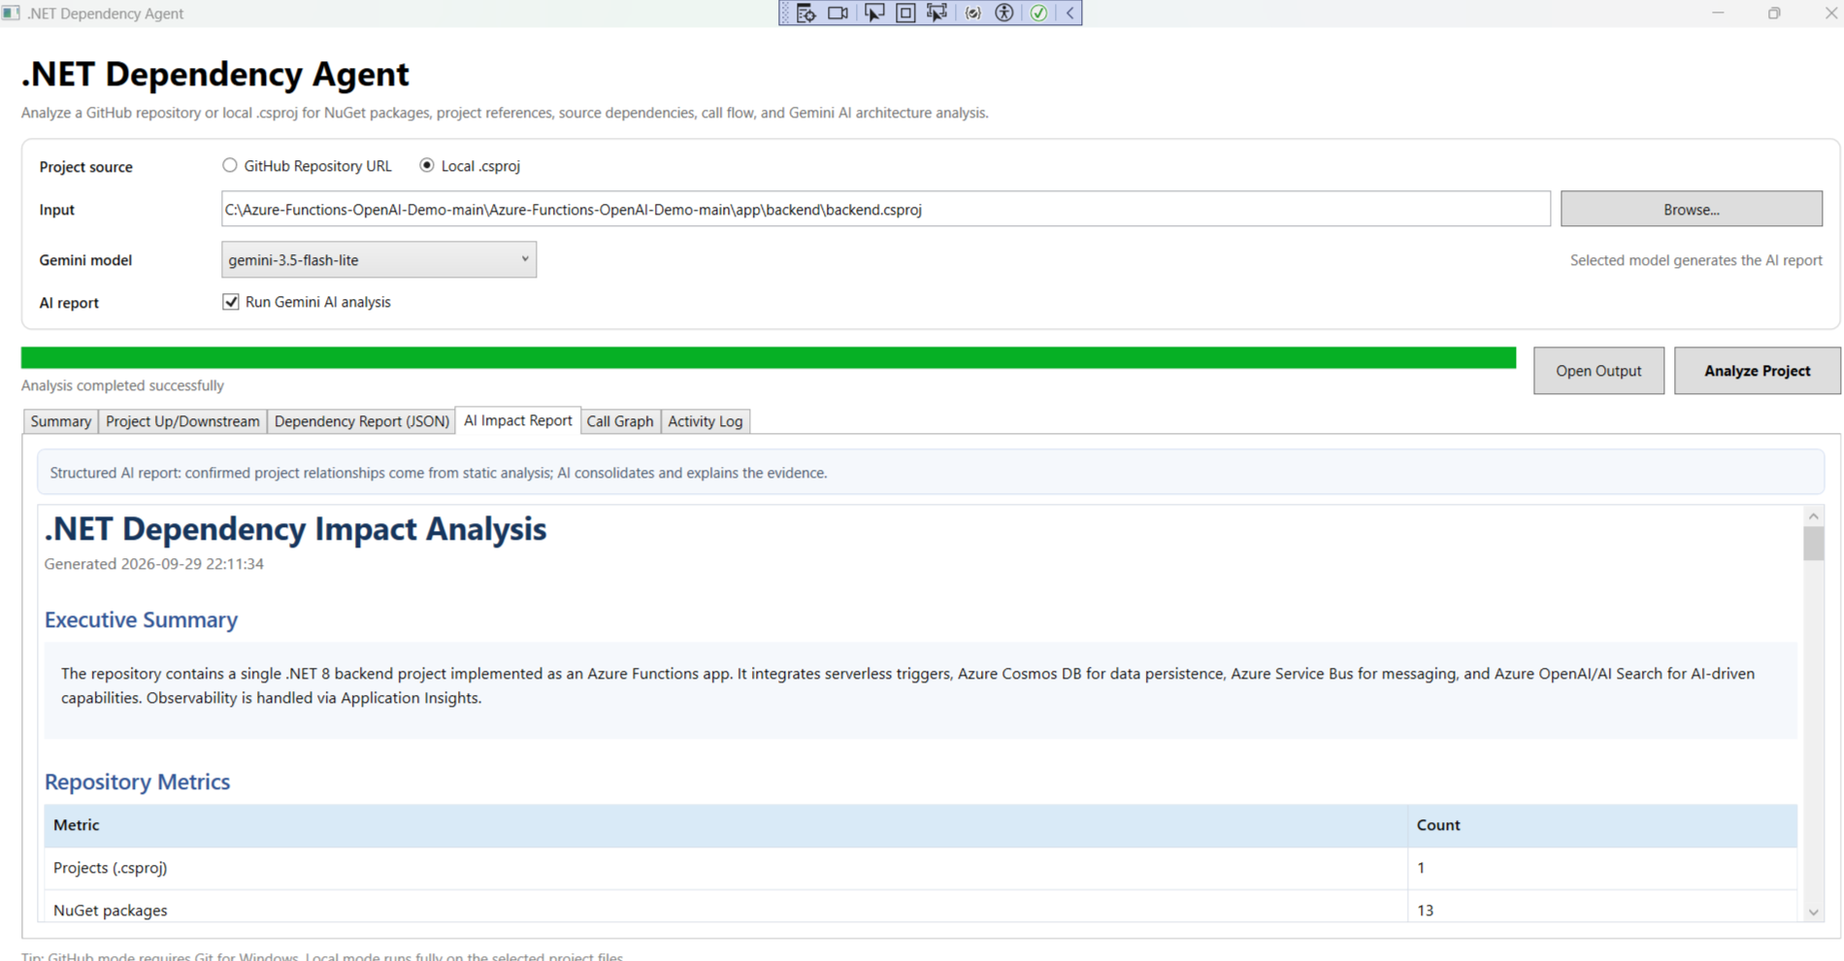
AI Impact Report - readable report generated after static analysis and optional Gemini processing

9. Generated Output Files
Output | Use
ai_dependency_analysis.html | Browser-readable AI dependency and architecture report.
ai_dependency_analysis.md | Portable Markdown version of the AI report.
ai_dependency_analysis.json | Structured AI result for automation or future integrations.
project_architecture_diagram.svg | Reusable visual architecture diagram.
dependency_report.json | Static dependency analysis result.
function_call_graph.json | Detected function/method call graph.

10. Architecture Diagram Meaning
The architecture diagram is generated dynamically from discovered projects, entry points, ProjectReference relationships, and evidence-backed external dependencies. It is not intended to invent components that are not present in the analysis.
- Project/Application block: discovered .csproj project.
- Entry-point block: HTTP trigger, function trigger or other detected entry.
- Database/Storage block: detected persistence dependency.
- Messaging block: queue/broker integration.
- AI/External block: OpenAI, Gemini or other external API/service.
- Telemetry block: monitoring/logging integration.
- Solid arrow: confirmed/high-confidence relationship.
- Dashed arrow: possible/low-confidence relationship.

11. Gemini Usage in This Project
Gemini does not replace the static analyzer. The application first creates a dependency report from the project files and source code. Gemini then receives the structured evidence and explains it in a project-wise report.
- API key is loaded from appsettings.json or GEMINI_API_KEY.
- Default model is loaded from appsettings.json.
- The model selected in the UI is used for the current analysis run.
- Gemini analysis can be disabled; static dependency analysis will still run.
- Confirmed ProjectReference information is injected from static analysis even if the AI response omits it.

12. Current Limitations / Important Notes
- Package names can indicate an integration but cannot always prove producer/consumer direction.
- Source scanning uses recognizable patterns, so uncommon custom wrappers may not be detected.
- Call graph is a static approximation and is not a full runtime trace.
- Gemini output depends on API availability and the selected model.
- GitHub mode requires Git for Windows and network access.
- Architecture quality depends on the evidence available in the repository.

13. Simple End-to-End Example
If a .NET Azure Functions backend contains HTTP triggers, Cosmos DB, Service Bus and OpenAI references, the agent can:
- identify the backend .csproj and target framework;
- list the NuGet packages;
- detect HTTP/Azure Function entry points;
- detect Cosmos DB as a data dependency;
- detect Service Bus as a messaging dependency;
- detect OpenAI/Azure OpenAI as an external AI dependency;
- show upstream/downstream direction where evidence is available;
- generate an AI explanation and visual architecture diagram;
- save the report files for review or presentation.

14. Project Understanding in One Line
The .NET Dependency Agent converts an existing .NET codebase into a structured dependency map, impact view, call graph, and evidence-based architecture report.

