Below steps describes how to compile and execute the programs to meet the goal of the given task

**Compiling**

1. server.c - jayanta@MyVM1:~/to_be_shared1$ make
2. Compiling sensor_simulator.c - jayanta@MyVM1:~/to_be_shared1$ gcc -pthread -o sensor sensor_simulator.c
3. Compiling client.c - jayanta@MyVM1:~/to_be_shared1$ gcc -o client client.c

**Launching**

Launching Server – (1st arg – binary, 2nd arg – config file) – Please compile the server with Makfile $ make

1. $ ./server server.config

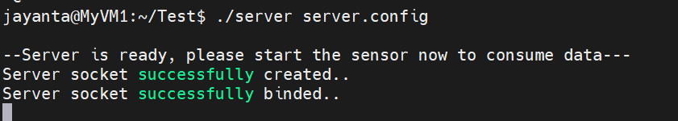

1. Launching sensor simulator – (1st arg – binary, 2nd arg – config file, 3rd arg - frequency of value generation(per second), 4th arg – device_id & 5th arg – measurement_id) – Please compile sensor_simulator.c with pthread option

$ ./sensor sensor.config 10 1 1

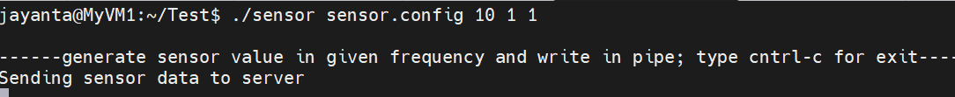

----After sensor simulator is launched, server starts capturing simulator output in given format----

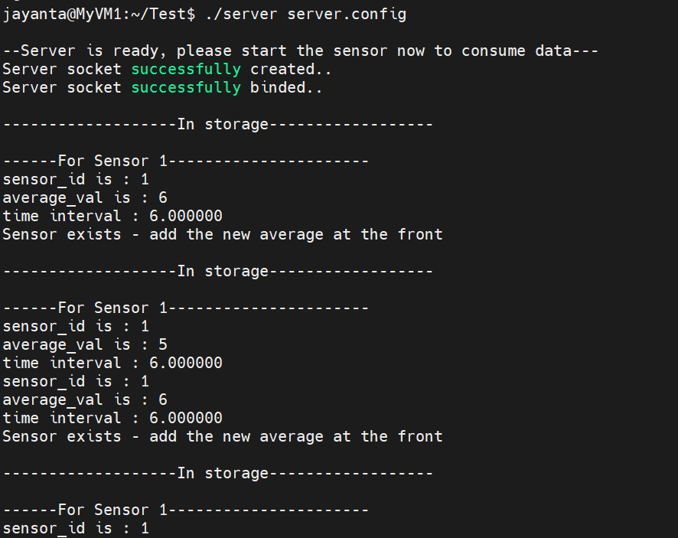

Once we see that Sensor average value is available in server memory we could query from client otherwise we would get “n/a”

6. Launching user/client - (1st arg – binary, 2nd arg – server ip, 3rd arg – server port) – to compile client

$ ./client 127.0.0.1 8080

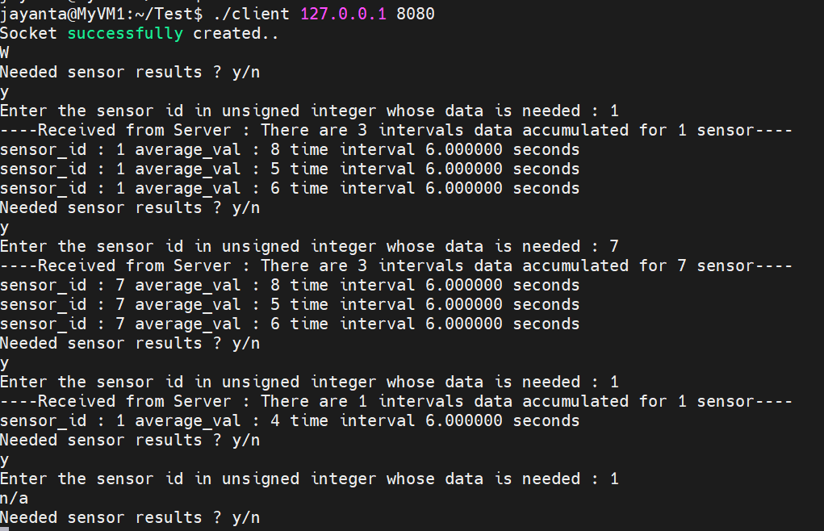

Files provided for this task to meet

1. sensor_simulator.c - sensor simulator
2. server.c - reads sensor vmeasurements, calculates average and manages user/client's request as per given requirement
3. client.c - User/client - who would query sensor data from server
4. server.config – server config file
5. sensor.config – sensor config file
6. Makefile - to make server.c