**Phase 3**

**SQL Operations**

**3.1 Insert records from 42_District_wise_crimes_committed_against_women_2001_2012.csv into a table.**

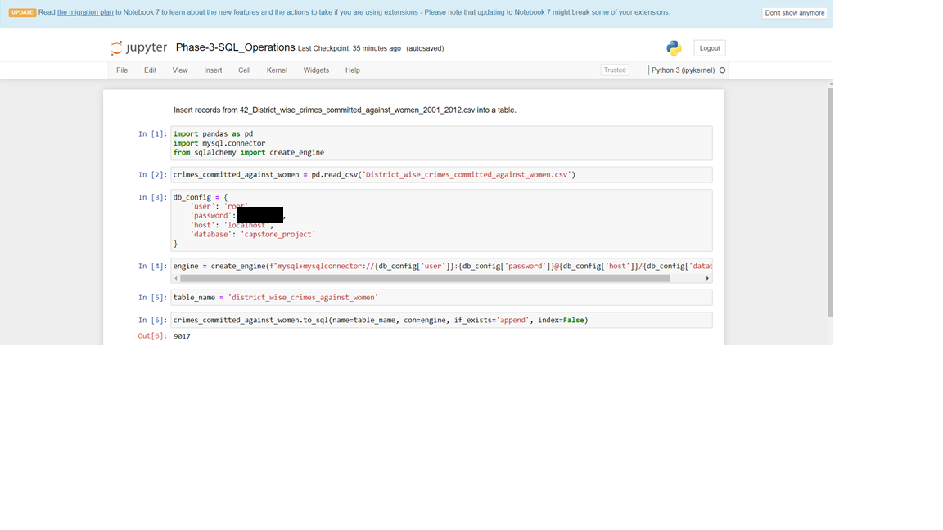

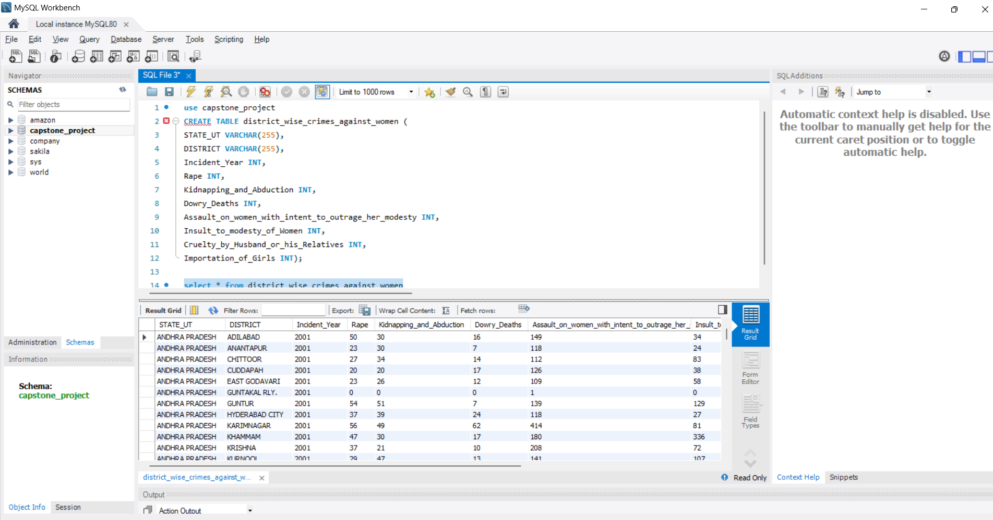

**3.2 Write SQL query to find the highest number of rapes & Kidnappings that happened in which state, District, and year.**

**Highest number of rapes in District and Year**

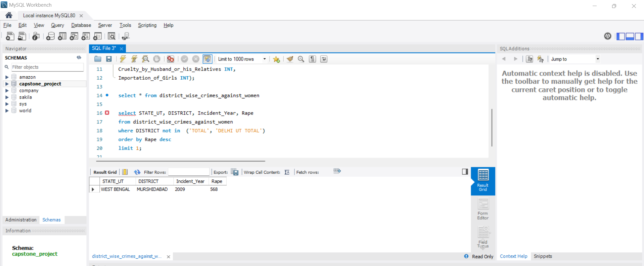

**Highest Kidnappings that happened in District and Year**

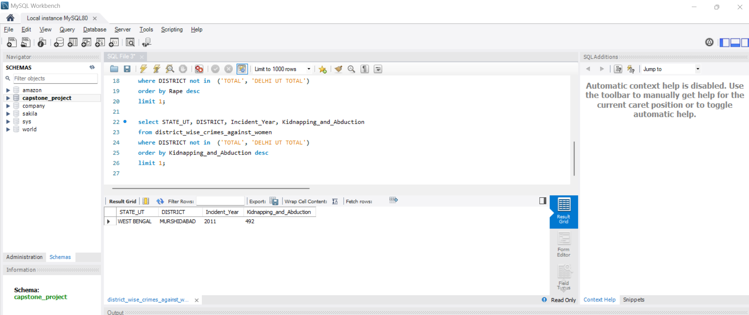

**3.3 Write SQL query to find All the lowest number of rapes & Kidnappings that happened in which state, District, and year.**

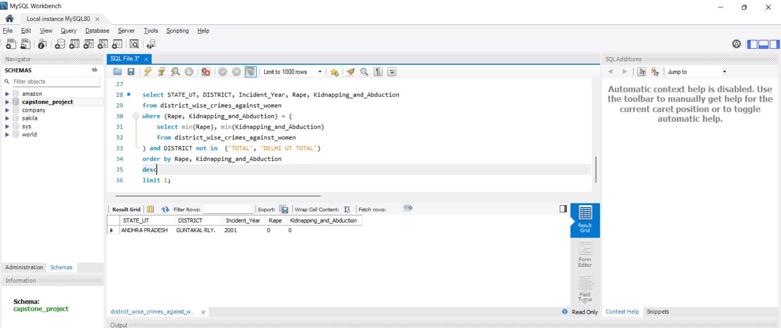

**3.4 Insert records from 02_District_wise_crimes_committed_against_ST_2001_2012.csv into a new table**

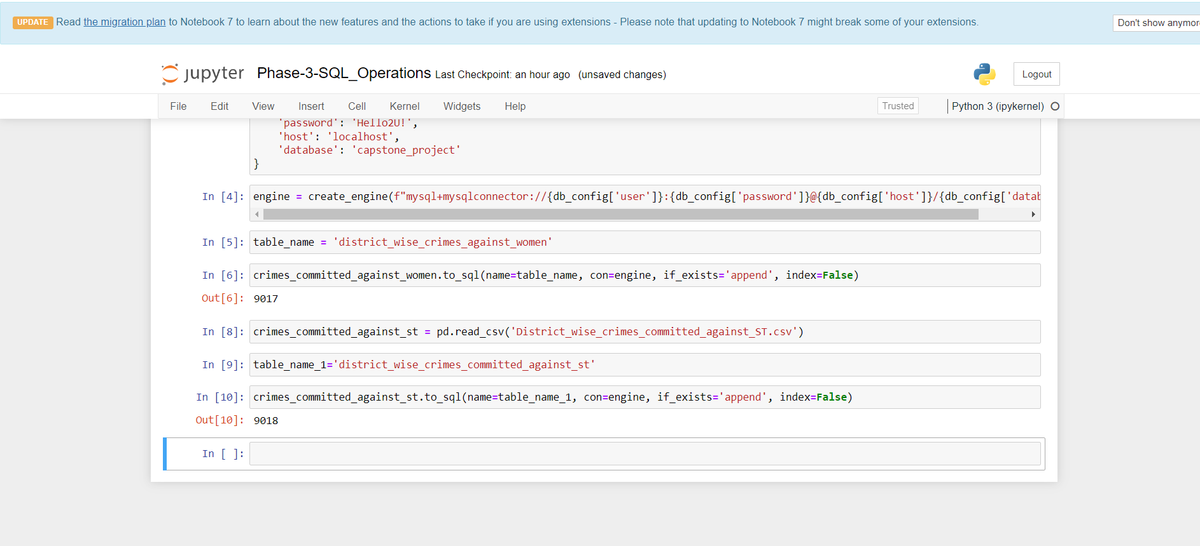

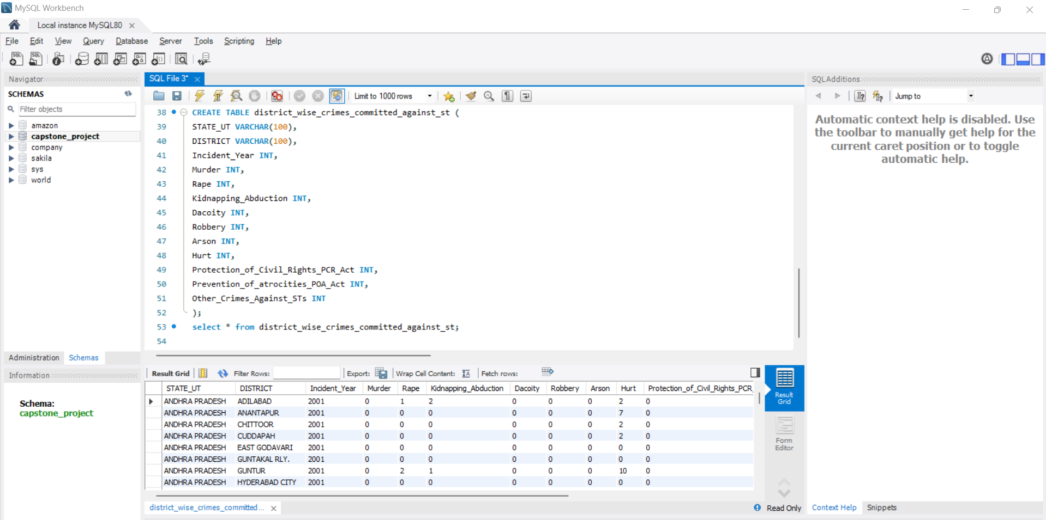

**3.5 Write SQL query to find the highest number of dacoity/robbery in which district.**

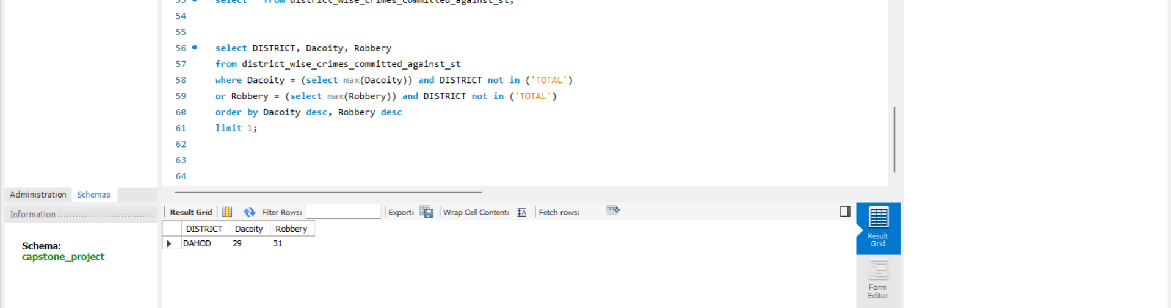

**3.6 Write SQL query to find in which districts (All) the lowest number of murders happened.**

**3.7 Write SQL query to find the number of murders in ascending order in district and year wise**

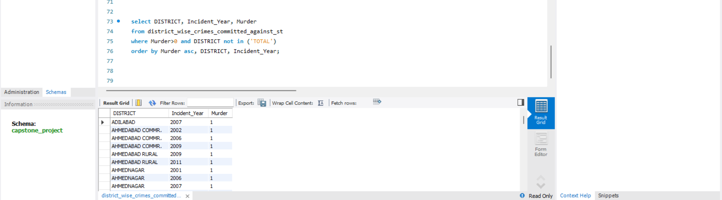

**3.8.1 Insert records of STATE/UT, DISTRICT, YEAR, MURDER, ATTEMPT TO MURDER, and RAPE columns only from 01_District_wise_crimes_committed_IPC_2001_2012.csv into a new table.**

**3.8.2 Write SQL query to find which District in each state/UT has the highest number of murders year wise. Your output should show STATE/UT, YEAR, DISTRICT, and MURDERS.**

