1.

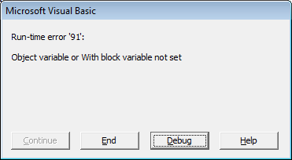

Reason:

nod = file.createNode(1, "AUTOSAR", "")

correction:

set nod = file.createNode(1, "AUTOSAR", "")