Project Document
StarUML Sample
:UCS
Usecase Specification Document


PLASTIC SOFTWARE INCORPORATION
http://www.staruml.com
Document Revision History
Rev# | Date | Affected Section | Author
1

Table of Contents
1. Introduction 6
1.1. Objective 6
1.2. Overall Description 6
2. Use-Case Diagram 7
2.1. Main Diagram 7
3. Actor Specification 8
3.1. Admin 8
3.1.1. Description 8
3.2. Customer 8
3.2.1. Description 8
3.3. IMS 8
3.3.1. Description 8
3.4. PayPal 8
3.4.1. Description 8
4. Use-Case Specification 9
4.1. Login 9
4.1.1. Description 9
4.1.2. Flow of Events 9
4.1.3. Pre-Conditions 9
4.1.4. Post-Conditions 9
4.2. Make Payment 9
4.2.1. Description 9
4.2.2. Flow of Events 9
4.2.3. Pre-Conditions 9
4.2.4. Post-Conditions 9
4.3. Manage 10
4.3.1. Description 10
4.3.2. Flow of Events 10
4.3.3. Pre-Conditions 10
4.3.4. Post-Conditions 10
4.4. Manage Order 10
4.4.1. Description 10
4.4.2. Flow of Events 10
4.4.3. Pre-Conditions 11
4.4.4. Post-Conditions 11

List of Figure
Figure 1 – Use-Case Diagram of Main 7

Introduction

Objective
This document is Usecase Specification Document generated from UCS template document by StarUML Generator.

Overall Description
This document describes….

Use-Case Diagram

Main Diagram

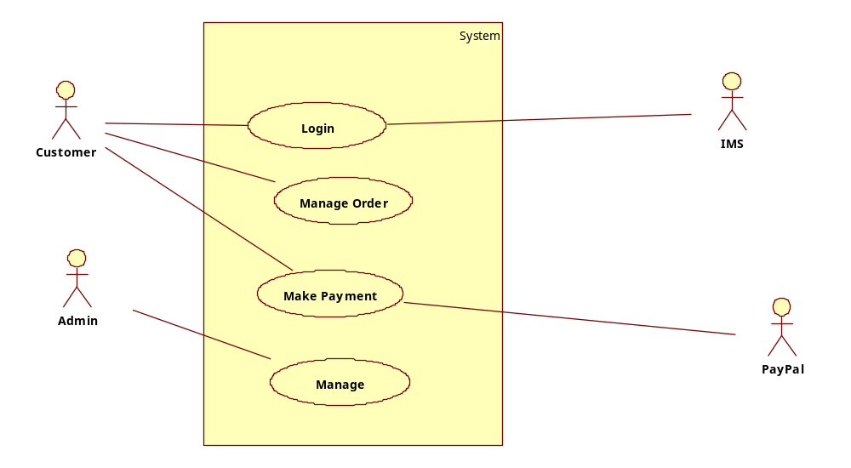
Figure 1 – Use-Case Diagram of Main

Actor Specification

Admin

Description

Customer

Description

IMS

Description

PayPal

Description

Use-Case Specification

Login

Description

Flow of Events

Basic Flow

Alternative Flow

Pre-Conditions

Post-Conditions

Make Payment

Description

Flow of Events

Basic Flow

Alternative Flow

Pre-Conditions

Post-Conditions

Manage

Description

Flow of Events

Basic Flow

Alternative Flow

Pre-Conditions

Post-Conditions

Manage Order

Description
1. The system retrieves a list of available Products from the existing Inventory System and displays the list to the Customer.
2. The Customer selects the product and system displays the available items in the selected Product.
3. Once the Customer has made his/her selections, the system creates a Order for the Customer containing the selected Product details.
4. System displays a Order Confirmation number to the customer.

Flow of Events

Basic Flow

Alternative Flow

Pre-Conditions

Post-Conditions

Index

Ａ
Admin 8
Ｃ
Customer 8
Ｉ
IMS 8
Ｌ
Login 9
Ｍ
Main 7
Make Payment 9
Manage 10
Manage Order 10
Ｐ
PayPal 8

