AUDIO & COMMUNICATION SYSTEMS
PRODUCT SYSTEM DESIGN
DELCO ELECTRONICS CORPORATION

FEATURE IMPLEMENTATION BEST PRACTICE

Delco Electronics
Serial Interface Protocol

Version 1.1

July 27, 1997

Copyright Delco Electronics Corporation, 1997.
Delco Electronics Corporation reserves the right to make changes to this document. Although the information in this document is believed to be reliable, Delco Electronics Corporation does not assume any liability arising out of the application described herein; neither does it convey any license under its patent rights nor the rights of others.

Author: Roger McDanell & Doug Hawkins

Maintained by:
Doug Hawkins
Delco Electronics Corporation
1800 East Lincoln Road
Mail Station E110
Kokomo, IN 46904
Phone: (765) 451-8693
GM line: 8-322-8693
Fax.: (765) 451-1340
TABLE OF CONTENTS
1. Purpose
2. Scope
3. General Information
4. Assumptions
5. Terms
5.1 Reliable Node:
5.2 Synchronization:
5.3 NP:
5.4 Packets:
6. Escape Sequences
7. Packets
7.1 Data Packet Format:
7.2 Control Packet Format:
7.3 Packets Usage:
8. Start-up Process
9. Normal Operation
10. Flow Charts

Purpose
The purpose of this document is to specify the Delco Electronics Serial Interface Protocol (DESIP).

In its preliminary releases, information in this document is subject to change.

Scope
This document contains the low level specifications for implementing a DESIP link.

General Information
DESIP is a protocol for a full duplex serial link between two devices. It features software flow control, reliability through the use of retransmission of packets, mixing of reliable and non-reliable nodes, low packet overhead, full duplex continuous communications, low link set-up configuration, and arbitrary (up to an application defined maximum) packet size. It is scalable in its implementation and may be easily implemented on even modest hardware platforms (i.e. 8-bit microprocessors).

It borrows some of its ideas from the data link control standard HDLC. These are: go-back-n ARQ (automatic repeat request), sending multiple packets without acknowledgement, and acknowledging multiple packets with a single acknowledgement. These ideas allow for full duplex continuous communications.

These ideas are extended by making the window size, ‘n’, of the go-back-n ARQ dynamically controlled by the receiver’s buffer status (down to zero) which results in software flow control of packets. A simple requirement that the transmit identification number is adapted to that requested (whether or not this implies retransmission) allow reliable and non-reliable nodes to be used together, and allows ‘partially reliable’ nodes which means that a transmitter may choose which packets must be reliably delivered.

Assumptions
A serial channel with an alphabet of 257 characters is assumed (256 characters for data and 1 character for message separator). For inherently 8-bit channels such as a UART, an escape sequence may be used to provide the 257 character alphabet.

The serial channel must have a low-level capability to receive all transmitted characters. These characters do not necessarily need to be received without error, but they should not be dropped in normal operation. Hardware handshaking is not required.

A property of a properly implemented DESIP protocol is that receivers can accept all transmitted packets. Control packets may be transmitted at any time and are processed completely upon reception. Permission to transmit data packets is pre-negotiated which means that packet buffer overruns cannot occur.

Terms

Reliable Node:
A reliable node is a node which: (i) issues a Nack (negative acknowledge) upon reception of packets out of order and (ii) retransmits data upon reception of a Nack or a timeout with acknowledgements pending. It will, upon reception of a Nack, reset its transmit identifier to match the identifier which is requested and retransmit data.

A non-reliable node is a node which violates either or both of (i) or (ii) above. Violation of (i) usually means that the receiver places more importance on avoiding the delay associated with a go-back-n retransmit operation than it places on avoiding dropped packets, and will thus acknowledge any packet it successfully receives. Violation of (ii) usually means that the transmitter does not have enough memory to buffer multiple possible retransmissions and places more importance on utilizing the full transmit window size than it places on avoiding dropped packets by not retransmitting. Note that even if (ii) is violated, and retransmissions do not occur, a non-reliable node is still required to reset its transmit identifier to match the identifier which is requested upon reception of a Nack.

DESIP allows reliable and non-reliable nodes to be used together. Which types of nodes are implemented is a system level decision.

Synchronization:
Synchronization of packets is accomplished unambiguously through the use of a special character called a Message Seperator (SEP).

NP:
Number of packets a receiver can currently buffer. Transmitters initially assume their corresponding receivers can buffer zero packets.

Packets:
Packets are of two types: data or control (indicated by the Cntl bit). A device has to be able to receive a control packet at any time. Multiple data packets can be sent consecutively without acknowledgement based upon the receiving node’s NP value. A receiving node has to reply with acknowledge(s) within TBD time.

Escape Sequences
Since a serial channel with an alphabet of 257 characters is assumed, implementation of DESIP over inherently 8-bit channels such as a UART requires some method of extending the alphabet. Although the choice of this method is not formally part of the definition of DESIP, a default method is described below. Obviously, whatever method is used, both ends of the communication must agree.

The method described here extends the native 256 character alphabet of an 8-bit interface to 257 characters as follows. Two consecutive characters are chosen to be remapped in order to make room for 2 special characters: ESC (escape) and SEP (Message Separator). The remapping involves simply adding a constant to the original character and preceeding it in the output stream with the ESC character. The particular values are ESC = 0x1b and SEP = 0x1c and the constant is 2. The resultant encoding of the 257 character alphabet is as follows:

0x00..0x1a and 0x1d..0xff | 0x00..0x1a and 0x1d..0xff
0x1b | 0x1b 0x1d
0x1c | 0x1b 0x1e
SEP | 0x1c

Notice that the use of the SEP character is unambiguous. SEP is not used after the ESC character as would be the case in most simple escape sequence methods.

There are 254 illegal sequences of the form <ESC><char>. These sequences are never transmitted, but may be received because of a channel error. Illegal sequences should be ignored.

Packets
Packets are separated by the SEP character. A stream of data would look like:

SEP
Packet
SEP
SEP
Packet

Data Packet Format:

byte 0 |  |  |  |  | byte 1 |  | byte 2 to byte 2 + Length -1 | byte 2 + Length
Cntl=0  (1) | Force  (1) | Nack  (1) | res  (1) | TxID  (4) | RxNP  (4) | RxID  (4) | Data  (8)*Length | Checksum  (8)

Cntl: 0 = Data packet
Force: 0 = --- 1 = Response demanded
Nack: 0 = --- 1 = Packet received out of sequence
res: Reserved for future use -- write as 0
TxID: ID (count) of current packet range 0-15
RxNP: Report of node’s current NP range 0-15
RxID: ID of last acknowledged packet range 0-15
Data: Application specific -- may be zero length
Checksum: 1’s complement of the sum of the 2 header bytes and the data bytes XOR’d with their corresponding data indices starting at 1 (i.e. Checksum = ~ [ (byte 0) + (byte 1) + xor(1, byte2) + xor(2, byte 3) + ... + xor(Length, byte Length+1) ]).

Control Packet Format:

byte 0 |  |  |  |  | byte 1 |  | byte 2
Cntl  =1  (1) | Force  (1) | Nack  (1) | res  (1) | RxLen  (4) | RxNP  (4) | RxID  (4) | Checksum  (8)

Cntl: 1 = Control packet
Force: 0 = --- 1 = Response demanded
Nack: 0 = --- 1 = Packet received out of sequence
res: Reserved for future use -- write as 0
RxLen Scaler for computing maximum receivable packet length range 0-15
where: Maximum Packet Length = 2^{(RxLen)}
Maximum Packet Length range: 1-32768 in 2^{n} increments
RxNP: Report of node’s current NP range 0-15
RxID: ID of last acknowledged packet range 0-15
Checksum: 1’s complement of the sum of the 2 header bytes

Packets Usage:
Data packets are those which have the Cntl bit = 0. A node must have permission to send a data packet. A data packet contains data that is specific to an application. In normal operation, two serial devices can be communicating in full duplex sending data packets and using the RxID field to piggy-back acknowledgement of received packets. In general, a transmitting device will send 1 thru NP packets to a receiving device (NP is the number of packets the receiving device can buffer). Each time a transmitter sends a packet, it increments its TxID field. When the transmitting device receives an acknowledge from the other device, it will re-compute how many data packets it can transmit. The computation is simply the value of the RxNP field reduced by the number of unacknowledged packets already transmitted. That is, the number of packets Node_A can send is computed as:

TxNP_{Node_A} = [ RxNP_{Node_B} - (( TxID_{Node_A} - RxID_{Node_B}) mod 16)] .

The RxID in the received data packet indicates that the receiving device has successfully processed up to and including that ID of the transmitter’s packets. Notice that it is not necessary to acknowledge every packet transmitted, therefore, an acknowledge means, since the receiver’s last acknowledge, all packets up to and including RxID were received sequentially and processed such that buffer space is available for RxNP more packets.

The purpose of the Force and Nack bits is as follows:

Force: This flag is used to force a response from the other device. When a device receives a packet with the Force flag set, it must transmit a control packet.

Nack: This flag is used for error control. When a device has received data packets out of order, it should transmit a packet with this bit set. The RxID field contains the ID of the last good packet received, any packets that followed are considered to be in error. By definition, all packets after this ID should be retransmitted by the other node for reliable communications. At the very least, upon reception of a Nack, a non-reliable transmitter must change its TxID to the value of RxID (i.e. tell the other end what he wants to hear).

Control packets are those which have the Cntl bit = 1. A device can send a control packet at any time. Control packets are used for initialization, flow control, error detection, and packet length limiting. One main difference between a control packet and a data packet is that a control packet does not carry any data and thus does not need the TxID field. The purpose of control packets is to distinguish between a control-only packet and a packet containing data with zero length. The only other difference is the RxLen field. This parameter is used to limit the maximum packet size that a node is willing to receive, any packet data received beyond this length would be lost. RxLen is intended to be a static parameter, once it its reported, it should not change within that power cycle. In general, transmitted packets can be of any length so long as they do not exceed the packet length encoded by the RxLen field (i.e. Packet Length = 2^{(RxLen)}).

Start-up Process
At start-up, nodes do not have permission the send data packets to one another because the NP default is zero. Therefore, when a node first starts up, it would send a control packet with Force = 1, RxNP and RxLen set accordingly. This informs the receiving node of the transmitter’s limitations, and forces the receiver to return the same information. Upon this return, permission to transmit would more than likely have been granted to both nodes. (Note: The very first packet on the bus should be preceded with a SEP; there after, SEP’s would follow a packet to initiate immediate decoding on the receiving end.)

Normal Operation
When in normal operation, two nodes can be communicating in a full duplex fashion. Node_A will transmit multiple packets (Node_B’s NP > 1) to Node_B. At some point, Node_B will transmit an acknowledge followed by data if any. Likewise, Node_A will also acknowledge Node_B as it sends even more data. In the event of a packet received out of sequence, a node would send a Nack, thereby indicating all previously good data packets, and those thereafter which need retransmitted.

Flow Charts
Shown below is a set of recommended flow charts for proper protocol implementation.

This implementation is based on polling. Event driven implementations are possible, but not shown. The interface is as follows: SIPOpen ( ) should be called once upon system initialization. SIPFSM ( ) should be called periodically to service the various transmit and receive requirements. SIPXmit ( ) and SIPRecv ( ) are the user interface for sending and receiving packets.

The details of the GetChr9 ( ) and PutChr9 ( ) functions are omitted since their implementation is not formally part of the definition of DESIP. Nonetheless, it should be noted that both functions use an alphabet of 257 characters.

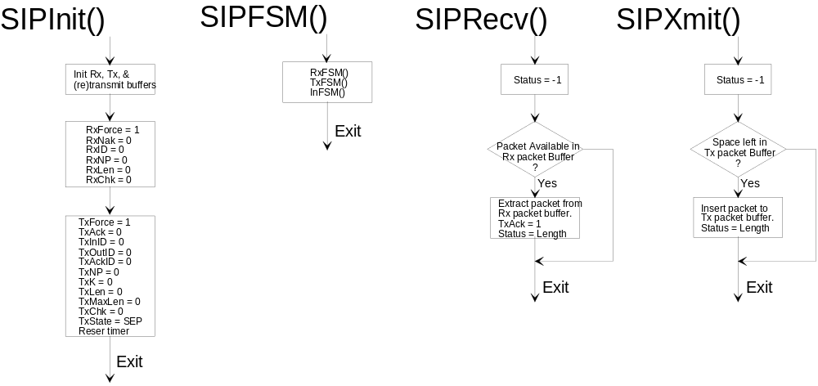

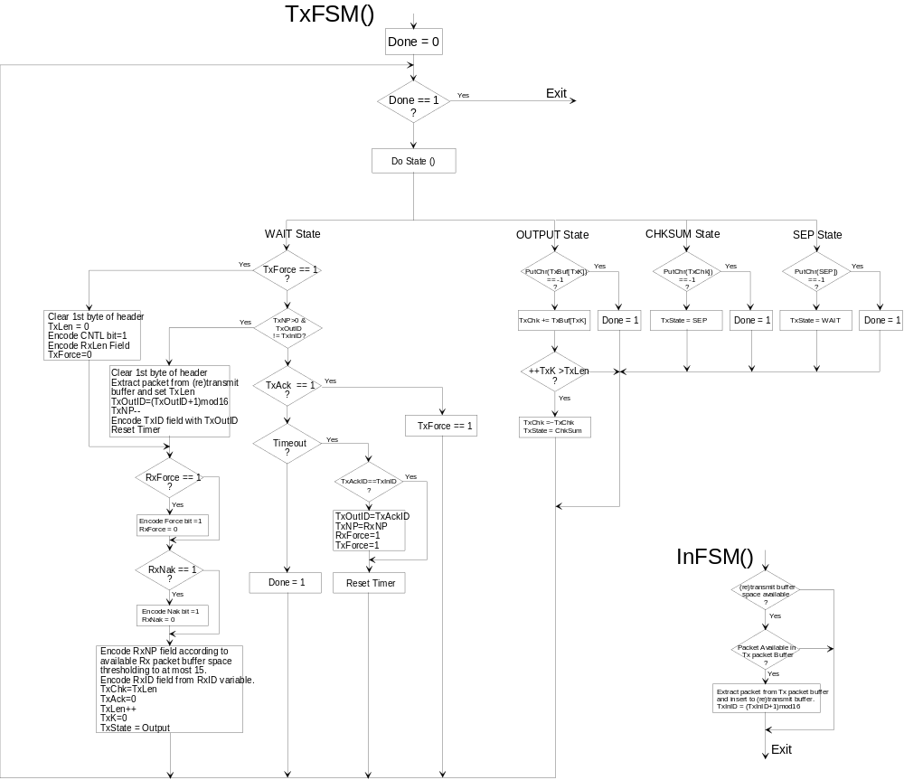

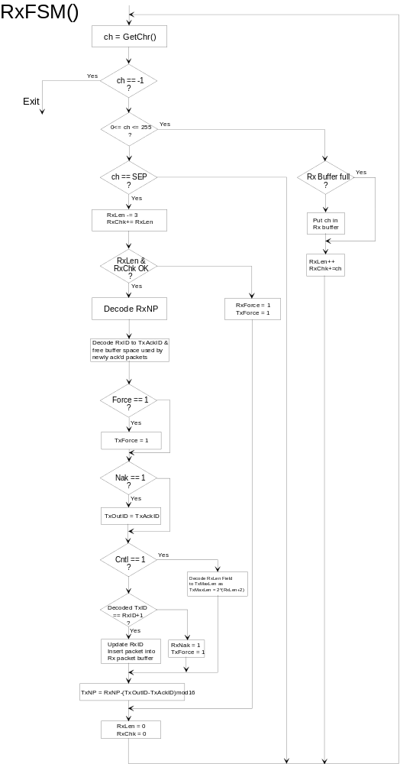
REVISION LOG

Date | Requester | Section | Details
5/6/97 | D. Hawkins | All | Initial release: Version 1.0
7/29/97 | R. McDanell | 7,10 | Changed field width of RxLen, definition of check sum, updated flowcharts

