
ICUP

Prepared for Infotainment Ip Service
Document: SDD-<Roster Number>-<XXX>
Prepared by: Dennis Arkeryd
Date: 2016-06-30 Version: 0.2

Revision History

Version | Date | State | Author | Company/  Department | Change Description
0.1 | 20160620 | draft | Dennis Arkeryd | Volvo Cars | Initial revision with class and component diagrams.
0.2 | 20160630 | draft | Dennis Arkeryd | Volvo Cars | Added diagnostics to class and component diagrams.
0.3 | 20160708 | Draft | Abhijeet Shirolikar | Delphi ID&I | Added IPLink Manager class and component diagram.
States of this document: draft, reviewed, approved, final
Table of Contents
1 Introduction 3
1.1 Purpose 3
1.2 Scope 3
1.3 Definitions, acronyms, and abbreviations 3
1.4 References 3
1.5 Overview 3
2 Software structure and interfaces 4
3 Dynamic behavior and algorithms 6
4 Resource consumption objectives 6
5 Test criteria 6
6 Open issues 6
7 Appendixes 6

Introduction

Purpose
The purpose of this document is to give developers an architecture and design overview for the Infotainment Ip Service component.

Scope
Infotainment IP Service acts as message broker between (other) applications on the IHU, using CommonAPI / Franca IPC interfaces, and other ecu:s on the Infotainment IP Bus (VCM, TEM), using the Infotaiment Ip Bus / IP Command protocol.

Definitions, acronyms, and abbreviations
Abbreviation | Explanation
IHU | Infotainment Head Unit
VCM | Vehicle Connectivity Master
TEM | Telematics Module
OTA | Over The Air Services (for software download management)
Source Selector | Component responsible for selecting internet source
Pdu | Protocol data unit (message)
IDL | Interface Description Language
IPC | Inter Process Communication
CommonAPI | Genivi compliant IPC standard
Franca | IDL for CommonAPI
Ip Command Protocol | Transport layer of VCC IP protocol
Infotainment Ip Bus | Servicer layer of VCC IP protocol
GNSS | Global Navigation Satellite System
Diagnostics | Diagnostics service application (DTC handling)
NSM | Node State Manager (powermoding)

References
No. | Document Name | Date | Version | Location

Overview

Responsibilities
- The Infotainment IP Service is responsible for low-level ASN.1 coding as defined in the VCC IP Command Bus Specification #31841985, found here.
- It is also responsible for the transport protocol, including retries and acknowledge of UDP messages.
- It provides a number of interfaces, grouped into services (Similar to MOST Function Blocks) like Positioning, Connectivity, Telematics, Phone, OTA, IP Link Manager etc.
- In cases where the server is deployed on a remote ECU, like VCM, the interface shall provide methods to request the server and broadcast status notifications to the clients which wants to access the server. In this case, the stub of the provided interface shall be implemented by the Infotainment IP Service.
- In cases where the server is local, i.e. deployed on the IHU, the interface shall be defined by the server application and the proxy is implemented by the Infotainment IP Service. It must listen to broadcasts from the server application and listen to notification requests from the remote ECUs, like VCM, and provide the broadcasted information to the subscribing remote clients.

Currently provided interfaces are:
- Connectivity
- Enhanced Position (Dead Reckoning)
- GNSS
- OTA
- WLAN
- IP Link Manager

The interfaces are defined in Franca IDL, and CommonAPI C++ is used as the IPC language binding API for C++.
This document currently contains the software structure and interfaces documentation. The remaining chapters are TBD.

Software structure and interfaces

Infotainment Ip Service component diagram.

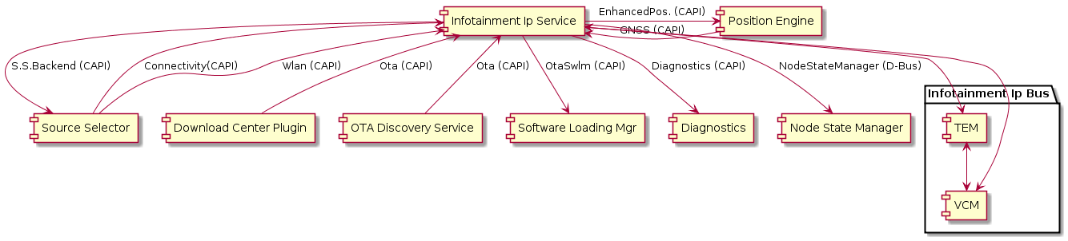

Infotainment Ip Service class diagram (transport layer is simplified).

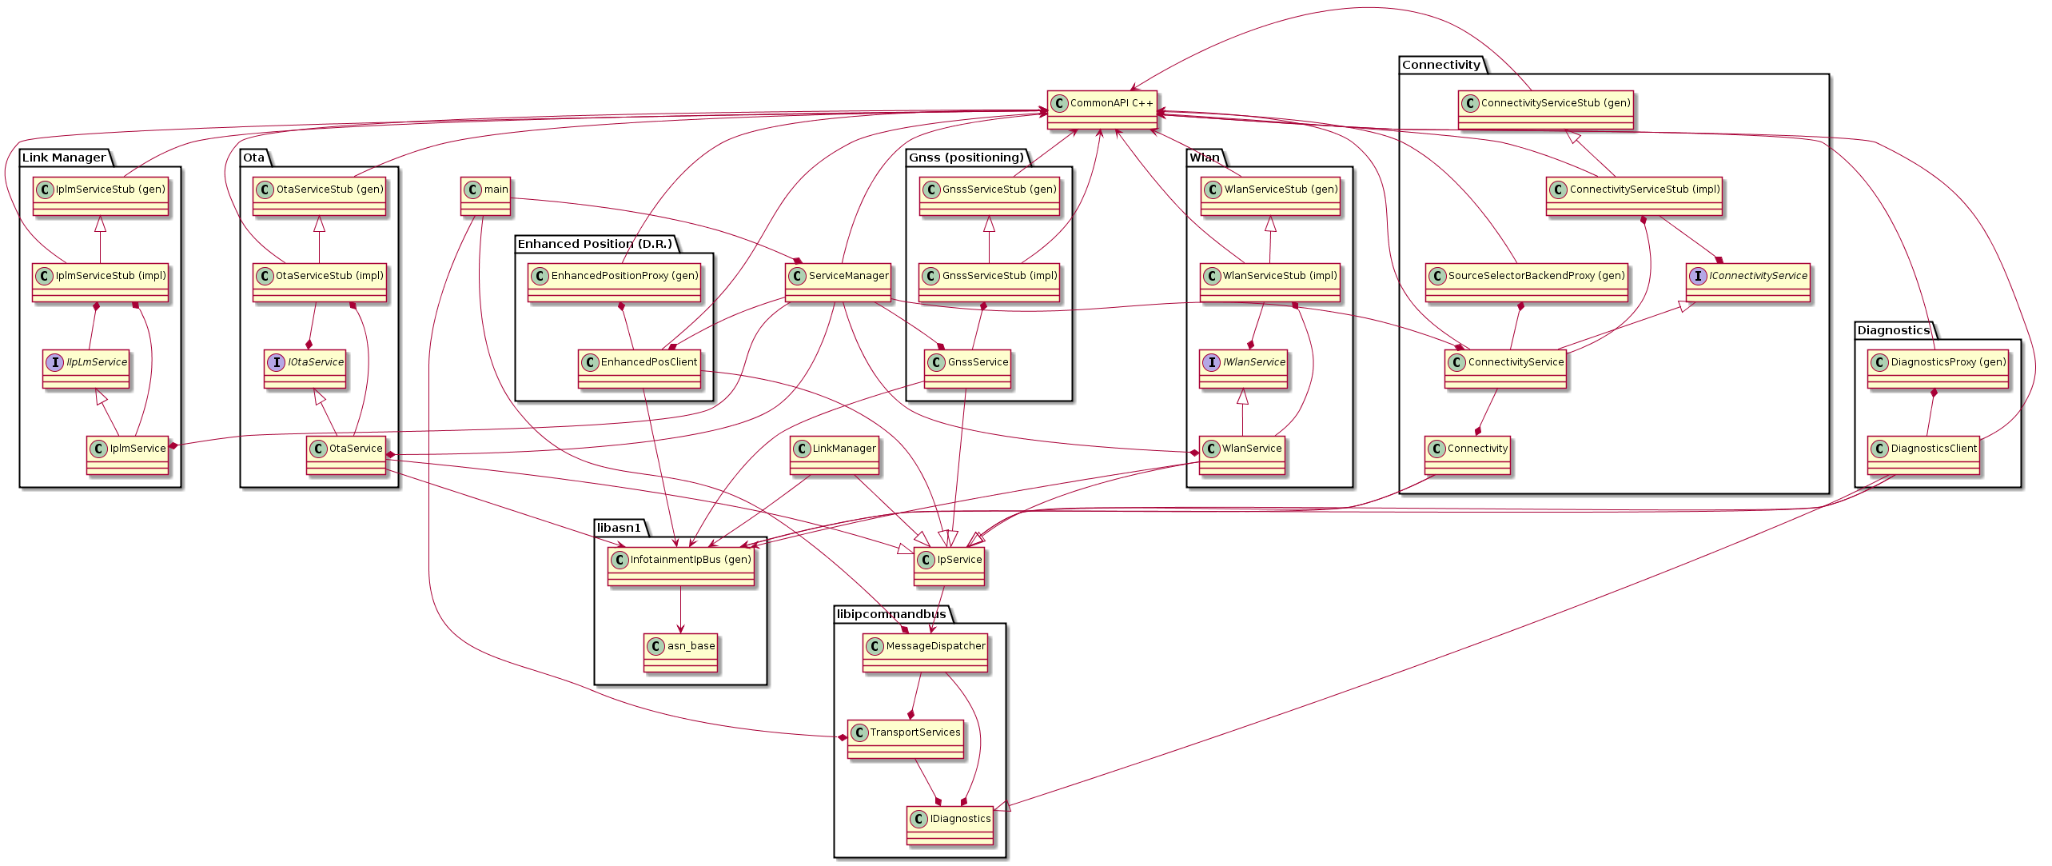

Class diagram for transport layer.
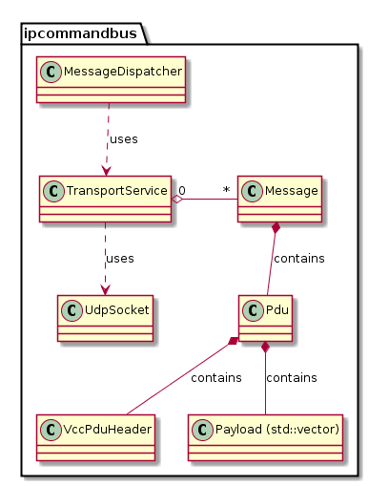

Dynamic behavior and algorithms

TBD

Resource consumption objectives

TBD

Test criteria

TBD

Open issues

No. | Issue | Comments / Proposed Solution | Person responsible | Issue to be resolved by date

Appendixes

