**Program Structures & Algorithms  
Spring 2022  
Assignment No. 4**

Name: Jayanth Vakkalagadda  
(NUID): 002950342

**Task**

* Implement a parallel sorting algorithm such that each partition of the array is sorted in parallel. You will consider two different schemes for deciding whether to sort in parallel.
* (Part 1) A cutoff (defaults to, say, 1000) which you will update according to the first argument in the command line when running. It's your job to experiment and come up with a good value for this cutoff. If there are fewer elements to sort than the cutoff, then you should use the system sort instead.
* (Part 2) Recursion depth or the number of available threads. Using this determination, you might decide on an ideal number (t) of separate threads (stick to powers of 2) and arrange for that number of partitions to be parallelized (by preventing recursion after the depth of lg t is reached).
* (Part 3) Implement a main program to run the following benchmarks: measure the running times of this sort.
* Show the results of your experiments and draws a conclusion (or more) about the efficacy of this method of parallelizing sort.
* Experiments should involve sorting arrays of sufficient size for the parallel sort to make a difference. You should run with many different array sizes (they must be sufficiently large to make parallel sorting worthwhile, obviously) and different cutoff schemes.

**Relationship Conclusion**

We have run simulations of experiments with different combinations of the cutoff values, threads and array sizes. From the observations of the runtimes, we can conclude that four threads is the optimal choice and there wouldn’t be much improvement in algorithm performance beyond four threads.

The lowest runtime is achieved when the cutoff value is 25% of the array size.

For recursion depth and number of threads available

Maximum depth possible:

Any depth more significant than the max depth is not feasible as the partitioned arrays hit the cutoff and turned into a system sort.

**Evidence to the Conclusion**

Below are the runtimes in ‘ms’ for different combinations of Array size, threads, and cutoffs.

Array size = 50000

|  |  |  |  |  |  |  |
| --- | --- | --- | --- | --- | --- | --- |
|  | Thread | | | | | |
| **Cutoff** | **2** | **4** | **8** | **16** | **32** | **64** |
| 5000 | 167 | 35 | 41 | 22 | 25 | 31 |
| 10000 | 101 | 25 | 22 | 22 | 34 | 22 |
| 15000 | 45 | 40 | 28 | 34 | 19 | 29 |
| 20000 | 37 | 35 | 21 | 18 | 15 | 17 |
| 25000 | 33 | 41 | 28 | 15 | 33 | 32 |
| 30000 | 67 | 35 | 27 | 33 | 33 | 27 |
| 35000 | 33 | 36 | 33 | 30 | 18 | 37 |
| 40000 | 85 | 32 | 33 | 22 | 33 | 19 |
| 45000 | 65 | 35 | 20 | 34 | 36 | 36 |
| 50000 | 34 | 36 | 36 | 22 | 32 | 32 |

Array size = 100000

|  |  |  |  |  |  |  |
| --- | --- | --- | --- | --- | --- | --- |
|  | Thread | | | | | |
| **Cutoff** | **2** | **4** | **8** | **16** | **32** | **64** |
| 5000 | 204 | 78 | 72 | 64 | 48 | 46 |
| 10000 | 165 | 74 | 42 | 50 | 42 | 33 |
| 15000 | 107 | 52 | 48 | 33 | 36 | 51 |
| 20000 | 120 | 66 | 53 | 53 | 47 | 32 |
| 25000 | 113 | 40 | 49 | 47 | 32 | 51 |
| 30000 | 77 | 87 | 50 | 39 | 47 | 33 |
| 35000 | 77 | 47 | 48 | 49 | 48 | 54 |
| 40000 | 70 | 58 | 52 | 42 | 31 | 27 |
| 45000 | 91 | 44 | 48 | 48 | 42 | 49 |
| 50000 | 95 | 84 | 52 | 49 | 54 | 32 |

Array size = 200000

|  |  |  |  |  |  |  |
| --- | --- | --- | --- | --- | --- | --- |
|  | Thread | | | | | |
| **Cutoff** | **2** | **4** | **8** | **16** | **32** | **64** |
| 5000 | 351 | 127 | 116 | 158 | 144 | 113 |
| 10000 | 209 | 108 | 97 | 98 | 95 | 90 |
| 15000 | 154 | 99 | 119 | 102 | 97 | 97 |
| 20000 | 183 | 100 | 95 | 99 | 119 | 90 |
| 25000 | 125 | 102 | 113 | 114 | 101 | 81 |
| 30000 | 142 | 116 | 113 | 103 | 107 | 109 |
| 35000 | 164 | 100 | 109 | 98 | 110 | 118 |
| 40000 | 133 | 116 | 101 | 117 | 98 | 100 |
| 45000 | 123 | 101 | 98 | 115 | 110 | 108 |
| 50000 | 119 | 96 | 97 | 114 | 108 | 108 |

**Output Screenshot**

Array size = 50000

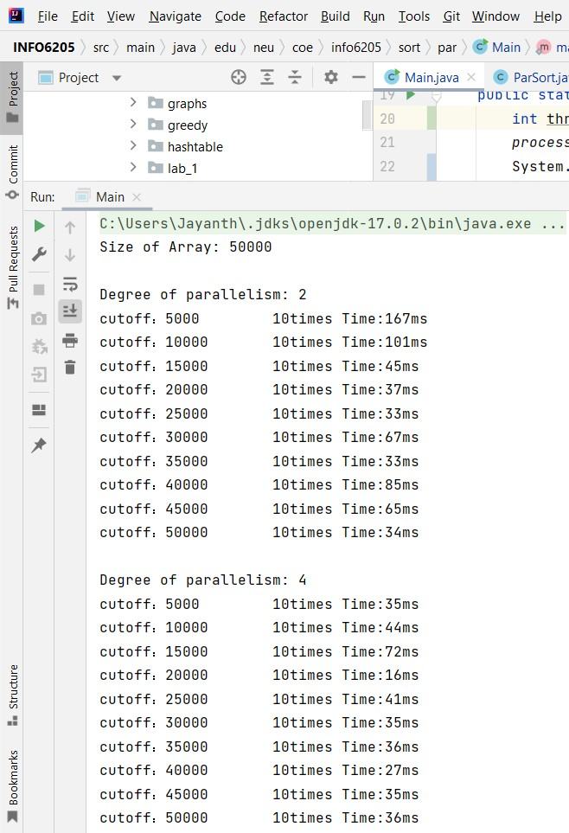

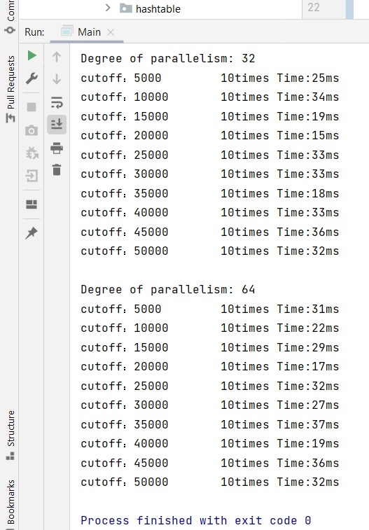

Array size = 100000

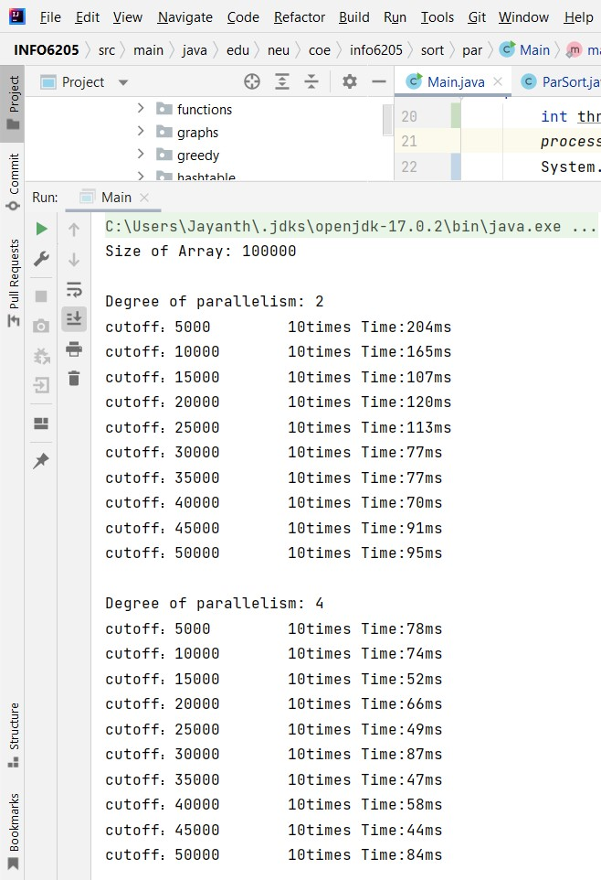

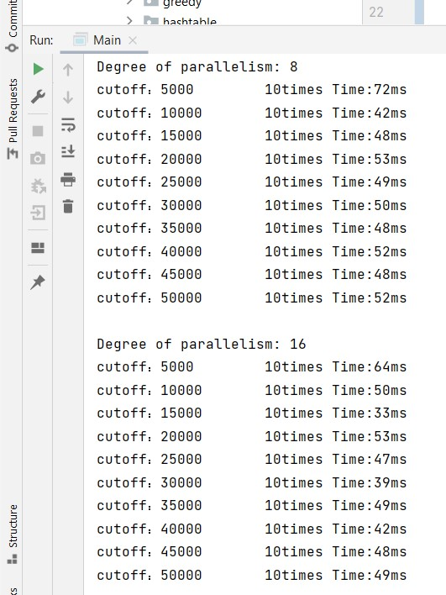

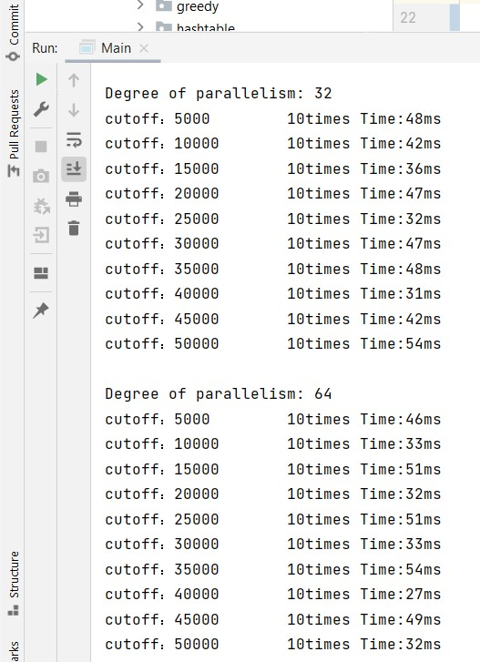

Array size = 200000

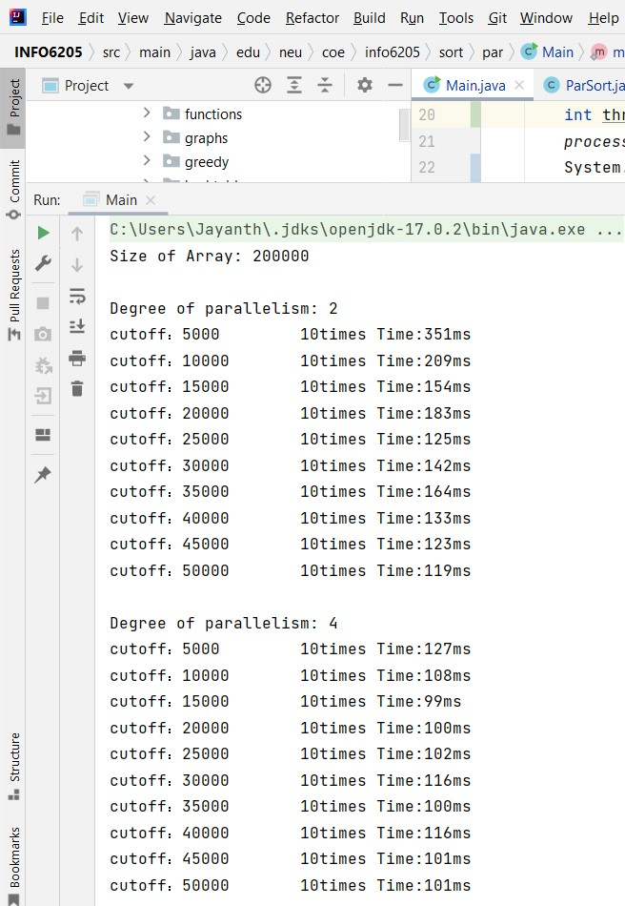

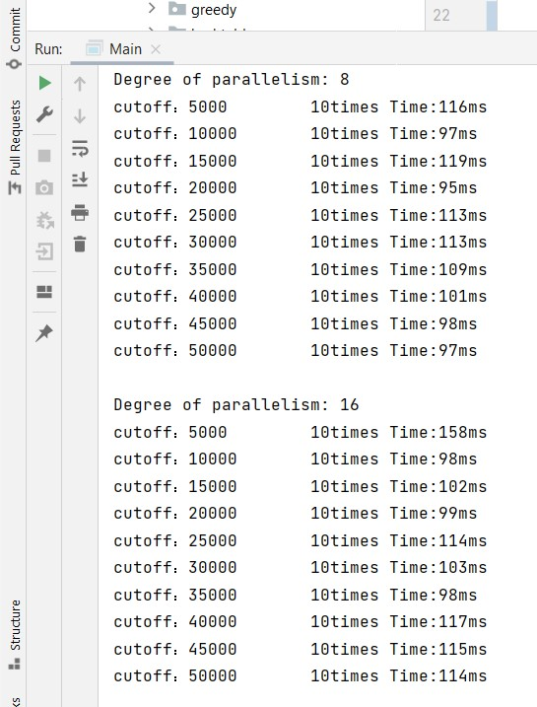

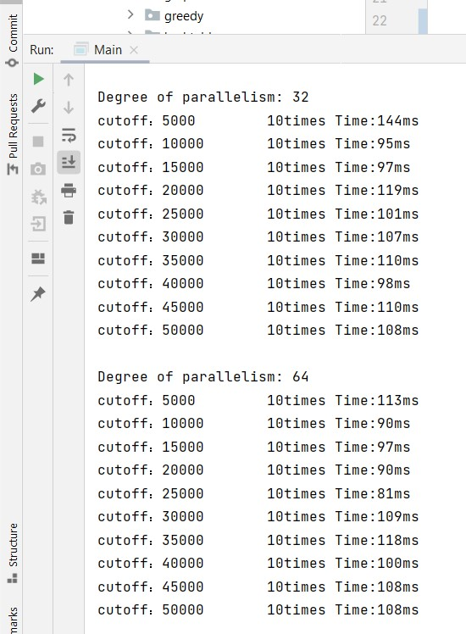

**Output**

Size of Array: 50000

Degree of parallelism: 2

cutoff：5000 10times Time:167ms

cutoff：10000 10times Time:101ms

cutoff：15000 10times Time:45ms

cutoff：20000 10times Time:37ms

cutoff：25000 10times Time:33ms

cutoff：30000 10times Time:67ms

cutoff：35000 10times Time:33ms

cutoff：40000 10times Time:85ms

cutoff：45000 10times Time:65ms

cutoff：50000 10times Time:34ms

Degree of parallelism: 4

cutoff：5000 10times Time:35ms

cutoff：10000 10times Time:44ms

cutoff：15000 10times Time:72ms

cutoff：20000 10times Time:16ms

cutoff：25000 10times Time:41ms

cutoff：30000 10times Time:35ms

cutoff：35000 10times Time:36ms

cutoff：40000 10times Time:27ms

cutoff：45000 10times Time:35ms

cutoff：50000 10times Time:36ms

Degree of parallelism: 8

cutoff：5000 10times Time:41ms

cutoff：10000 10times Time:22ms

cutoff：15000 10times Time:28ms

cutoff：20000 10times Time:21ms

cutoff：25000 10times Time:28ms

cutoff：30000 10times Time:27ms

cutoff：35000 10times Time:33ms

cutoff：40000 10times Time:33ms

cutoff：45000 10times Time:20ms

cutoff：50000 10times Time:36ms

Degree of parallelism: 16

cutoff：5000 10times Time:22ms

cutoff：10000 10times Time:22ms

cutoff：15000 10times Time:34ms

cutoff：20000 10times Time:18ms

cutoff：25000 10times Time:15ms

cutoff：30000 10times Time:33ms

cutoff：35000 10times Time:30ms

cutoff：40000 10times Time:22ms

cutoff：45000 10times Time:34ms

cutoff：50000 10times Time:22ms

Degree of parallelism: 32

cutoff：5000 10times Time:25ms

cutoff：10000 10times Time:34ms

cutoff：15000 10times Time:19ms

cutoff：20000 10times Time:15ms

cutoff：25000 10times Time:33ms

cutoff：30000 10times Time:33ms

cutoff：35000 10times Time:18ms

cutoff：40000 10times Time:33ms

cutoff：45000 10times Time:36ms

cutoff：50000 10times Time:32ms

Degree of parallelism: 64

cutoff：5000 10times Time:31ms

cutoff：10000 10times Time:22ms

cutoff：15000 10times Time:29ms

cutoff：20000 10times Time:17ms

cutoff：25000 10times Time:32ms

cutoff：30000 10times Time:27ms

cutoff：35000 10times Time:37ms

cutoff：40000 10times Time:19ms

cutoff：45000 10times Time:36ms

cutoff：50000 10times Time:32ms

Process finished with exit code 0

////////////////////////////////////////////////////////////////////////////////////////////////////////////////////////////////////////////////////////////////////////

Size of Array: 100000

Degree of parallelism: 2

cutoff：5000 10times Time:204ms

cutoff：10000 10times Time:165ms

cutoff：15000 10times Time:107ms

cutoff：20000 10times Time:120ms

cutoff：25000 10times Time:113ms

cutoff：30000 10times Time:77ms

cutoff：35000 10times Time:77ms

cutoff：40000 10times Time:70ms

cutoff：45000 10times Time:91ms

cutoff：50000 10times Time:95ms

Degree of parallelism: 4

cutoff：5000 10times Time:78ms

cutoff：10000 10times Time:74ms

cutoff：15000 10times Time:52ms

cutoff：20000 10times Time:66ms

cutoff：25000 10times Time:49ms

cutoff：30000 10times Time:87ms

cutoff：35000 10times Time:47ms

cutoff：40000 10times Time:58ms

cutoff：45000 10times Time:44ms

cutoff：50000 10times Time:84ms

Degree of parallelism: 8

cutoff：5000 10times Time:72ms

cutoff：10000 10times Time:42ms

cutoff：15000 10times Time:48ms

cutoff：20000 10times Time:53ms

cutoff：25000 10times Time:49ms

cutoff：30000 10times Time:50ms

cutoff：35000 10times Time:48ms

cutoff：40000 10times Time:52ms

cutoff：45000 10times Time:48ms

cutoff：50000 10times Time:52ms

Degree of parallelism: 16

cutoff：5000 10times Time:64ms

cutoff：10000 10times Time:50ms

cutoff：15000 10times Time:33ms

cutoff：20000 10times Time:53ms

cutoff：25000 10times Time:47ms

cutoff：30000 10times Time:39ms

cutoff：35000 10times Time:49ms

cutoff：40000 10times Time:42ms

cutoff：45000 10times Time:48ms

cutoff：50000 10times Time:49ms

Degree of parallelism: 32

cutoff：5000 10times Time:48ms

cutoff：10000 10times Time:42ms

cutoff：15000 10times Time:36ms

cutoff：20000 10times Time:47ms

cutoff：25000 10times Time:32ms

cutoff：30000 10times Time:47ms

cutoff：35000 10times Time:48ms

cutoff：40000 10times Time:31ms

cutoff：45000 10times Time:42ms

cutoff：50000 10times Time:54ms

Degree of parallelism: 64

cutoff：5000 10times Time:46ms

cutoff：10000 10times Time:33ms

cutoff：15000 10times Time:51ms

cutoff：20000 10times Time:32ms

cutoff：25000 10times Time:51ms

cutoff：30000 10times Time:33ms

cutoff：35000 10times Time:54ms

cutoff：40000 10times Time:27ms

cutoff：45000 10times Time:49ms

cutoff：50000 10times Time:32ms

Process finished with exit code 0

////////////////////////////////////////////////////////////////////////////////////////////////////////////////////////////////////////////////////////////////////////

Size of Array: 200000

Degree of parallelism: 2

cutoff：5000 10times Time:351ms

cutoff：10000 10times Time:209ms

cutoff：15000 10times Time:154ms

cutoff：20000 10times Time:183ms

cutoff：25000 10times Time:125ms

cutoff：30000 10times Time:142ms

cutoff：35000 10times Time:164ms

cutoff：40000 10times Time:133ms

cutoff：45000 10times Time:123ms

cutoff：50000 10times Time:119ms

Degree of parallelism: 4

cutoff：5000 10times Time:127ms

cutoff：10000 10times Time:108ms

cutoff：15000 10times Time:99ms

cutoff：20000 10times Time:100ms

cutoff：25000 10times Time:102ms

cutoff：30000 10times Time:116ms

cutoff：35000 10times Time:100ms

cutoff：40000 10times Time:116ms

cutoff：45000 10times Time:101ms

cutoff：50000 10times Time:101ms

Degree of parallelism: 8

cutoff：5000 10times Time:116ms

cutoff：10000 10times Time:97ms

cutoff：15000 10times Time:119ms

cutoff：20000 10times Time:95ms

cutoff：25000 10times Time:113ms

cutoff：30000 10times Time:113ms

cutoff：35000 10times Time:109ms

cutoff：40000 10times Time:101ms

cutoff：45000 10times Time:98ms

cutoff：50000 10times Time:97ms

Degree of parallelism: 16

cutoff：5000 10times Time:158ms

cutoff：10000 10times Time:98ms

cutoff：15000 10times Time:102ms

cutoff：20000 10times Time:99ms

cutoff：25000 10times Time:114ms

cutoff：30000 10times Time:103ms

cutoff：35000 10times Time:98ms

cutoff：40000 10times Time:117ms

cutoff：45000 10times Time:115ms

cutoff：50000 10times Time:114ms

Degree of parallelism: 32

cutoff：5000 10times Time:144ms

cutoff：10000 10times Time:95ms

cutoff：15000 10times Time:97ms

cutoff：20000 10times Time:119ms

cutoff：25000 10times Time:101ms

cutoff：30000 10times Time:107ms

cutoff：35000 10times Time:110ms

cutoff：40000 10times Time:98ms

cutoff：45000 10times Time:110ms

cutoff：50000 10times Time:108ms

Degree of parallelism: 64

cutoff：5000 10times Time:113ms

cutoff：10000 10times Time:90ms

cutoff：15000 10times Time:97ms

cutoff：20000 10times Time:90ms

cutoff：25000 10times Time:81ms

cutoff：30000 10times Time:109ms

cutoff：35000 10times Time:118ms

cutoff：40000 10times Time:100ms

cutoff：45000 10times Time:108ms

cutoff：50000 10times Time:108ms

Process finished with exit code 0