***Scenario for Project 1***

Heaven Classics, a music company, decided to launch its music store, but soon it ran into a  problem related to storing, managing, and streaming of audio files for users from their on premise data centers. The internal servers weren’t able to take the load during peak hours,  which led to the disappointment of listeners.

One of their technical team members suggested the AWS services. The company had invested a  lot in setting up their on-premises data centers, and to invest again in a new service didn’t seem  a profitable proposition. But, they still wanted to know what AWS can offer.

With AWS services, the company’s team need not manage the servers on their premises, and  would only pay for what they use, and this got them interested. However, the company wasn’t  too keen on investing a huge amount. Then, the AWS representative introduced them to the  concept of AWS Free Tier for 12 months. During this period, the team at Heaven Classics would  be able to use the AWS services with certain limitations, and once they are sure that AWS  services would be beneficial, they can utilize the paid services.

To manage all the AWS activities, Heaven Classics formed their own support group. They  created an AWS account, and were assigned the following objectives:

1. Select AWS Region.

2. Create an Amazon S3 Bucket.

3. Create EC2 instance, and select Windows 2012 Server Configuration on AWS Cloud. ***1. Select an AWS Region***

Amazon has its own data centers across the globe to host the AWS infrastructure. They are  spread across different regions in the world, namely, Asia, Australia, Europe, North America,  and South America.

Each data center site is called a Region, and each region consists of several distinct sites termed  as Availability Zones, or AZ.

Selecting a Region enables Amazon to efficiently distribute and manage your data requested by  users across the globe.

To select an AWS Region:

1. Open the Amazon Management Console.

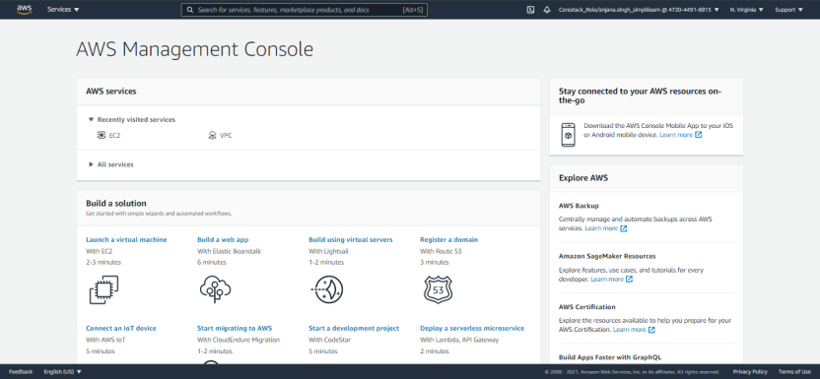

2. From the Navigation bar, use the region selector to select the desired Region, US East (N.Virginia).

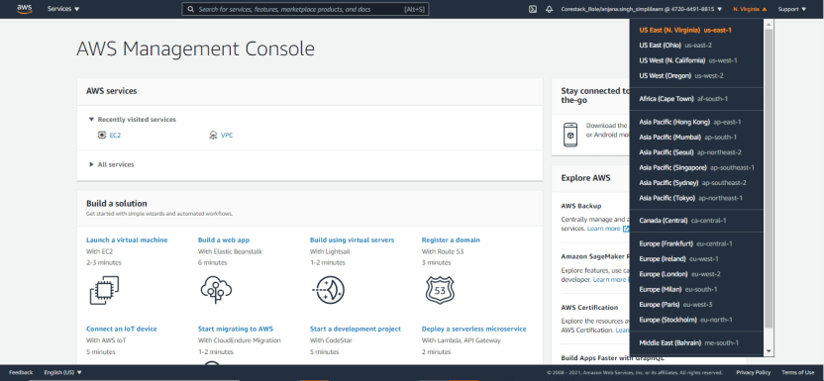

***2. Create an Amazon S3 bucket***

The Amazon S3 bucket enables the team at Heaven Classics to store their audio files in the US  West (Oregon) region.

To create an S3 bucket:

1. In the AWS Management Console, locate the Amazon S3 icon under the Storage & Content  Delivery services. Then, click the icon to display the S3 Management Console page.

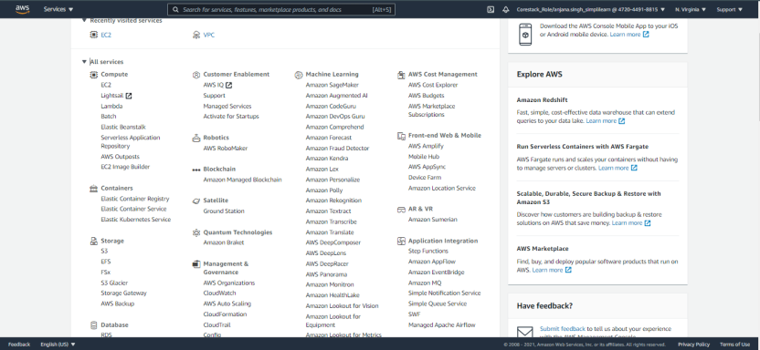

2. On this page, click **Create Bucket** to display the Create a Bucket - Select a Bucket Name and  Region dialog box.

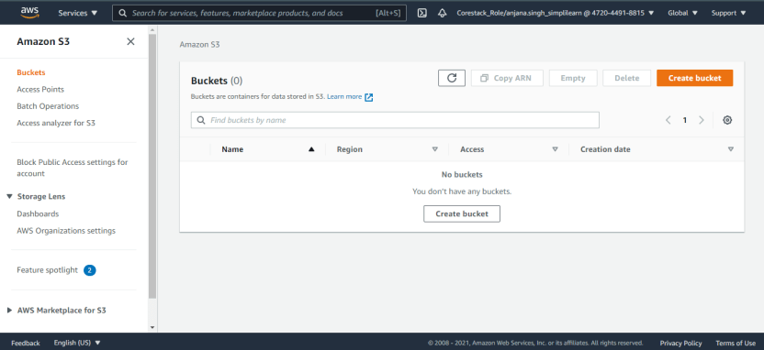

3. Next, enter a globally unique bucket name in the provided space. It was recommended to  name the bucket with the company’s initials and the current date to ensure uniqueness.  Besides this, Heaven Classic has to confirm the bucket name does not contain upper case,  special characters, or spaces between characters. Enter the name as: hc2016.

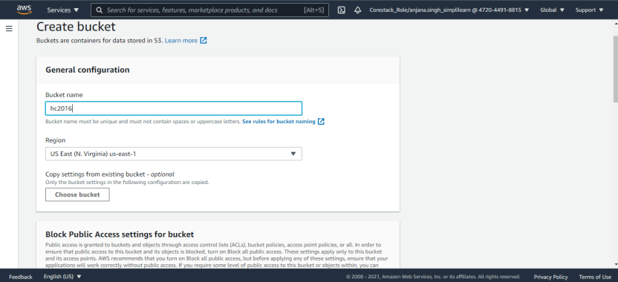

4. In the space provided for the Region, choose a location nearest to the office premises from  the dropdown list. Heaven Classics will select the US East(N.Virginia) region.

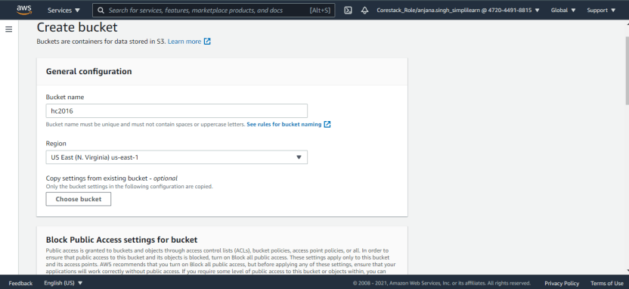5. Next, click **Create** to add the bucket leaving the rest values as default and display its name on the left panel.

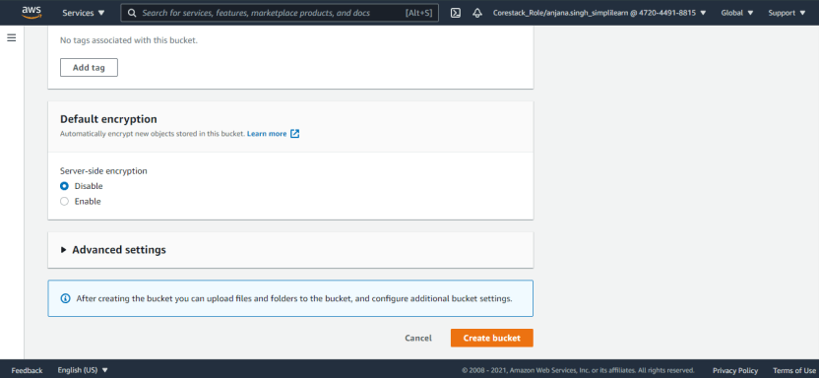

6. Now, click the created bucket.

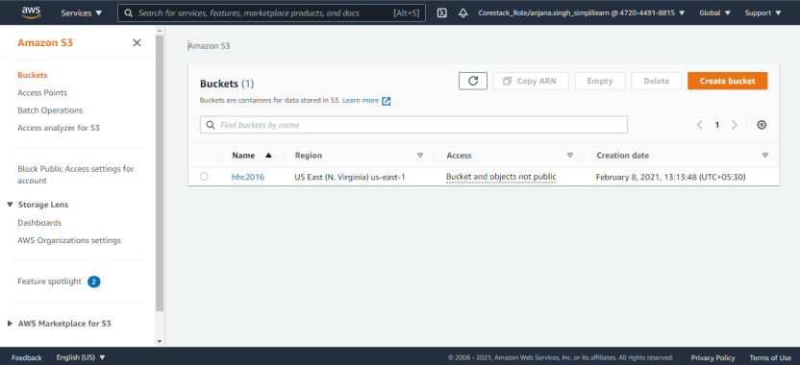7. Clicking on the created bucket gives a message indicating the bucket is empty.

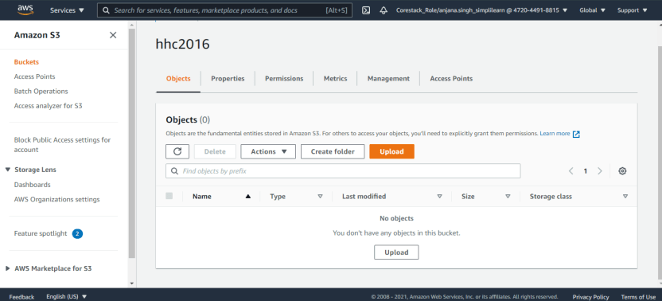

8. Here, click **Upload** to select files from their local machine. There is another option of drag  and drop the files to Upload.

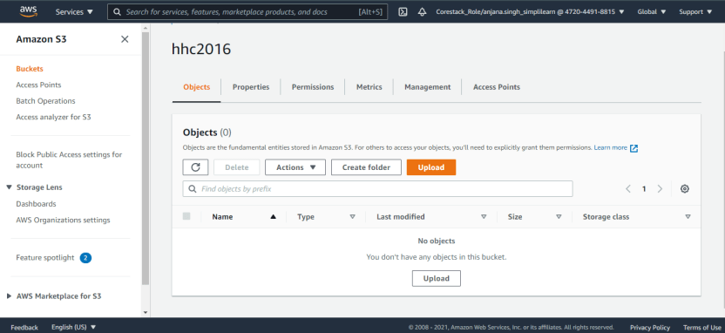9. Click **Add Files**.

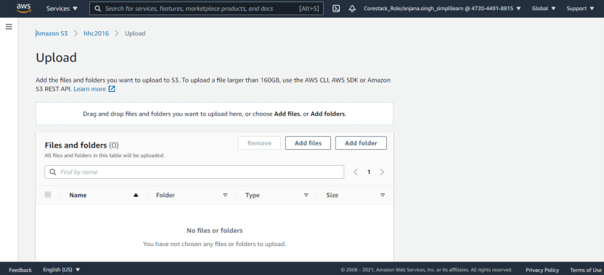10. Select the files, and click **Open**.

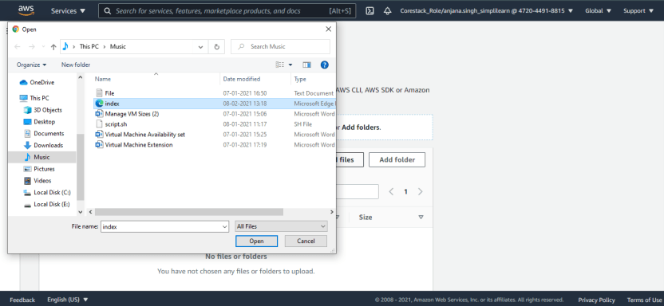

11. After selecting the files, the file name is displayed on the screen.

12. Click **Upload** to begin the upload process.

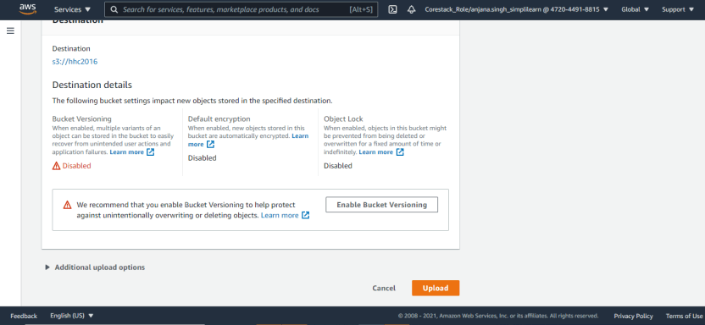

13. Check whether the upload status is changed to **Done**.

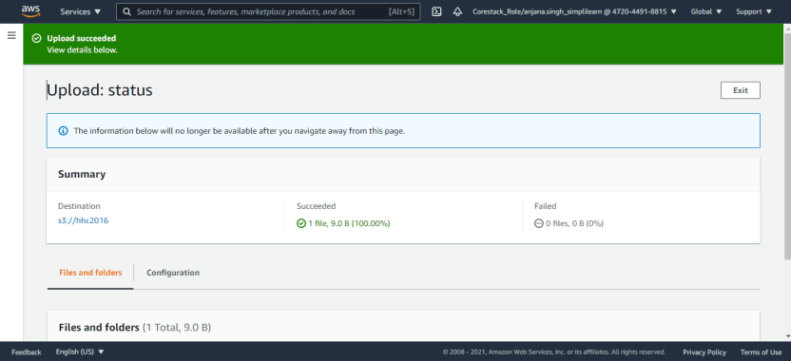

14. Select the object to confirm if the file is uploaded to the created S3 bucket.

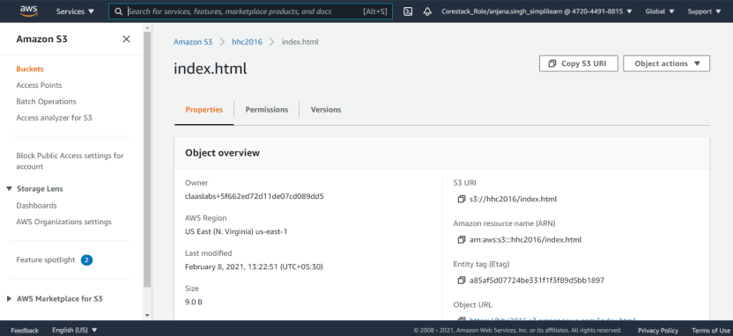

Note: It is important to note that the box towards the left of the name of the object, turns blue.  This indicates that the object is selected.

***3. Create an EC2 Instance***

After selecting the Region and creating an S3 bucket, the team has to set up their own Cloud  Server. This could be done by creating an Amazon EC2 instance.

Since the free tier allowed limited storage space of 30 GB and 1 CPU, the team went ahead with  the configuration.

To create an EC2 instance:

1. In the AWS Management Console, under Compute Services, click **EC2** to open the Amazon  EC2 Console.

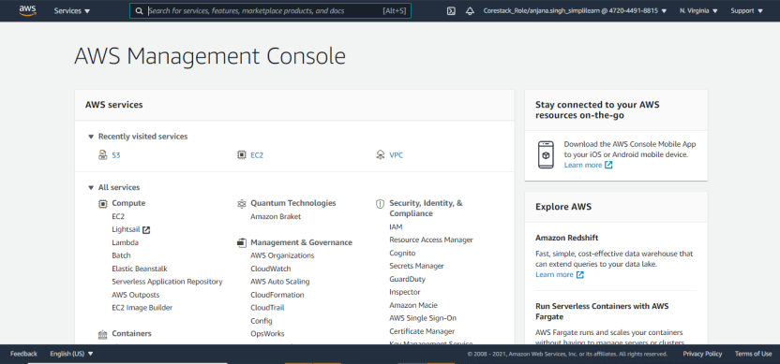

2. Next, click **Launch Instance** to display the page to choose an Amazon Machine Image, or  AMI. AMI is a template that helped the company select the configuration for the Operating  System, Application Server, and applications.

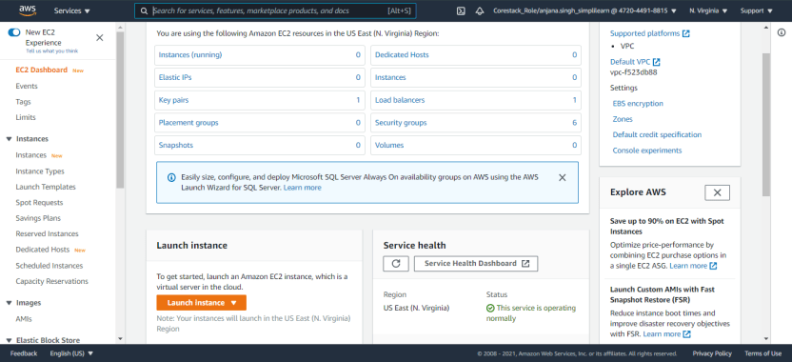3. Select the **Microsoft Windows Server 2012 Base**.

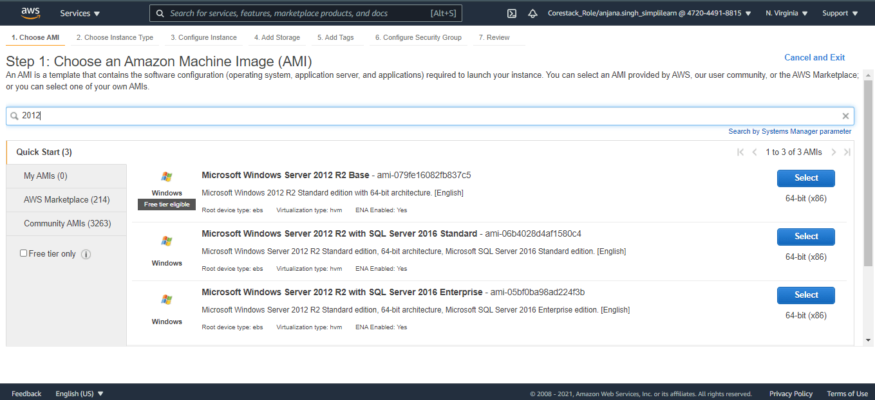

4. On the **Choose Instance Type** page, select the instance with *t2.micro* instance type, and 1 vCPU.

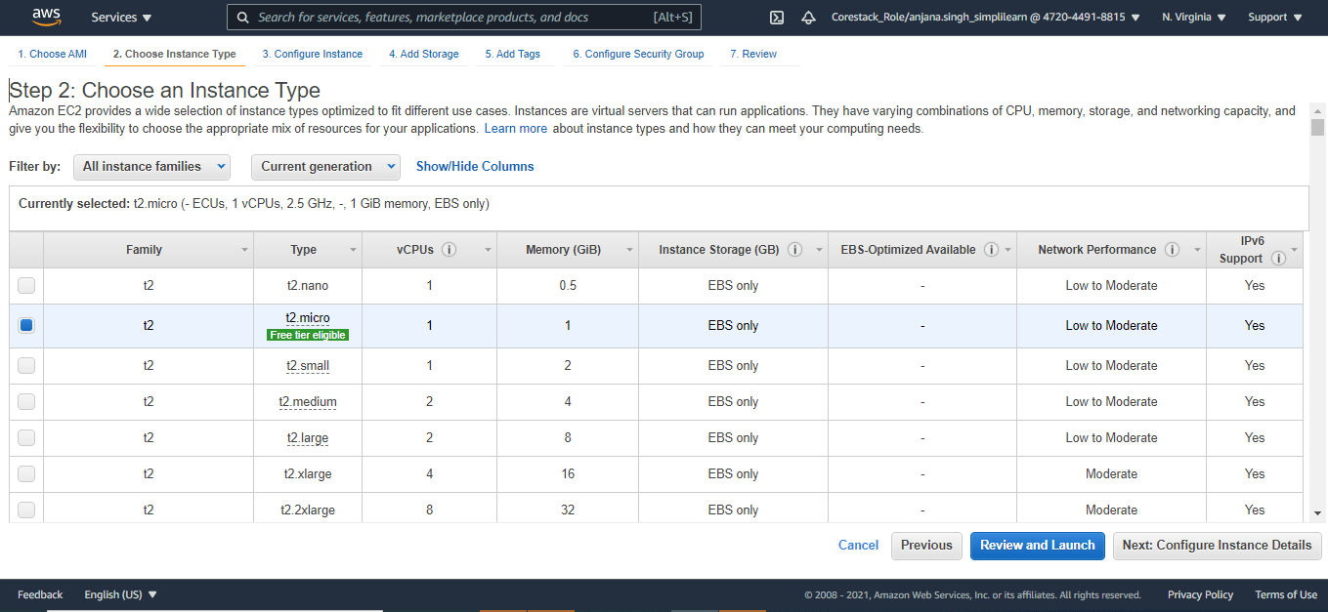5. Click **Next: Configure Instance Details** to display the Configure Instance Details page.



6. Here, use the default configuration, and then click **Next: Add storage** to display the Add  Storage page.

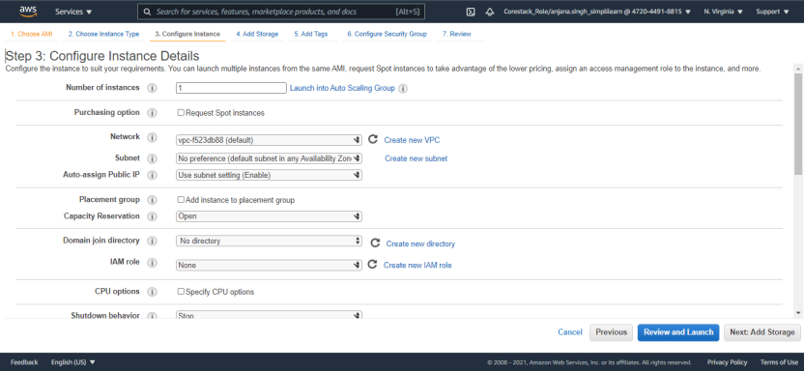

7. Again, select the default storage, and then click **Next: Tag instance** to display the Tag  Instance page.

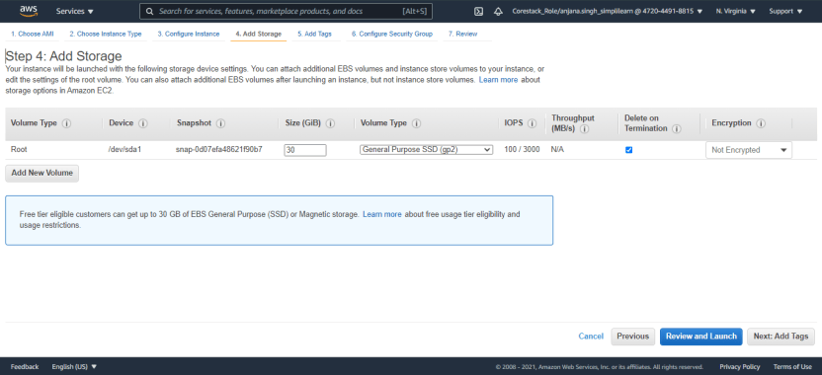

8. On the Tag Instance page, define the key-value for EC2 instance as: EC2-HC.

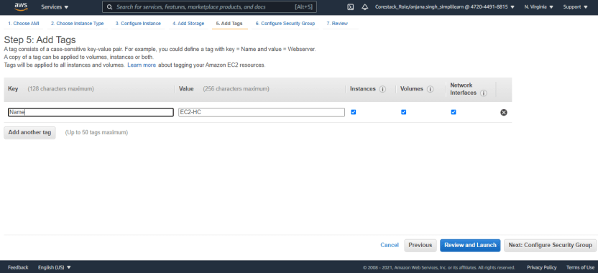9. Click **Next: Configure Security Group** to display the Configure Security Group page.



10. Click **Select an existing security group** to display the existing security groups.

11. Select the required Security Group, and then click **Review and Launch** to display the Review  page.

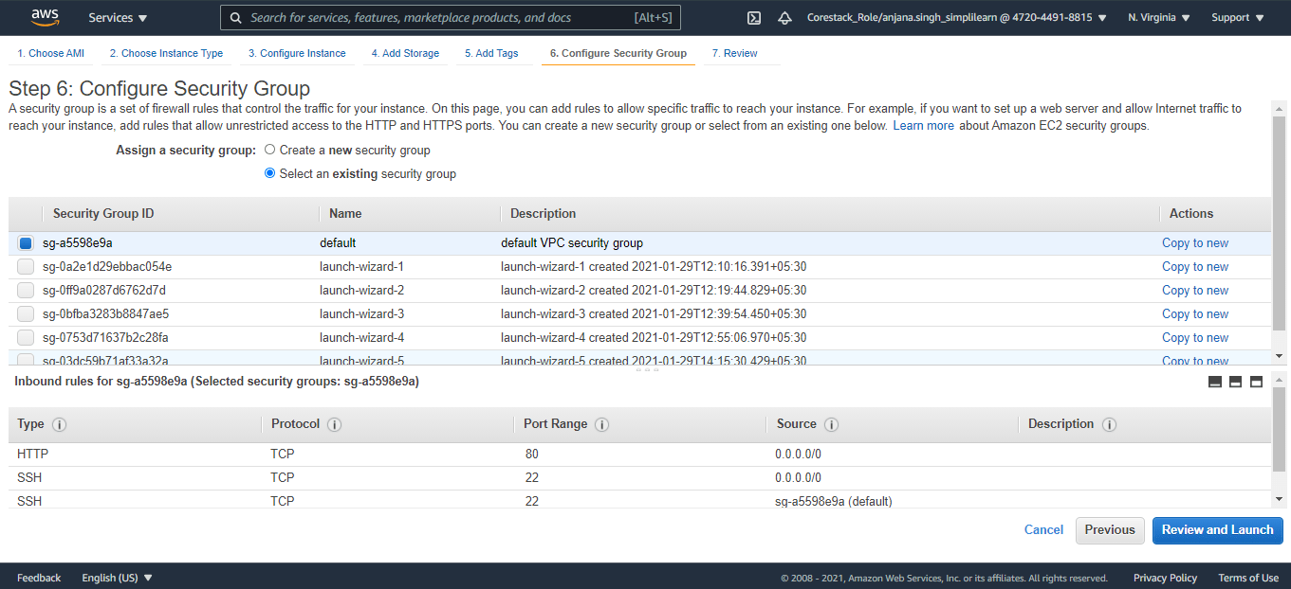

12. Review all the selected options as per need, and then click **Launch(Ignore the warning Message)**.

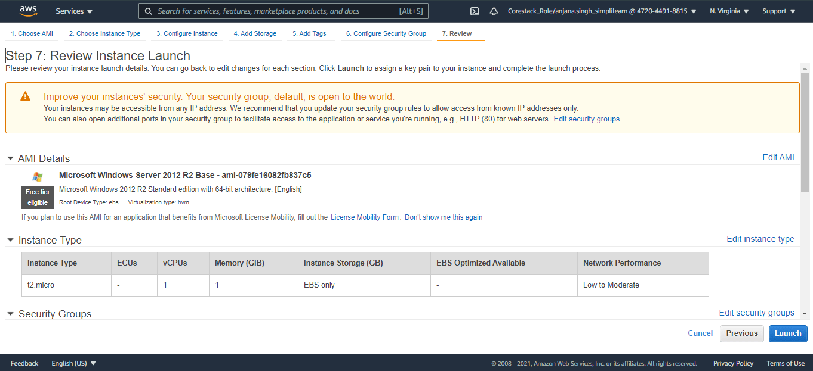

**Note**: It is important to enter the private key file to open the created EC2 instance.

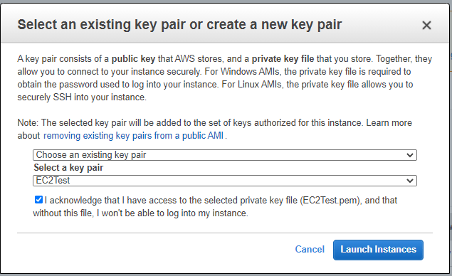

13. Select the **I acknowledge…** check box.

14. Click **Launch Instances**. AWS creates the EC2 instance.

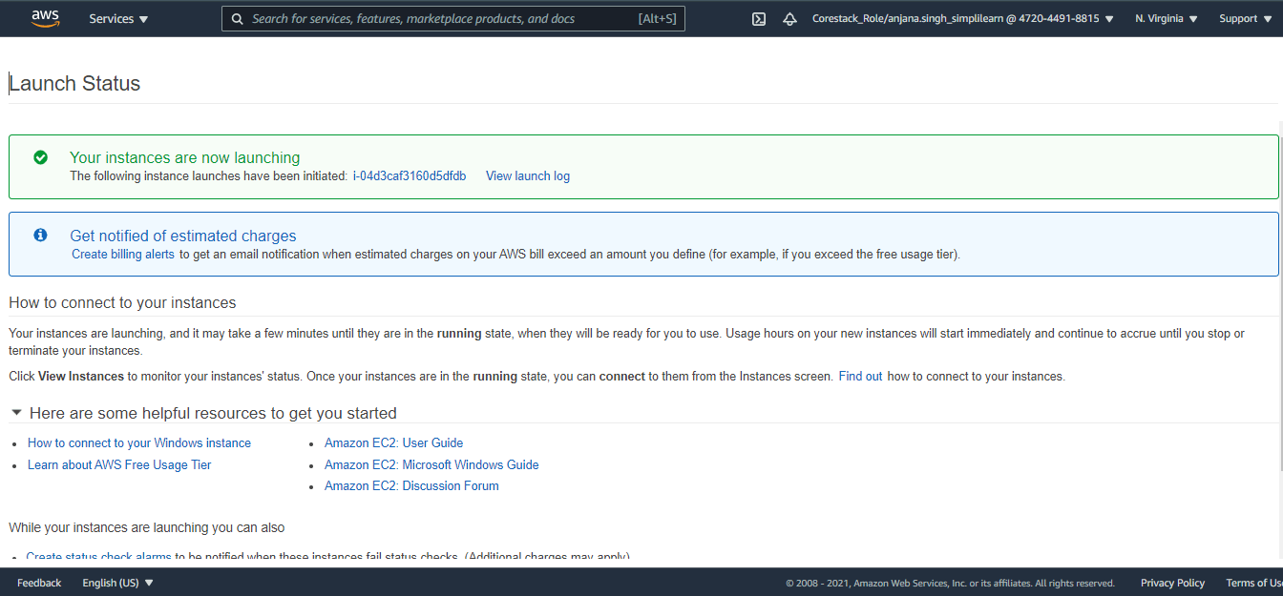

**Work for Students**:

Launch the created EC2 instance using the selected Private Key.