
A project Report
on
EVENT ATTENDANCE DASHBOARD
Submitted in partial fulfilment of requirements for the award of the
Degree of
BACHELOR OF TECHNOLOGY
in
ARTIFICIAL INTELLIGENCE AND MACHINE LEARNING
Under the Guidance of
Ms. SIVASANKARI. B
IBM CORPORATE TRAINER
Submitted By
JAYANTHAN S [ 927622BAL016 ]
DEPARTMENT OF ARTIFICIAL INTELLIGENCE AND MACHINE LEARNING
M KUMARASAMY COLLEGE OF ENGINEERING, KARUR
( Autonomous )
Karur 639-113

M. KUMARASAMY COLLEGE OF ENGINEERING
(Autonomous Institution affiliated to Anna University, Chennai)

BONAFIDE CERTIFICATE

This is to certify that the project report entitled “Event Attendance Dashboard” is a bonafide record of work done by JAYANTHAN S [927622BAL016] of Department of Artificial Intelligence And Machine Learning, M Kumarasamy College of Engineering, Karur, in partial fulfillment of the requirements for the Data Analytics and Business Intelligence course during the academic year 2025 – 2026.

Signature
Ms. B. SIVASANKARI
IBM CORPORATE TRAINER,
SUPERVISOR,
Department of Artificial Intelligence
and Machine Learning,
M. Kumarasamy College of
Engineering,
Thalavapalayam,
Karur-639113.

Signature

Dr. A. SELVI, M. E., Ph.D.,
Head of the Department,
Department of Artificial Intelligence,
M.Kumarasamy College of Engineering,
Thalavapalayam,
Karur-639113.

ABSTRACT

The Event Attendance Dashboard stands as a strategic command center that unifies every thread of an organisation’s event ecosystem, capturing attendance patterns, participant behavior, and logistical efficiency in one consolidated, insight-driven flow. It blends the timeless discipline of structured registers with the agility of modern data intelligence, enabling teams to monitor real-time turnout, analyse engagement trends, forecast capacity needs, and benchmark event performance with boardroom-ready clarity. By integrating registration data, check-in activity, feedback sentiment, and resource utilization, the dashboard transforms scattered details into a cohesive narrative that empowers leaders to make grounded, future-aligned decisions. In essence, it becomes a living archive of organisational culture honoring the past, elevating the present, and guiding events toward smarter, more impactful outcomes.

Keywords: Event Analytics, Attendance Monitoring, Participant Insights, Engagement Metrics, Dashboard Visualization, Organizational Events, Data Integration, Real-Time Tracking.

TABLE OF CONTENTS

CHAPTER | TITLE | PAGE NO.
1 | Introduction | 5
2 | Objectives | 6
3 | Existing System | 7
4 | Proposed System | 8
5 | Tools and Technologies Used | 9
6 | Methodology | 9
7 | Implementation | 11
8 | Output | 12
9 | Conclusion | 13
10 | Future Scope | 13
 | References | 14

CHAPTER 1
INTRODUCTION
The Event Attendance Dashboard is designed to bring clarity, structure, and strategic foresight into the way organisations plan, track, and evaluate their events. In workplaces where gatherings whether workshops, summits, or cultural sessions serve as touchpoints for learning, collaboration, and culture-building, understanding attendance patterns becomes a powerful lever for decision-making. This project centralises event metadata, participant records, registration details, check-in activity, and feedback insights into one cohesive system, creating a streamlined view of how employees engage across the organisational landscape. By transforming fragmented event information into accessible, real-time analytics, the dashboard empowers teams to improve planning accuracy, optimise resource allocation, strengthen engagement outcomes, and elevate the overall event experience with deeper operational awareness. Rooted in the legacy of meticulous documentation yet infused with the energy of modern data intelligence, this system acts as a bridge between tradition and transformation helping leaders read the pulse of participation, anticipate future needs, and steer events with confidence, clarity, and cultural alignment while fostering accountability, transparency, and long-term organisational growth. With its unified data flow and intuitive insights, the dashboard supports smarter leadership decisions, nurtures stronger community engagement, and reinforces a culture of continuous improvement across every layer of the organisation.

CHAPTER 2
OBJECTIVES
In many organisations today, event monitoring and attendance tracking still depend on manual or semi-digital methods that lack efficiency and real-time visibility. Details such as registration counts, check-in status, participant engagement, and feedback are often recorded in spreadsheets or scattered across multiple platforms, making it difficult to maintain accuracy and consistency. As organisations grow and employee engagement becomes more critical to cultural and operational success, traditional event management processes struggle to support evolving needs.
Because of this, the existing system faces several challenges:
- There is no real-time tracking of participant check-ins or event-level engagement.
- Attendance patterns remain unclear due to fragmented or delayed reporting.
- Feedback and performance insights are scattered, making analysis difficult.
- Event teams must rely on manual inputs, increasing the possibility of errors and inconsistencies.
- Data-driven decision-making becomes slow, limiting opportunities to optimise events effectively
Hence, the inefficiencies in the current process result in reduced engagement, poor planning accuracy, and missed opportunities to enhance the event experience.

CHAPTER 3
EXISTING SYSTEM
Most organisations still rely on manual or semi-digital methods to manage event attendance, using spreadsheets, email lists, or paper registers to record participant details. This scattered approach makes it difficult to track check-ins accurately, monitor engagement, or generate timely reports. Without a centralized system, data becomes inconsistent, feedback remains unorganised. As a result, leaders lack real-time insights and depend heavily on manual reporting, which slows decision-making and limits the ability to plan events efficiently.
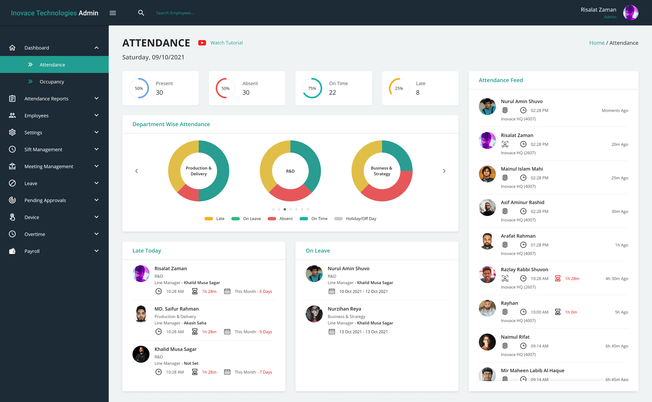
Figure 1. Existing System
This image shows an organised attendance dashboard displaying daily stats like Present, Absent, On Time, and Late, along with department-wise charts and a live check-in feed. It also highlights late arrivals and employees on leave, with navigation for major HR modules on the left.

CHAPTER 4
PROPOSED SYSTEM
The proposed Event Attendance Dashboard introduces a fully digital, analytics-driven platform designed to overcome the limitations of manual tracking and disconnected data sources. Through interactive visualizations and real-time insights, the system enables organisations to monitor engagement, logistics, and event performance with far greater clarity and precision.
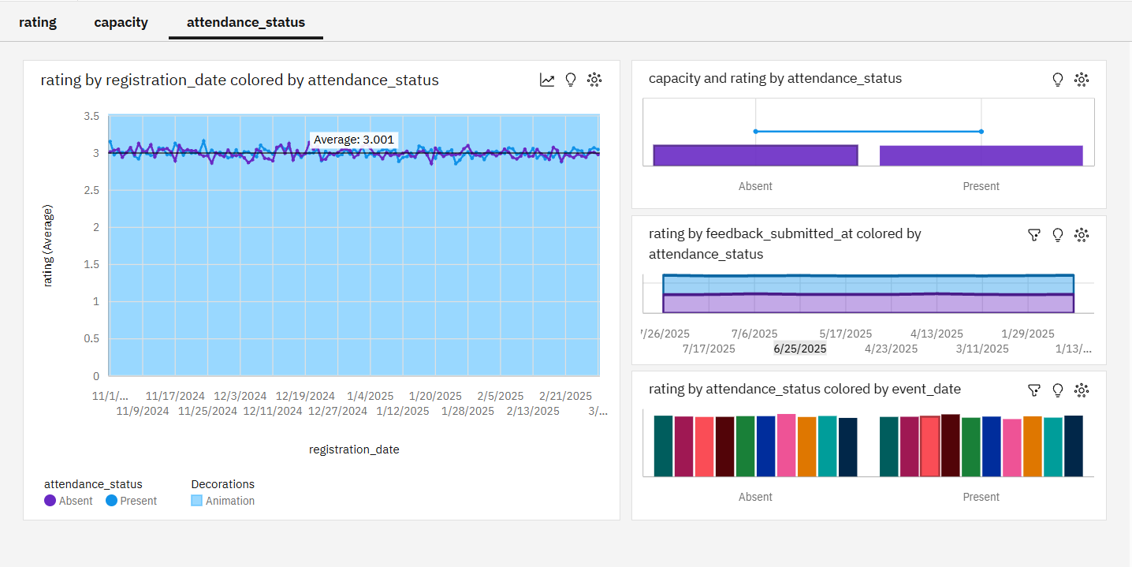
Figure 2. Proposed System
By integrating advanced visual analytics, the system transforms raw event data into actionable intelligence. Line charts highlight cost fluctuations, bar charts map department or status comparisons, and bubble charts visually correlate feedback, capacity, and attendance insights. This layered approach allows decision-makers to identify trends, track inconsistencies, and pinpoint areas that require operational improvements. With structured navigation and dashboards for ratings, capacity, and attendance status, the system supports intuitive exploration while maintaining the discipline of traditional reporting.

CHAPTER 5
TOOLS AND TECHNOLOGIES USED
Category | Technology / Tool
Frontend | HTML, CSS, JavaScript
Database | Cognos DB
Data Visualization | Power BI / IBM Cognos / Tableau
Hosting Platform | IBM Cloud or Local Server
Development Tools | Visual Studio Code, GitHub
Languages Used | JavaScript, SQL

Table 1. Tools and Technology
CHAPTER 6
METHODOLOGY
The development of the Event Attendance Dashboard follows a structured, data-centric methodology designed to ensure accuracy, clarity, and meaningful insights. The process is divided into multiple stages, starting from data acquisition and ending with dashboard deployment. Each phase contributes to building a reliable, interactive system capable of visualizing event performance and participant engagement in real time.
  - Data Collection
This stage focuses on gathering all essential event-related information from multiple organisational sources. Data elements include event metadata such as

event name, date, venue, organiser, and capacity; attendance logs with check-in and check-out details; registration records showing participant interest and confirmations; feedback data containing ratings and comments; and logistics inputs such as vendor details and costs.
  - Data Cleaning and Preprocessing
Once the data is collected, it undergoes comprehensive cleaning to remove inconsistencies, missing values, and duplicate records. This ensures the dataset is accurate, complete, and ready for reliable analysis.
  - Data Storage
After preprocessing, the refined dataset is stored in a scalable and organised database format suitable for analytical operations. Data is systematically divided into logical collections—Event Data (event type, date, capacity, logistics cost), Attendance Data (status and check-in records), Registration Data (registration dates and confirmation status), and Feedback Data (ratings and comments). This structured storage model enables efficient retrieval, easy filtering, and smooth integration with business intelligence tools.
  - Data Analysis and Visualization
In this phase, the prepared data is analysed and transformed into interactive visual insights using BI platforms such as Power BI or IBM Cognos Analytics. The analysis focuses on identifying rating trends across events, understanding attendance patterns, comparing capacity utilisation with logistics cost, and evaluating the relationship between registrations, feedback, and event performance. Using bar charts, line graphs, scatter plots, and combined visuals, the dashboard presents the data in a clear, intuitive manner, allowing event teams and decision-makers to quickly interpret patterns, discover insights, and enhance planning strategies.

CHAPTER 7
IMPLEMENTATION
The implementation phase focuses on constructing the Event Attendance Dashboard using modern BI tools and structured data processing techniques. The system integrates backend data preparation with a dynamic, interactive dashboard interface to deliver real-time insights on attendance trends, event performance, and participant engagement.
7.1 Frontend Implementation
The dashboard interface was designed using Power BI (or your chosen BI tool), supported by data models prepared with structured datasets. The front end includes visually rich components such as charts, tables, slicers, and filter panels to ensure the dashboard remains easy to navigate and interpret.
7.2 Data Visualization in IBM Cognos Analytics
Data visualization for the Event Attendance Dashboard was implemented using Power BI / IBM Cognos Analytics, which connects directly to the cleaned and processed dataset to generate interactive and insightful visual representations. The dashboard incorporates a range of visual components, including line and bar charts to highlight attendance and rating trends, donut and column charts to illustrate attendance status across different event categories, and scatter or bubble visuals to analyse relationships between capacity, logistics cost, and participant feedback. Interactive filters and slicers further enhance the dashboard, enabling users to explore event data from multiple perspectives and perform detailed comparisons with ease. This visualization layer transforms raw event information into clear, intuitive insights that support effective decision-making and event optimisation.

CHAPTER 8
OUTPUT
The Waste Management Dashboard developed in IBM Cognos Analytics successfully visualizes key insights related to waste collection and recycling efficiency. The dashboard displays various interactive charts, graphs, and filters that allow users to explore data dynamically and gain a better understanding of municipal waste management performance.
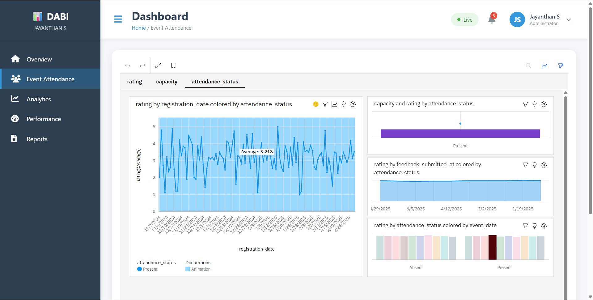

Figure .3 Output with Webpage

- Dashboard Home Screen: Shows an overview of event attendance analytics with quick access to rating trends, capacity insights, and attendance status comparisons.
- Attendance Visual Insights: Displays status-based breakdowns such as Present vs Absent, feedback trends, and event-wise participation patterns for easier interpretation and decision-making.

CHAPTER 9
CONCLUSION
The Event Attendance Dashboard delivers a modern, data-driven solution for organisations seeking to monitor, analyse, and enhance event engagement with greater accuracy and clarity. By replacing manual tracking methods with real-time analytics and intuitive visualisations, the system strengthens transparency, improves planning efficiency, and supports informed decision-making across departments. It highlights key performance indicators such as attendance status, capacity utilisation, ratings, and feedback patterns, enabling teams to understand participation behaviour and refine future events accordingly. This dashboard not only streamlines operational workflows but also promotes a culture of continuous improvement, accountability, and data-centric management. In conclusion, the Event Attendance Dashboard stands as a significant step toward digital transformation in organisational event management empowering leaders to create more structured, meaningful, and impactful events aligned with long-term organisational growth.

CHAPTER 10
FUTURE SCOPE
The Event Attendance Dashboard has the potential to evolve into a more advanced and intelligent event management ecosystem by integrating emerging technologies and automated capabilities. Future enhancements may include real-time attendance tracking using RFID, QR codes, or biometric systems; AI-powered engagement prediction models; automated feedback sentiment analysis; and cloud-based event data storage for scalable performance.

REFERENCES

[1] A. Kumar, R. Srinivasan, and P. Nair, “Data-Driven Event Management Using Real-Time Dashboards and Analytics,” IEEE International Conference on Data Science and Intelligent Applications, pp. 110–116, 2023.
[2] S. Mehta and K. Bansal, “Design and Implementation of an Interactive Dashboard for Organisational Attendance Monitoring,” IEEE Journal of Information Systems and Analytics, vol. 14, no. 3, pp. 58–65, 2022.
[3] M. Verghese and H. Rao, “Performance Tracking Through BI Tools: A Study on Event Participation Metrics,” IEEE Access, vol. 12, pp. 48210–48218, 2024.
[4] T. Das and V. Reddy, “Application of Business Intelligence Platforms for Event Data Visualization,” IEEE Conference on Smart Data Analytics (ICSDA), pp. 134–140, 2021.
[5] L. Sharma and N. Gupta, “Enhancing Organisational Decision-Making with Power BI Dashboards,” IEEE Symposium on Computational Intelligence and Data Engineering, pp. 72–79, 2023.

