**HTML**

* HTML is a markup language to create static web pages
* HTML stands for Hyper Text Markup Language which is based on a standard called SGML (Standard Generalised Markup Language)
* It is a industry standard for creating webpages/documents
* HTML is parsed/executed/rendered by parsers which are built-in in the browsers
* It is platform independent provided browsers for that platform
* It is case insensitive
* HTML elements(HTML <Tags></tags> are used to decorate the hyper text)
* Every tag useage is optional
* It varies on other browsers

Basic Structure:

<html>

<head></head>

<body></body>

</html>

NOTE: Browsers will ignore newlines, white spaces and tabs.

Attributes:

* Attributes are key value pair which are used to configure the tag for extra functionality apart from default functionality

Text Color attribute:

<body text="red">

This text appears in red color

</body>

Background Colour Attribute:

<body text=red bgcolor=green>

This text appears in red color

</body>

Background Image Attribute:

background=path

dealing paths:

files can be relative paths, absolute paths

relative paths:

absolute paths:

program:

<body background="file:///e:/photos/places/maredumilli/IMG20230111175217.jpg">

</body>

NOTE: Html tags attributes are deprecated which means they can be removed in future, because these attributes which involves in styling were not preferred to use because styling is the job of css, so it may be removed from the future, it is preferred to avoid deprecated tags

CSS Properties:

Style tag:

<body style="color: red; background-color:lightgreen;">

This text appears in red color

</body>

Heading tags:

* These tags are used to print headings
* And also this comes with newline after the element

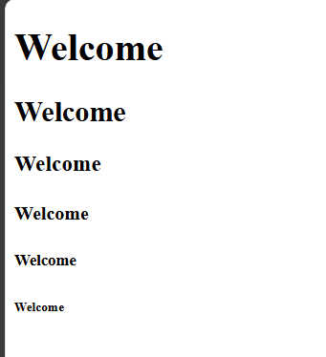Program:

<body>

<h1>Welcome</h1>

<h2>Welcome</h2>

<h3>Welcome</h3>

<h4>Welcome</h4>

<h5>Welcome</h5>

<h6>Welcome</h6>

</body>

Pre tag:

<pre> body </pre>

* It considers whitespaces and new lines
* This pre tag display the texts exactly as written in html file, considering whitespaces, tabs, newlines
* Such that it is used to display code, or text which indentations are mattered

Subscript and superscript tags:

<sub></sub>

<sup></sup>

S tag: <s>

Del tag: <del>

Strike tag: <strike>

Underline tag: <u>

Horizontal rule: <hr>

* Default color is grey
* Default aligned center

Attribute: size=5 “for increasing thickness”

Color=red “to change the color”  
 width = 50% “shortens to 50%”

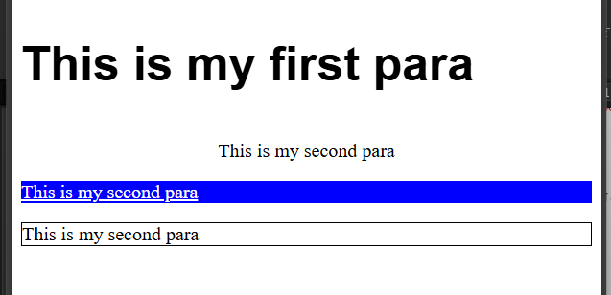Paragraph tag:

<p> This is my first para</p>

<p> This is my second para</p>

Attributes:

font-size:

font-family:

font-style

font-weight:

text-align:center

text-decoration: under-line, over-line, line-through;

color:red;

background-color: blue;

program:

<p style="font-size:40px; font-family:arial; font-weight:bold; "> This is my first para</p>

<p style="text-align:center;"> This is my second para</p>

<p style="text-decoration:underline;"> This is my second para</p>

<p style="border: 1px solid black"> This is my second para</p>

Image Tag:

<img src="E:\photos\places\maredumilli\IMG20230112091720.jpg" style="width:50px;" alt="hill station image">

Attributes:

src: source of an image

alt: alternate of name of

style: width: 100px;

height: 100px;

float: left/right;

LIST:

* Ordered list
* Unordered list

<ol></ol> : for defining complete block of list as ordered list

<li></li>: for defining each item of list

Attributes:

Type=default=1/A/I/i : this is used to define the type of listing

Start=4 : this is used to define the starting value of listing

Program:

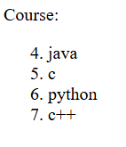 <body>

Course:

<ol type=1 start=4>

<li>java</li>

<li>c</li>

<li>python</li>

<li>c++</li>

</ol>

</body>

Unordered list:

<ul></ul> : for defining complete block of list as unordered list

<li></li>: for defining each item of list

Attributes:

Type=default=disc,circle, square : this is used to define the type of listing

Program:

<body>

Course:

<ul type=disc>

<li>java</li>

<li>c</li>

<li>python</li>

<li>c++</li>

</ul>

</body>