Table Tag:

* <table>
* </table>
* contains two sections:
  + thead tag: <thead> </thead>
  + tbody tag: <tbody></tbody>
* To display data in tabular format we table tag
* It also contains caption tag: <caption></caption> to display caption above table

Thead tag:

* Contains tr tag which defines rows in html: <tr></tr>

Tr tag:

* + Contains th tag to display one element inside the table as a heading in first row

Basic structure of thead tag:

<thead>

                <tr>

                    <th>Employee Id</th>

                    <th>Empoyee Name</th>

                    <th>Salary</th>

                    <th>Department</th>

                </tr>

</thead>

Tbody tag:

<tbody>

                <tr>

                    <td>101</td>

                    <td>Jayanth</td>

                    <td>25000.00</td>

                    <td>sales</td>

                </tr>

                <tr bgcolor="yellow">

                    <td>102</td>

                    <td>Jayanth</td>

                    <td>25000.00</td>

                    <td>sales</td>

                </tr>

                <tr>

                    <td>103</td>

                    <td>Jayanth</td>

                    <td>25000.00</td>

                    <td>sales</td>

                </tr>

</tbody>

Attributes:

Note: it is preferred to provide value in double quotes

border=”1”

align= “left”(default), center, right : aligns complete table in left/center/right

width= ”50%” : used to set the width of complete table:

bgcolor= “blue” applicable for table tag, thead tag, tbody tag, th tag, td tag, tr tag.

cellspacing=”4” : used to maintain spacing between cells.

cellpadding=”5” : used to maintain spacing between cell border and inside data.

Spaning:

colspan: 2 : this attribute is used to merge two cells (that is it takes width of two cells) in different side by side columns

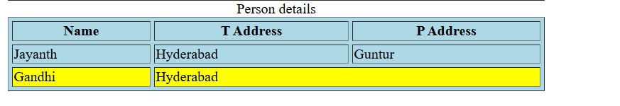 <tr bgcolor="yellow">

                    <td>Gandhi</td>

                    <td colspan="2">Hyderabad</td>

                </tr>

rowspan: 2 : this attribute is used to merge two cells (that is it takes height of two cells) in different rows

<tr>

                    <td rowspan="2">Jayanth</td>

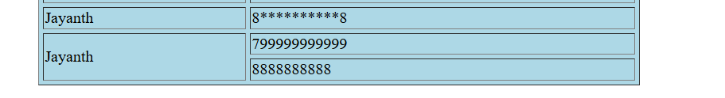                    <td>799999999999</td>

                </tr>

                <tr>                     <td>8888888888</td>

                </tr>

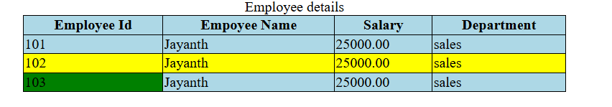Internal css:

<head>

        <style>

            table, tr, td, th{border-collapse:collapse;}

            table, tr, td, th{border: 1px solid black;}

        </style>

    </head>

HyperLinks:

A hyper link is a reference to another resource (by clicking this hyper link user can navigate to another resource/resource’s page)

* We create hyperlink using using anchor tag

Anchor tag: <a></a>

Attributes:

href=: “url” from root(ie complete address starting from http://

target= “_parent” (default): displays in same tab

“_blank” : displays in new tab

program:

 <a href="http://google.com">google</a>

Using relative path: relative path is nothing but considering the parent path

        <a href="hyperlink_sub.html">inner file</a>

iframe:

iframe tag is used to display multiple html documents on tab

<iframe> </iframe>

Attributes:

src: used to mention the path of html to display in one section

name: issues name for the frame so that it can be referred when wanted in hyperlinks which are in other frames

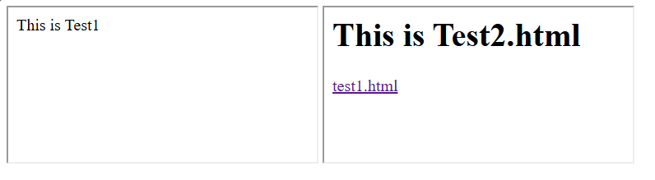 program:

<body>

        <iframe src="test1.html"></iframe>

        <iframe src="test2.html"></iframe>

    </body>

Program:

<body>

        <iframe src="test1.html"></iframe>

        <iframe src="test2.html"></iframe>

        <iframe src="" name="gframe"></iframe>

    </body>

div:

div is used to create the group or place dedicating to set of elements.

styles properties:

positions: absolute – absolute position is browsers topleft positon   
 using that we can positon using top and left properties

top: 10px- used to assign distance from top of the web page since the position is

absolute

left: 10px- used to assign distance from left of the web page since the position is

absolute

HTML Form and Form Controls:

* Form is used to send the set of data from the fields in a one binding

Attributes:

* + action= “url_resourse” : this attribute is used to define the resource path to which the data should be sent
  + methods= “” This attribute is used to define the method by which method the data should be sent. http methods are: get(default), post, put, delete, patch

Form elements:

Input element: this element is used to create an input elment based on type we

mention

attributes:

* + type= “text” – this type defines and creates a text type element
  + size= “100” (this shows the 100 characters at a time but takes 256 any way)
  + maxlength= “10” – it limits to 10 characters (i.e. only takes 10 characters)
  + placeholder= “username” – it shows the username message on the field
  + value= “Ram@gmail.com” -it sets default value for that particular field and this comes with the mentioned value in the field
  + required – this is an attribute which does not need a value and this defines the field as a required such that it should be entered for sure
  + hidden – this attribute hides the field completely.

Program:

<form>

            <input type="text" size="100" maxlength="10" placeholder="username" value="Ram@gmail.com" required hidden>

        </form>