HematoVision: Advanced Blood Cell Classification Using Transfer Learning

1. INTRODUCTION

1.1 Project Overview
HematoVision is an Artificial Intelligence-based web application developed to classify blood cell images into different categories using deep learning and transfer learning techniques. The system uses a pre-trained Convolutional Neural Network (CNN) model to identify blood cell types such as:
- Eosinophils
- Lymphocytes
- Monocytes
- Neutrophils
The application allows users to upload blood cell images and receive instant predictions through a simple web interface.

1.2 Purpose
The purpose of this project is to:
- Assist medical professionals in early blood cell analysis
- Reduce manual classification errors
- Automate hematology screening using AI
- Improve diagnostic efficiency and speed

2. IDEATION PHASE

2.1 Problem Statement
Manual blood cell classification under microscopes is:
- Time-consuming
- Prone to human error
- Requires experienced professionals
There is a need for an automated, accurate, and scalable solution that can classify blood cells efficiently using AI.

2.2 Empathy Map Canvas
Users: Lab technicians, Pathologists, Medical students
Think | Feel | Say | Do
Need faster diagnosis | Overworked | "This takes too long" | Examine slides manually
Want accurate results | Fear of mistakes | "Hope results are correct" | Compare cells manually

2.3 Brainstorming
Ideas generated:
- Use CNN for image classification
- Apply transfer learning for better accuracy
- Develop web-based UI
- Provide drag-and-drop image upload
- Store results for analysis
Selected Idea:
- Transfer learning with pre-trained CNN (MobileNet / ResNet) + Flask Web Application.

3. REQUIREMENT ANALYSIS

3.1 Customer Journey Map
- User opens web application
- Uploads blood cell image
- System processes image
- AI model predicts cell type
- Result displayed with confidence score

3.2 Solution Requirement

Functional Requirements
- Upload image
- Classify blood cell type
- Display prediction result
- Show confidence percentage

Non-Functional Requirements
- Fast response time (< 3 seconds)
- High accuracy (>90%)
- User-friendly interface
- Secure file handling

3.3 Data Flow Diagram (DFD)
Level 0 DFD
User → Upload Image → Web Server → AI Model → Prediction → User

3.4 Technology Stack
Layer | Technology Used
Frontend | HTML, CSS
Backend | Flask (Python)
AI Model | TensorFlow / Keras
Model Type | Transfer Learning (MobileNetV2 / ResNet50)
Dataset | Blood Cell Image Dataset

4. PROJECT DESIGN

4.1 Problem Solution Fit
Problem: Manual blood cell classification.
Solution: AI-based automated classification
This solution reduces time, increases accuracy, and supports medical diagnosis.

4.2 Proposed Solution
HematoVision uses a pre-trained CNN model (Transfer Learning) trained on a dataset of 12,000+ labeled blood cell images.
The system:
- Preprocesses uploaded image
- Resizes to model input size
- Normalizes pixel values
- Predicts cell category
- Displays result instantly

4.3 Solution Architecture
User
↓
Flask Web App .
↓
Image Preprocessing .
↓
Pre-trained CNN Model .
↓
Prediction Layer .
↓
Result Display

5. PROJECT PLANNING & SCHEDULING

5.1 Project Planning
Phase | Duration
Problem Identification | 3 Days
Dataset Collection | 1 Days
Model Training | 6 Days
Web Development | 4 Days
Testing & Deployment | 4 Days
Total Duration: 18 Days

6.FUNCTIONAL AND PERFORMANCE TESTING

6.1 Performance Testing
- Model Accuracy: ~90–95% (depending on dataset)
- Prediction Time: < 2 seconds
- Tested on multiple image samples
- Cross-validation performed

7.RESULTS
Step-1:HematoVision Home page
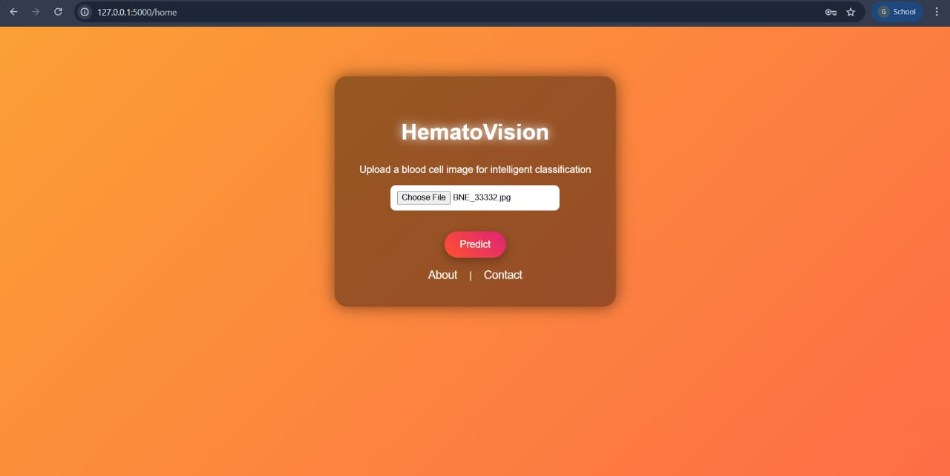
Step-2:HematoVision About page
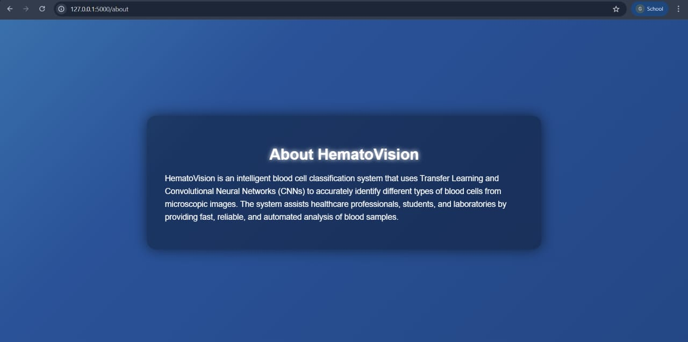
Step-3:HematoVision Contact Page
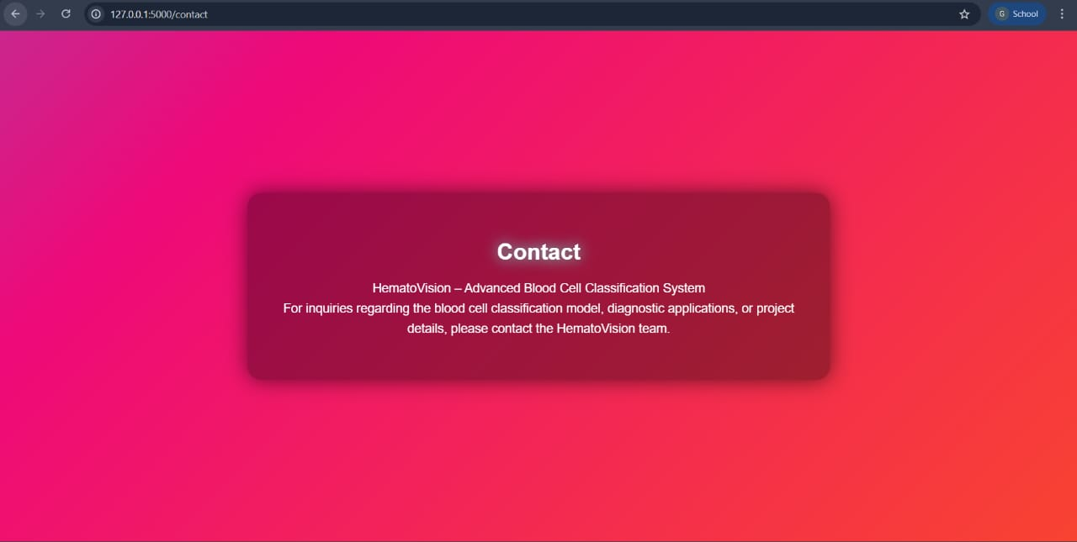
Step-4:HematoVision Blood Prediction Pages
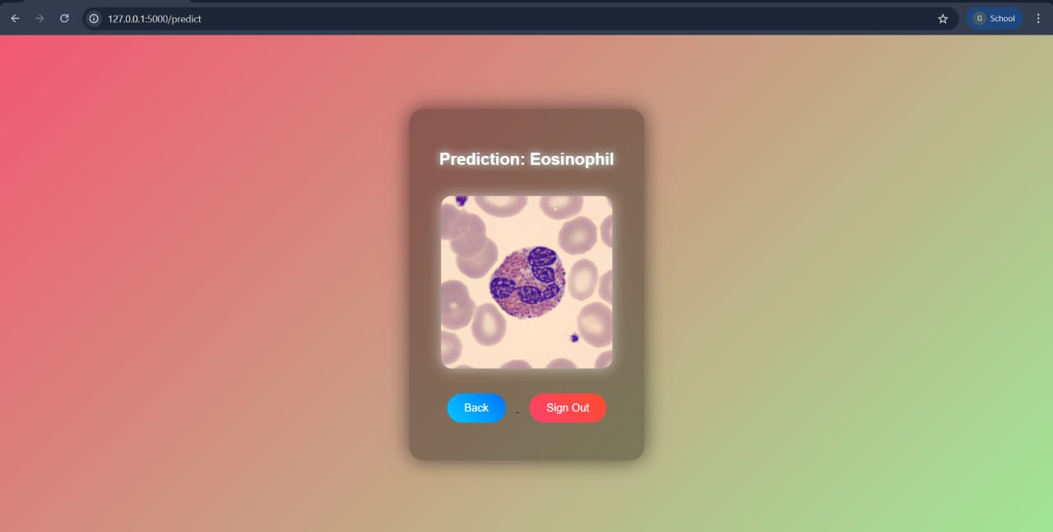
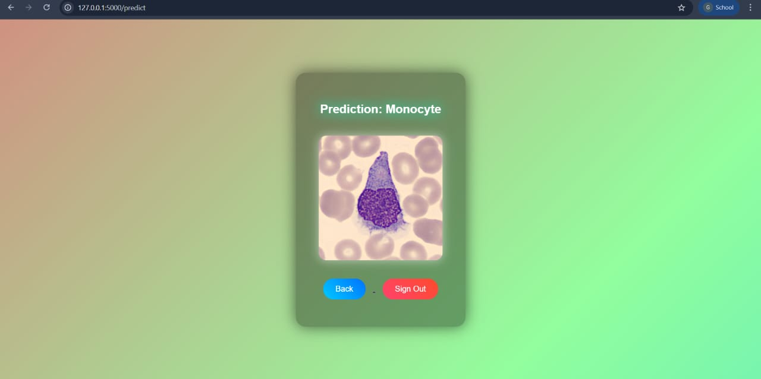
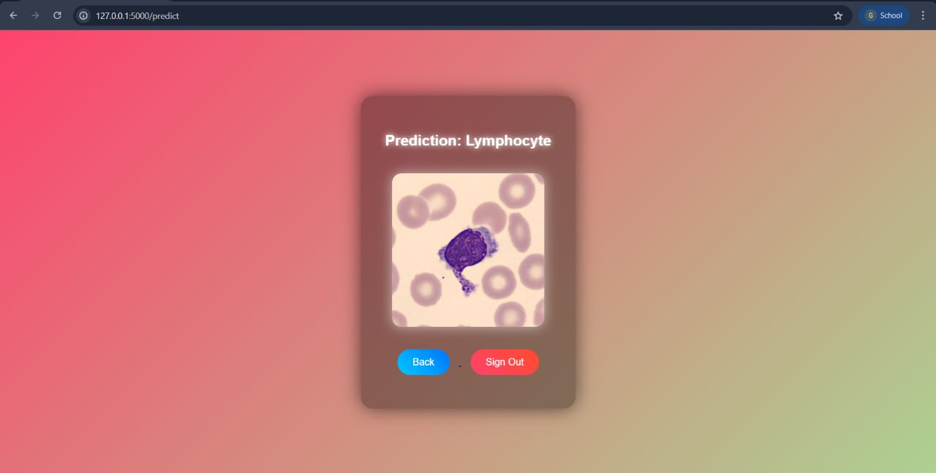
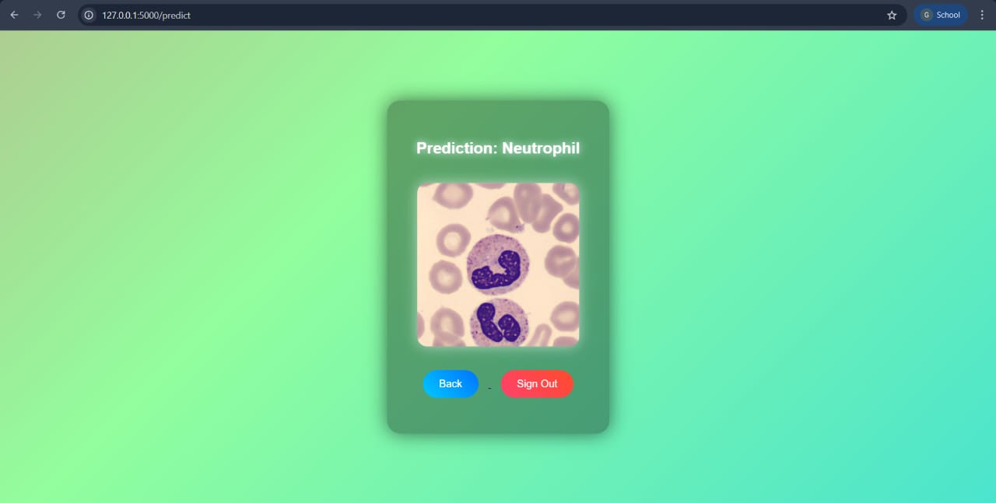
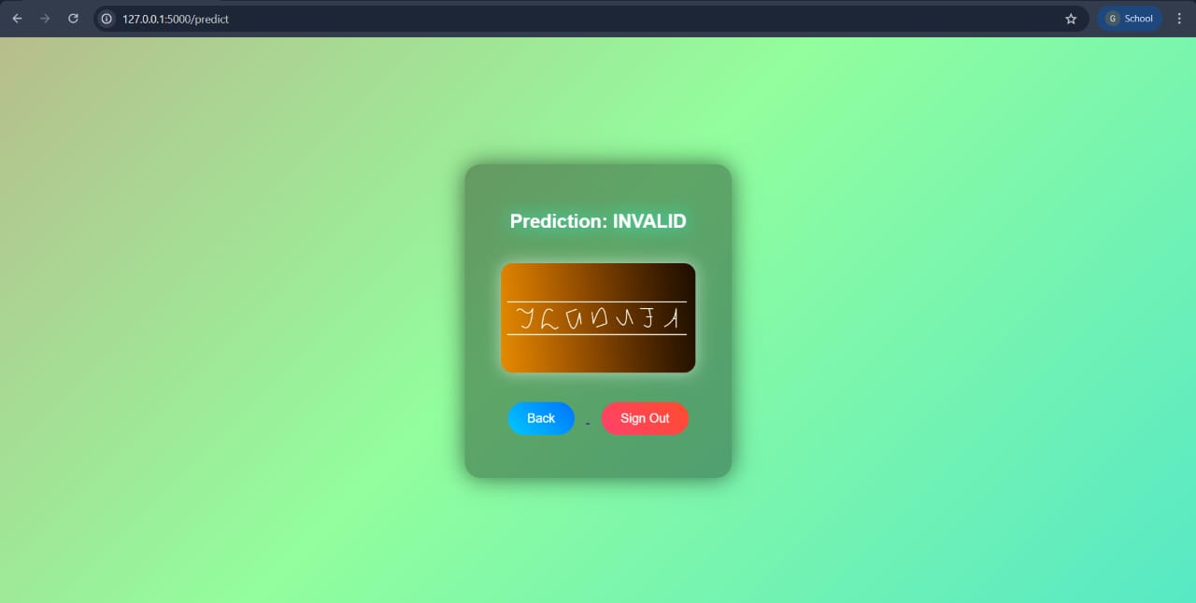

8. ADVANTAGES & DISADVANTAGES

Advantages
✔Fast diagnosis
✔ High accuracy
✔ Reduces manual workload
✔ Easy to use

Disadvantages:
✘ Requires good dataset quality
✘ Needs GPU for faster training
✘ Not a replacement for expert doctors

9. CONCLUSION
HematoVision successfully demonstrates the use of Transfer Learning in medical image classification. The system provides accurate and fast blood cell classification, helping medical professionals improve diagnostic efficiency. The project proves the effectiveness of deep learning in healthcare applications.

10. FUTURE SCOPE
- Add more blood cell categories
- Deploy on cloud (AWS/Azure)
- Integrate with hospital systems
- Add patient report generation
- Develop mobile application version

11. APPENDIX

Source Code
(Include your Python files like:)
- app.py
- model_utils.py
- templates/index.html
- requirements.txt

Dataset Link
Example:
Kaggle Blood Cell Dataset (https://www.kaggle.com/datasets/unclesamulus/blood-cells-image-dataset).

