System Validation Report
End-to-end validation against the running application and MySQL
Item | Detail
Project | Student Club Event Ticketing & Budget Portal
Repository | github.com/jayanthh02/Software_Engineering-Lab (Mini_project/)
Build tested | main @ c6357c2
Report date | 09-11-2026
Prepared by | Mohammad Bilal A (QA Lead)
Version | 1.0

1. Purpose and Scope
This report validates the integrated system (React client, Express API, MySQL 8 database) against the 26 test cases of the Test Plan (section 13), covering all 15 functional requirements, the non-functional requirements and the security requirements. Each case was executed on the running application with real HTTP requests and a real database.

2. Test Environment
Item | Value
Application | main @ c6357c2; API on http://localhost:3000, React client (Vite) on http://localhost:5173
Database | MySQL 8.0.33, fresh database scp_demo created by npm run migrate and npm run seed
Test data | Seed script: 3 clubs, 8 users (one per role, 2 students, 2 club leads), 3 approved demo events; proposals, registrations and tickets created by the test run itself
Tools | Python 3.11 HTTP client (API calls, load test), Playwright with Chromium (browser checks), OpenCV (QR decoding), direct SQL reads for database checks
Executed | 2026-11-09 17:17:58 to 17:18:09

3. Summary
Test cases | Passed | Failed | Not executed | Pass rate (executed)
26 | 25 | 0 | 1 | 100%

All 15 functional requirements (SCP-F-001 to SCP-F-015) passed system validation. TC-SEC-05 (HTTPS) was not executed because the application is not yet deployed; it is not applicable to localhost per the SRS.

4. Results by Test Case
ID | Title | Req. | Expected | Actual | Result
TC-AUTH-01 | Login with valid / invalid credentials | SCP-F-001 | JWT with expiry issued; error for wrong password; logout OK | wrong password -> 401: yes (Invalid email or password); correct password -> 200 + token: yes; token expires in 8 h: yes; logout -> 200: yes | Pass
TC-AUTH-02 | Role-based access control | SCP-F-002 | 403 Forbidden | student decision -> 403: yes (FORBIDDEN) | Pass
TC-PROP-01 | Submit proposal with all / missing fields | SCP-F-003 | 400 with field error; 201 and PENDING_FACULTY | empty budget -> 400 field error: yes ({"error": "VALIDATION_ERROR", "message": "Some fields are missing or invalid", "fields": {); valid -> 201 PENDING_FACULTY: yes (proposal #4) | Pass
TC-PROP-02 | Edit and resubmit rejected proposal | SCP-F-004 | Status returns to PENDING_FACULTY; history kept | resubmit -> PENDING_FACULTY: yes; history kept: yes (2 rows) | Pass
TC-PROP-03 | Club Lead views own proposal status | SCP-F-005 | Only own club proposals with correct stage | Club Lead A sees Tech Fest APPROVED: yes; Club Lead B does not see it: yes | Pass
TC-APPR-01 | Stage order is enforced | SCP-F-006 | Request rejected; status unchanged | dean -> 403: yes (This proposal is not waiting at your stage); status unchanged: yes (PENDING_FACULTY) | Pass
TC-APPR-02 | Approve / reject with comment | SCP-F-007 | Moves to PENDING_FINANCE; reject blocked until comment entered | in Faculty inbox: yes; approve -> PENDING_FINANCE: yes; reject without comment -> 400: yes (COMMENT_REQUIRED) | Pass
TC-APPR-03 | Approval history recorded | SCP-F-008 | History rows with approver, decision, time | history returned: yes (5 rows); final 3 approvals FACULTY, FINANCE, DEAN: yes; each row has approver and time: yes | Pass
TC-NOTI-01 | Notifications on status change | SCP-F-009 | Finance and Club Lead notified on approval; Club Lead notified on rejection | Finance notified: yes; Club Lead notified of approval: yes; Club Lead notified of rejection: yes | Pass
TC-TKT-01 | Register for event (capacity / duplicate) | SCP-F-010 | First succeeds; duplicate and full rejected (409); only one simultaneous request wins | first -> 201: yes; duplicate -> 409: yes (ALREADY_REGISTERED); race: exactly one 201: yes ([409, 201]); full -> 409: yes (ALREADY_REGISTERED) | Pass
TC-TKT-02 | Unique signed QR generated | SCP-F-011 | 3 distinct tokens, each verifies with the server key | 3 distinct tokens: yes; all verify with HMAC-SHA256 key: yes | Pass
TC-TKT-03 | View / download ticket | SCP-F-012 | PNG with readable QR downloaded | ticket listed: yes; PNG attachment: yes; QR decodes to the signed token: yes | Pass
TC-CHK-01 | Valid first check-in | SCP-F-013 | 'Valid' shown; ticket becomes USED | 200 valid: yes (Student One); check-in row written: yes | Pass
TC-CHK-02 | Duplicate / invalid / wrong-event ticket rejected | SCP-F-013 | 409 'Already used'; 400 'Invalid'; 403 'Wrong event' | again -> 409: yes (Already used); edited -> 400: yes (Invalid); other club -> 403: yes (Wrong event) | Pass
TC-DASH-01 | Dashboard counts and filters | SCP-F-014 | Only matching rows; counts equal DB query; Club Lead sees only own club | filter rows all PENDING_FINANCE: yes (1 row(s)); pipeline counts equal DB: yes ({"PENDING_FINANCE": 1, "APPROVED": 5}); Club Lead only own club: yes | Pass
TC-DASH-02 | Export budget / attendance report | SCP-F-015 | Files download; totals match dashboard | budget CSV download: yes; attendance CSV download: yes; approved total = dashboard: yes (138000.00); pending total = dashboard: yes (9000.00); event date not shifted: yes | Pass
TC-PERF-01 | Page / API response time | SCP-NF-001 | 90th percentile <= 2 s | all 200: yes; p90 <= 2 s: yes (p90 31 ms, avg 28 ms, 1000 requests in 0.6 s) | Pass
TC-PERF-02 | Check-in response time | SCP-NF-002 | Average <= 1 s | average <= 1 s: yes (avg 16.8 ms, max 31.5 ms) | Pass
TC-UX-01 | Responsive layout | SCP-NF-003 | No overlapping or cut-off elements | 360px /home: no horizontal overflow: yes (0px); 360px /events: no horizontal overflow: yes (0px); 360px /tickets: no horizontal overflow: yes (0px); 1366px /home: no horizontal overflow: yes (0px); 1366px /events: no horizontal overflow: yes (0px); 1366px /tickets: no horizontal overflow: yes (0px) | Pass
TC-REL-01 | Availability in demo week | SCP-NF-004 | No downtime during the run | health always 200: yes (6 checks, 0 failures) | Pass
TC-OPS-01 | Audit log entries | SCP-NF-005 | Entries with user and timestamp; no delete function for audit tables | approval rows have user + time: yes (5 rows); check-in rows have user + time: yes (1 rows); no DELETE on audit tables in code: yes | Pass
TC-SEC-01 | Password hashing | SCP-SR-001 | Only bcrypt hashes; no plaintext | all hashes bcrypt ($2b$, 60 chars): yes (8 users); password not in server log: yes | Pass
TC-SEC-02 | Token and role checks | SCP-SR-002 | 401 / 403 | no token -> 401 for all: yes ([401, 401, 401, 401, 401, 401, 401, 401, 401]); wrong role -> 403 for all: yes ([403, 403, 403, 403, 403, 403, 403, 403]) | Pass
TC-SEC-03 | Forged QR rejected | SCP-SR-003 | 'Invalid' returned | forged token -> 400 Invalid: yes | Pass
TC-SEC-04 | SQL injection attempt | SCP-SR-004 | Rejected; no data change | login injection rejected: yes (401, 401); proposal text stored literally: yes; users table unchanged: yes (8 users) | Pass
TC-SEC-05 | HTTPS enforced | SCP-SR-005 | Redirect to https with TLS 1.2+ | - | Not executed

5. Non-functional Measurements
Requirement | Target | Measured | Result
SCP-NF-001 response time | 90th percentile <= 2 s | p90 31 ms, avg 28 ms, 1000 requests in 0.6 s | Pass
SCP-NF-002 check-in latency | Average <= 1 s | avg 16.8 ms, max 31.5 ms | Pass
SCP-NF-003 responsive layout | No overflow at 360 / 1366 px | No horizontal overflow on Home, Events, My Tickets | Pass
SCP-NF-004 availability | No downtime | 6 checks, 0 failures | Pass

6. User Interface Validation
In addition to the cases above, every user story was walked through in the browser by a scripted run with real mouse clicks and typing (Playwright, Chromium). The recording, "SCP - User Story Verification v3.mp4", shows: login and wrong password, proposal submission, rejection with comment, notification, edit and resubmit, the three approvals, approval history, My Proposals, role-based access denial, the Events page and registration, My Tickets with the QR ticket, check-in (Valid, Already used, Invalid, Wrong event), the Club Lead and Campus Admin dashboards with filters, and both CSV exports. Screenshots of the responsive-layout check at 360 px follow.
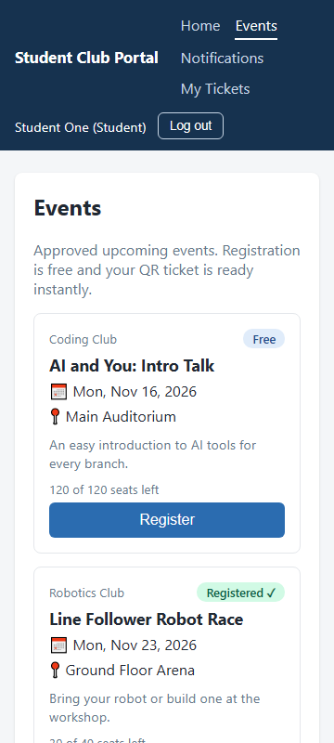
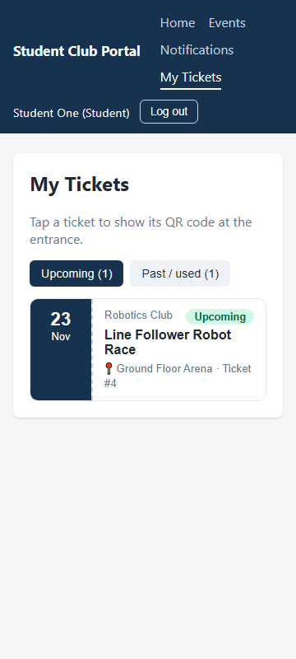

7. Deviations from the Test Plan
- Performance (TC-PERF-01) used a Python load generator with 50 concurrent users and 1000 requests on localhost instead of Apache JMeter on a deployed host. The response-time target was met with a wide margin.
- Availability (TC-REL-01) was checked by polling /api/health throughout the run; a week-long uptime monitor needs the deployed host.
- TC-SEC-05 (HTTPS redirect, TLS 1.2+) was not executed: there is no deployed host yet.
- Camera-based QR scanning needs HTTPS or a phone browser; check-in was validated with the full QR text and the manual ticket-code path, which use the same server validation.

8. Defects
ID | Area | Severity | Description | Status
D-01 | SCP-22 / SCP-F-015 | Medium | Event dates in both CSV reports were one day early when the server runs in IST (MySQL DATE converted with toISOString). | Fixed (PR #24, merged). Regression tests run with TZ=Asia/Kolkata.
D-02 | SCP-15 / SCP-F-008 | Medium | The "Approval History" menu link opened the route pattern /proposals/:id/history and showed "Invalid proposal id". | Fixed in PR #25 (menu opens a proposal-ID lookup; inbox has View history links). Awaiting merge.
D-03 | Test environment | Low | Two Vite dependency caches loaded at once after a second dev server shared node_modules; clicks did not reach React. | Environment only, not an application defect. Cleared the .vite cache and restarted.

9. Conclusion and Exit Criteria
Exit criterion (Test Plan section 5) | Status
100% of planned test cases executed | 25 of 26 executed; TC-SEC-05 blocked by the missing deployment
0 critical / high defects open | Met: no critical or high defects; D-02 (medium) fixed, merge pending
All High-priority requirements passed in the RTM | Met: all 15 functional requirements passed

The system meets its functional, performance, audit and security requirements on the test environment and is ready for user acceptance and deployment. TC-SEC-05 must be executed once the application is deployed.

