Software Architecture and Design Specification
Project: Student Club Event Ticketing & Budget Portal
Version | 1.0
Authors | Jayanth K (PES1UG24AM123)  Kishore V (PES1UG24AM139)  Leeladhar G Sairaju (PES1UG24AM148)  Mohammad Bilal A (PES1UG24AM162)
Date | 28-10-2026
Status | Draft
Course | Software Engineering - Mini Project (Section C)

Revision history
Version | Date | Author | Change summary | Approval
1.0 | 28-10-2026 | Project team | Initial version for review | Pending

Approvals
Role | Name | Signature / Email | Date
Course Coordinator
Team Lead

1. Introduction

1.1 Purpose
This document specifies the architecture and design of the Student Club Event Ticketing & Budget Portal.

1.2 Scope
Covers proposal submission, the three-stage approval workflow, notifications, event registration with QR tickets, venue check-in, and the admin dashboard with reports.

1.3 Audience
Developers, testers, the course instructor and future maintainers of the portal.

1.4 Definitions
SCP, RBAC, JWT, QR, HMAC, REST, MERN, ORM, STRIDE, TLS (see SRS section 1.4).

2. Document Overview

2.1 How to use this document
Section 3 gives the architecture (component diagrams, pattern, technology, risks, security). Section 4 gives the detailed design (sequence diagrams, API design, error handling, UX).

2.2 Related Documents
Software Requirements Specification (SRS) v1.0, Software Test Plan (STP) v1.0, and the RTM in SRS section 8.

3. Architecture

3.1 Goals & Constraints
Goals: simple and maintainable for a four-person team, secure role-based access, tamper-proof single-use tickets, and fast check-in (<= 1 s).
Constraints: React + Node.js/Express + MySQL stack, two one-week sprints, free hosting tier, no payment gateway.

3.2 Stakeholders & Concerns
Stakeholder | Main concern
Club Leads | Quick proposal submission and clear status tracking
Approvers (Faculty, Finance, Dean) | Simple review inbox, correct stage order
Campus Admin | Visibility of all proposals and budgets, reports
Students | Easy registration and a ticket that works at the gate
Developers | Modularity, testability, clear APIs

3.3 Component (UML) Diagram
The system is shown in two UML component diagrams, one per major functional area. Each «subsystem» shows its internal components, ports, and provided (ball) / required (socket) interfaces.
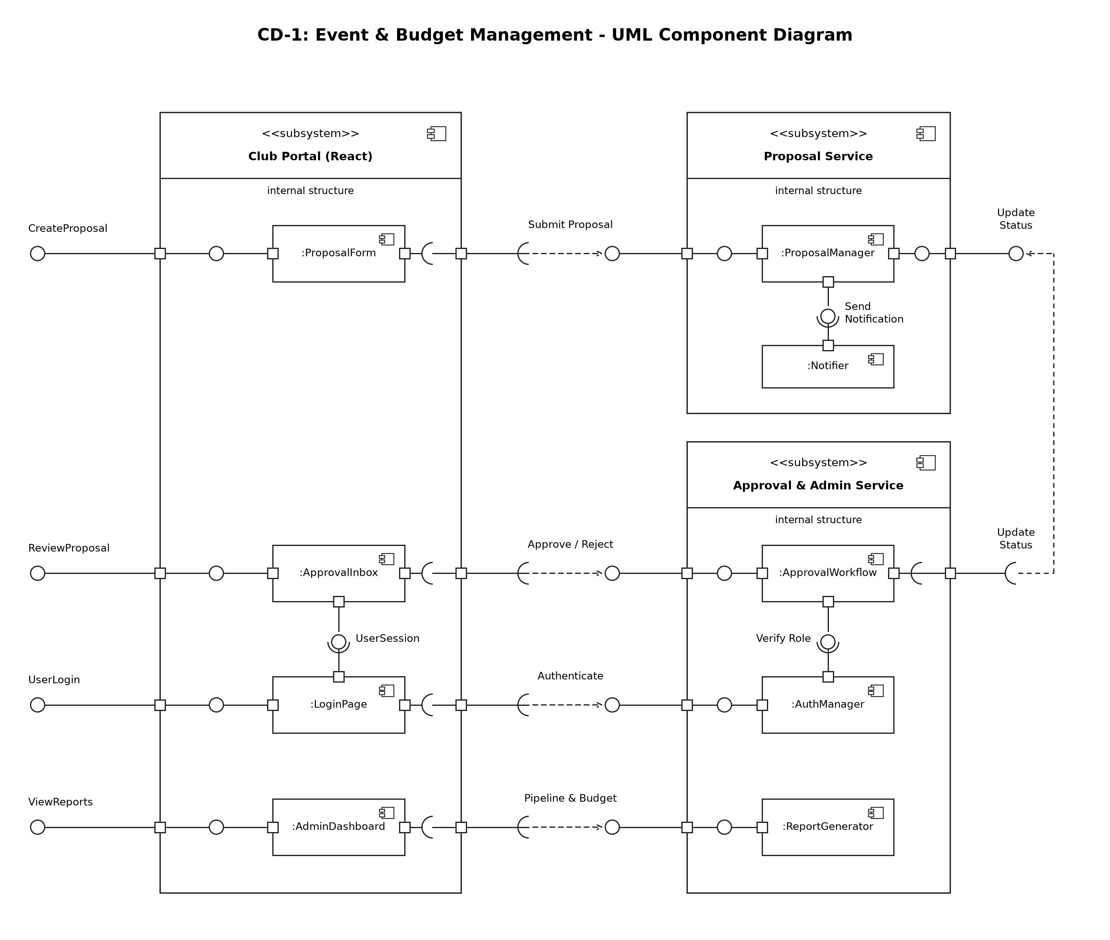
Figure 1: CD-1 Event & Budget Management
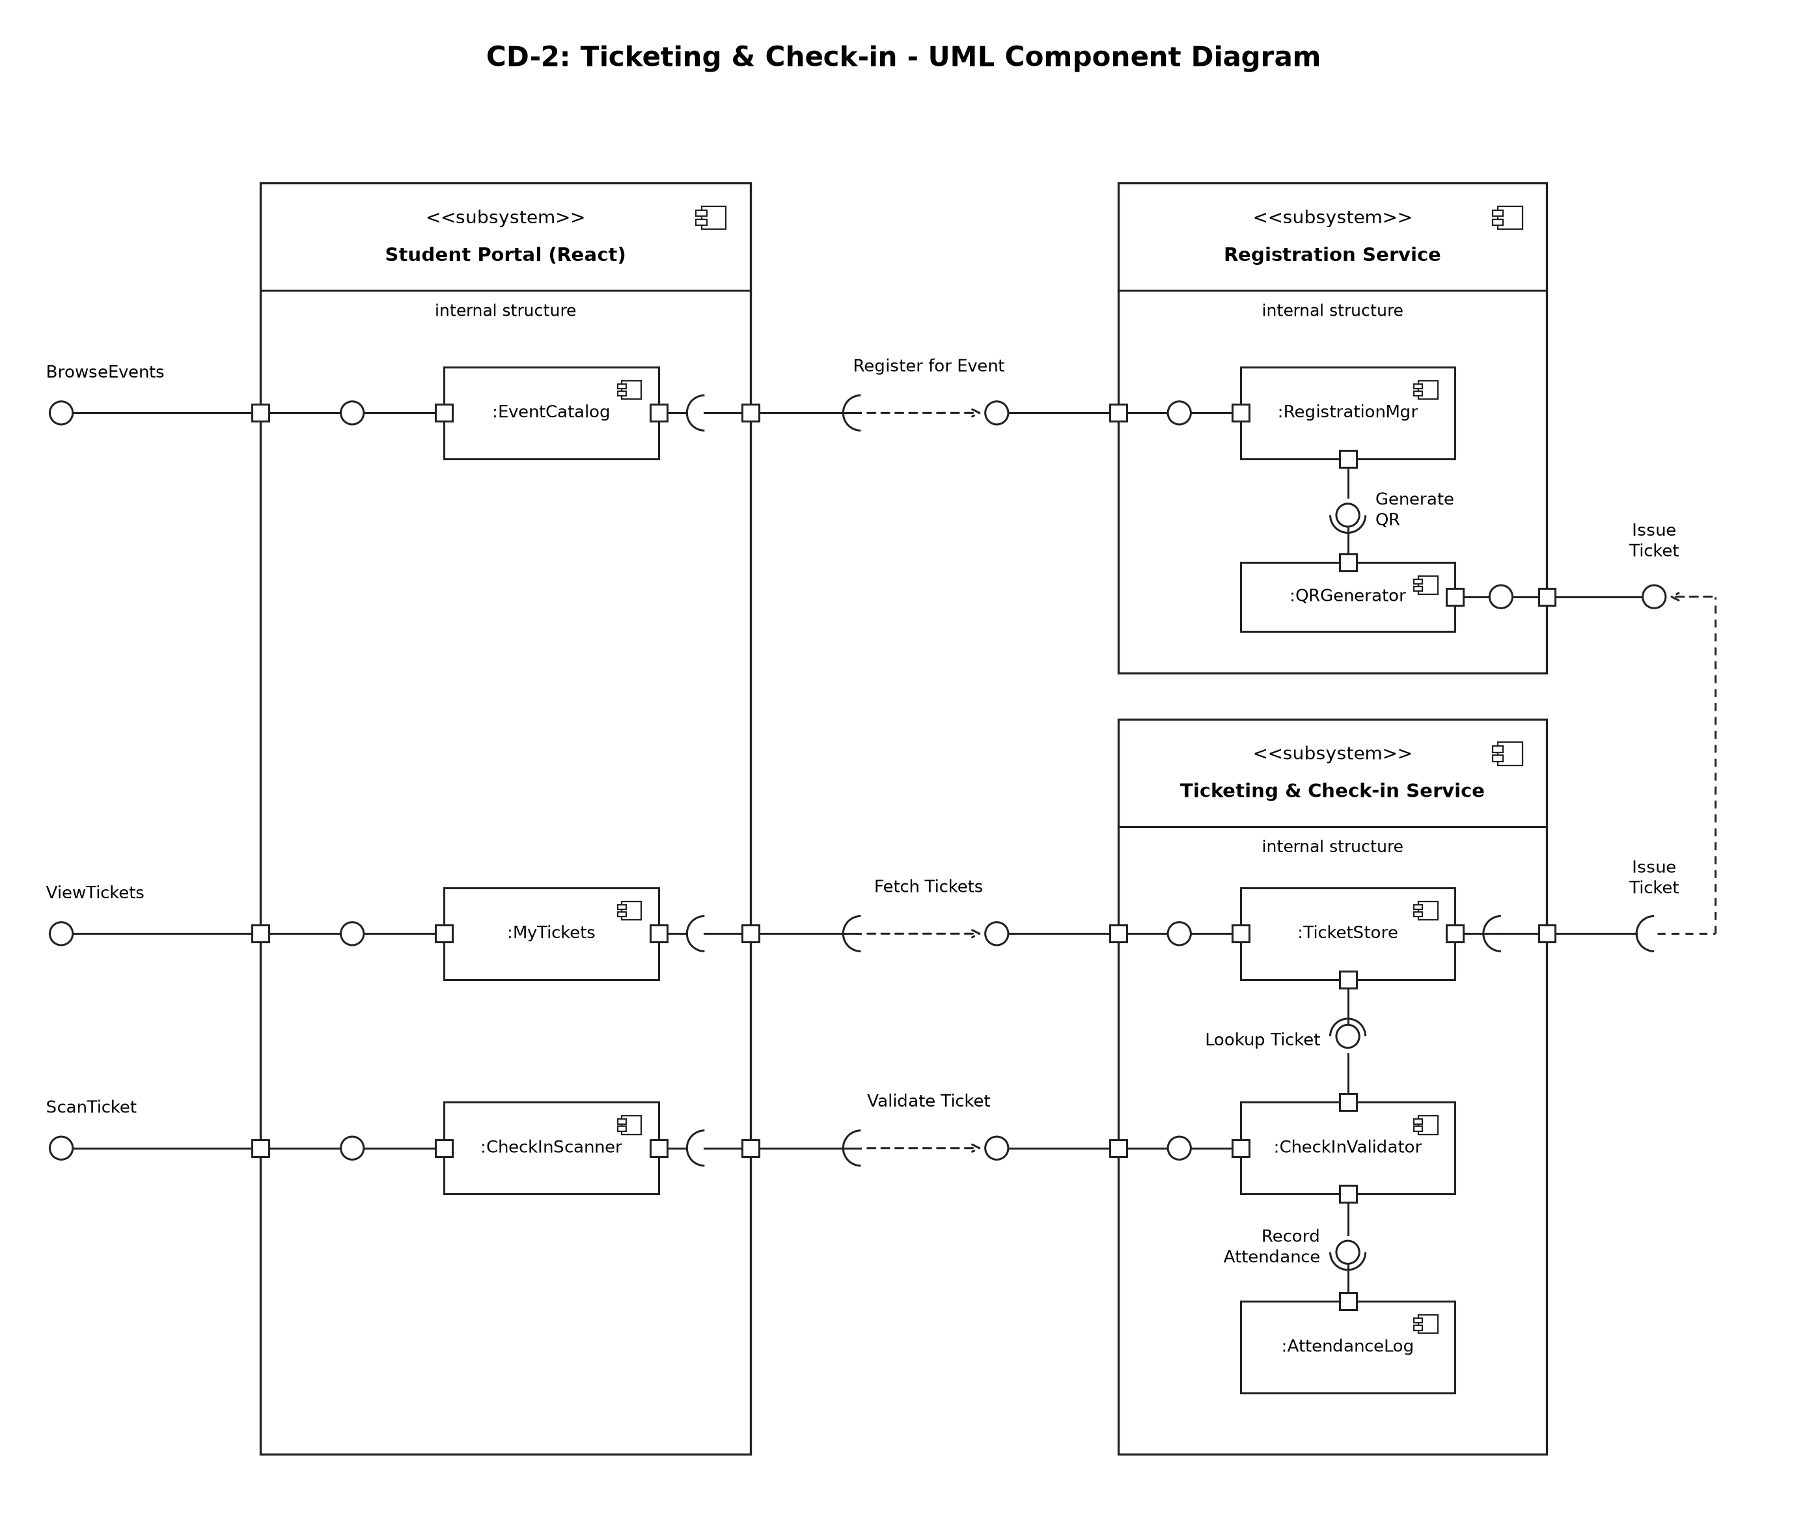
Figure 2: CD-2 Ticketing & Check-in

3.4 Component Descriptions
- Club Portal / Student Portal (React): UI pages - ProposalForm, ApprovalInbox, LoginPage, AdminDashboard, EventCatalog, MyTickets, CheckInScanner.
- Proposal Service: ProposalManager validates and stores proposals and updates their status; Notifier creates in-app notifications.
- Approval & Admin Service: ApprovalWorkflow enforces Faculty -> Finance -> Dean order and records history; AuthManager handles login, JWT and role checks; ReportGenerator builds dashboard data and PDF / CSV exports.
- Registration Service: RegistrationMgr checks capacity and duplicate registration; QRGenerator creates signed ticket tokens and QR images.
- Ticketing & Check-in Service: TicketStore stores and returns tickets; CheckInValidator verifies and marks tickets USED; AttendanceLog records check-ins for reports.
- Database (MySQL): single relational database used by all services (tables: users, clubs, proposals, approval_history, notifications, events, registrations, tickets, checkins).

3.5 Chosen Architecture Pattern and Rationale
Layered (3-tier) architecture: Presentation (React), Business logic (Express service modules) and Data (MySQL). It keeps UI, rules and data separate, is easy for a small team to build and test, and keeps approval and ticket data consistent in one transactional database. Microservices were rejected as too complex to deploy and operate within two sprints; a plain client-server monolith was rejected because it would mix UI and business rules, making the approval workflow harder to test.

3.6 Technology Stack & Data Stores
Layer | Technology
Presentation | React 18 (Vite), React Router, Axios, browser QR scanner library
Business / API | Node.js 20 LTS, Express, jsonwebtoken, bcrypt, qrcode, PDF/CSV export library
Data | MySQL 8.0 (mysql2 driver with parameterised queries)
DevOps | GitHub, GitHub Actions CI (lint + tests on every push)

3.7 Risks & Mitigations
Risk | Mitigation
Approval stage skipped through a direct API call | Server-side stage check in ApprovalWorkflow; never trust UI state
Ticket screenshots shared and reused | Single-use tickets: status set to USED on first valid scan
Camera not available at venue | Manual ticket-code entry on the check-in page
Team falls behind schedule | Notifications by email and PDF export kept as stretch items; core flow first

3.8 Traceability to Requirements
Requirement(s) | Component(s)
SCP-F-001, SCP-F-002 (User Authentication & Roles) | AuthManager
SCP-F-003, SCP-F-004, SCP-F-005 (Event Proposal Management) | ProposalManager
SCP-F-006, SCP-F-007, SCP-F-008 (Multi-stage Approval Workflow) | ApprovalWorkflow
SCP-F-009 (Notifications) | Notifier
SCP-F-010, SCP-F-011, SCP-F-012 (Event Registration & QR Ticketing) | RegistrationMgr, QRGenerator, TicketStore
SCP-F-013 (Venue Check-in) | CheckInValidator
SCP-F-014, SCP-F-015 (Dashboard & Reports) | ReportGenerator, AttendanceLog

3.9 Security Architecture
Threat modelling (STRIDE):
Threat | Example | Control
Spoofing | Someone logs in as an approver | bcrypt passwords, JWT with expiry
Tampering | Edited QR token or budget value | HMAC-signed tickets, server-side validation
Repudiation | Approver denies a decision | Approval history with user and timestamp
Information disclosure | Club sees another club's budget | RBAC filters on every query, HTTPS
Denial of service | Login or check-in flooding | Rate limiting on auth and check-in endpoints
Elevation of privilege | Student calls approval API | Role check middleware on every route

4. Design

4.1 Design Overview
Each business component is an Express router + service module with its own MySQL tables. The React client calls these through REST endpoints; shared middleware handles authentication, role checks, validation and error formatting.

4.2 UML Sequence Diagrams
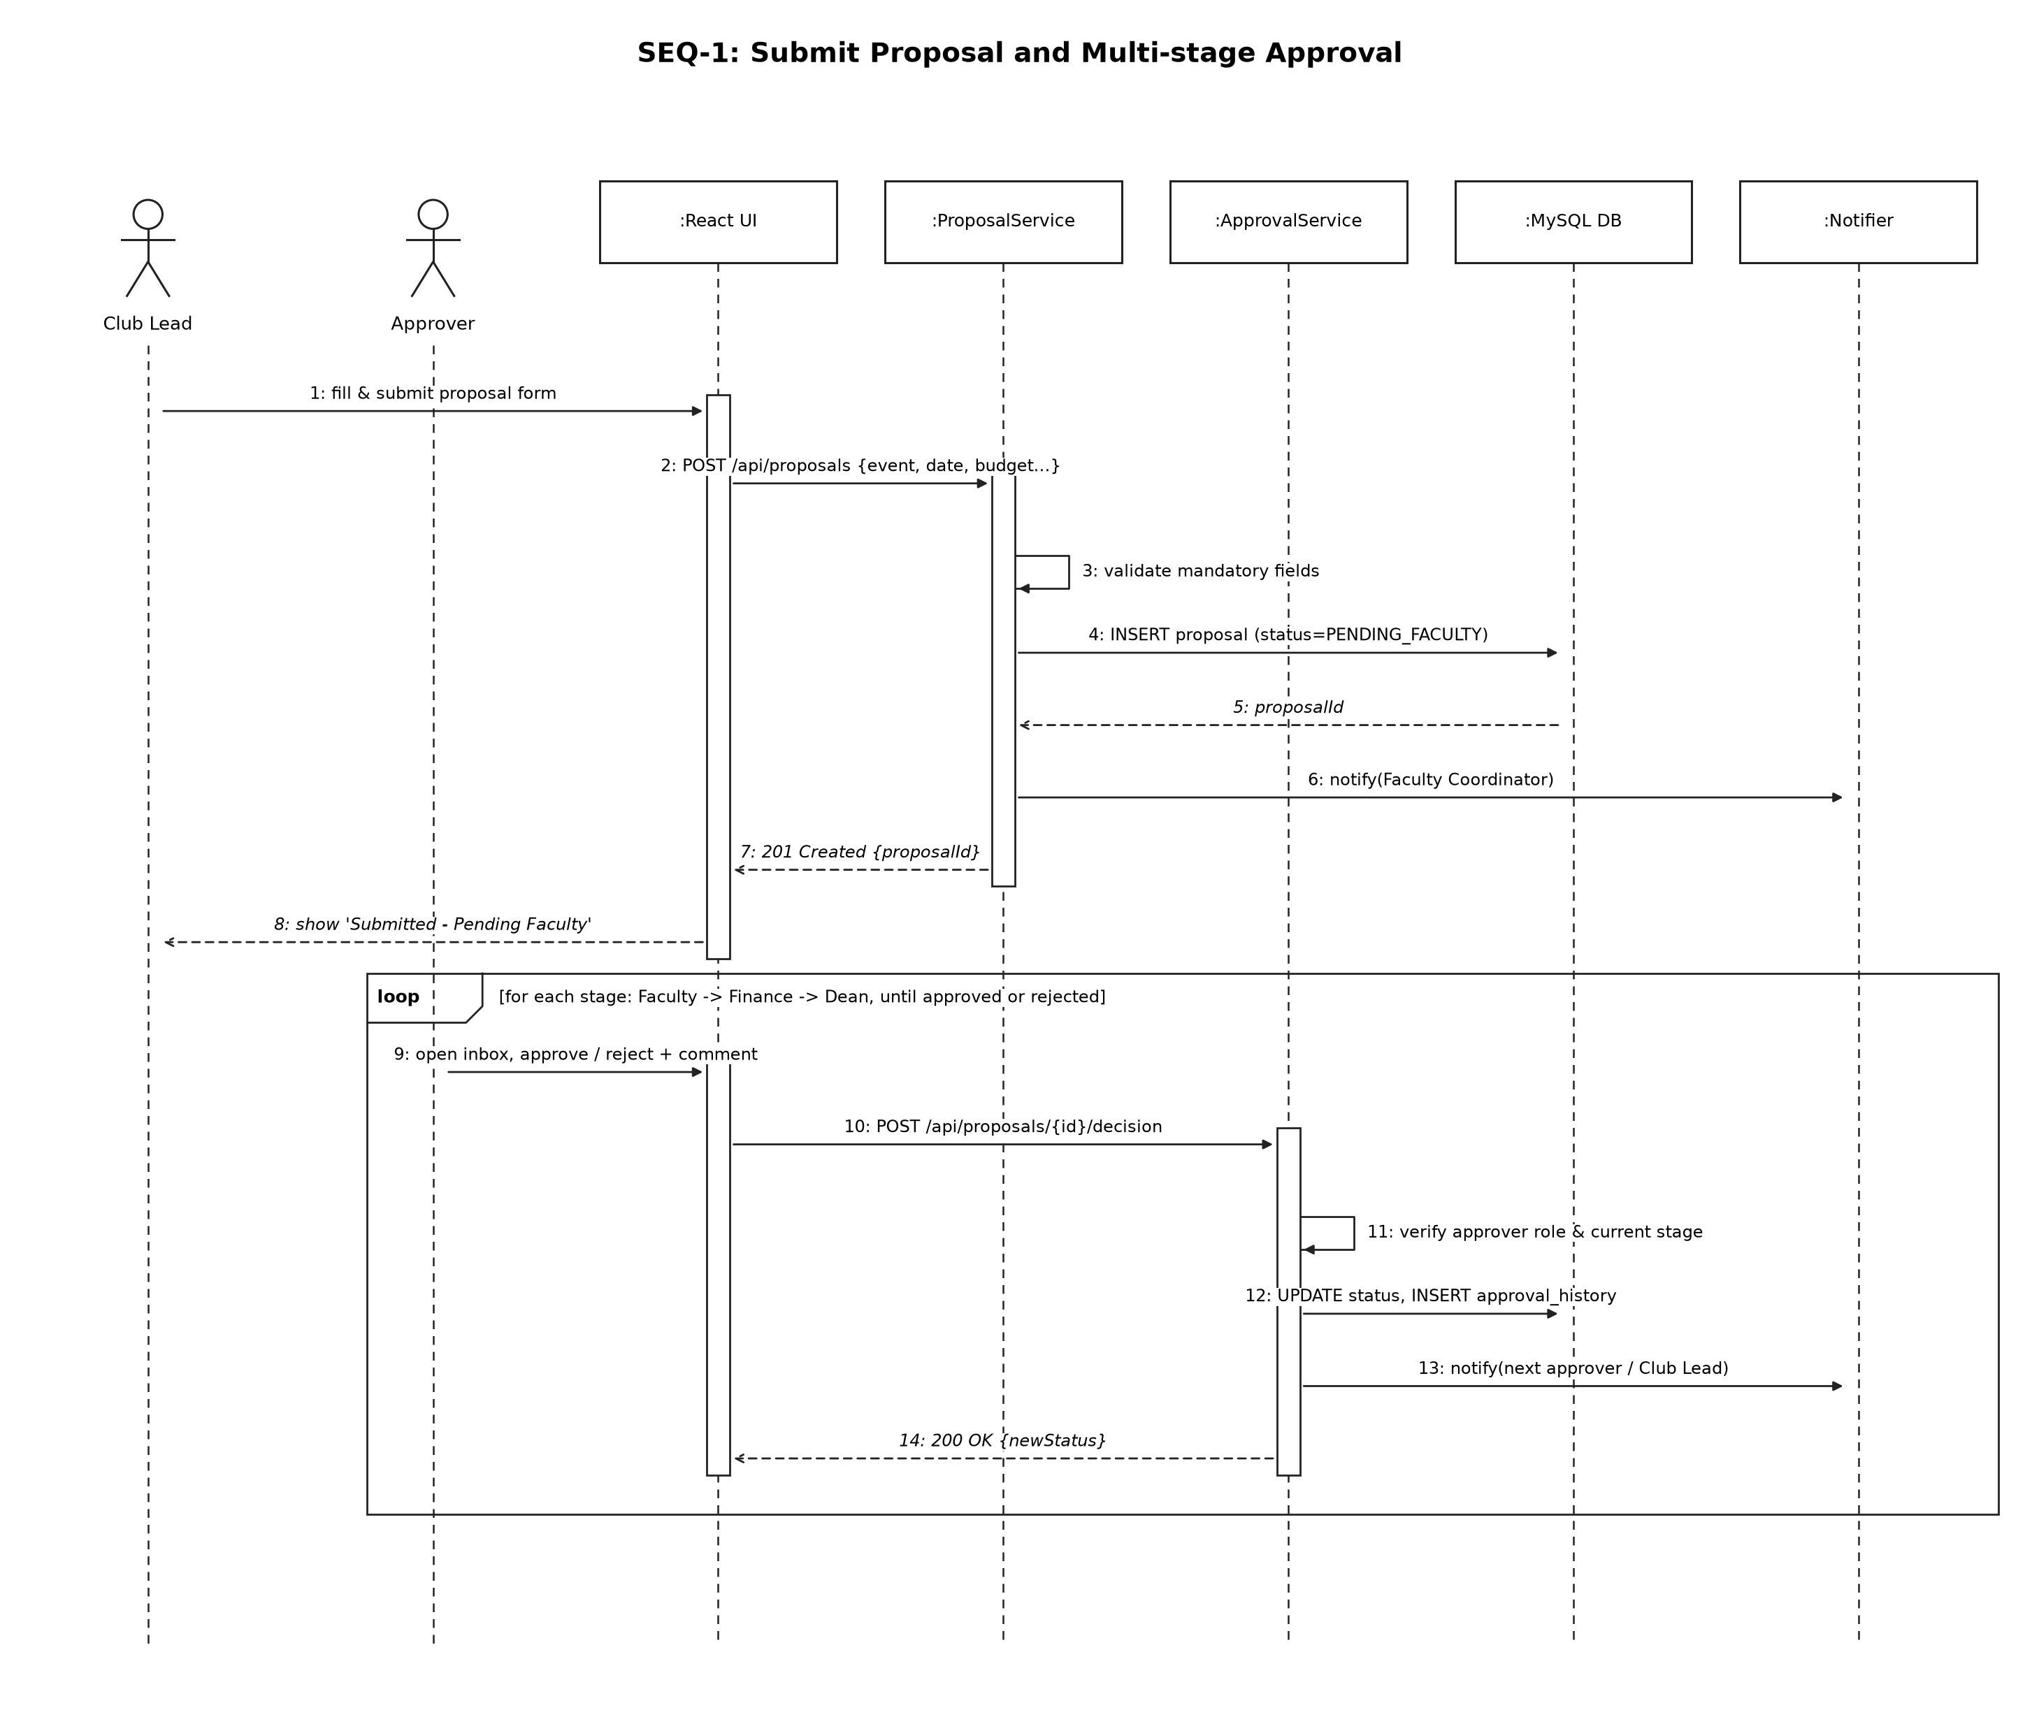
Figure 3: SEQ-1 Submit proposal and multi-stage approval
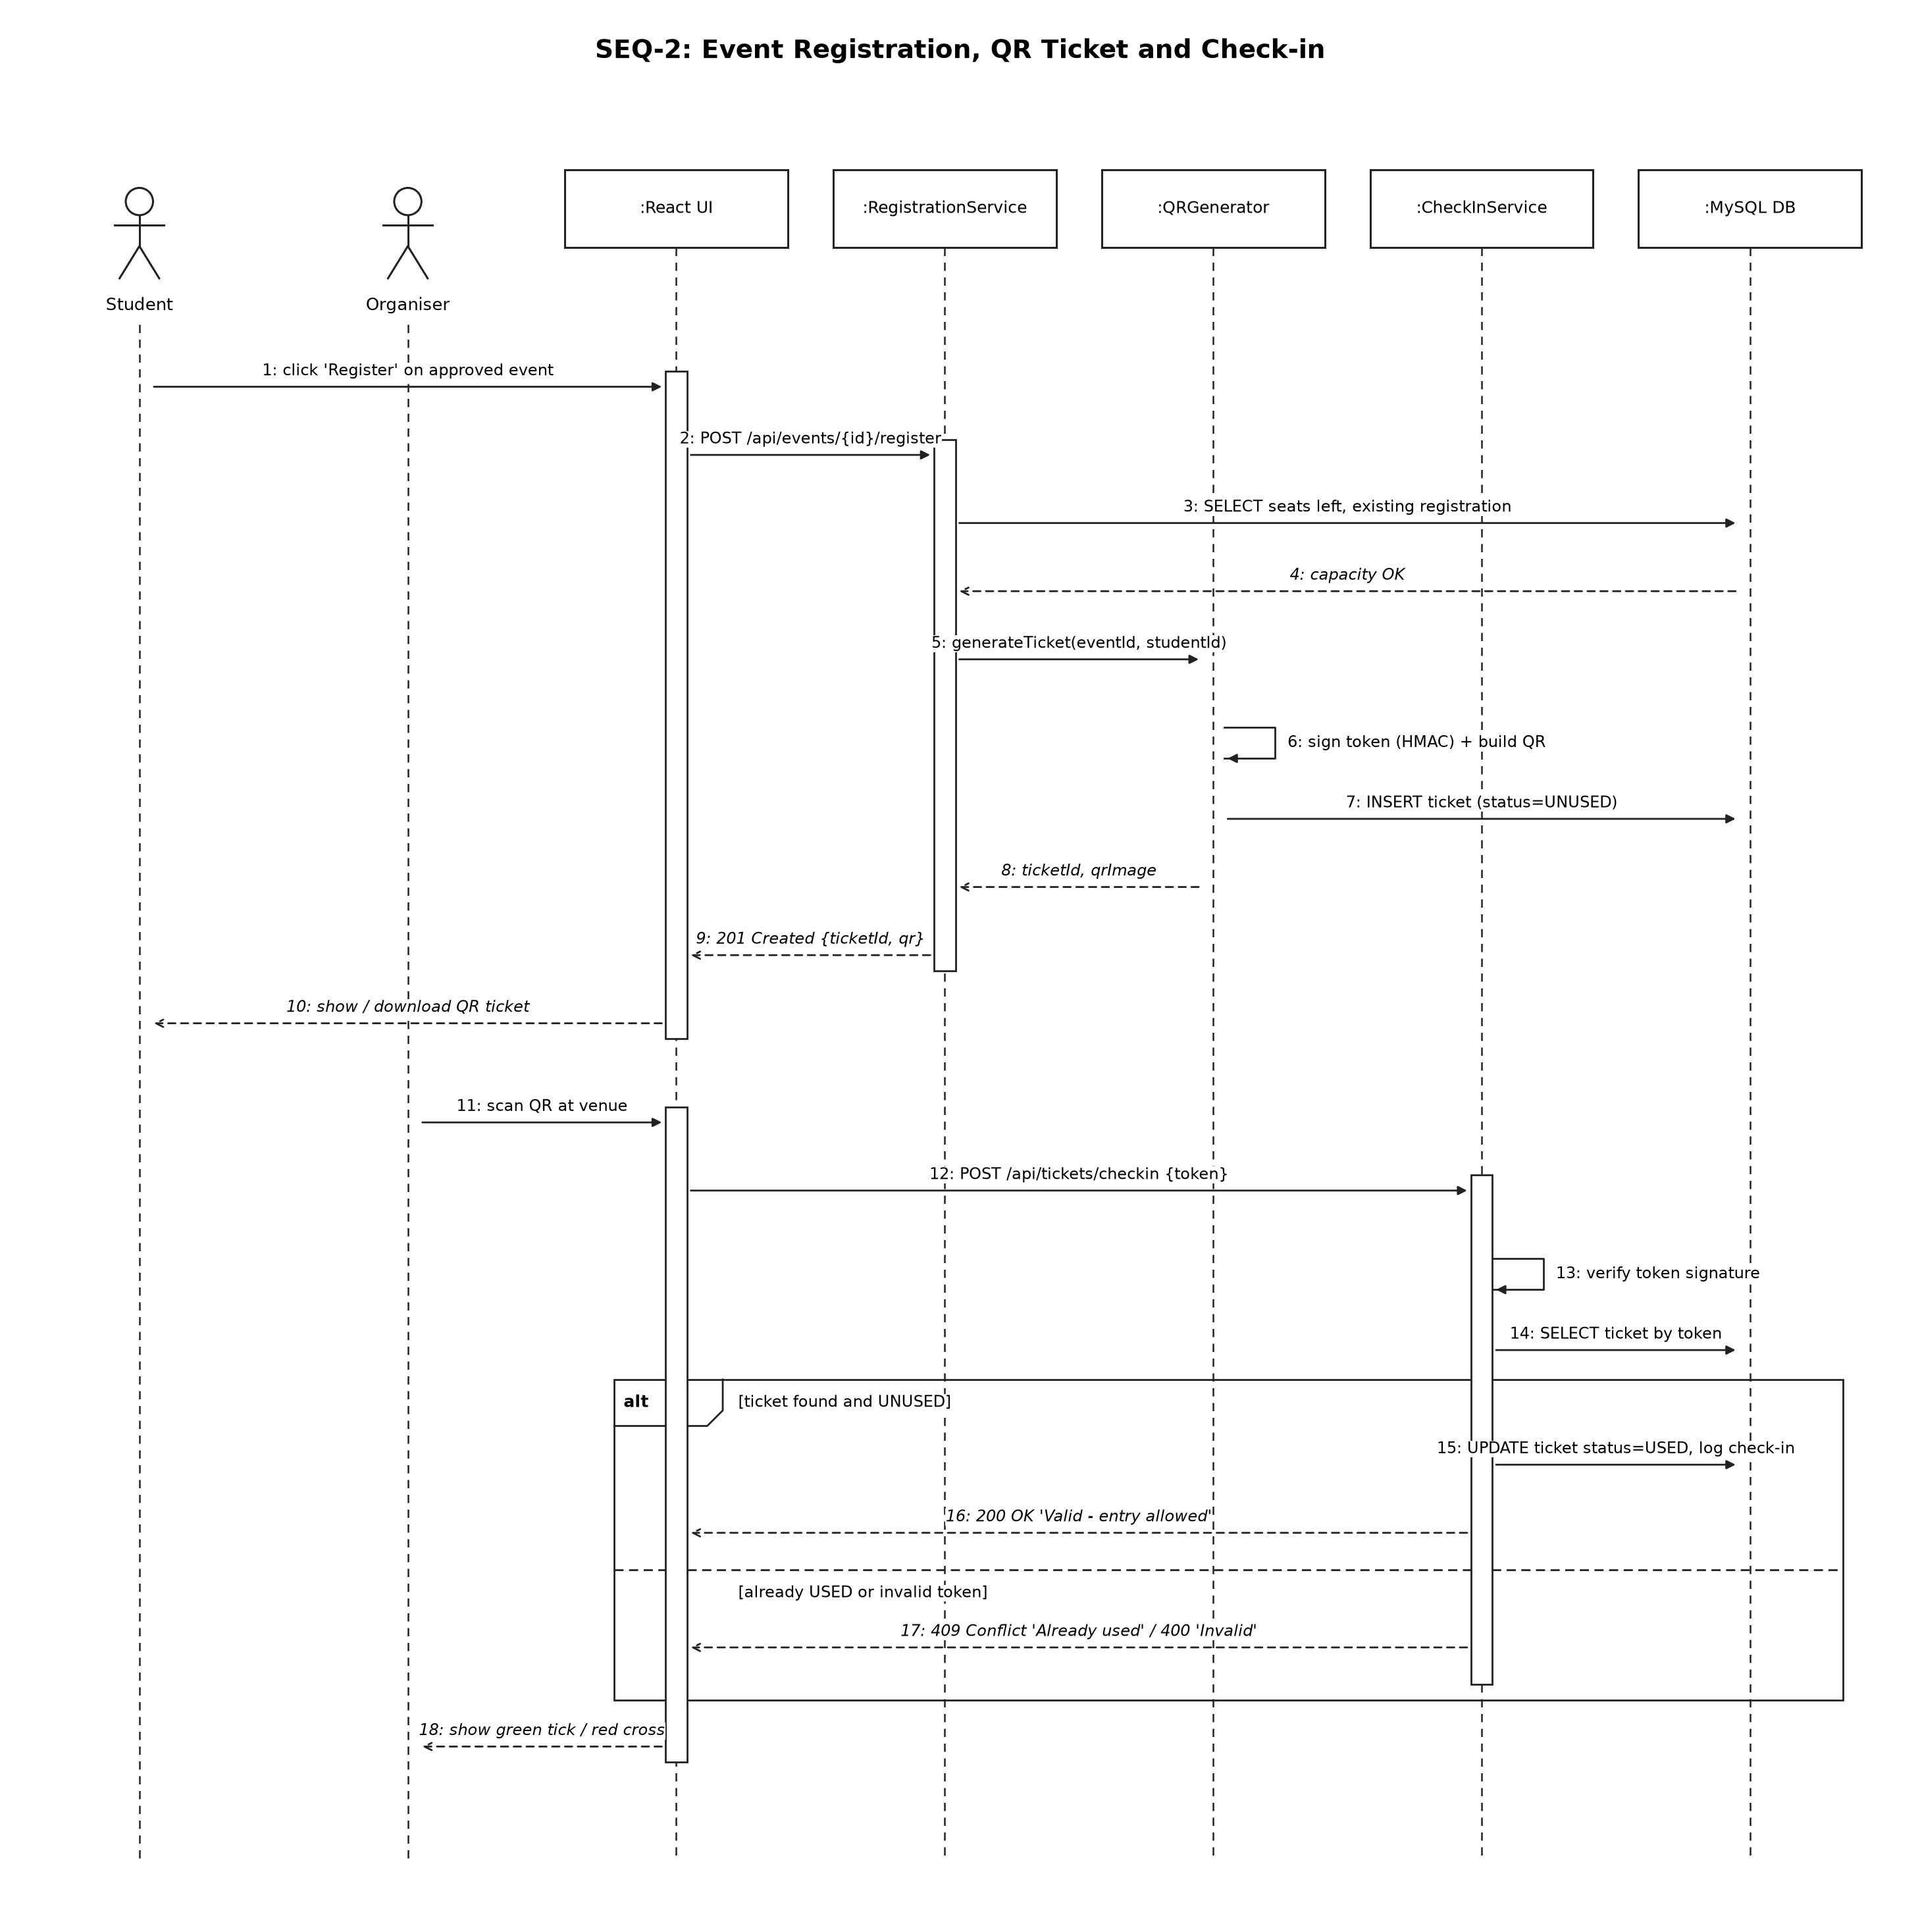
Figure 4: SEQ-2 Event registration, QR ticket and check-in

4.3 API Design
Interface definitions for two components: Proposal / Approval and Ticketing / Check-in. All endpoints need Authorization: Bearer <JWT>.
Component | Endpoint | Method | Role | Request | Response | Errors
Proposal Service | /api/proposals | POST | Club Lead | {eventName, eventDate, venue, expectedAttendance, budget, description} | 201 {proposalId, status: "PENDING_FACULTY"} | 400 Missing/invalid field, 401 Not logged in, 403 Not a Club Lead
Approval Service | /api/proposals/{id}/decision | POST | Faculty / Finance / Dean | {decision: "APPROVE" | "REJECT", comment} | 200 {proposalId, newStatus} | 400 Comment required on reject, 403 Not current stage, 404 Proposal not found
Registration Service | /api/events/{id}/register | POST | Student | (no body) | 201 {ticketId, qrImage} | 404 Event not found, 409 Already registered, 410 Event full
Check-in Service | /api/tickets/checkin | POST | Club Lead (organiser) | {token} | 200 {valid: true, studentName, eventName} | 400 Invalid token, 409 Ticket already used, 403 Not organiser of event

4.4 Error Handling, Logging & Monitoring
- All errors return JSON {error, message} with the correct HTTP status; no stack traces sent to the client.
- Passwords, JWTs and ticket tokens are never written to logs.
- Approval decisions and check-ins are written to audit tables with user and timestamp.
- A /api/health endpoint is monitored for uptime; failed check-ins and 5xx errors are counted.

4.5 UX Design
Role-based menu so each user sees only their tasks; status badges coloured by stage (pending, approved, rejected); large green / red result on the check-in screen; responsive layout for phones at the venue.

4.6 Open Issues & Next Steps
- Email notifications and SMS reminders (stretch goal).
- Paid events with a payment gateway.
- Single sign-on with the university login system.

5. Appendices
5.1 Glossary: SCP, RBAC, JWT, QR, HMAC, REST, STRIDE, TLS.
5.2 References: IEEE 42010 (architecture description), OWASP Top 10, IEEE 830 / 29148, project SRS v1.0.
5.3 Tools: VS Code, GitHub, MySQL Workbench, Postman, UML diagramming tool.

