Software Requirements Specification (SRS)
Project: Student Club Event Ticketing & Budget Portal
Version | 1.0
Authors | Jayanth K (PES1UG24AM123)  Kishore V (PES1UG24AM139)  Leeladhar G Sairaju (PES1UG24AM148)  Mohammad Bilal A (PES1UG24AM162)
Date | 28-10-2026
Status | Draft
Course | Software Engineering - Mini Project (Section C)

Revision history
Version | Date | Author | Change summary | Approval
1.0 | 28-10-2026 | Project team | Initial version for review | Pending

Approvals
Role | Name | Signature / Email | Date
Course Coordinator
Team Lead

Table of Contents
1. Introduction
2. Overall description
3. External interfaces
4. System features (detailed)
5. Non-functional requirements (detailed)
6. Quality attributes & Acceptance tests
7. UML Use-Case Diagram
8. Requirements Traceability Matrix (RTM)

1. Introduction

1.1 Purpose
This document is the Software Requirements Specification (SRS) for the Student Club Event Ticketing & Budget Portal. It defines the functional and non-functional requirements, interfaces and verification criteria the team will build and test during the two-sprint mini project.

1.2 Scope
The portal lets student clubs submit event proposals with budgets, routes them through a three-stage approval (Faculty Coordinator, Finance Officer, Dean), issues QR-code tickets to students for approved events, validates tickets at the venue and gives the Campus Admin a dashboard with reports. Online payments, SSO with the university system, a native mobile app and venue hardware are out of scope.

1.3 Audience
Project team (developers and testers), course instructor / evaluators, and club and administration staff who review the requirements.

1.4 Definitions
SCP - Student Club Portal; FR / NFR - Functional / Non-functional Requirement; RBAC - Role-Based Access Control; JWT - JSON Web Token; QR - Quick Response code; HMAC - Hash-based Message Authentication Code; MERN - MongoDB, Express, React, Node.js stack (this project uses MySQL in place of MongoDB); API - Application Programming Interface; TLS - Transport Layer Security; RTM - Requirements Traceability Matrix; UAT - User Acceptance Testing.

2. Overall description

2.1 Product perspective
A new, self-contained web application. A React single-page app talks to a Node.js / Express REST API, which stores data in a MySQL database. It replaces paper and email-based event approvals and manual entry lists at club events.

2.2 Major product functions
- Login and role-based access
- Submit, edit and track event proposals with budgets
- Three-stage approval workflow with comments and history
- In-app notifications on status changes
- Event registration and unique QR-code tickets
- Single-use ticket validation at venue check-in
- Dashboard with filters and PDF / CSV reports

2.3 User roles and characteristics
- Club Lead: creates and tracks proposals for their club; scans tickets at their events.
- Faculty Coordinator / Finance Officer / Dean: review and approve or reject proposals at their stage.
- Campus Admin: views all proposals, manages users and roles, exports reports.
- Student: browses approved events, registers and shows the QR ticket at entry.

2.4 Operating environment
Modern web browsers (Chrome, Firefox, Edge, Android Chrome) on desktop and mobile. Server: Node.js 20 LTS with Express, MySQL 8.0 database, hosted on a college lab machine or a free cloud tier.

2.5 Constraints
- Must be built and tested within two one-week sprints by a team of four.
- Technology stack fixed to React, Node.js / Express and MySQL.
- No payment gateway: event registration is free.
- Users are identified by college email addresses.

3. External interface requirements

3.1 User interfaces
Responsive web UI with a role-based navigation menu: proposal form, approval inbox, proposal status page, event list, My Tickets, check-in scanner page and admin dashboard. Clear error messages next to invalid form fields.

3.2 Hardware interfaces
No special hardware. The check-in page uses the device camera (phone or laptop webcam) through the browser to read QR codes, with manual ticket-code entry as a fallback.

3.3 Software interfaces
- MySQL 8.0 database accessed from Express through a parameterised query library.
- REST/JSON API between the React client and the Express server.
- Open-source libraries: jsonwebtoken (sessions), bcrypt (password hashing), qrcode (QR images), PDF/CSV export library.
- Optional SMTP mail service for email notifications (stretch goal).

3.4 Communications
HTTPS (TLS 1.2+) between browser and server in deployment; JSON request / response bodies; JWT sent in the Authorization header.

4. System features (detailed)
Each requirement includes acceptance criteria and a reference test case. IDs follow SCP-F-###. Total: 15 functional requirements.

4.1 User Authentication & Roles
Description: Users sign in with their college email and get access only to the screens and actions allowed for their role.
Req ID | Requirement (shall...) | Priority | Source | Acceptance criteria / Test case ref | Comments / Dependencies
SCP-F-001 | The system shall allow users to log in and log out using college email and password, issuing a JWT session token on success. | High | All users | Valid credentials open the role's home page; wrong password shows an error and no token is issued. Test: TC-AUTH-01 | Passwords stored hashed (SCP-SR-001)
SCP-F-002 | The system shall enforce role-based access for Club Lead, Faculty Coordinator, Finance Officer, Dean, Campus Admin and Student. | High | Security | A user calling an API outside their role receives 403 and the UI hides the action. Test: TC-AUTH-02 | Roles seeded by Campus Admin

4.2 Event Proposal Management
Description: Club Leads create event proposals with a budget and can correct and resubmit them if rejected.
Req ID | Requirement (shall...) | Priority | Source | Acceptance criteria / Test case ref | Comments / Dependencies
SCP-F-003 | The system shall allow a Club Lead to submit an event proposal with event name, date, venue, expected attendance, budget amount and description. | High | Club Lead | Proposal is saved with status PENDING_FACULTY; submission fails with field errors if any mandatory field is missing or invalid. Test: TC-PROP-01 | Budget must be a positive number
SCP-F-004 | The system shall allow a Club Lead to edit and resubmit a proposal that is rejected, restarting the approval from the Faculty stage. | Medium | Club Lead | Rejected proposal can be edited; on resubmit status returns to PENDING_FACULTY and history is kept. Test: TC-PROP-02 | Approved proposals are read-only
SCP-F-005 | The system shall allow a Club Lead to view the current status and stage of each of their club's proposals. | Medium | Club Lead | Proposal list shows status (Pending Faculty / Finance / Dean, Approved, Rejected) for own club only. Test: TC-PROP-03 | -

4.3 Multi-stage Approval Workflow
Description: Each proposal moves through Faculty Coordinator, Finance Officer and Dean in a fixed order.
Req ID | Requirement (shall...) | Priority | Source | Acceptance criteria / Test case ref | Comments / Dependencies
SCP-F-006 | The system shall route every proposal sequentially through Faculty Coordinator, Finance Officer and Dean approval stages. | High | University policy | A proposal cannot reach Finance before Faculty approval, or the Dean before Finance approval. Test: TC-APPR-01 | Core business rule
SCP-F-007 | The system shall allow the approver of the current stage to approve or reject a proposal, with a mandatory comment on rejection. | High | Approvers | Approve moves the proposal to the next stage (or APPROVED after the Dean); reject without a comment is blocked. Test: TC-APPR-02 | Only the current-stage role may decide
SCP-F-008 | The system shall record an approval history entry (stage, approver, decision, comment, timestamp) for every decision. | Medium | Audit | History tab lists every decision in order with approver name and time. Test: TC-APPR-03 | Supports SCP-SR-005

4.4 Notifications
Description: Users are told when something needs their action or when their proposal changes status.
Req ID | Requirement (shall...) | Priority | Source | Acceptance criteria / Test case ref | Comments / Dependencies
SCP-F-009 | The system shall send an in-app notification to the next approver when a proposal reaches their stage, and to the Club Lead on every approval or rejection. | Medium | All users | Notification appears in the bell list within 1 minute of the status change. Test: TC-NOTI-01 | Email is optional (stretch)

4.5 Event Registration & QR Ticketing
Description: Students register for approved events and receive a unique QR-code ticket.
Req ID | Requirement (shall...) | Priority | Source | Acceptance criteria / Test case ref | Comments / Dependencies
SCP-F-010 | The system shall list approved upcoming events and allow a student to register once per event while seats are available. | High | Student | Registration succeeds only if seats are left and the student is not already registered. Test: TC-TKT-01 | Capacity = expected attendance
SCP-F-011 | The system shall generate a unique, signed QR-code ticket containing event ID, student ID and ticket ID for each registration. | High | Club Lead | Every registration gets exactly one ticket; QR tokens are unique and verify against the server signature. Test: TC-TKT-02 | HMAC-signed token (SCP-SR-003)
SCP-F-012 | The system shall allow a student to view and download their QR tickets from the My Tickets page. | Medium | Student | My Tickets lists all tickets; QR downloads as a PNG image. Test: TC-TKT-03 | -

4.6 Venue Check-in
Description: Organisers scan tickets at the venue; each ticket can be used only once.
Req ID | Requirement (shall...) | Priority | Source | Acceptance criteria / Test case ref | Comments / Dependencies
SCP-F-013 | The system shall validate a scanned or typed QR ticket at check-in, mark it USED, and reject tickets that are already used, invalid or for another event. | High | Organiser | First scan shows 'Valid'; a second scan of the same ticket shows 'Already used'; a tampered code shows 'Invalid'. Test: TC-CHK-01, TC-CHK-02 | Webcam/phone camera or manual code entry

4.7 Dashboard & Reports
Description: Campus Admin and Club Leads get a summary of proposals, budgets and attendance.
Req ID | Requirement (shall...) | Priority | Source | Acceptance criteria / Test case ref | Comments / Dependencies
SCP-F-014 | The system shall provide a dashboard with the proposal pipeline (count per stage), a proposal table and filters by status, club and date range. | Medium | Campus Admin | Counts match the database; applying filters refreshes the table with only matching rows; Club Leads see only their club. Test: TC-DASH-01 | -
SCP-F-015 | The system shall export a budget allocation report and an event attendance report in PDF or CSV format. | Medium | Campus Admin | Exported file opens correctly and totals match the dashboard. Test: TC-DASH-02 | -

5. Non-functional requirements (detailed)
NFRs below are measurable and tied to the test plan. IDs SCP-NF-###.
Req ID | Requirement | Category | Priority | Acceptance criteria / Measurement
SCP-NF-001 | Pages and API responses shall load within 2 seconds for 90% of requests with 50 concurrent users. | Performance | High | 90th percentile <= 2 s in a JMeter load test. Test: TC-PERF-01
SCP-NF-002 | QR ticket validation at check-in shall return a result within 1 second. | Performance | High | Average check-in response <= 1 s over 100 scans. Test: TC-PERF-02
SCP-NF-003 | The UI shall be responsive and usable on desktop and mobile browsers (Chrome, Firefox, Edge, Android Chrome). | Usability | Medium | All main pages render without layout breakage at 360 px and 1366 px widths. Test: TC-UX-01
SCP-NF-004 | The system shall be available 99% of the time during event submission and check-in windows. | Reliability | Medium | Uptime monitored during the demo week >= 99%. Test: TC-REL-01
SCP-NF-005 | Approval and check-in actions shall be logged with timestamps and retained for at least 1 year. | Audit / Maintainability | Medium | Log entries exist for every decision and check-in; older entries are retrievable. Test: TC-OPS-01

5.1 Security

5.1.1 Security Objectives
- Confidentiality: Personal data of students and staff (emails, registrations) and club budgets are visible only to authorised roles.
- Integrity: Approval decisions, budgets and tickets cannot be forged or altered; every ticket can be used only once.
- Accountability: Every approval decision and check-in can be traced to the user who performed it.

5.1.2 Security Requirements
Req ID | Requirement (shall...) | Type | Priority | Acceptance criteria / Test case ref
SCP-SR-001 | User passwords shall be stored only as salted bcrypt hashes; plaintext passwords shall never be stored or logged. | Security | High | Database contains only bcrypt hashes; log files contain no passwords. Test: TC-SEC-01
SCP-SR-002 | Every API endpoint shall verify the JWT and the user's role before processing the request. | Security | High | Requests without a token return 401; wrong role returns 403. Test: TC-SEC-02
SCP-SR-003 | QR ticket tokens shall be HMAC-signed by the server so that forged or modified tickets are rejected. | Security | High | Editing any character of a token causes 'Invalid'. Test: TC-SEC-03
SCP-SR-004 | All database access shall use parameterised queries and all inputs shall be validated on the server. | Security | High | SQL-injection payloads in form fields are rejected and do not alter data. Test: TC-SEC-04
SCP-SR-005 | All traffic between browser and server shall use HTTPS (TLS 1.2+) in deployment. | Security | High | HTTP requests redirect to HTTPS; TLS version >= 1.2. Test: TC-SEC-05

6. Quality attributes & Acceptance tests
- Exit criteria for acceptance: all High-priority FRs implemented and verified, no critical NFR or security failures, and the RTM shows all planned test cases passed.
- Acceptance test suites: Authentication, Proposals, Approval Workflow, Notifications, Ticketing, Check-in, Dashboard & Reports, Performance, Usability and Security.

7. System models and diagrams

7.1 UML Use-Case diagrams
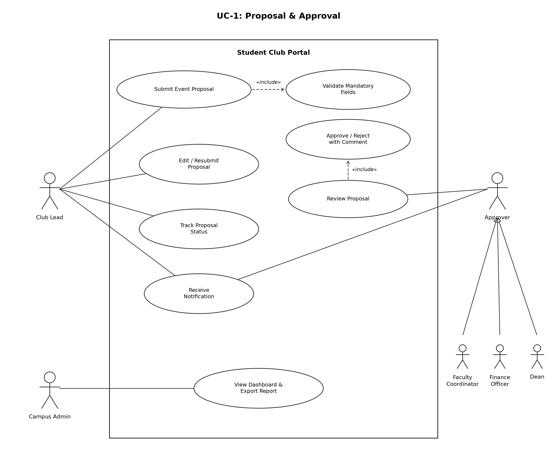
Figure 1: UC-1 Proposal & Approval
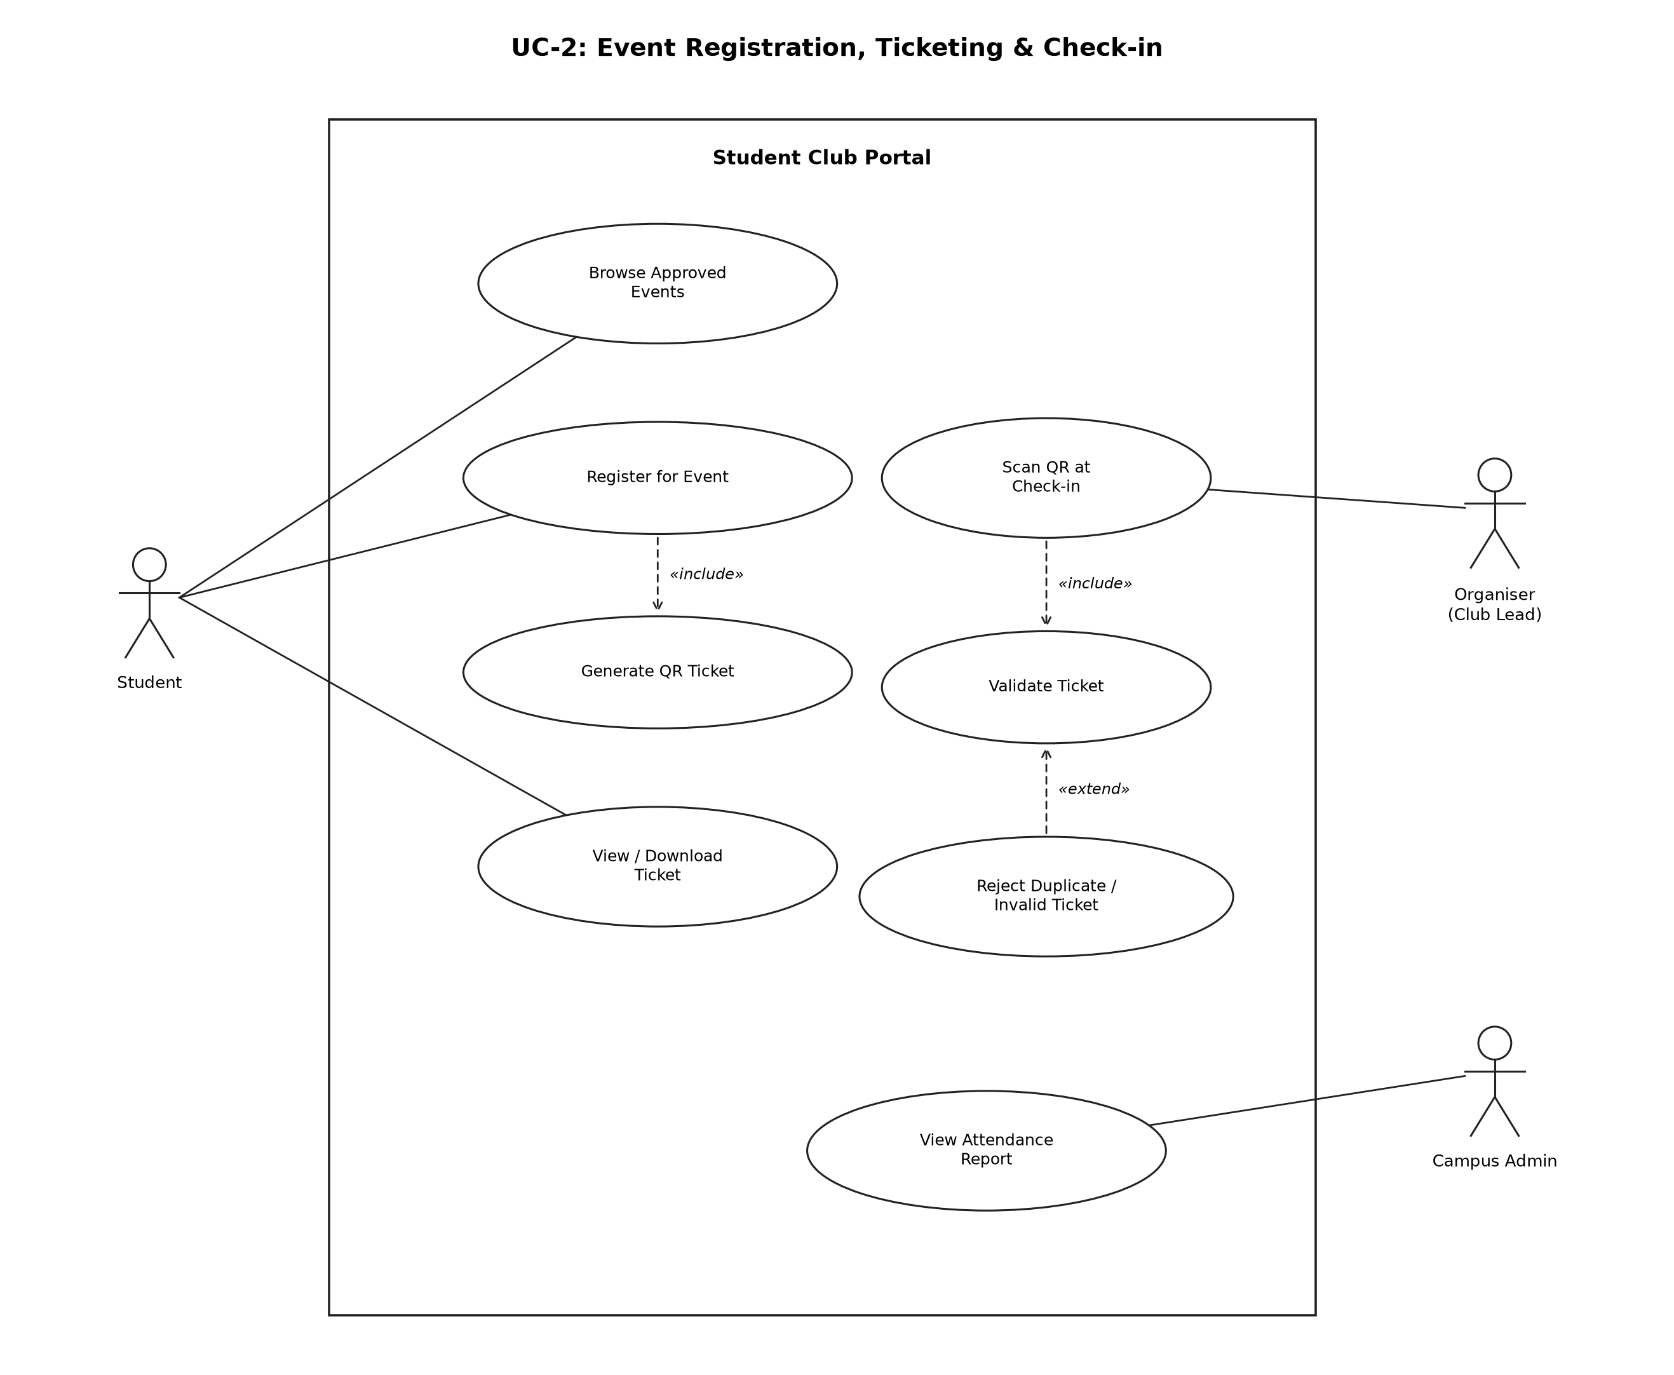
Figure 2: UC-2 Event Registration, Ticketing & Check-in

8. Requirements Traceability Matrix (RTM)
Status: N = Not started, P = In progress, A = Accepted (tested and passed).
Req ID | Requirement short | Section ref / Design spec | Module | Test case(s) | Status (N/P/A)
SCP-F-001 | Login / logout | 4.1 / DS-AUTH-01 | AuthManager | TC-AUTH-01 | N
SCP-F-002 | Role-based access | 4.1 / DS-AUTH-02 | AuthManager | TC-AUTH-02 | N
SCP-F-003 | Submit proposal | 4.2 / DS-PROP-01 | ProposalManager | TC-PROP-01 | N
SCP-F-004 | Edit & resubmit | 4.2 / DS-PROP-02 | ProposalManager | TC-PROP-02 | N
SCP-F-005 | Track status | 4.2 / DS-PROP-03 | ProposalManager | TC-PROP-03 | N
SCP-F-006 | Sequential stages | 4.3 / DS-APPR-01 | ApprovalWorkflow | TC-APPR-01 | N
SCP-F-007 | Approve / reject | 4.3 / DS-APPR-02 | ApprovalWorkflow | TC-APPR-02 | N
SCP-F-008 | Approval history | 4.3 / DS-APPR-03 | ApprovalWorkflow | TC-APPR-03 | N
SCP-F-009 | Notifications | 4.4 / DS-NOTI-01 | Notifier | TC-NOTI-01 | N
SCP-F-010 | Register for event | 4.5 / DS-TKT-01 | RegistrationMgr | TC-TKT-01 | N
SCP-F-011 | Generate QR ticket | 4.5 / DS-TKT-02 | QRGenerator | TC-TKT-02 | N
SCP-F-012 | View / download ticket | 4.5 / DS-TKT-03 | TicketStore | TC-TKT-03 | N
SCP-F-013 | Validate at check-in | 4.6 / DS-CHK-01 | CheckInValidator | TC-CHK-01, TC-CHK-02 | N
SCP-F-014 | Dashboard & filters | 4.7 / DS-DASH-01 | ReportGenerator | TC-DASH-01 | N
SCP-F-015 | Export reports | 4.7 / DS-DASH-02 | ReportGenerator, AttendanceLog | TC-DASH-02 | N
SCP-NF-001 | Response time | 5 / DS-PERF-01 | React UI / Express API | TC-PERF-01 | N
SCP-NF-002 | Check-in time | 5 / DS-CHK-01 | CheckInValidator | TC-PERF-02 | N
SCP-NF-003 | Responsive UI | 5 / DS-UX-01 | React UI | TC-UX-01 | N
SCP-NF-004 | Availability | 5 / DS-OPS-01 | Express API / MySQL | TC-REL-01 | N
SCP-NF-005 | Audit logging | 5 / DS-OPS-02 | ApprovalWorkflow / AttendanceLog | TC-OPS-01 | N
SCP-SR-001 | Password hashing | 5.1.2 / DS-AUTH-01 | AuthManager | TC-SEC-01 | N
SCP-SR-002 | Token & role check | 5.1.2 / DS-AUTH-02 | AuthManager | TC-SEC-02 | N
SCP-SR-003 | Signed QR | 5.1.2 / DS-TKT-02 | QRGenerator / CheckInValidator | TC-SEC-03 | N
SCP-SR-004 | Input validation | 5.1.2 / DS-OPS-03 | All services | TC-SEC-04 | N
SCP-SR-005 | HTTPS | 5.1.2 / DS-OPS-04 | Deployment | TC-SEC-05 | N

