Software Architecture and Design Specification
Project: Student Club Event Ticketing & Budget Portal
Version | 1.0
Authors | Jayanth K (PES1UG24AM123)  Kishore V (PES1UG24AM139)  Leeladhar G Sairaju (PES1UG24AM148)  Mohammad Bilal A (PES1UG24AM162)
Date | 28-10-2026
Status | Draft
Course | Software Engineering - Mini Project (Section C)

Revision history
Version | Date | Author | Change summary | Approval
1.0 | 28-10-2026 | Project team | Initial version for review | Pending

Approvals
Role | Name | Signature / Email | Date
Course Coordinator
Team Lead

1. Introduction

1.1 Purpose
This document specifies the architecture and design of the Student Club Event Ticketing & Budget Portal.

1.2 Scope
Covers proposal submission, the three-stage approval workflow, notifications, event registration with QR tickets, venue check-in, and the admin dashboard with reports.

1.3 Audience
Developers, testers, the course instructor and future maintainers of the portal.

1.4 Definitions
SCP, RBAC, JWT, QR, HMAC, REST, MERN, STRIDE, TLS (see SRS section 1.4).

2. Document Overview

2.1 How to use this document
Section 3 gives the architecture (component diagrams, pattern, technology, risks, security). Section 4 gives the detailed design (sequence diagrams, API design, error handling, UX).

2.2 Related Documents
Software Requirements Specification (SRS) v1.0, Software Test Plan (STP) v1.0, and the RTM in SRS section 8.

3. Architecture

3.1 Goals & Constraints
Goals: simple and maintainable for a four-person team, secure role-based access, tamper-proof single-use tickets, and fast check-in (<= 1 s).
Constraints: React + Node.js/Express + MySQL stack, two one-week sprints, free hosting tier, no payment gateway.

3.2 Stakeholders & Concerns
Stakeholder | Main concern
Club Leads | Quick proposal submission and clear status tracking
Approvers (Faculty, Finance, Dean) | Simple review inbox, correct stage order
Campus Admin | Visibility of all proposals and budgets, reports
Students | Easy registration and a ticket that works at the gate
Developers | Modularity, testability, clear APIs

3.3 Component (UML) Diagram
The system is shown in two UML component diagrams, one per major functional area. Each «subsystem» shows its internal components, ports, and provided (ball) / required (socket) interfaces.
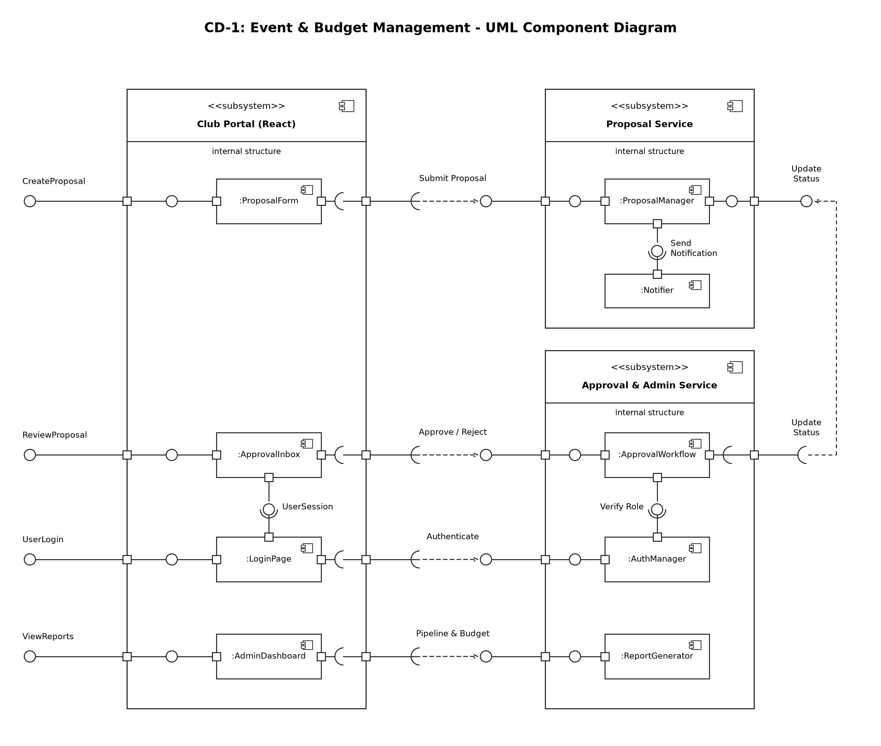
Figure 1: CD-1 Event & Budget Management
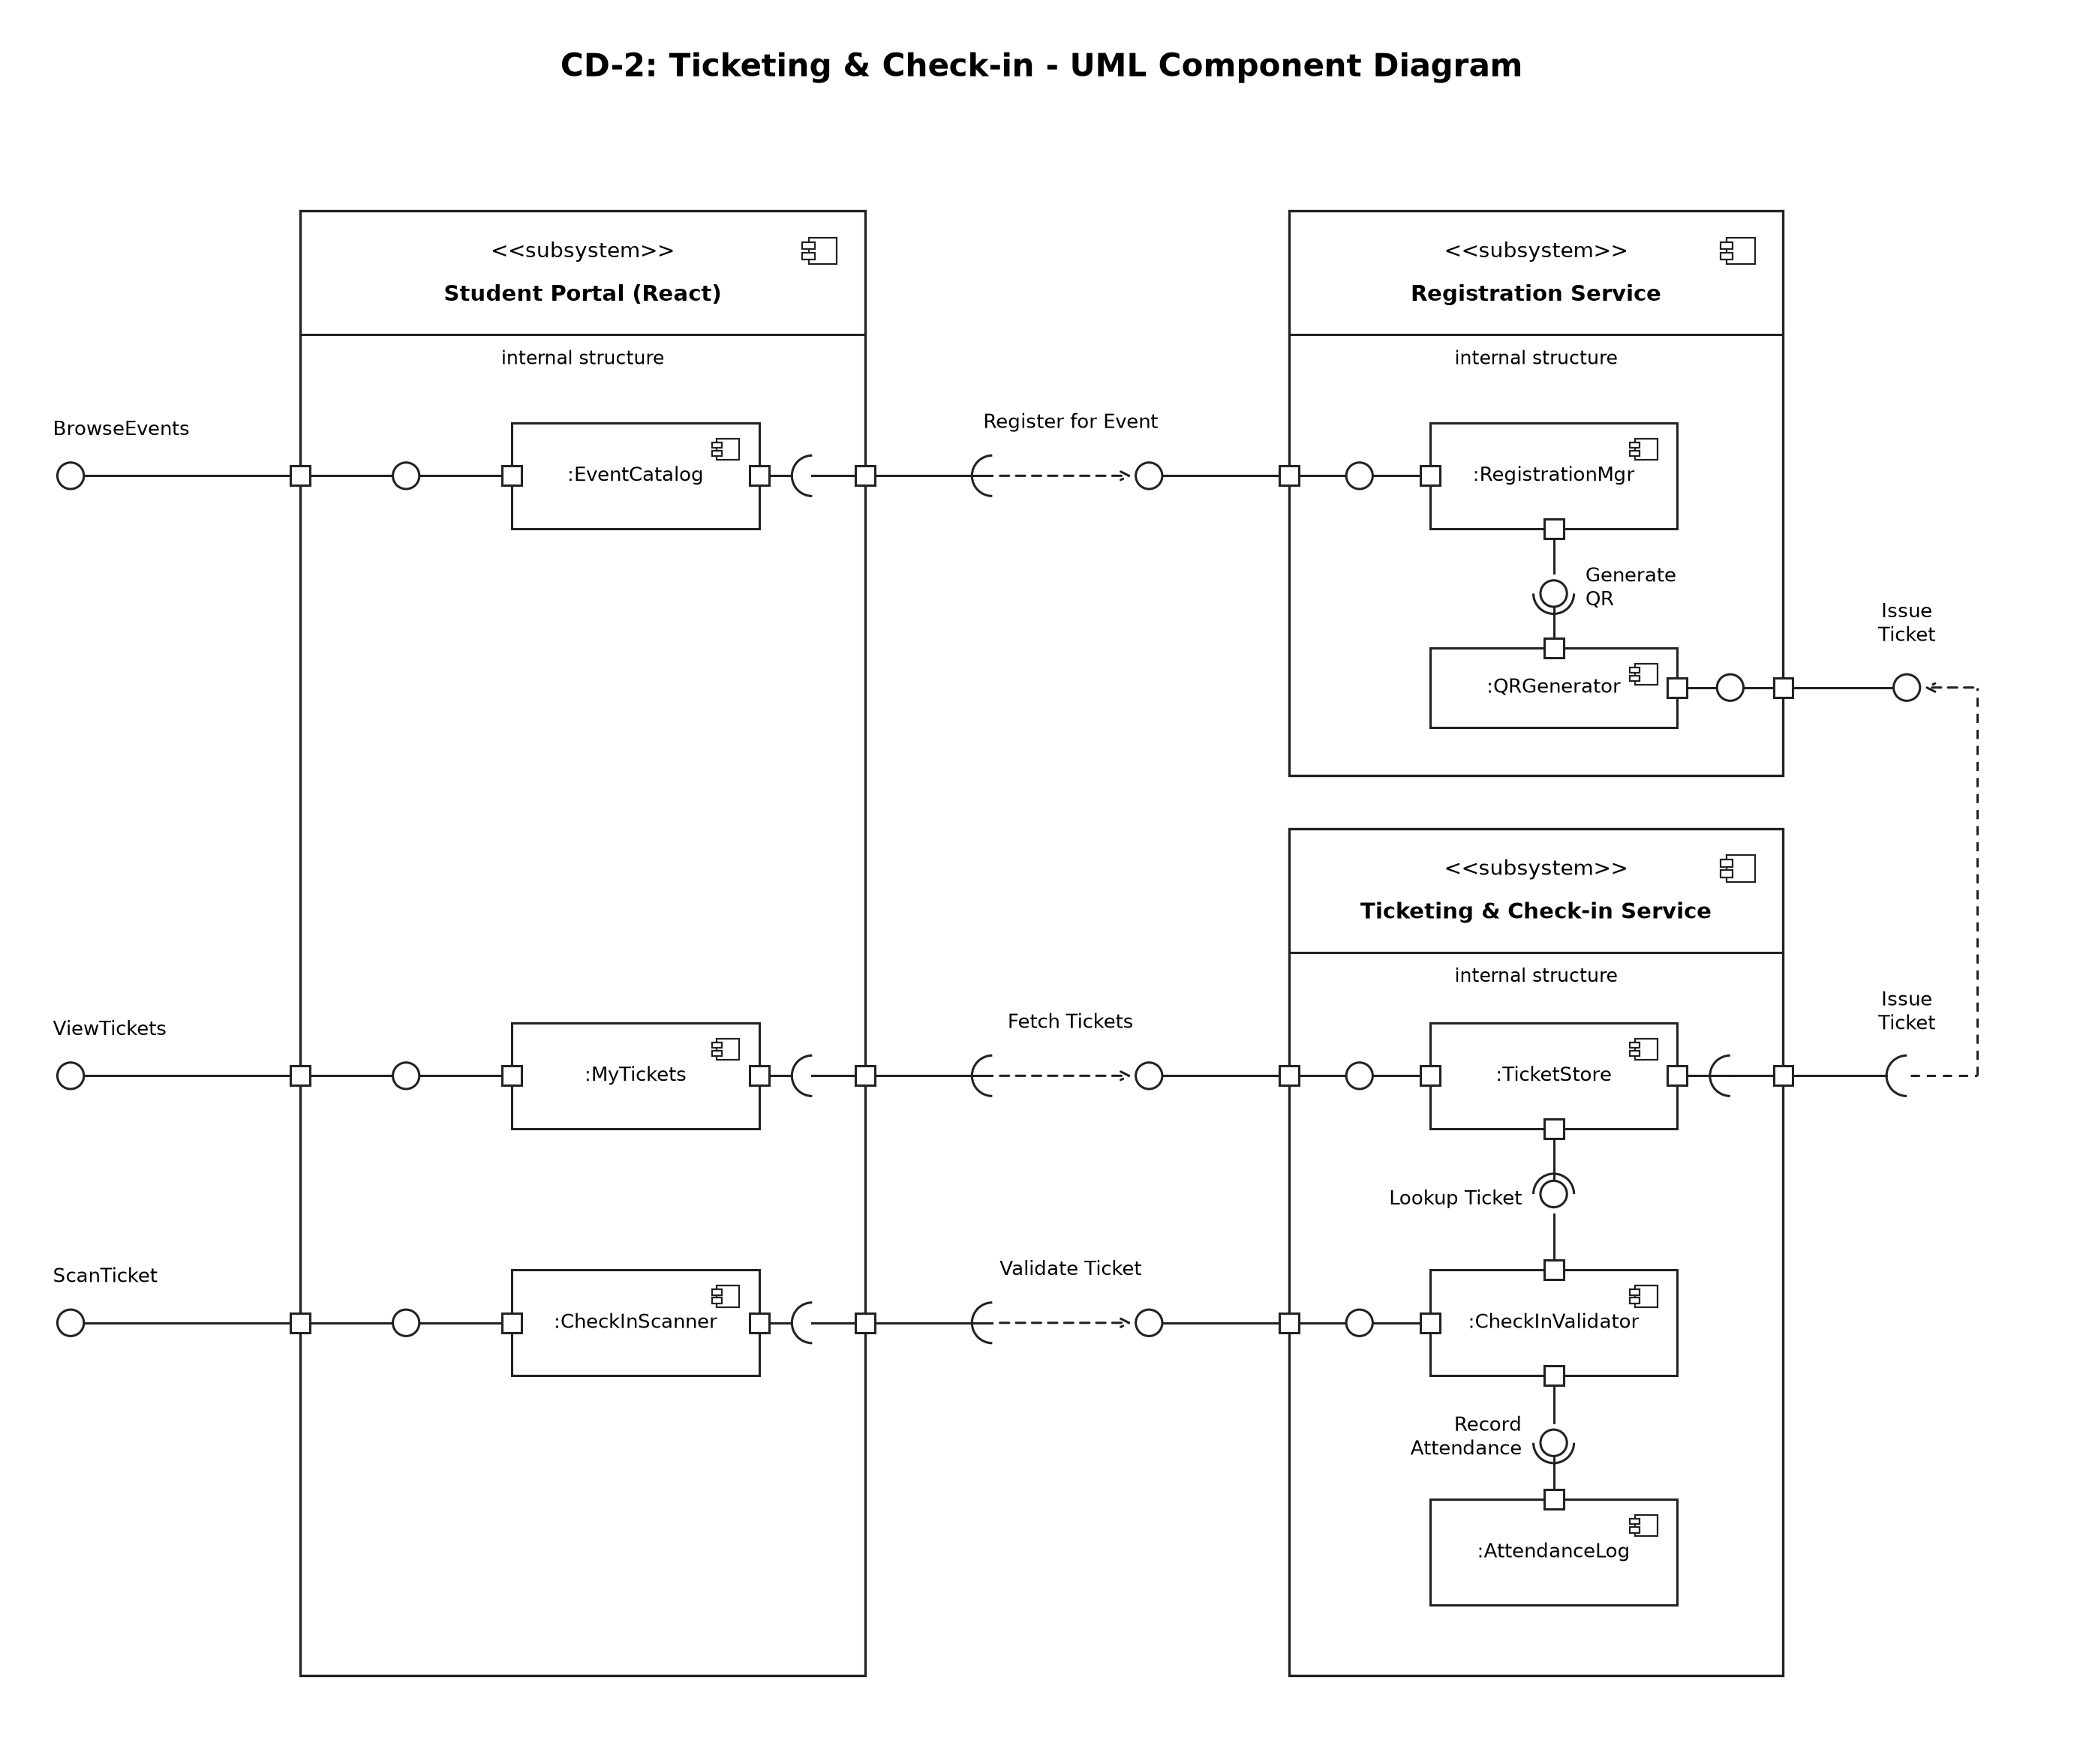
Figure 2: CD-2 Ticketing & Check-in

3.4 Component Descriptions
- Club Portal / Student Portal (React): UI pages - ProposalForm, ApprovalInbox, LoginPage, AdminDashboard, EventCatalog, MyTickets, CheckInScanner.
- Proposal Service: ProposalManager validates and stores proposals, updates their status (also when ApprovalWorkflow records a decision), publishes an approved proposal as an event, and triggers Notifier, which creates in-app notifications.
- Approval & Admin Service: ApprovalWorkflow enforces Faculty -> Finance -> Dean order, records history and updates the proposal status through ProposalManager's Update Status interface; AuthManager handles login, JWT and role checks; ReportGenerator builds dashboard data and CSV exports (PDF optional).
- Registration Service: RegistrationMgr checks capacity and duplicate registration; QRGenerator creates signed ticket tokens and QR images.
- Ticketing & Check-in Service: TicketStore stores and returns tickets; CheckInValidator verifies and marks tickets USED; AttendanceLog records check-ins for reports.
- Database (MySQL): single relational database used by all services (tables: users, clubs, proposals, approval_history, notifications, events, registrations, tickets, checkins).

3.5 Chosen Architecture Pattern and Rationale
Layered (3-tier) architecture: Presentation (React), Business logic (Express service modules) and Data (MySQL). It keeps UI, rules and data separate, is easy for a small team to build and test, and keeps approval and ticket data consistent in one transactional database. Microservices were rejected as too complex to deploy and operate within two sprints; a plain client-server monolith was rejected because it would mix UI and business rules, making the approval workflow harder to test. The services named in this document are modules inside one Express application deployed as a single unit, not separate processes.

3.6 Technology Stack & Data Stores
Layer | Technology
Presentation | React 18 (Vite), React Router, Axios, browser QR scanner library
Business / API | Node.js 20 LTS, Express, jsonwebtoken, bcrypt, qrcode, CSV export (PDF library optional)
Data | MySQL 8.0 (mysql2 driver with parameterised queries)
DevOps | GitHub, GitHub Actions CI (lint + tests on every push)

3.7 Risks & Mitigations
Risk | Mitigation
Approval stage skipped through a direct API call | Server-side stage check in ApprovalWorkflow; never trust UI state
Ticket screenshots shared and reused | Single-use tickets: status set to USED on first valid scan
Camera not available at venue | Manual ticket-code entry on the check-in page
Team falls behind schedule | Notifications by email and PDF export kept as stretch items; core flow first

3.8 Traceability to Requirements
Design spec ID | Requirement(s) | Component(s)
DS-AUTH-01 | SCP-F-001, SCP-SR-001 (Login, JWT, password hashing) | AuthManager
DS-AUTH-02 | SCP-F-002, SCP-SR-002 (Role-based access, token and role check) | AuthManager (role middleware)
DS-PROP-01 | SCP-F-003 (Submit proposal) | ProposalManager
DS-PROP-02 | SCP-F-004 (Edit and resubmit) | ProposalManager
DS-PROP-03 | SCP-F-005 (Track proposal status) | ProposalManager
DS-APPR-01 | SCP-F-006 (Sequential approval stages) | ApprovalWorkflow
DS-APPR-02 | SCP-F-007 (Approve / reject with comment, approver inbox) | ApprovalWorkflow
DS-APPR-03 | SCP-F-008 (Approval history) | ApprovalWorkflow
DS-NOTI-01 | SCP-F-009 (Notifications) | Notifier, ProposalManager
DS-TKT-01 | SCP-F-010 (Register for event) | RegistrationMgr
DS-TKT-02 | SCP-F-011, SCP-SR-003 (Signed QR ticket) | QRGenerator, CheckInValidator
DS-TKT-03 | SCP-F-012 (View / download ticket) | TicketStore
DS-CHK-01 | SCP-F-013, SCP-NF-002 (Check-in validation and speed) | CheckInValidator, TicketStore, AttendanceLog
DS-DASH-01 | SCP-F-014 (Dashboard and filters) | ReportGenerator
DS-DASH-02 | SCP-F-015 (Export reports) | ReportGenerator, AttendanceLog
DS-PERF-01 | SCP-NF-001 (Response time) | React UI, Express API
DS-UX-01 | SCP-NF-003 (Responsive UI) | React UI
DS-OPS-01 | SCP-NF-004 (Availability, /api/health) | Express API, MySQL
DS-OPS-02 | SCP-NF-005 (Audit logging) | ApprovalWorkflow, AttendanceLog
DS-OPS-03 | SCP-SR-004 (Parameterised queries, input validation) | All service modules
DS-OPS-04 | SCP-SR-005 (HTTPS) | Deployment

3.9 Security Architecture
Threat modelling (STRIDE):
Threat | Example | Control
Spoofing | Someone logs in as an approver | bcrypt passwords, JWT with 8-hour expiry
Tampering | Edited QR token or budget value | HMAC-signed tickets, server-side validation
Repudiation | Approver denies a decision | Approval history with user and timestamp
Information disclosure | Club sees another club's budget | RBAC filters on every query, HTTPS
Denial of service | Login or check-in flooding | Basic rate limiting on login and check-in endpoints (stretch goal)
Elevation of privilege | Student calls approval API | Role check middleware on every route

4. Design

4.1 Design Overview
Each business component is an Express router + service module with its own MySQL tables. The React client calls these through REST endpoints; shared middleware handles authentication, role checks, validation and error formatting. Registration runs inside a database transaction with a unique (event, student) constraint, so seats cannot be oversold and a student cannot register twice. When the Dean approves a proposal, ProposalManager publishes it as an event that students can register for.

4.2 UML Sequence Diagrams
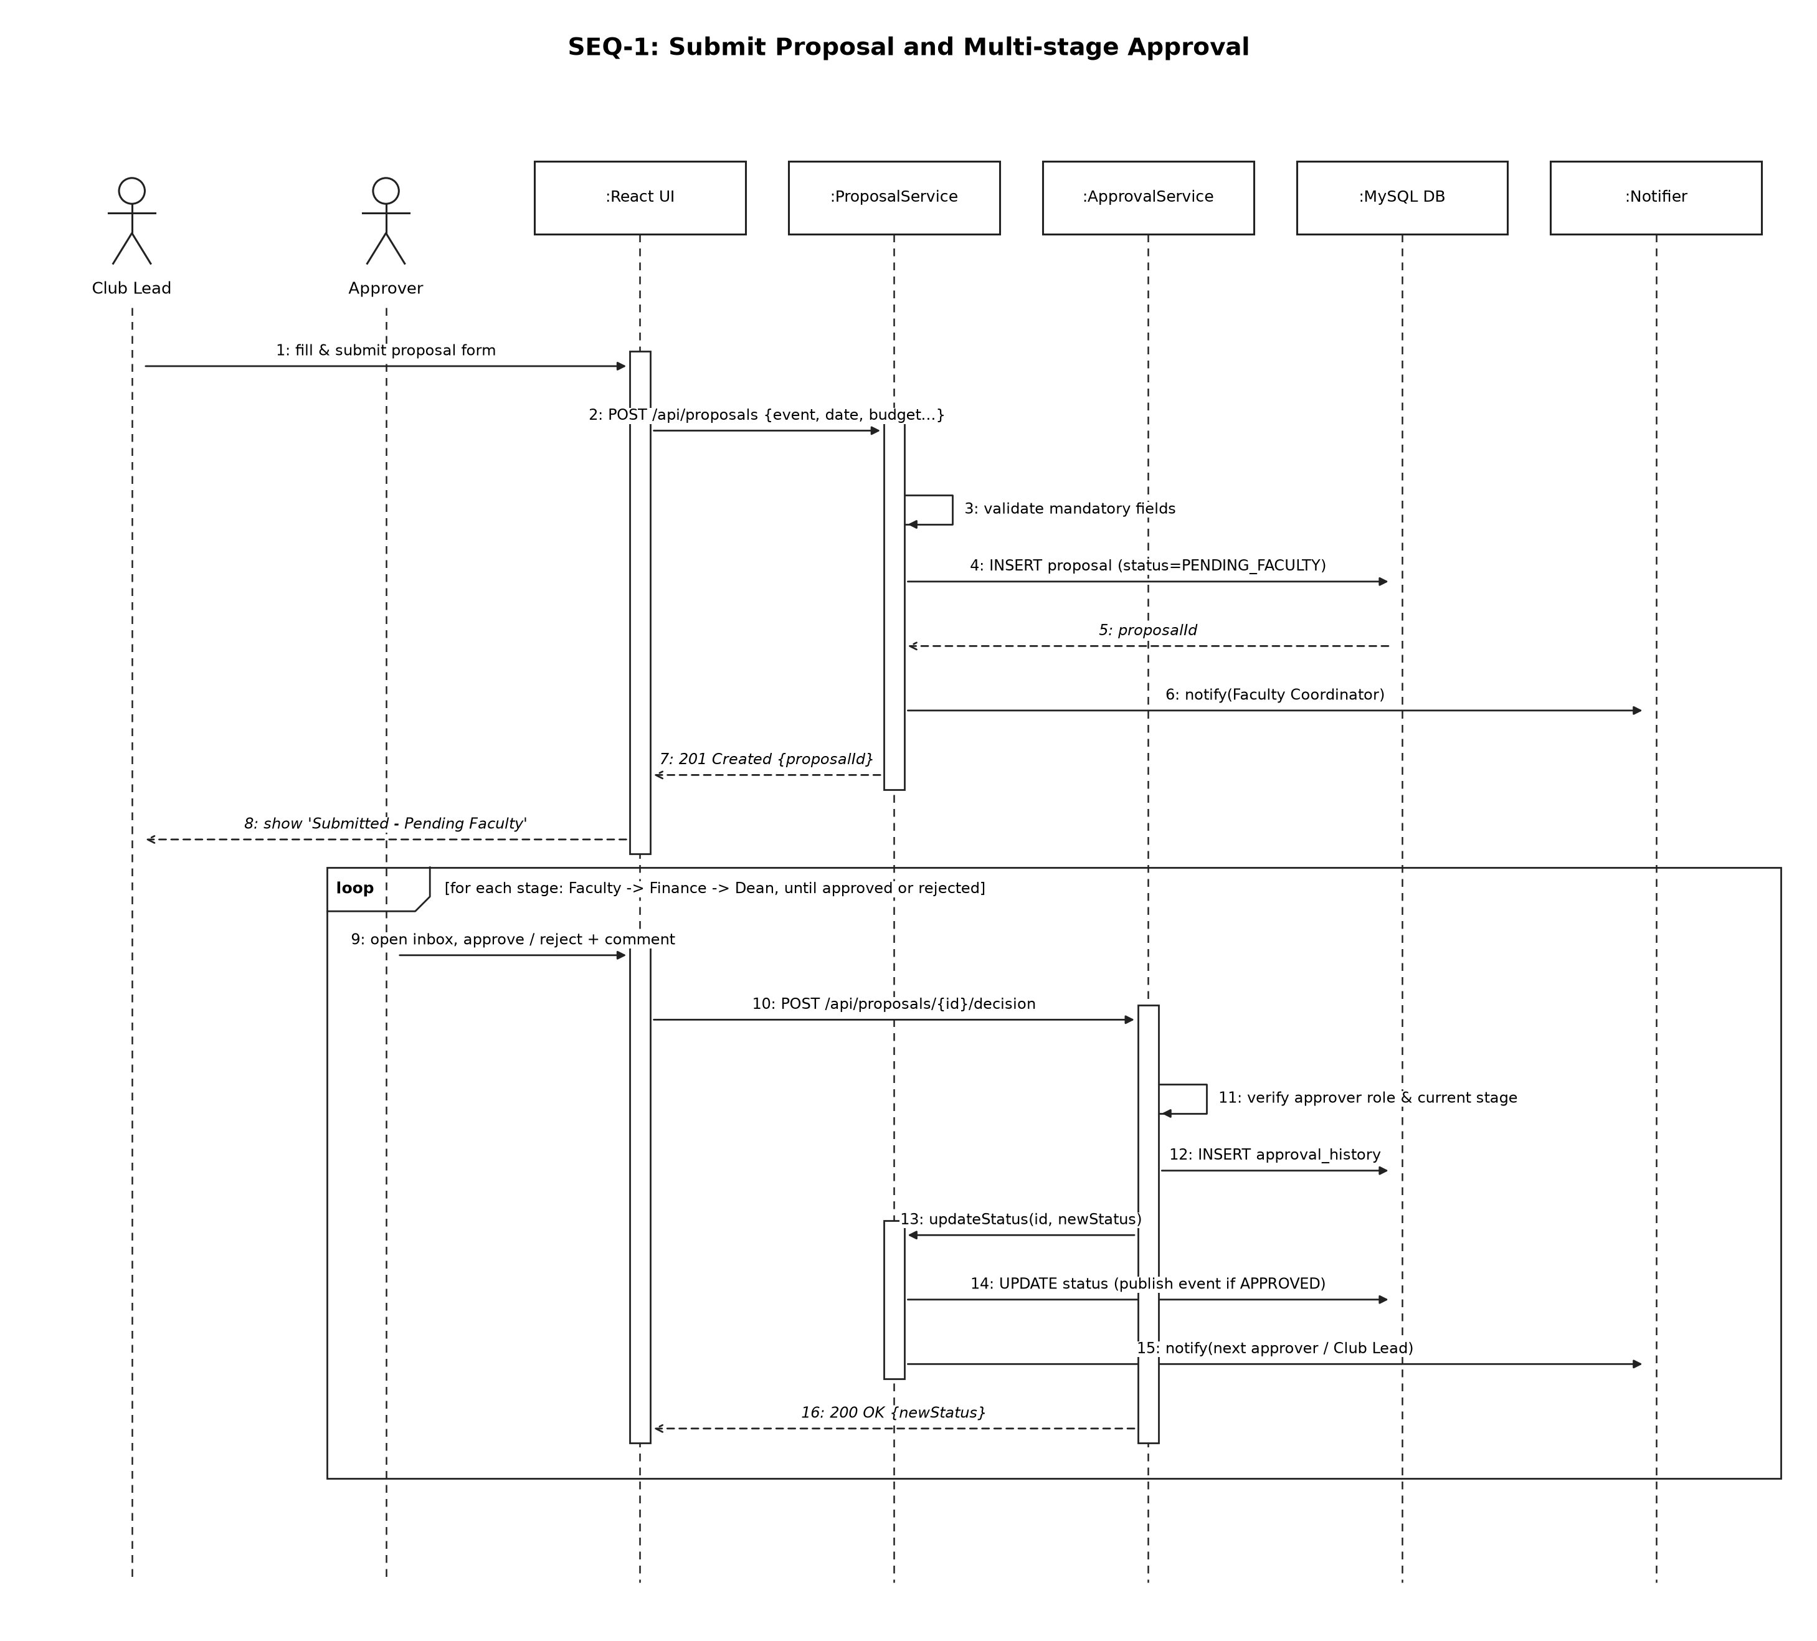
Figure 3: SEQ-1 Submit proposal and multi-stage approval
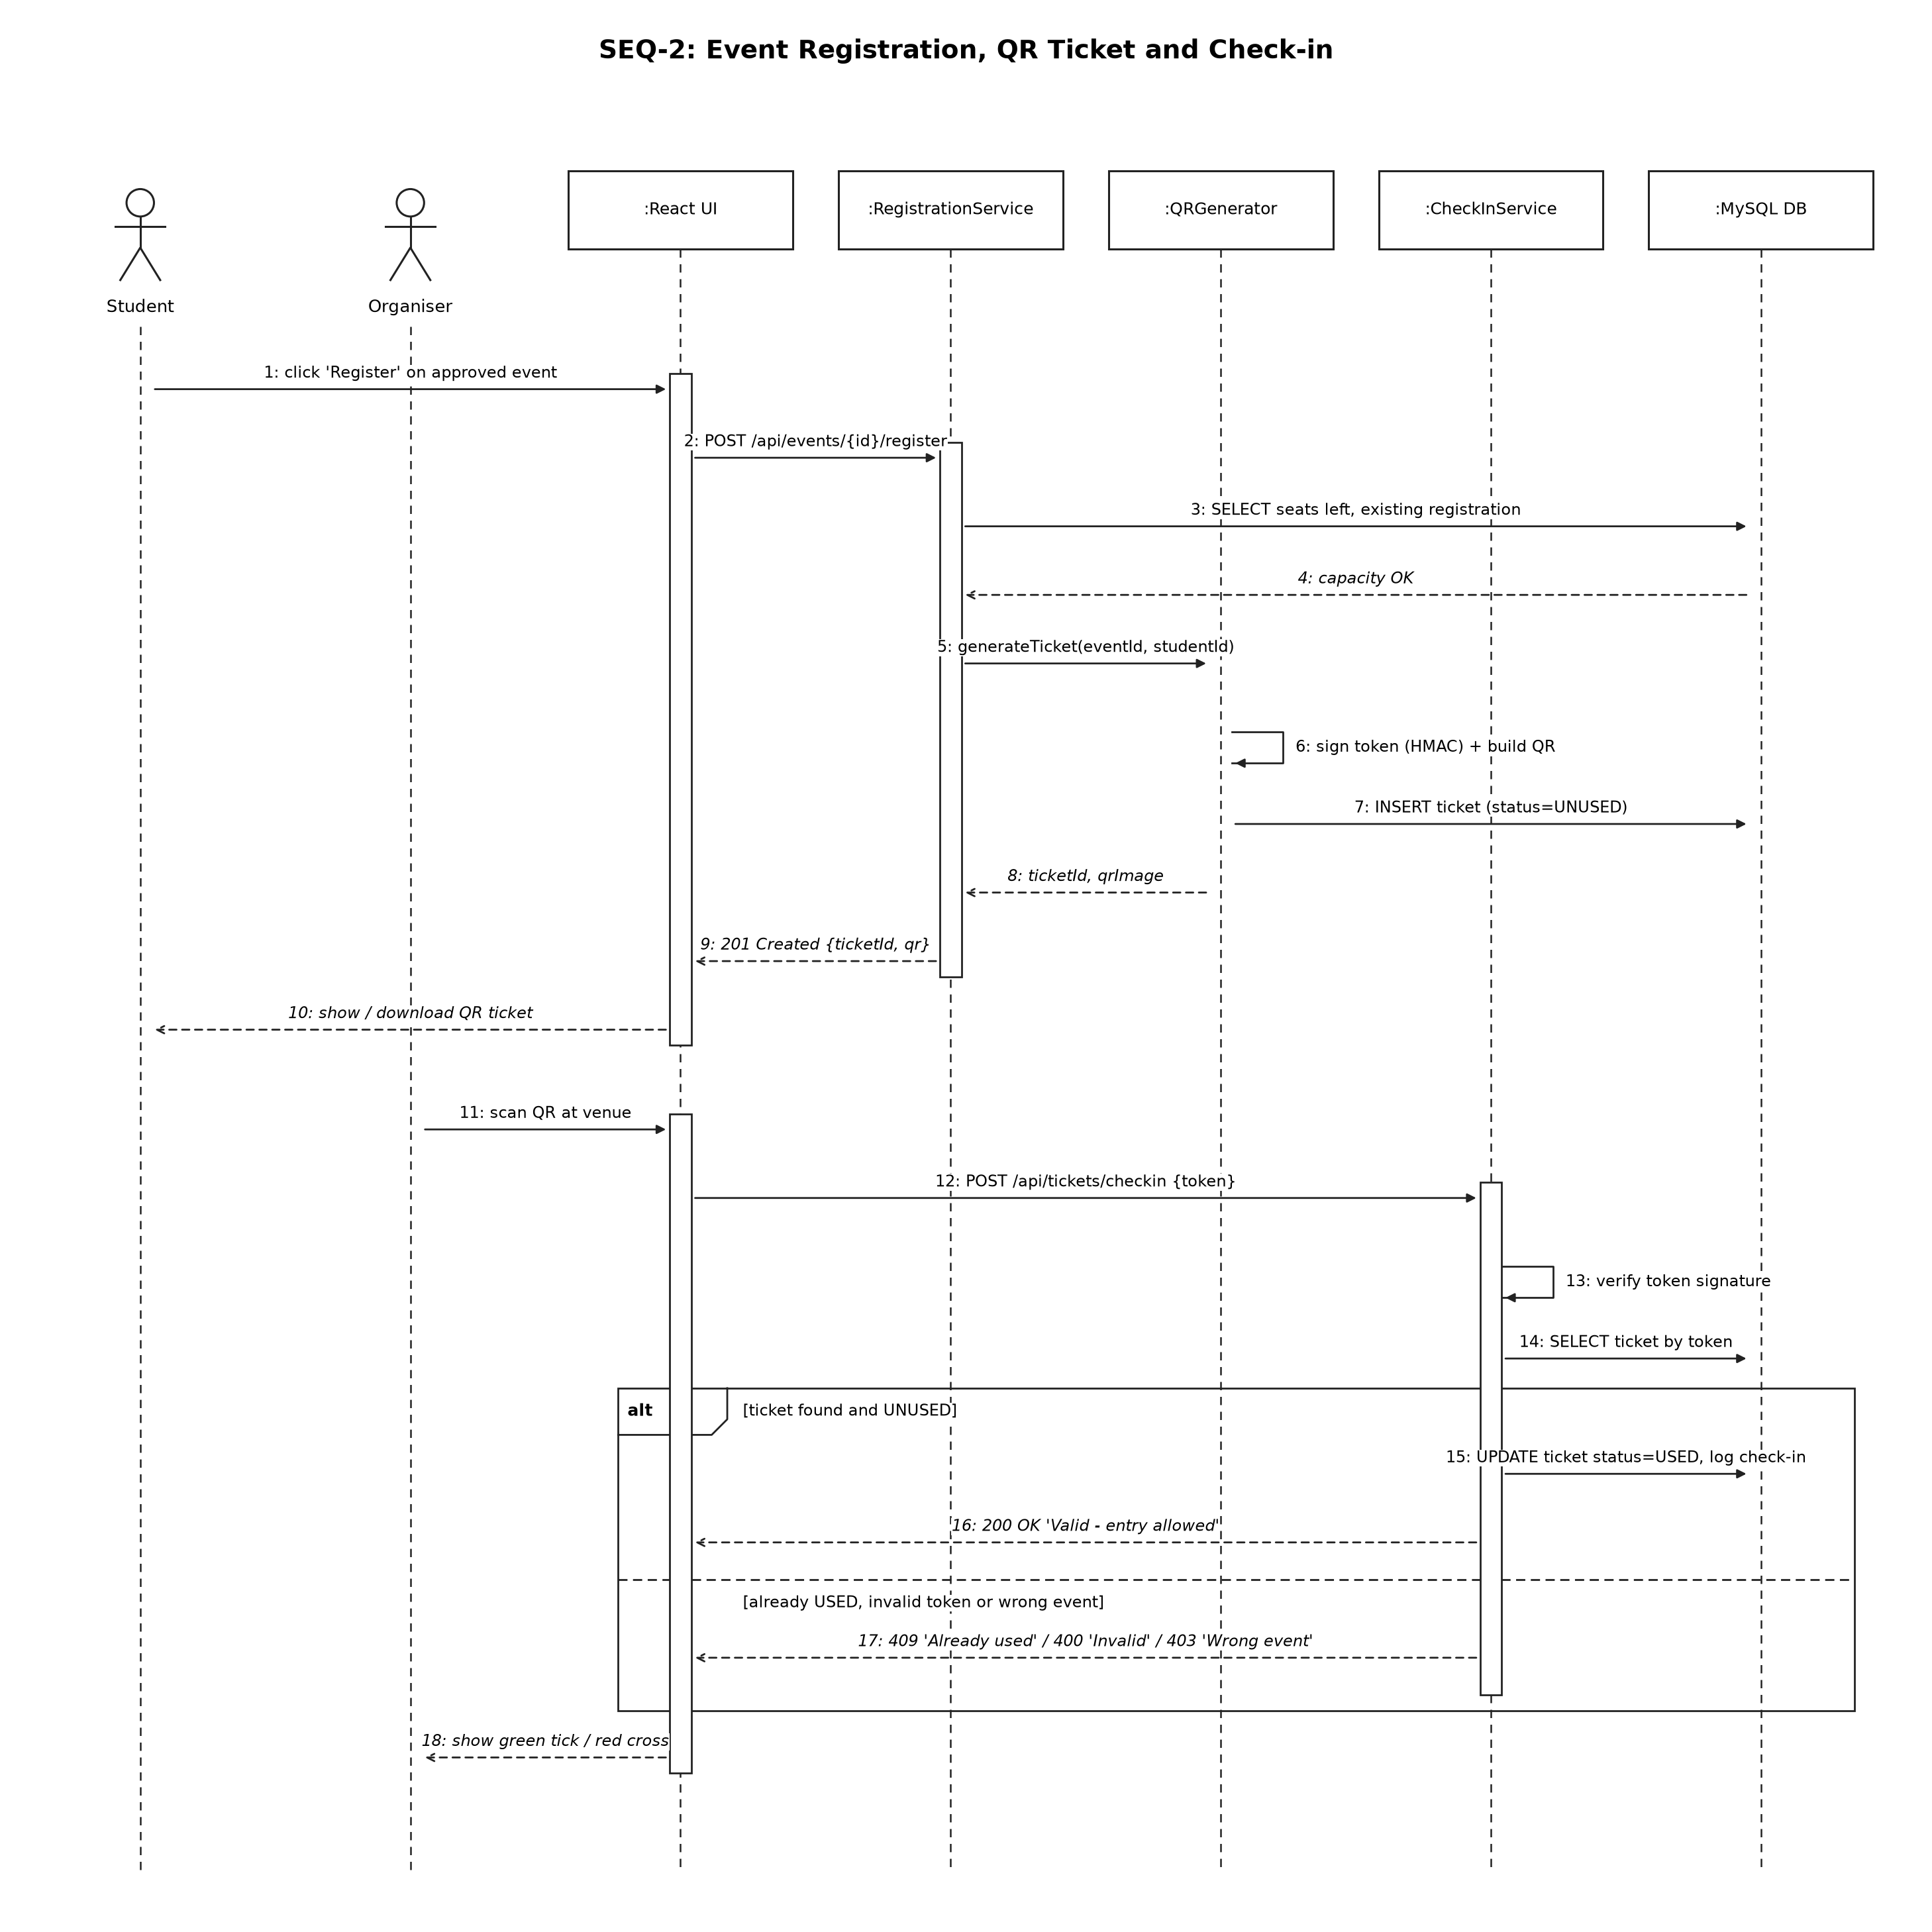
Figure 4: SEQ-2 Event registration, QR ticket and check-in

4.3 API Design
Interface definitions for two components: Proposal / Approval and Ticketing / Check-in. All four endpoints need Authorization: Bearer <JWT>; only login and /api/health are public.
Component | Endpoint | Method | Role | Request | Response | Errors
Proposal Service | /api/proposals | POST | Club Lead | {eventName, eventDate, venue, expectedAttendance, budget, description} | 201 {proposalId, status: "PENDING_FACULTY"} | 400 Missing/invalid field, 401 Not logged in, 403 Not a Club Lead
Approval Service | /api/proposals/{id}/decision | POST | Faculty / Finance / Dean | {decision: "APPROVE" | "REJECT", comment} | 200 {proposalId, newStatus} | 400 Comment required on reject, 403 Not current stage, 404 Proposal not found
Registration Service | /api/events/{id}/register | POST | Student | (no body) | 201 {ticketId, qrImage} | 404 Event not found, 409 Already registered or event full
Check-in Service | /api/tickets/checkin | POST | Club Lead (organiser) | {token} | 200 {valid: true, studentName, eventName} | 400 Invalid token, 409 Ticket already used, 403 Ticket is for another event, or caller is not its organiser

4.4 Error Handling, Logging & Monitoring
- All errors return JSON {error, message} with the correct HTTP status; no stack traces sent to the client.
- Passwords, JWTs and ticket tokens are never written to logs.
- Approval decisions and check-ins are written to audit tables with user and timestamp; the application never deletes audit entries.
- A /api/health endpoint is monitored for uptime; failed check-ins and 5xx errors are counted.

4.5 UX Design
Role-based menu so each user sees only their tasks; status badges coloured by stage (pending, approved, rejected); large green / red result on the check-in screen; responsive layout for phones at the venue.

4.6 Open Issues & Next Steps
- Email notifications and SMS reminders (stretch goal).
- Paid events with a payment gateway.
- Single sign-on with the university login system.

5. Appendices
5.1 Glossary: SCP, RBAC, JWT, QR, HMAC, REST, STRIDE, TLS.
5.2 References: IEEE 42010 (architecture description), OWASP Top 10, IEEE 830 / 29148, project SRS v1.0.
5.3 Tools: VS Code, GitHub, MySQL Workbench, Postman, UML diagramming tool.

